ASIA-PACIFIC TELECOMMUNITY
The South Asian Telecommunication Regulator’s Council Meeting (SATRC-15)

SATRC REPORT ON
RATIONALIZATION OF TAX STRUCTURE IN TELECOMMUNICATION SECTOR

Prepared by
SATRC Working Group on Policy, Regulation and Services

Adopted by
15th Meeting of the South Asian Telecommunications Regulator’s Council
05 – 07 August 2014, Paro, Bhutan

CHAPTER-1
BACKGROUND OF THE STUDY

1.1 Work Item: Rationalization of Tax Structure in Telecommunications Sector

Background
Telecommunication/ICTs/Broadband is not only a tool for socio-economic development for any country but an industry in itself. Even during the economic downturn this sector remained largely unaffected. In the liberalized economy, there has been a steady growth of private investment both domestic and foreign in this sector. At the same time, some of the governments are trying to make this sector as a goose that lay golden eggs. And there have been some negative impacts in the development of this sector due to heavy taxation. The purpose of this study will be to find the types and amount of taxes that the government levies from telecom sector and to identify if there is any correlation between taxation and the sector development and its adoption. The study will also identify areas of taxation which can be rationalized.

Objective and scope
The study has been carried out based on the following broad scope and objectives set by the SATRC Working Group on Policy, Regulation and Services.
To assess the policy and legal framework for taxation including the direct and indirect taxes applicable for telecom sector value chain/ecosystem in the SATRC countries.

To estimate the contribution of telecom sector value chain/ecosystem on the GDP and total government tax in the SATRC countries.

To estimate the total FDI in the telecom sector/value chain/ecosystem in the SATRC countries.

To assess the impact of taxation on the development of the telecom sector sector/value chain/ecosystem in the SATRC countries.

To assess the Impact of taxation on the tariff, service adoption and QoS of telecom services Time frame
This study was carried out during 2012-2014
Utilization of the report
This study and its report is expected to be useful for:
Policy makers/Government/Regulator (as advisors to Government on Taxation on telecom sector) as well as the operators in SATRC member states and other countries
CHAPTER- 2
INTRODUCTION TO TAXATION

General introduction on tax and non-tax revenues
Taxes are compulsory payments to government without any guarantee of direct benefit for person who pays the tax. The governments collect taxes from sector in many ways depending on the classification of taxes.

Classification of taxes: Taxes can be classified depending on many aspects as listed below:
1. As to subject matter or object
A. personal, poll or capitation- tax of a fixed amount on individuals residing within a specified territory, without regard to their property, occupation or business. Ex. Community tax (basic)
B. property- imposed on property, real or personal, in proportion to its value, or in accordance with some reasonable method or apportionment. Ex. Real estate Tax
C. Excise- imposed upon the performance of an act, the enjoyment of a privilege, or the engaging in an occupation, profession or business. Ex. Income tax, VAT, Estate Tax, Donor’s Tax
2. As to who bears the burden of the tax
a. Direct- the tax is imposed on the person who also bears the burden thereof
Ex. Income tax, community tax, estate tax
b. Indirect – imposed on the taxpayer who shifts the burden of the tax to another, Ex. VAT, customs duties.
3. As to determination of amount
a. specific – imposed and based on a physical unit of measurement as by head number, weight, length or volume. Ex. Tax on distilled spirits, fermented liquors, cigars
b. Ad Valorem of a fixed proportion of the value of the property with respect to which the tax is assessed. Ex. Real estate tax, excise tax on cars, non-essential goods.
4. As to purpose
A. general, fiscal, or revenue- imposed for the general purpose of supporting the government. Ex. Income tax, percentage tax
B. special or regulatory- imposed for a special purpose, to achieve some social or economic objective. Ex. Protective tariffs or custom duties on imported goods intended to protect local industries.
5. As to scope or authority imposing the tax
a. national- imposed by the national government ex. NIRC, custom duties
b. municipal or local- imposed by municipal corporations or local governments ex. Real estate tax,
6. As to graduation of rates.
a. proportional- based on a fixed percentage of the amount of the property, receipts or on other basis to be taxed ex. Real estate tax, VAT
b. progressive and graduated- the rate of the tax increases as the tax base or bracket increases ex. Income tax, estate tax, donor’s tax
c. regressive- the rate of tax decreases as the tax base or bracket increases.
d. digressive- increase of rate is not proportionate to the increase of tax base.
General tax and non-tax revenues levied from the telecom sector
Most of the governments impose taxes, including customs duties, which are specific to telecommunication/ICT, rather than general taxes and customs taxes on goods and services, factors of production and assets. Of course, the general economic climate in a country depends on the overall tax take and share of public expenditure (which, particularly at the moment, are not the same thing), but the focus here is specifically sectorial. This leaves quite a lot of latitude for governmental ingenuity, as the following list of sector-specific taxes indicates.
1) Many countries have a specific ad valorem (percentage) tax on telecommunication bills. There are lots of options here: mobile, fixed, or both sorts of bill can be targeted; particular components of the bill could be targeted, such as a monthly charge, or calls (perhaps of a particular type). These options will have different effects.
2) A fixed charge tax per time period can be imposed on a bill. This might be so much per month on post-pay mobile contracts.
3) A specific tax on handsets.
4) Sector-specific taxes on hand-sets and devices such as computers, tablets, or game consoles.
5) Taxes on wholesale telecommunication services, notably on the termination of incoming international calls.
6) Customs taxes on the import of devices or telecommunication equipment more generally, such as switches or antennae.
7) Tax or excessive charges for spectrum. If a spectrum tax were imposed, it would fit clearly into the category. But suppose a government or spectrum regulator from one day to the next simply raised spectrum usage charges by, say, 20 per cent. Or suppose (more probably) it withheld available spectrum in an auction in order to raise the price. Both effects would be the equivalent of a tax. This may be a particularly important form of the government appropriating revenue from the sector, but it largely escapes notice as a fiscal measure.
General tax in Telecom sector: - Basically the revenue collected by the government in the form of tax is known as general tax. The source of general tax from the telecom sector are Corporate tax, capital gain tax, custom duty, central excise duty, Royalty, service tax, ownership tax, handset tax, VAT etc.

Non-Tax revenues in Telecom sector: - Revenue collected by the government from sources other than tax is known as Non-Tax Revenue. The sources of non-tax revenue of telecom sector are:- Fees, Fines or Penalties, Surplus from Public Enterprises, special assessment of betterment levy i.e. USO fund, spectrum acquisition fee, activation charge, connection charge, uses charge, Numbering fee, Grant and Gifts, Deficit Financing etc.

Sector specific tax from the telecom sector
Sector specific tax of the telecom sector
Additional tax and levies imposed by the government for the particular sector is known as sector specific Taxes. Some example of sector specific Tax/charges paid by telecom operator to the government or regulators in Telecom sector are regulatory fees, spectrum fees, licence fees, USF fees, Ownership tax, handset tax, activation charge, connection charge, uses charge, etc.

CHAPTER -3
REGIONAL PRACTICES ON THE TAXATION IN TELECOM SECTOR

The SATRC member states have different taxation regime as applicable to telecommunication sector. The range of total taxes varies. Some countries are satisfied with lower overall taxes and some countries seem to levy higher taxes for larger contribution to the government exchequer.

The studies by GSMA show that the countries with highest tax as a proportion of Total Cost on Mobile Ownership (TCMO) are Pakistan, Bangladesh and Nepal respectively. In all other SATRC countries tax as a proportion of TCMO ranked below the SATRC average value.

Highest tax as a proportion of handset cost (TPHC) in SATRC countries are Pakistan, Bangladesh, Nepal and Iran respectively. All other SATRC countries tax as a proportion of handset cost ranked below the SATRC Average value.

Similarly highest tax as a share of total cost on mobile user (TCMU) is Pakistan, Sri-Lanka and Nepal respectively. In all other SATRC countries taxes as a share of total cost on mobile user ranked below the SATRC average.

SATRC consumers pay the lowest tax as a proportion of mobile service ownership, due to low VAT rates and limited mobile-specific taxation compared to the region.
The table below shows a comparative listing of TCMO, TP

Comparative chart of TCMO, TPHC and TCMU of SATRC countries

Country | TCMO | TPHC | TCMU | 7. Maldives | - | - | -
1. Afghanistan | - | - | - | 8. Nepal | 18.41% | 23.00% | 18.00%
2. Bangladesh | 20.21% | 33.75% | 15.00% | 9. Pakistan | 31.61% | 36.08% | 31.00%
3. Bhutan | 10.00% | 10.00% | 10.00% | 10. Sri Lanka | 12.26% | 0.00% | 20.00%
4. India | 10.35% | 13.56% | 10.30% | 11. Global Average | 18.14% | 23.29% | 17.97%
6. Iran | 6.20% | 26.50% | 1.50% | 12. SATRC Average | 15.58% | 20.41% | 15.11%
Source: - GSMA Global Mobile Tax Review 2011 Deloitte LLP

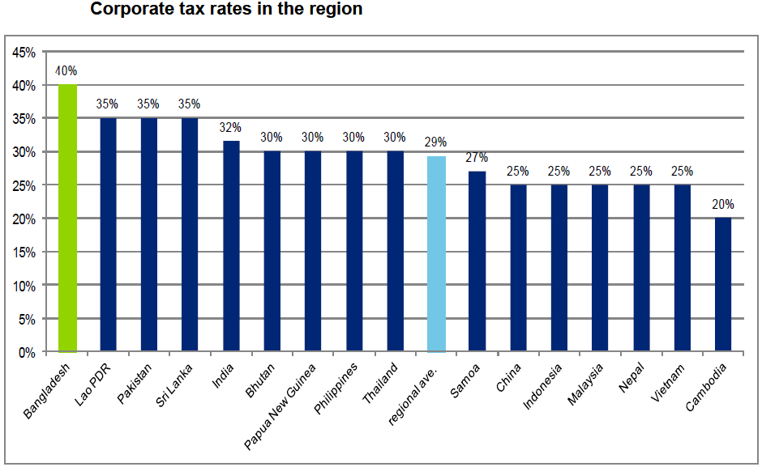

In the following paragraphs the taxation scenario in the SATRC member states will be described country by country. The data has been collected from different sources.

Afghanistan

In Afghanistan, a mobile licensee has to pay US$ 5 million onetime license fee and US$ 1.8 Million annual administrative fee. The license remains valid for 15 years. The validity of the license may be extended upon the mutual agreement. Spectrum usage fee is calculated as per specified rate. The licensees paid US$167.33 Million in 2010 and US$ 123.76 Million in 2011.

In case of tax, the Government imposes 2% to 5% VAT depending on the type of product being purchased, 4% withholding tax, 2% USO levy on AGR, 20% corporate tax and 0 to 25% Import tariffs.

To reform the tax structure, Adam Smith International has been engaged in a long-term contract to lead the provision of tax reform assistance in Afghanistan. The project involves technical and project management co-ordination, and is focusing on combining capacity building of the General Presidency of Revenues (GPR), with overseeing tax administration and tax policy/revenue forecasting and analysis on a day-to-day basis.

The project covers a wide range of issues, including reforming and consolidating tax policy and law; recruiting and training tax officials in everything from revenue analysis to dealing with correspondence; and using taxpayer education to inform the taxpaying public about changes to the tax regime. A basic subject in the reforms is the implementation of modern, international best practices that can be applied effectively in Afghanistan.

Bangladesh
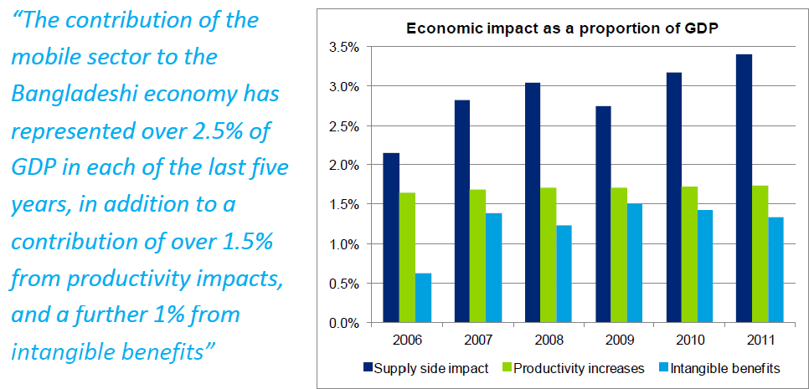
Source: 2012 Deloitte LLP
In addition to a 15% VAT rate on all goods and services, mobile consumers in Bangladesh are subject to mobile specific taxation in the form of a BDT 800 tax on SIM cards and a BDT 300 tax on handset imports, significantly increasing the cost of entering the mobile market for the first time. In 2011, tax on mobile telephony is estimated to make up 21% of the total cost of mobile ownership in Bangladesh. This increased in the last five years from 18.8%, as prices decreased, and is significantly above the regional average of 12.81%.

MNOs also face a higher level of corporation tax than other businesses across the economy, at 35% and 45% for similar publicly traded and non-publicly traded MNOs respectively.

Consumer related taxes are often subsidized by MNOs, who also contribute 5.5% of their revenue for a ‘revenue share tax’, which is used by the regulator to fund the lease of Bangladesh railways’ fiber optic network.
The total cost of mobile ownership in Bangladesh is estimated to be US$48.5 (BDT 3,558). This amount is significant compared to the incomes of consumers, making up approximately 7% of Gross National Income per capita. For those living under the poverty line, the cost of mobile ownership represents more than 11% of income.

Evidence from consumers behavior in this market shows that, as mobile prices fell 67% between 2004 and 2008, average minutes of use doubled over that period. This indicates that mobile users in Bangladesh are very sensitive to changes in price. As such the benefits to penetration levels of reducing the cost of entry to the market, e.g. through reduction in mobile specific taxation allowing mobile to be taxed similarly to other goods, are likely to be significant.
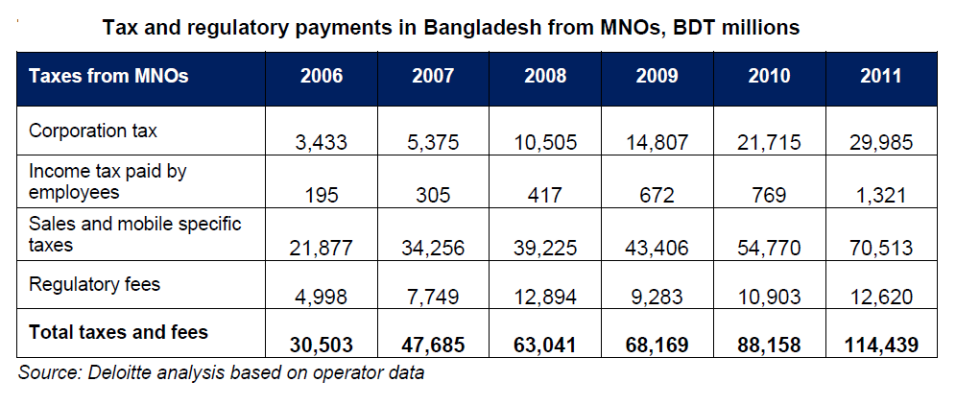 Tax and regulatory fees represented 54% of company revenues for Bangladeshi MNOs in 2011. This high rate is likely to be due, in part, to the subsidization of SIM card taxes by MNOs in order to promote take up of mobile. The largest proportion of tax revenue is raised through sales and mobile specific taxes, including the SIM card tax and the 300 BDT excise on handsets. Together these accounted for 62% of taxes and regulatory fees paid in 2011.
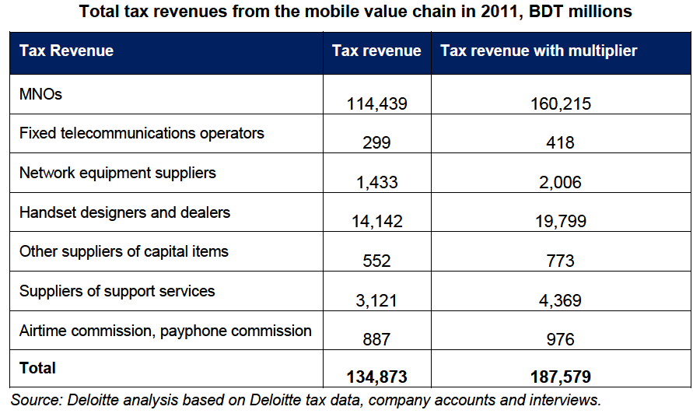 The largest payers of tax in the mobile supply chain, aside from the MNOs, are handset designers and dealers. A fixed import tax of 300 BDT is levied on each imported handset. Sales taxes of 15% are applied to the retail price and those within the handset value chain pay taxes on profits and employee wages.
Annual License fee of BDT 50Mn, Spectrum charges based on investment, License/ spectrum Auction Fee/ direct allocation fee (+ 15% VAT*)

There is customs duty on telecom equipment ranging from 3% - 25% and 5%- 25% duty on NW, Service Equipment & Computer Hardware and similarly duty on SIM 85%+ 5% Regulatory Surcharge, SIM activation tax BDT 300 per SIM and 12% duty of Invoice value per mobile hand set. In Operation Stage, 5.5 % Revenue sharing in Gross collected Revenue with BTRC, 1% SOF of AGR with BTRC, 15% VAT, Local Government taxes, Surcharge on Customers, 15% on commercial rent and 2% AIT on billing and recharge. The rate for corporate tax is 45% or 0.5% of Gross Revenue (Whichever is higher) workers profit participation fund WPPF: 5% on profit before Tax. For each outgoing call BDT 0.22 per minute (of which BDT 0.18 is payable to other operators and BDT 0.04 to inter connection exchange), and operator will receive BDT 0.18 per minute for each incoming call.
Besides, in Bangladesh, a 100 Taka special handset tax applies in addition to an 800 Taka connection tax. This is in addition to a 12% custom duty on all imported handsets and a VAT rate of 15%.

Government of Bangladesh recognizes that it faces major tax policy challenges that need to be addressed urgently. The current tax regime is characterized by being: 1) onerous to business that face a high fiscal burden, 2) complex and difficult to comply with given differentiated corporate income tax (CIT) rates and extensive use of incentives, and by 3) not generating enough revenues for the Government.

The Government indicated in the letter of intent signed with the IMF under the three year extended credit facility in March 2012 that it would seek to broaden the tax base and increase tax receipts, including through reforms in the income tax regime and the structure of VAT. At the moment, however, industrial and investment policies continue to rely heavily on the use of tax incentives. In addition, Bangladesh extends significant subsidies and price controls as a social policy tool, even though their cost is significant, their effects at time perverse or inadequately targeted, and their operation opaque.

* VAT on the 3G mobile service license and spectrum fees reduced to 7.5 per cent recently. During 2G renewal it was 15%
Bhutan
License fees for operating a mobile service is Nu. 777 Million (14.67 Million USD) for a period of 15 years. Importers have to pay 10 % Sale tax on the import of mobile handsets from third country for sale. There is 30% corporate tax, 10% VAT and 3% on International bandwidth purchase tax in Bhutan, There is no tax on infrastructure import in Bhutan. BIT on net profit replaced 2% turnover tax. Export income is exempted from tax liability. Plant machinery is also exempted from sales tax and import duty and other nuisance taxes have also been abolished

The government of Bhutan came up with a major tax reform in 1992.The purpose of this was the rationalization and simplification of procedures in line with the development objective enshrined in the 7th Five Year Plan. The guiding principles of the reform include the Rationalization of tax structure, Expansion of tax base, Promotions of savings and investments, Correct trade imbalances, Ensure equity and Simplify administrative procedures for compliance and transparency.

India
Taxes and levies applicable on telecom sector can be classified into three broad categories:
 Central taxes: levied by Central Government
 State taxes: levied by State Government
 Other levies: levied by Governmental / Local bodies

Taxes and Levies in a nutshell:
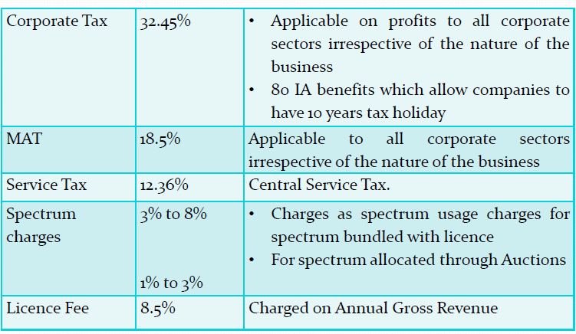
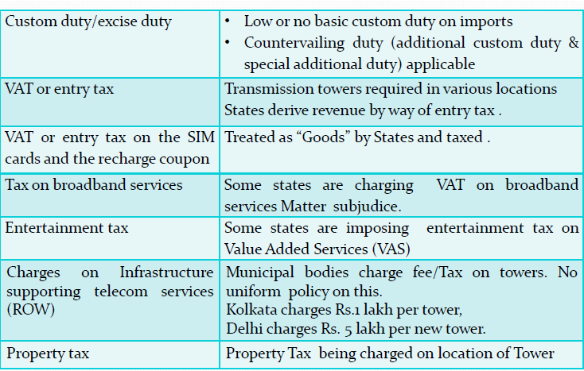

License and Spectrum fee in India
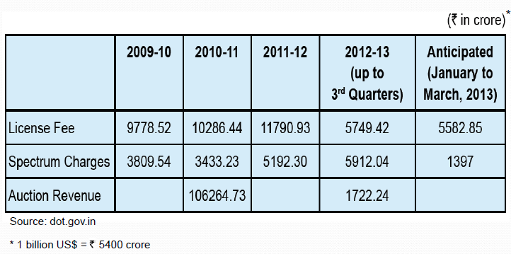

INITIATIVES at TRAI

- TRAI constituted a study on this subject. The findings of the study are-
- Taxation issues are still evolving as
- All levels of Government are trying to bring the sector within the tax ambit
- More than 30% of revenue as tax on telecom sector
- Non uniform tax environment
- Service delivery requires the establishment of a wide network of delivery points
- Strategic location of business is not possible
Contribution of Taxes on the Revenue to the Government is summarized below-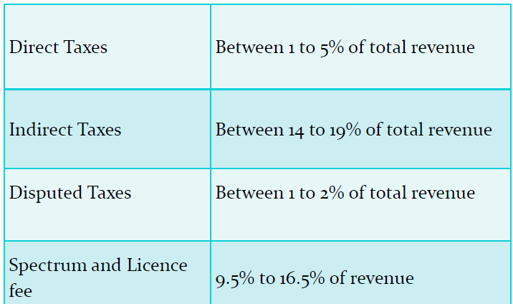
Suggestions from the study on taxation:
- Where new levies are proposed or unrecognized taxable activities are recognized, sector can ask for mandate that tax would be payable prospectively.
- A joint periodical review of the sector be carried out by both levels of government
- Since sector paying VAT on SIM cards and Recharge Vouchers, input tax credit to be made available against these taxes
- Rationalization of rates/taxes by municipal authorities
- Due consideration of these inputs in upcoming unified Goods and Services Tax (GST)

Study argues the need to deliberate on following issues to provide clarity.
1. Should the telecom sector be treated as providing goods or services?
• Power to tax manufacturing and services lies with Centre
• Right to tax sale of goods lies with the State
• In the absence of clarity in coverage of taxes, sector gets taxed by both administrations.
2. VAT and Entry Tax on inputs and Central Sales Tax on procurement from outside the state become sunk costs.
• No mechanism for their recovery
• Other sectors have option of claiming input tax credit
• Telecom sector not invoking this option
3. Input tax Credit in respect of CENVAT paid on tower materials
• Input tax credit is refused on CENVAT paid for tower materials
• Grounds‐ once the tower is assembled, it becomes
Immovable property and there is a break in the tax chain
• Hence credits cannot be claimed against service tax on lease or user charges
• With cross credit between CENVAT and service tax, towers can be called excisable goods.
4. Charges and fees on installation of transmission towers
• Local bodies collecting such fees.
• Streamlining and rationalizing this procedure necessary to reduce compliance costs.

Iran
License fees for operating a mobile service is US$ 450 million and frequency acquisition fees are different according to the usage, time, coverage and spectrum. There is 4.69% communication charge in Iran. Customs duty 25 %, in entering handsets there is a tax for importing, There is 1.5% VAT and SIM ownership tax or charge for mobile while buying (There is a tax such as other services (no difference between communication services and other services), USO Levy in Iran is 3%, corporate tax rate is 25% and Telecommunication Infrastructure Company (A governmental center) purchase international bandwidth in Iran.

Iran has undertaken several major structural reforms. Personal income tax rate were reduce significantly and minimum nontaxable income raised along with a reduction of corporate tax rate from 64 percentage to twenty five percent in 2002/03 and tax assessment and collection method were made less discretionary .

As a part of rationalization of indirect taxes several taxes and fees were combined in a single sales tax of 3 percentages in all goods and services and all import duties, taxes and charges (except commercial benefit taxes) were unified in to a single customs duty rate of 4 percentage.

Maldives
Major indirect taxes are import duty and tourism tax. Import duty is levied on imported goods. It is charged at varying rates from 5% to 200%. Import duty brings approximately 25% of the government annual revenue from taxation. The government imposes 15% corporate tax and 6% VAT in Maldives.
Bank profit tax is the only levied direct tax and is charged at 25% on the taxable income. It constitutes approximately 2% of the annual revenue derived from taxation. Tourist tax is levied at a flat rate on every night a tourist spends in Maldives. Tourist tax brings around 15% of the overall income derived from taxation on the annual basis.
Nepal: The license fees, renewal fees and royalty are fixed for the types of telecommunication services which are fully opened. Those services for which the operators are selected through auction, pay different amount of license fees, renewal fees and royalty based on the amount quoted during the auction. Six voice operators were licensed following different approaches. The government has initiated a license migration regime to bring all the operators into a level playing field by making provision for migration into unified license. For this service the license fees has been fixed at US$ 35Million for 10 yrs. and then renewal fee for every 5 years is US$ 2000 Million for 25 yrs.
There is policy to auction frequency but this has not happened yet. The operators pay frequency fees which has both revenue based as well as fixed. Annual spectrum charges are 0.4% AGR for minimum use of spectrum which is 6 MHZ in 900 MHz band or 9MHz in 1800 MHz band. The charge for additional spectrum is 12Million per MHz in 900 and 8Million per MHz in 1800 band. For 3G spectrum at 2100MHz band the annual charge for 2x10MHz is 24 Crore NRs.

Telecom sector specific charges in Nepal is as follows-Telecom Service Charge ( TSC) is 10%, VAT 13%, Ownership tax in PSTN ,fixed wireless and Postpaid mobile is levied at NRs 1000. The ownership tax for Prepaid mobile is recurrently charged at 2% in recharge amount. 5% excise duty for infrastructure equipment and 1% for Radio equipment import is also levied. There is 2% USO levy and 4% royalty of AGR, Similarly 13% VAT and 25% corporate tax is also applicable for telecom industry as well. For international bandwidth 5% TDS and 13% VAT is levied.
Nepalese tax administration is on the way of its modernization process. Tax reform agenda have been oriented towards enhancing tax compliance of the taxpayers and reducing compliance and collection cost. Moreover, reform initiatives have been focused towards developing equitable, fair, and neutral tax system required for creating an investment friendly climate to ensure economic growth and development.

Apart from this, the department has declared some additional reform agenda and believed to collect more tax revenue during the year. Government’s motto is “Our tax contribution for our own development and for creation of modern and prosperous Nepal."
Thus the department hereby committed to promote proper and fair taxation system by enhancing voluntary tax compliance behaviour and applying electronic tax filing system.

Pakistan
It is said that Pakistan’s Telecommunication sector is one of the most heavily taxed in comparison to regional and comparable economies, second only to Bangladesh. Around 63% of general population believes that the Telecommunication sector is being taxed rather heavily.

Telecommunication sector is also suffering from its share of problems and issues such as the problem of double tax domain where both the federation and provinces are bent upon taxing the sector. Another issue is heavy taxation with high rates of Federal Excise Duty.

Revenue Contribution of Telecom Industry
Telecommunication sector has been a very significant source of taxes for the Government of Pakistan over the past ten years. Following table shows the year wise contribution of Telecommunication sector to the Government revenues.
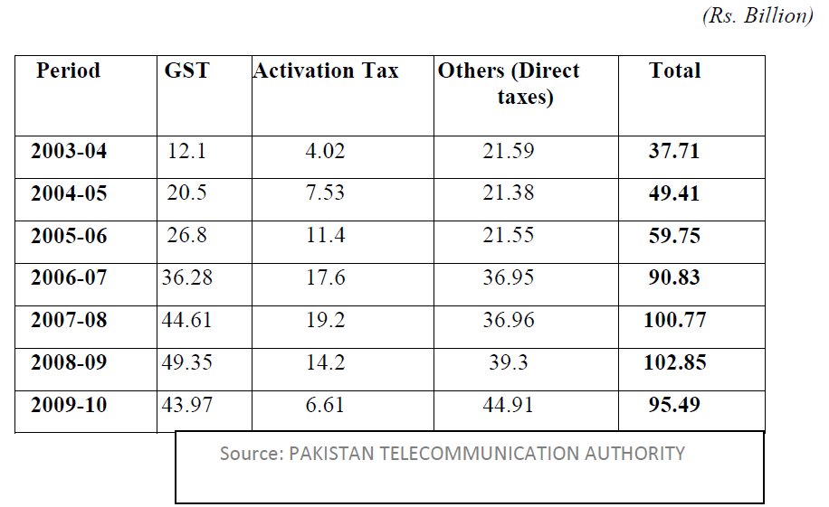

The Federal Board of Revenue (FBR) collected Rs 44 billion as sales tax and federal excise duty (FED) from the Telecom sector during 2009-10 as compared to Rs 49 billion in the corresponding period of previous fiscal year, reflecting a major decrease of Rs 5 billion. The annual report for 2009-10 of Pakistan Telecommunication Authority (PTA) showed that telecom sector contributed about Rs 44 billion as FED/GST during fiscal year 2009-10 whereas the sector also contributes in other tax heads like withholding, income taxes and duties, etc. The decline in FED/GST collection has been attributed to increase in its rate, low tariffs and decline in service use due to high inflation in the country, the report says. According to the PTA annual report, the Authority kept on reminding the tax authorities about the fact that telecom sector is over-burdened with taxes, and requested for relief so that more tax collections could be achieved from the sector. Pakistan mobile phone industry continued to be one of the main contributors to national exchequer in terms of taxes. At the end of the year, total tax collection by mobile sector was Rs 71.95 billion, which was Rs 82.3 billion in 2008-09. Therefore, a dip of 13 percent in total tax collection from mobile sector was witnessed during the reported year. Similarly, a dip of 10 percent was observed in total FED/GST collection from mobile sector where Rs 36 billion had been deposited in national exchequer by all mobile operators during 2009-10. Activation tax was another area where collection declined by about 53 percent in 2009-10. Initial License fee was determined through auction and Annual License fee is o.5% of annual gross revenue minus inter-operators payments.
For postpaid mobile user monthly rental is charged at Rs. 2,000 and the Sales Tax (@19.5 percent): is Rs. 390. Withholding Tax (@10 percent after adding sales tax): is Rs 239. Total Bill adds to Rs. 2,629. With Holding Tax (WHT) is levied at 15%, and the Federal Excise Duty (FED) is levied @ 19.5 % which comes to a Total of 34.5 %. In addition to these, every cellular operator has to pay 7% service charges as well.

VAT is also significantly higher when compared to other industries locally (19.5% for cellular industries vs. 16% for most other industries.) The FED on cellular service is 19.5% compared with 17% on other sectors. The withholding tax rate on telephony services is set at 11.5%, which is 6% on rest of the sectors. Besides these taxes, the activation tax of Rs. 250 on each new connection is additional burden on all cellular companies. There is 35% corporate tax and 19.5% VAT, 1.5% USO levy and 1.5% Royalty on AGR.

Pakistan imposes several special taxes on mobile services and handset. The tax rate on cellular industry is not only higher amongst all different sectors of Pakistan but it is also comparatively huge as compared with different countries of the region including Bangladesh, Sri-Lanka, India, Nepal, Bhutan, Iran etc.
In one the very extensive research carried out by Directorate General of Training and Research,(IR) Lahore under the title ‘TELECOMMUNICATION SECTOR -ITS ROLE, CONTRIBUTION TO FBR REVENUE, PROBLEMS AND ISSUES’ came up with the following recommendations-
I. The Telecom sector should remain the exclusive domain of the Federal government as sharing this regulation with the provincial or local governments would create complications, as for example the jurisdiction of a mobile number registered in Karachi and being used in Lahore cannot be clarified. If it is inevitable that the provinces would charge tax on this sector, then there should be uniformity of tax laws in all provinces and the Federal government should ensure that there is an equal rate of tax being charged by all provinces including Azad Kashmir.

II. The tax burden on the telecom sector should be lessened particularly for the consumers. The rate of FED which is very high currently standing at 19.5% can be significantly lowered. As the burden of FED directly falls on the consumers.
III. The rate of corporate income tax for Telecommunication sector may be increased from 35% to 45%. This can benefit in two-fold; firstly it will generate more revenue for the state and have a direct positive impact on the exchequer, secondly it will discourage the flight of dollars remitted abroad in the form of profits of these companies and come to rescue of the balance of payment deficit of the economy.

IV. The areas in which exemptions are being given, e.g. Call Centers and Software Development houses etc, there should be taxation to increase the revenue of the government. However the rate of tax should be minimum. The government should take measures to bring into the tax net all such services which are providing services abroad while physically being in Pakistan. Pakistan Telecommunication Authority should be empowered to screen calls and online messages coming in and out of the country to identify business transactions taking Place. The government should also request the countries who are acquiring such services to provide information to the Pakistani government that would identify the service providers here.

V. Further amendments should be introduced in the Income Tax Ordinance which should address the areas identified in the paragraph of the problems and issues, named “Ambiguity in Tax Law”.

VI. There should be no restriction on the use of any technology in Pakistan until and unless it is harmful to the interests of the country.

VII. Cell phones and wirelesses shouldn’t be banned in any area of Pakistan; further screening of its usage should be introduced instead.

VIII. The government should focus on the providing finance to the non-cellular/mobile component of Telecom sector in the form of loans instead of providing exemptions in tax laws.

IX. The government should embark on an awareness campaign in the public to highlight that taxes are inevitable on consumers for personal and business uses, otherwise the government wouldn’t be able to facilitate the public and telecom sector in the form of loans or civic facilities, which would result in low investment in this sector and the quality plus competition would be affected adversely.

X. The government should realize the enormous growth the telecom sector has shown in the country. This is the time for the decision makers to lead this sector to further expansion and progress. The government should reduce the taxation on the Telecom services and its related equipment that will help in reduction of the cost of the service, which ultimately will encourage more telecom usage. This approach on the part of the government will help in more revenue collection in respect of more taxes on these services. The telecom operators should be given tax concessions especially in the rural areas of the country for more investment there which will help link the digital divide as well between urban and rural areas. The more investments; the more promotion of telecom sector and the more revenue collection will be there, if these concession are given to the telecom operators in the country.

XI. A detailed survey should be conducted by FBR so that a satisfactory sample should be taken to determine the consumer’s perspective. Because after having known the consumer’s views, more prudent steps can be taken for more revenue collection. The syndicate conducted a survey on the basis of questionnaire, annexed, as to how taxation of telecommunication affect the consumer and what are their views and perspectives on these issues.

XII. Due to law and order situation in the country, there has been extensive damage to the infrastructure of the country, which has also affected the infrastructure of telecom sector. The terrorist activities have brought down the foreign direct investment which has ultimately caused loss in respect of investment in this sector. The lower the investment the lesser revenue collection. Keeping in view the misuse of information through mobile phones, the government banned or jammed the mobile phones in various areas of the country in order to prevent any mishap or which could bring any tragedy in shape of terrorism. No doubt this measure is in the interest of our nation but on the other side of the picture, if we realize, this measure has caused much revenue loss. Our county is now going through a hard time which needs an injection of revenue to run the affairs of nation. Without revenue, it will be very difficult for our beloved nation to survive. That is why, if viable, government should take some other measures, instead of blocking the mobile phones, to curb terrorism which should bring peace in the county as well as more revenue .

Sri-Lanka
Recently Sri-Lanka has reviewed its tax system in telecom sector and decided to implement single flat rate of 22% of telecom tax to its entire customer rather than various layers. According to GSMA a 12.26% sector specific tax prevails in Sri-Lanka.

Comparative chart of the taxation in telecom sector in SATRC countries

- License fee in US$ (M=Million and figure shown in % is Revenue sharing)
Afghanistan | Licensee has to pay US$5 million onetime license fee and US$1.8 Million annual administrative fee. The license will be valid for 15 years and if necessary may be extended upon the mutual agreement.
Bangladesh | License fee is subject to revenue sharing and it is 6.5% of annual gross revenue.
Bhutan | License fees for operating a mobile service is Nu. 777 Million (14.67 Million USD) for a period of 15 years.
India | License fee is depending on the license provided, TRAI has recently recommended a uniform license fee of 6% across all license categories, Entry fee (Non-refundable): US$ 185,000 for each Service Area Level Unified License (Access Services) Jammu & Kashmir and North East Service Areas Entry Fee is US$ 92,500 each. In addition to the onetime non-refundable Entry Fee, Annual License Fee as a percentage of AGR will be payable as per the rates specified by DoT.
Iran | License fees for operating a mobile service is US$ 450 million.
Maldives
Nepal | Operator has to pay 35 carore (US$ 35Million) for unified license for the 1st tenure of license i.e. 10 yrs and then renewal fee for every 5 years is NRs. 20Billion (US$ 2000Million) up to 25 yrs.
Pakistan | Pakistan, Initial License fee was determined through auction and Annual License fee: - As per the new mobile policy o.5% of annual gross revenue minus inter-operators payments.
Sri-Lanka

- Frequency acquisition fees for operating a mobile service
Afghanistan | Spectrum usage fee is calculated as per specified rate it was US$167.33 Million in 2010 and US$ 123.76 Million in 2011.
Bangladesh
Bhutan
India | Spectrum is acquired through auction. Annual spectrum usage charge is as a percentage of the Adjusted Gross Revenue are payable by the successful bidder as per the rates notified by the Government from time to time. Spectrum usage charges are payable based on the total amount of spectrum hold by an operator. The present spectrum usage charges are mentioned below: In case of GSM Up to 4.4 MHz-3%,6.2MHz-4%,8.2MHz-5%,10.2MHz6%,12.2MHz7% and Up to 15.2MHz8% For CDMA Up to 5 MHz-3%,6.25MHz-4%,7.5MHz-5%,10MHz6%,12.5MHz7% and Up to 15MHz8%
Iran | Frequency acquisition fees are different according to the usage, time, coverage and spectrum.
Maldives
Nepal | Policy to auction frequency fee. Annual frequencies charges are 0.4% AGR for minimum frequency which is 6 MHZ in 900 and 9MHz in 1800. The charge for additional frequency is 12Million per MHz in 900 and 8Million per MHz in 1800 band and The annual frequency charge for the maximum frequency is 24 Million for 900 Bands and 16 Million in 1800 Bands.
Pakistan
Sri-Lanka

- Mobile Service tax payable by the subscribers in actual bills
Afghanistan
Bangladesh | The Bangladeshi cell phone subscribers are paying Rs 15 as government taxes on Rs 100 scratch card.
Bhutan | No tax on mobile services in Bhutan.
India | Service Tax @ 12.36%
Iran
Maldives
Nepal | TSC 10%, VAT13%, Ownership tax in PSTN 1000 and Post paid 1000, Prepaid 2% in recharge amount.
Pakistan | The Pakistani cell phone subscribers are paying Rs 33.10 as government taxes. For post paid user Monthly Rental: Rs. 2,000 Sales Tax (19.5 percent): Rs. 390. Withholding Tax (10 percent after adding sales tax): 239 Total Bill: Rs. 2,629
Sri-Lanka

- Telecom specific taxes: some countries charge an additional special communications tax as a percent of the service bill in %
Afghanistan
Bangladesh | MNOs pay 5.5% “Revenue share tax”, MNOs have reported a number of unpredictable tax authority policies.
Bhutan | There is no tax on any telecommunications services including internet.
India | No sector specific levies, According GSMA report there is 0.02% Mobile specific taxes.
Iran | 4.69%
Maldives
Nepal | TSC 10%, Ownership tax in PSTN 1000 and Post paid 1000, Prepaid 2% in recharge amount.
Pakistan | The withholding tax (WT) was paid by customers as direct tax at the rate 11.5 %. This tax is deducted on the recharge of load/balance through scratch card whereas postpaid or fixed-lined customers pay it at the time of bill payments.
Sri-Lanka | 12.26% According GSMA Report

- Fixed taxes: in addition to the tax as a percentage of usage, some countries charge a fixed tax that could be either driven by general communications usage or wireless usage. Any other taxes?
Afghanistan | N/A
Bangladesh | N/A
Bhutan | N/A
India | N/A
Iran | N/A
Maldives | N/A
Nepal | N/A
Pakistan | WHT: 15%, FED: 19.5 %, Total: 34.5 %. In addition to these, every cellular operator has to pay 7% service charges as well. 42% of Load Goes in Taxes and Charges. A customer loading Rs. 100 card will be taxed as following:  Initial Load: Rs. 100. Remaining amount after WHT (15 %): Rs. 85. Remaining amount after Cellular Charges (7 %): Rs. 78. After loading a Rs. 100 card, a customer will be left with Rs. 78 of credit for airtime usage. Out of Rs. 78, another 19.5 percent of FED is also deducted Remaining Amount After FED Collection (19.5 %): 58.5
Sri-Lanka | A 20% special tax applies to connection, rental and usage rates

- In addition to service-based taxes, other levies imposed on handsets: VAT paid directly by the consumer at time of purchasing a subscription or handset, as well as when exchanging the device in % Customs duty in % Other taxes on handsets (e.g. royalties calculated on the cost of handset) in % Fixed taxes: special fixed duties on handset, such as ownership fees.
Afghanistan | The rate of VAT is 2% to 5% depending on the type of product being purchased and there is 4% withholding taxes.
Bangladesh | Customs duty 12 % 12% duty applied at the import stage The government in Bangladesh imposes a 100 Taka tax on each new handset.
Bhutan | 10 % Sale tax on the import of mobile handsets from Third country for sale in Bhutan.
India | Customs duty comprises of three components Basic custom duty (BCD) applicable at 10%, countervailing duty (‘CVD’) applicable at 10.3%, Customs cess applicable at 3% and Additional duty of customs (‘ADC’) applicable at 4%. Most of the goods imported by Telecom operators are exempt from BCD, however CVD and ADC are applicable.
Iran | Customs duty 25 % In entering handsets there is a tax for importing Value added tax : Such as other services (no difference between communication services and other services)
Maldives | Major indirect taxes are import duty and tourism tax. Import duty is levied on imported goods. It is charged at varying rates from 5% to 200%. Import duty brings approximately 25% of the government annual revenue from taxation.
Nepal | Previously custom duty was 10% No custom duty but 5% excise duty for infrastructure equipment and 1% for Radio equipment import.
Pakistan | FED: 19.5 percent
Sri-Lanka | A tax on telecom services which include voice calls has been raised to 25 percent from 20 percent, but broadband services will continue to be taxed at a lower 10 percent, a budget for 2014 said

- SIM ownership tax
Afghanistan
Bangladesh | Tax was reduced from BDT 605 to BDT 300
Bhutan | No SIM ownership tax or charge for mobile
India | No SIM ownership tax or charge for mobile
Iran | SIM ownership tax or charge for mobile while buying, there is a tax Such as other services (no difference between communication services and other services)
Maldives | Data not available
Nepal | Ownership tax for Postpaid 1000, Prepaid 2% in recharge amount.
Pakistan | Data not available
Sri-Lanka | Data not available

- USO , Royalty, Corporate tax, VAT
Countries | USO FUND | Royalty | Corporate Tax | VAT
Afghanistan | 2.5% | Data not available | 20% | Data not available
Bangladesh | Data not available | Data not available | 40% | 15%
Bhutan |  | There is no royalty | 30% | 10%
India | 5% | 8% of AGR | 32%
Iran | 3 % | Data not available | 25% | 1.5%
Maldives | Data not available | Data not available | 15% | 6%
Nepal | 2% | 4% of AGR | 25% | 13%
Pakistan | 1.5% | 1.5% of AGR | 35% | 19.5%
Sri-Lanka | Data not available | Data not available | 35% | 12%

Operators of the SATRC countries are paying following corporate tax to Government

Figure 1 USO, Royalty, Corporate Tax and VAT in SATRC
J. infrastructure import tax such as BTS/M SC etc, International bandwidth purchase tax, Telecom sector specific levy and amount of tax imposed for the international call termination.
Countries | infrastructure import tax such as BTS/M SC etc | International bandwidth purchase tax | amount of tax imposed for the international call termination
Afghanistan | Import tariffs in the range of 0 – 25%. | Data not available | Data not available
Bangladesh | Data not available | Data not available | For each outgoing call, operators will have to pay BDT 0.22 per minute (of which BDT 0.18 is payable to other operators and BDT 0.04 to ICXs), and will receive BDT 0.18 per minute for each incoming call
Bhutan | No tax on infrastructure import tax such as BTS/M SC etc. However, the spares are not included in the list of exemption. | 3% on International bandwidth purchase | Data not available
India | Generally, customs duty at 23.89%/ 26.85% is applicable on procurement of goods from outside India. Effective customs duty rate depends upon the nature of goods/ equipment from outside India. | Data not available | International call termination Tax rate is as follows:- Revenue from international call termination is included in AGR of service provider. Telecom service providers pay Annual License Fee - 8% of AGR.
Iran | The infrastructure import tax such as BTS/M SC etc. payable by the telecom service provider or operator has to pay according to custom duties laws but sometimes it changes based on CRA issues (even it can be changed to zero till helping to ICT development) | Telecommunication Infrastructure Company (A governmental center) purchase international bandwidth | Data not available
Maldives | Data not available | Data not available | Data not available
Nepal | 5% excise duty for infrastructure equipment and 1% for Radio equipment import. | For international bandwidth 5%TDS and 13% VAT At the end of Fiscal Year operator will get vat refund. | There is equal tax for domestic and international.
Pakistan | Data not available | Data not available | Data not available
Sri-Lanka | Data not available | Data not available | Data not available

Mobile specific taxes disproportionately impacting mobile services are now imposed in SATRC
Countries as well. (This analysis is obtained by removing VAT and other sales taxes, such as
only mobile specific taxation and custom duties on imported handsets are considered.)

Countries | Mobile specific taxation, excluding VAT | VAT Rate | Tax as a proportion of handset cost | Countries imposing a duty on imported handset
Afghanistan | Data not available | Data not available | Data not available | Data not available
Bangladesh | 4.77% | 15% | 33.75% | 12%
Bhutan |  | 10% | 10%
India | 0.02% | 10.30% | 13.56% | 1.06%
Iran | 4.69% | 1.50% | 26.50%
Maldives |  | 6%
Nepal | 5.41% | 13% | 23% | 10%
Pakistan | 15.35% | 19.50% | 36.08%
Sri-Lanka | 12.26% | 0.00% | 0.00% | Data not available

CHAPTER 4
INTERNATIONAL PRACTICES ON THE TAXATION IN TELECOM SECTOR

There is quite a wide variation in the level of telecommunication taxation across the world. A study by Deloitte has calculated taxes as a proportion of the total cost of mobile ownership (TCMO) of a mobile telephone to end users, defined as the monetary sum required to be connected to telecom services, taking into consideration the price of the handset, services (calls and SMS) and taxes. Deloitte has also calculated the total cost of mobile usage (TCMU) as well as the tax as a proportion of handset price.
Using 2011 data from a sample of 111 countries in Europe, Central and Eastern Europe, Africa, Latin America and Asia for pre-pay and post-pay mobile users the TCMO breakdown into these three categories is as shown in Figure 1.

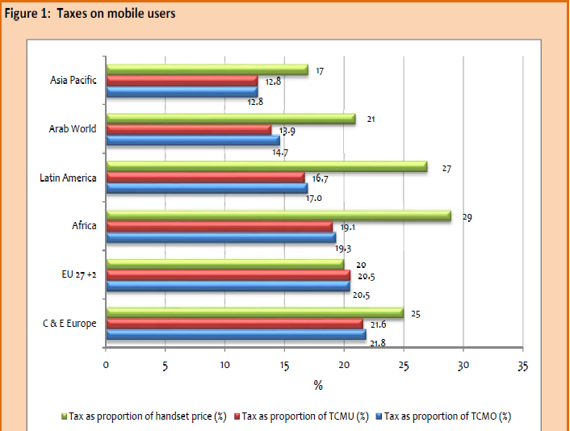
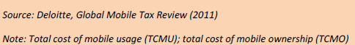
Case studies from selected sub-Sahara African countries
This section examines the tax environment in five sub-Saharan African countries – Cameroon, Democratic Republic of Congo, Nigeria, South Africa and Uganda.

Figure 3 shows for the five countries tax as a proportion of total cost of mobile ownership (TCMO), tax as proportion of the total cost of mobile usage (TCMU) and tax as a proportion of handset price. TCMO varies from 5.4 per cent in Nigeria to 29.1 per cent in the Democratic Republic of Congo (DRC). The average for Africa is 19.3 per cent and global average is 18.4 per cent. Cameroon records the highest tax as proportion of handset cost (49.3%) mainly accounted for by high custom duty imposed on handsets at 30 per cent closely followed by the DRC. Nigeria records the lowest (10%) in the sample.
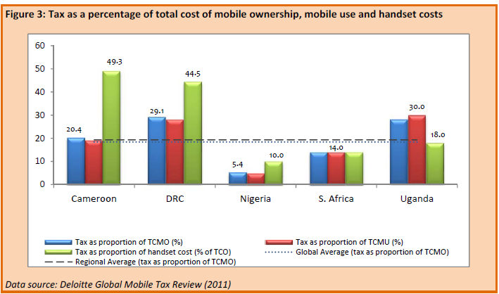

Figure 4 shows, for each country, tax as a percentage of total cost of mobile ownership (TCMO) and service penetration, in the form of lines per 100 people. South Africa has the highest service penetration level in the sample (105.1%). The other countries, except Nigeria, have higher tax rates, and they also have lower penetration rates. But as noted in section 3 above, penetration rates are affected by many other factors than tax rates.
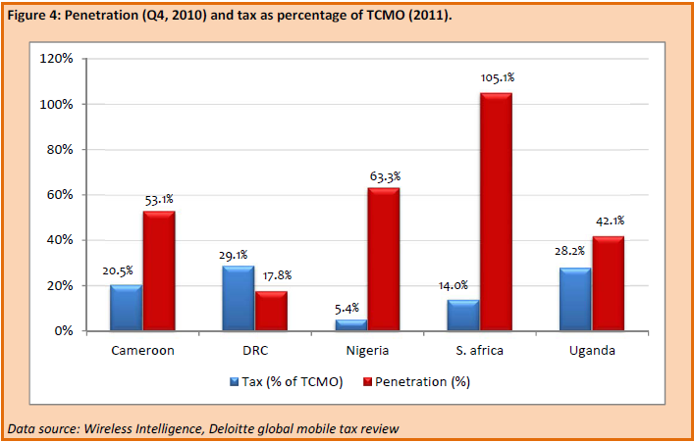
Telecommunication operators in many countries including the case countries are subject to all regular business taxes plus some sector specific taxes.43 In the Democratic Republic of Congo (DRC) for example, in addition to regular business taxes, the telecom sector is subject to two other types of taxes:

Direct contributions (paid by operators):

• Annual operation tax: 2 per cent of revenue (estimated);
• Frequency charges: 2.4 per cent of revenue (estimated);
• numbering charges: 2 per cent of revenue (estimated);
• Tax on profits: 40 per cent.
Indirect contributions (usually paid by the consumer):
• Network access and usage rights: 2 per cent;
• International in-bound surcharges (also known locally as regulation tax): 0.05 per cent;
• Tax on consumption: 18 per cent (in 2012, this is set to be replaced with VAT at 16%);
• Excise duty on airtime: 10 per cent.

In Cameroon, the telecommunication sector is also subject to both general business taxes and sector specific taxes.
The following main taxes are paid by the telecoms companies:
General business taxes:
• VAT: 19.25 per cent of turnover before tax;
• Company Tax: 35 per cent – 38.5 per cent;
• Business License tax: 25 per cent – 35 per cent depending on income.
Sector specific taxes:
• Spectrum fees: Annual flat-fee of XAF 200 million (for a 8MHzs or 42 channels);
• Contribution to special telecom development fund: 3 per cent since Q4 2010, up from 2 percent since 1998;
• Regulatory fees: 1.5 per cent of turnover. Nigeria appears as the economy with the lowest taxes. Nonetheless, the following sector specific taxes have been instituted as percentage of operating income:
- Frequency fees: 0.14 per cent;
- Numbering fees: 0.15 per cent;
- Technology and research and development fee: 0.04 per cent;
- Regulatory fees: 2.9 per cent.
The following table shows the handset and service tax rates for the five countries.
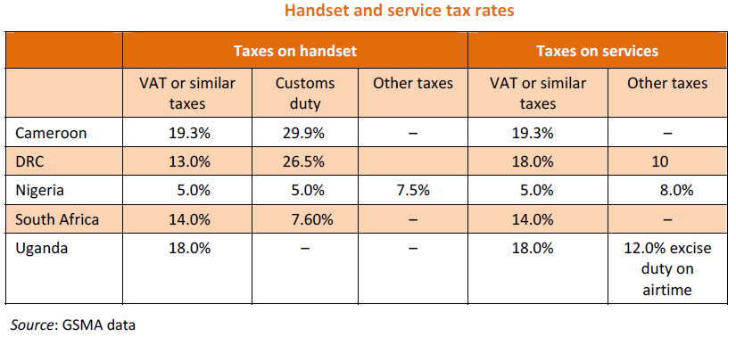
According to the table above, Cameroon has the highest import duty and VAT rates on handsets and services, suggesting that the government should generate relatively higher revenue from this activity than the South African government for example. But this is hardly true. A high tax drives up tax avoidance and cost of collection. Cameroon like Nigeria traditionally has a very broad informal economic sector from which it is very costly to collect taxes.

THE MOBILE COMMUNICATIONS SECTOR AND TAXATION IN THE EUROPEAN UNION

A great importance is placed on the development of the telecommunications sector in the European Union. Information technologies enjoy a priority status in the Lisbon Strategy which was put into effect in order to transform the EU into the world's most competitive and dynamic economy in 2010.

In the EU Member States, public policies related to the taxation of the communications sector have taken into consideration the importance of the sector and the sector has not been subjected to taxation any differently than other economic activities. In EU countries, the mobile communications sector is essentially taxed by way of the Value Added Tax (VAT). With the exception of Greece and Italy, there are no other levies that increase the tax burden of the sector. Internal taxation in the EU, to a large extent, still lies within the competence of Member States. However, Member States shall not act in a manner that may disrupt competition in the EU Single
Market in this area. In EU countries, the taxation of the mobile communications sector is limited to VAT. Except for Greece and Italy, there is no tax specific to the communications sector in the EU. In these two countries, a monthly utilization fee is charged. In Greece, subscribers pay a usage fee ranging between US $1.92 and US $5.75 depending on the amount of their monthly bill. In Italy, only postpaid lines are charged a fixed monthly usage fee of US $6.82.There is a tendency in EU nations to stabilize or reduce the tax burden.

The figure below shows the taxes imposed on mobile communications in the EU member states.

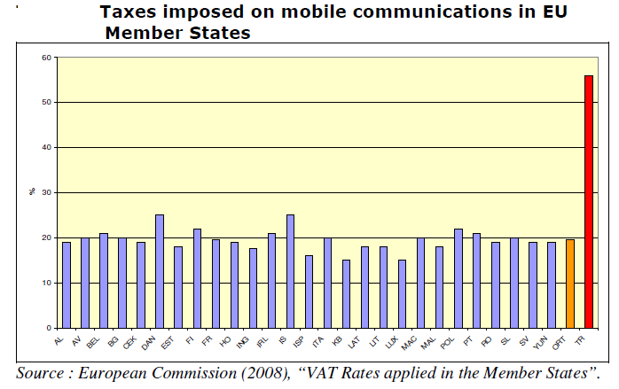
Tax burden in Turkey is almost 3 times the EU average. On the other hand, the taxation of mobile operators in Turkey is also incompatible with the EU’s principle of taxes not being discriminatory between businesses operating in the same sector. Taxation system in Turkey violates the EU’s principle of Tax neutrality.

Consumer related tax practices in representative countries are listed in the tables below.
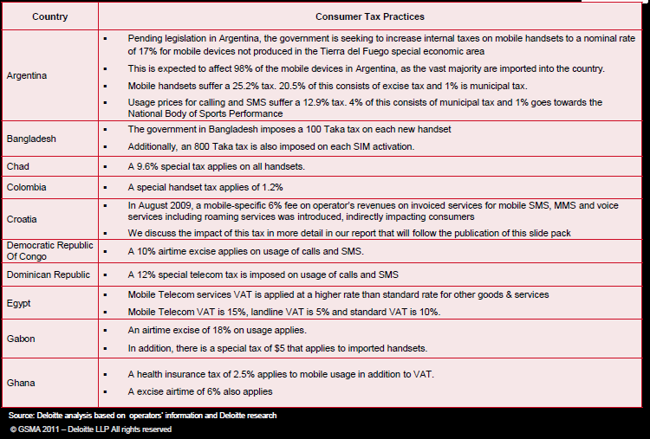

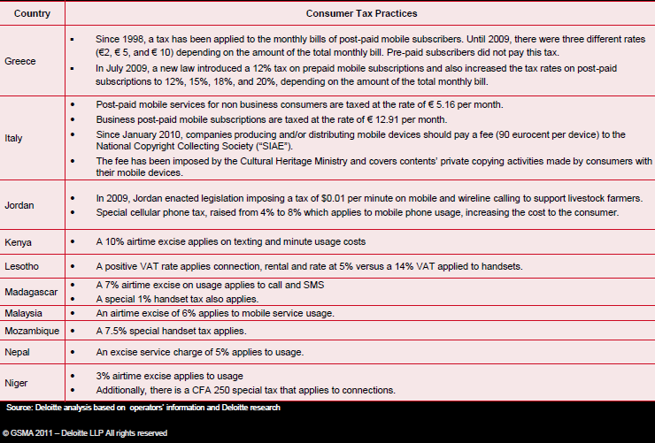

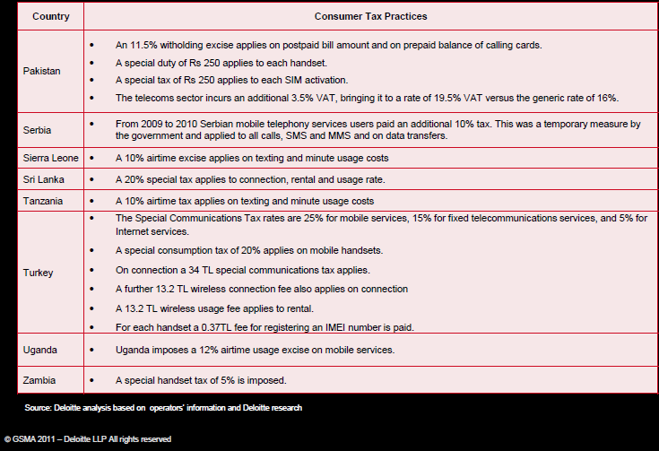

CHAPTER-5
IMPACT OF TAXATION

Even though there has been an evolutionary growth of telecom sector in coutries which impose heavy taxation on the telecom sector including mobile and Internet services, studies have shown that the taxation has a direct correlation with many aspects of telecom sector as discussed below. In this chapter we discuss some of the major areas where heavy and irrational taxation has negative impacts for the telecom sector growth. These issues are identified as follows:

5.1 Impact on Private Sector Investment –both domestic and foreign
Despite the continued growth of telecommunications/ICTs and broadband services, much still needs to be done in this region. The growth and proliferation of mobile communications has created a very positive impact on economic and social development.

To attract private sector investment government are providing tax incentives in many countries for the fastest development of these sector.

A modernized, technology neutral communications tax structure that reduces taxes on network investments and eliminates excessive taxes on users of communications services would encourage private investment, promote economic development, improve business productivity, create jobs and increase tax collections.

The irrational tax structure and heavy taxation as well as sector specific tax burden imposed on telecom sector will certainly demotivate the private investment-both domestic and foreign. The investors will look into markets which are more investment friendly and have the prospects of higher and quicker rate of return in their investment.

If the governments and regulators are serious about promoting private sector investment in telecom sector, the tax regime has to be accordingly rationalized.

Impact on Infrastructure development
The telecom industry has been demanding lowering of taxes saying the levies in the region are among the highest compared to the earnings of the user in the developed world and the tariffs are lower due to the cut-throat competition in the sector, because of the above, the revenues are falling, affecting investments in the telecom sector. Telecom industry’s revenues are coming under pressure and funding becoming difficult. Certainly these situations hamper for the infrastructure development. Due to an unprecedented growth of the data services, there is a heavy pressure on increasing the capacity of both the access as well as backbone networks. This requires tremendous pressure for the operators to invest in infrastructure. The return from investment on infrastructure is a long term project. This requires a great deal of confidence on the investor. It is imperative that the taxation on investment on infrastructure has to be taken differently and taxation policy should provide a conducive environment for heavy investment in telecom infrastructure. Lack of such environment will certainly have a negative impact on infrastructure development.

Impact on Quality of Service
Best tax policies in telecommunications sector always consider significantly increased investment in mobile networks including broadband access network and boost mobile penetration and usage with best quality of services. Individual consumers and society both benefit when there is a well-managed regulatory and taxation framework. Then only telecom sector can increase and continue to make a vital contribution to the development of economies and societies. To be a long-term winner in this sector, governments should set in place sound regulation by providing quality services to its consumer. It has been seen in many countries where there is a heavy taxation, weak regulation, fierce competition, the quality of services has suffered. To ensure good quality of service and good quality of consumer experience, the operators need to invest more in networks and consumer care.

Impact on Adoption of telecom services
The GSM Association commissioned Deloitte to undertake a global study on taxation of mobile services in 111 countries worldwide. The study measured consumer taxes on mobile services as a proportion of the Total Cost of Mobile Ownership (TCMS) and the Total Cost of Mobile Usage (TCMU).

Previous GSMA studies indicated that mobile telecommunication taxes were disproportionately high in many developing countries and that even small cuts in taxes may attract significantly more mobile users.

Sector specific taxation on usage, such as airtime taxes, can represent a significant obstacle to usage of mobile services by the poorer sectors of the population, who could derive significant benefits from being connected.

And the taxes on handsets are particularly inefficient as they increase the access barriers to adoption of telecommunications services, especially in developing countries. Since handsets and smart phones may represent the only access to wireless broadband in the developing world, handset taxes may also lead to under adoption of internet services.

Impact on sector growth
By lowering and removing sector specific taxes from this sector, Governments will be able to collect incremental increase in tax receipts as millions more people will be able to afford to connect to and use this services.

This would lead to a reduction in tariffs, which would then increase usage of mobile services.
Greater usage of mobile phones improves fuelling economic development and attracts private sector investment and lifting tax receipts from across the wider economy. So lowering taxes will have positive impact on sector growth.

Impact on Government Revenue
Lowering telecommunications related taxes from telecom sector Poorer can have affordability to purchase the handset and services, which would then increase usage of mobile services.

If there are more users then definitely there would be more tax payers.

If there are more tax payers then it certainly increase in tax receipts as millions more people will be able to afford to connect to and use this services.

In essence lower the taxes, higher will be the chances for private sector investment, higher will be the sector growth, higher will be the adoption of telecom services by common people, higherinvestment in infrastructure development, higher will be the quality of services etc.
CHAPTER 6
RATIONALIZATION OF TAX STRUCTURES

Rationalization of tax systems is generally understood to be simplification of tax laws, procedure and administration with a view to minimizing cost of tax compliance and collection. It also includes improvement of tax systems with a view to minimizing the negative effects of taxation on prices, savings and investment without reducing the revenue yield. This may require reduction of rates, minimizing of exemptions, broadening of tax base and if necessary replacing the existing taxes by new taxes.

Issues on Rationalization of taxes:

In most of the SATRC countries the telecommunications tax structure were developed during the monopoly landline telephone service era and has not been updated to reflect changes in the marketplace and the development of new, competing technologies.

In some countries taxes on telecom sector faces discrimination compared to other sectors, taxes and fees on telephone service are higher than taxes on liquor. Thus, government of this region should review their tax policy to address the following tax related issues to facilitate the expansion and development of the telecom sector ecosystem.

The following are some of the key issues that need to be considered while the governments are looking for rationalization of the tax structure-

- Complex administration of tax vs. scientific administration.
- Maximum taxes vs. balanced tax.
- Single tax rate vs. multiple tax rate.
- Equal tax rate vs. discriminatory tax rate.
- Regressive or traditional tax policy vs. progressive scientific tax policy.

1. Complex tax administration vs. Easy and scientific tax administration.
Taxes and fees should be easy to administer and collect. Reforms should strive to simplify the administration, collection, remittance, reporting and auditing of state and local taxes and fees on telecommunications services. Administration that is unfair and unreliable may bring the tax system into disrepute and weaken the legitimacy of state actions.

Obtaining targets of revenues from tax rate changes requires effective tax administration. Increasing revenues through base expansion requires even better administration. It is imperative that the governments need to develop the new collection techniques and try to accommodate new users and bring them into the tax network. The governments should ensure a good tax administration so that users and operators feel no hassles while they come into the tax regime.

The techniques needed for effective tax administration are not difficult if the following mantras are adopted
- have a clear strategy;
- keep it simple;
- treat taxpayers as clients;
- chase down defaulters;
- keep a tight check on corruption; and
- use available technology wisely.

Using modern Information and Communications Technologies for withholding, information reporting, provisioning web-based client focused interfaces with the private sector, and value chain analysis and monitoring could be proved enormously effective in reducing corruption, curbing evasion and improving revenue yields.

2. Maximum taxes vs. balanced tax
Tax systems (combination of tax policy and tax administration) are central to successful fiscal policy and the overall management of the public sector. Too little tax revenue can make it difficult for governments to spend adequately in critical areas for socio-economic growth, including public infrastructure and investment in human capital creation through education and health services.
But tax burdens that are too high can also be detrimental to economic growth; these decrease private investment and discourage savings and work effort. In addition, tax revenues can be raised with a minimum of distortions in the economy. Based on the international best practices and our own experiences, a balance has to be found.

3. Single tax rate vs. multiple.

There are a number of sector specific taxes imposed in telecommunication industry compared to other industries. Such taxes are Air time tax, SIM activation tax, Ownership tax, Telecommunications service tax (TSC), Handset tax, Telecom equipment import tax etc. The higher the number of headings for which the taxes are imposed the greater is the chance of additional hurdles to administer and greater is the confusion to the consumer.

Instead of taxes in multiple headings the government may impose a flat rate to its customer so that consumer can easily understand the rate of taxes imposed on them for using a service and the tax authority and tax collector may feel comfortable to administer the taxes.

4. Equal tax rate vs. discriminatory tax rate.
There is number of sector specific taxation in telecommunication industry compared to other industries. These industries are heavily taxed as compared to other sectors. Sector specific taxation may have a number of social and economic impacts, especially in developing countries, where fixed line telephony is more limited. Sector specific taxation on usage, such as airtime taxes, can represent a significant obstacle to usage of mobile services by the poorer sectors of the population, who could derive significant benefits from being connected.

Taxes on handsets are particularly inefficient as they increase the access barriers to consumption of telecommunications services, especially in developing countries. Since handsets and smart phones may represent the only access to wireless broadband in the developing world, handset taxes may also lead to under consumption of Internet services.

5. Regressive or traditional tax policy vs. progressive scientific tax policy.
In most of the countries in the world the telecommunications tax structure were developed during the monopoly landline telephone service era and has not been updated to reflect changes in the marketplace and the development of new, competing technologies.

It has been felt that Telecommunication taxes and fees are highly regressive. Families in the lowest quintile of earnings pay 10 times as much as families in the highest quintile, as a percentage of their income.

CHAPTER 7
CONCLUSION AND RECOMMENDATIONS

It has been widely accepted and recognized that the intervention or initiatives of the Governments and the regulators are necessary for the harmonious and equitable development and growth of telecommunications/ICTs and broadband services including the infrastructure. In particular, taxation policies have a significant impact on the value that societies derive from mobile and other forms of ICTs services in telecom sector as they affect the key factors that determine the success of telecom industry as well as ensuring sustainable socio-economic and cultural development.
Taxation has a measurable impact on access to telecommunication services Research shows that there is a direct link between connectivity and economic growth; therefore, providing access at affordable prices to the broadest base of the population is essential to driving economic growth and alleviating poverty. Lowering the taxes or duty or removing the sector specific taxes will help to narrow down digital divide between urban and rural areas as well as between rich and poor and also for able people as well as people with disabilities. It will add value to the specific strategic plans for each nation in meeting the millennium development goals and poverty reduction as well.

Taxation on usage, such as airtime taxes, can represent a significant obstacle to usage of mobile services by the poorer sectors of the population, who could derive significant benefits from being connected. Taxes on handsets are particularly inefficient as they increase the access barriers to consumption of telecommunications services, especially in developing countries. Since handsets and smart phones may represent the only access to wireless broadband in the developing world, handset taxes may also lead to under consumption of internet services.

Taxes and fees should be easy to administer and collect. Reforms on tax policy should strive to simplify the administration, collection, reporting and auditing of state and local taxes and fees on telecommunication services. Tax policy should be pro-growth, encourage competition and innovation. And it should encourage the deployment of traditional and advanced communication infrastructure on a technology neutral basis.

Tax reform is a continuous process and there is no single principle intended to be held as a higher priority and they should be viewed as a package to address taxation issues in the country.
Taxation is not only a means of collecting revenue but also an important instrument of encouraging production, productivity, corporate sector and domestic economic activities. The reform should focus on making tax system progressive, productive and favorable to stabilization and growth of the sector.

The taxation policies should ensure to provide a level playing field to allow equal distribution of services to all users.
Taxation policy should be designed on the basis of achieving the best long-term economic goal for the society. It should be designed in ways that pick up the pace of the expansion of services to the unreached and that does not add any further barriers to access.
Taxation policy should be designed that does not add additional cost of service provision for the poor and not discourage or weaken competitive market forces.
Policy should not add any further barriers to access or add additional cost of service provision and it should be designed to lowering the rates or removing the sector specific taxes and simplifying tax payment and reducing the rates.
Thus, the governments in SATRC region require an urgent review of their own taxation policies for telecom sector. To address the above issues, initiations should have been started in the region for paying taxes faster and easier such as by consolidating filings, reducing the frequency of payments or offering electronic filing and payment. Simplifying tax payment and reducing the tax rates have seen tax revenue rise in the sector. While restructuring on a tax policy above mentioned points should be considered which can be a win-win situation for consumer, Government, service provider and the overall sector could not only survive but thrive.
Annex-1 Summary of the Responses of the SATRC members on the Questionnaire

Country Specific responses on Questionnaire
Country/Q.N.1 | What are the telecom-specific taxation laws and policies currently underway in your country? A brief summary is appreciated. Please also provide a link to the website of the document if it is available.
Afghanistan | No response on whole questionnaire
Bangladesh | No response on this question
Bhutan | Currently in Bhutan, while importing, the following Telecommunications Equipments are exempted from taxes:  - Towers  - Diesel generator and power supply system ( any alternative power source for continuity of the service)  - Air conditioning system specific to the control rooms  However, the spares are not included in the list of exemption.  There is no tax on any telecommunications services including internet.
India | There is no single law or policy for telecom specific taxation. The taxes and levies paid by the telecom sector spans the breadth of Central to State to local bodies. Taxes and levies applicable on telecom sector can be classified in to three broad categories:  - Central taxes: levied by Central Government  - Service tax  - Customs duty  - Excise duty  - Central Sales Tax (‘CST’)  - State taxes: levied by State Government  - Value Added Tax (VAT)  - Entry tax  - Other levies: levied by Governmental/ Regulatory Authorities  - Spectrum charges  - License Fees  - Municipal charges  - Right of way charges (‘ROW’)
Iran | There is no special telecom taxation law in Iran any they are followed by general taxation law.
Maldives | No response on whole questionnaire
Nepal | No telecom specific taxation and law in Nepal, they are followed by common taxation law.
Pakistan | No response on whole questionnaire
Sri Lanka | No response on whole questionnaire
Country/Q.N.2 | What has been the contribution of telecom sector to Government taxes over the last few years? Current 3-5 years data and its contribution in percentage to the overall tax would be desirable.
Afghanistan | No response on whole questionnaire
Bangladesh | No response on this question
Bhutan | The National Revenue Report 2011-2012 indicates that the service sector has contributed 12.1 percent of the total revenue. Here service sector includes tourism, sales tax on hotels, and telecom services.  The Incumbent Operators, Bhutan Telecom Ltd is among the top ten revenue agencies. It is the seventh top agencies contributing to the national revenue (248.496 Million Ngultrum)
India | There is no consolidated data available as taxes are paid to different agencies. However, an estimate of overall taxes and levies which are applicable on Telecom sector (either on its revenue or on its cost, whose credit is not available) and their proportion to total revenue as made by the industry is summarized in the following tables  Estimate of Taxes/ Levies paid to Central Government/DoT (in million US$)  Particulars Authority FY’07 FY’08 FY’09 FY’10 FY’11  Service Tax Central government 1907 2315 2593 2222 2315  Additional duty of customs Central government 185 204 185 148 148  CST Central government 74 111 111 93 74  Spectrum charges (including microwave charges) DoT 389 574 648 704 722  Annual License Fees DoT 1296 1648 1759 1815 1852  Total Taxes and levies 3851 4852 5296 4982 5111  Total Industry AGR 15611 18796 20926 21630 22519  Percentage of taxes/levies to AGR 25% 26% 25% 23% 23%  Estimate of taxes/ levies paid to State Government  (in million US$)  Particulars Authority FY’07 FY’08 FY’09 FY’10 FY’11  VAT State government 13 15 17 20 22
Iran | No response on this question
Maldives | No response on whole questionnaire
Nepal | US$ 358.92 Million in 2012,
Pakistan | No response on whole questionnaire
Sri Lanka | No response on whole questionnaire

Country/Q.N.3 | What is the contribution of telecom sector to taxes as compared to its contribution to the GDP?
Afghanistan | No response on whole questionnaire
Bangladesh | No response on this question
Bhutan | There is no specific data on telecom sector contributing to the GDP. However, service sector which including telecommunications contributes 37.9% to the GDP.
India | Year Contribution of Telecom sector to GDP  2006-07 2.84%  2007-08 2.73%  2008-09 3.14%  2009-10 3.6%  2010-11 4.0%
Iran | 2 % and 4 % is desirable
Maldives | No response on whole questionnaire
Nepal | 2008-10.44%, 2009-11.84%, 2010-13.40%, 2011-13.25% 2012-13.60%
Pakistan | No response on whole questionnaire
Sri Lanka | No response on whole questionnaire

Country/Q.N.4 | What is the contribution of telecom sector to taxes as compared to its contribution to the GDP?
Afghanistan | No response on whole questionnaire
Bangladesh | No response on this question
Bhutan | Service sector including telecom contributes 12. 1 % as revenue when compared to 37.9 % GDP
India | See response to question No. 3 & 4
Iran | No response on this question
Maldives | No response on whole questionnaire
Nepal | Contribution of Telecom Sector to Taxes as compared to its contribution to GDP is 2.10% in 2012
Pakistan | No response on whole questionnaire
Sri Lanka | No response on whole questionnaire

Country/Q.N.5 | How can the revenue collection from telecom sector be enhanced?
Afghanistan | No response on whole questionnaire
Bangladesh | No response on this question
Bhutan | No Comments
India | Teledensity in rural areas of India is still 40%,
Iran | With giving more services and better quality
Maldives | No response on whole questionnaire
Nepal | Address industry-wide challenges that increase profits. Establish an on demand operating environment to integrate resources and simplify IT management. Infrastructure management streamlines management of existing IT resources to help lower costs.  Integrating people, business processes and information throughout the organization drives flexibility and responsiveness.
Pakistan | No response on whole questionnaire
Sri Lanka | No response on whole questionnaire

Country/Q.N.6 | What improvements can be made in the taxation laws and policies regarding the telecom sector to ensure sector growth?
Afghanistan | No response on whole questionnaire
Bangladesh | No response on this question
Bhutan | If possible, all equipments including spare parts should be exempted from taxes.
India | No comments
Iran | No response on this question
Maldives | No response on whole questionnaire
Nepal | Design of the tax system should be as neutral as possible to minimize interference in the allocation process. The system should also have simple and transparent administrative procedures so that it is clear if the system is not being enforced as designed.
Pakistan | No response on whole questionnaire
Sri Lanka | No response on whole questionnaire

Country/Q.N.7 | Is the existing tax structure the most efficient means of raising the current level of tax revenue?
Afghanistan | No response on whole questionnaire
Bangladesh | No response on this question
Bhutan | No comments
India | No comments
Iran | Yes
Maldives | No response on whole questionnaire
Nepal | Existing tax structure of Nepal is not efficient means of raising the current level of tax revenue from the Telecom sector. Sector specific taxes are prevailing there and the harmful impact of excessive taxes impacts on its growth.
Pakistan | No response on whole questionnaire
Sri Lanka | No response on whole questionnaire

Country/Q.N.8 | Does the existing tax system distort the consumer’s choice between competing telecommunications services and technologies?
Afghanistan | No response on whole questionnaire
Bangladesh | No response on this question
Bhutan | No, it does not. Since taxes are applied equally to both the operators.
India | No
Iran | No
Maldives | No response on whole questionnaire
Nepal | Yes, existing tax system distorts the consumer’s choice between competing telecommunications services and technologies. “Policymakers and governments in Nepal need to recognize the potential of the mobile telecoms industry and the harmful impact of excessive taxes,”
Pakistan | No response on whole questionnaire
Sri Lanka | No response on whole questionnaire

Country/Q.N.9 | Does the existing tax system distort the location decision of telecommunications providers or consumers?
Afghanistan | No response on whole questionnaire
Bangladesh | No response on this question
Bhutan | No, it does not.
India | No comments
Iran | No
Maldives | No response on whole questionnaire
Nepal | Existing tax system of Nepal does not distort the location decision of telecommunications providers or consumer.
Pakistan | No response on whole questionnaire
Sri Lanka | No response on whole questionnaire

Country/Q.N.10 | What is the trend of telecom’s contribution to growth and investment in the economy for the past few years?
Afghanistan | No response on whole questionnaire
Bangladesh | No response on this question
Bhutan | Telecommunications sector is contributing a lot towards the growth and investment in Bhutan. Now, government of Bhutan wants to capitalize on ICT as the tool for socio-economic development.  Government is trying to bring in more investment in IT and IT enabled business into the country through the established of IT Park.
India | Year Revenue of Telecom sector (US$ in billions)  2008-09 7.0  2009-10 7.7  2010-11 8.9  2011-12 9.5
Iran | No response on this question
Maldives | No response on whole questionnaire
Nepal | The trend of telecom’s contribution to growth and investment in the economy for the past few years are increasing gradually i.e. contribution to the GDP from Telcos was 10.44% in 2008 but Now it is 13.60%
Pakistan | No response on whole questionnaire
Sri Lanka | No response on whole questionnaire

Country/Q.N.11 | What role has the telecom sector played in employment generation? Please identify the broad categories of telecom sector ecosystem where jobs are created and provide the numbers if available.
Afghanistan | No response on whole questionnaire
Bangladesh | No response on this question
Bhutan | Besides, their normal employees, it has also generated lots of business for local people. Many of the local shops have been the sale-agent of their services including e-toping of mobile credits or sale of mobile recharge card.  Many of the shops have also started to sell mobile handsets and some have even started to cater repair services.
India | A lot of direct employment has been generated by the telecom companies. Apart from this Telecom companies have outsourced some of their activities like marketing & sales, which has also created employment. In addition, sales and repair of mobile phones, laptops, PCs have generated a large amount of employment in India. Another area, which has generated significant employment opportunity, is the Value Added Services provided over telecom networks.
Iran | 140000-150000 directional jobs
Maldives | No response on whole questionnaire
Nepal | Telecom sector is being one of the fastest growing sectors and there is a great demand for skilled and qualified HR with a good technical know-how. “Many jobs are related to the development and maintenance of devices, lines, systems and networks used to facilitate communication. This offers a wide range of career prospects, and one can have a career in application/ product development, application testing / integration, system administration, network planning, data networking, mobile application development and value-added services.” “Telcos require large Capex and skilled manpower for their expansion to host and provide these services.
Pakistan | No response on whole questionnaire
Sri Lanka | No response on whole questionnaire

Country/Q.N.12 | What has been the impact of boom in telecom sector on the cost of doing business in your country?
Afghanistan | No response on whole questionnaire
Bangladesh | No. response on this question
Bhutan | With the development of telecommunications sector, the cost of doing business in Bhutan has reduced a lot. Now most of the people are availing fast communications services to order or purchase goods and services.
India | With the fast proliferation of telecom services like Mobile telephony, video conferencing, Internet, VoIP, Cloud computing etc, the cost of doing business has reduced as these enable enhanced efficiency, better management and reduction in the travel requirements among other things.
Iran | By indirectional effects such as decreasing educational and transports costs
Maldives | No response on whole questionnaire
Nepal | The pace of growth in telecom sector of Nepal was very slow for many years and no major progress was seen in this segment due to the monopoly of state own company i.e. Nepal Telecom. Now time has been changed and with the liberalization of the sector, National and international investors found a friendly atmosphere here, which helping in the improvement of economy and attracting foreign investors. The number of mobile users has been increased dramatically than fixed-line users and telecom sector of Nepal has become the fastest growing sector as compared other.
Pakistan | No response on whole questionnaire
Sri Lanka | No response on whole questionnaire

Country/Q.N.13 | How has telecom sector enhanced the efficiency and productivity of the economy?
Afghanistan | No response on whole questionnaire
Bangladesh | No response on this question
Bhutan | No response on this question
India | No response on this question
Iran | No response on this question
Maldives | No response on whole questionnaire
Nepal | Investment in telecommunications infrastructure plays vital role for economic growth. Other conditions must be present. The country must have the human and capital resources as well as other infrastructure investments to obtain greater benefits from telecommunications infrastructure investment. Quality of service includes minimizing outages and blockages as well as the ability to expand to meet new demands. A critical constraint is the enormous investment requirements needed to provide the population with adequate telephone communications. Another constraint is a shortage of adequately trained technical and managerial personnel.
Pakistan | No response on whole questionnaire
Sri Lanka | No response on whole questionnaire

Country/Q.N.14 | Is there any study on assessment of the impact of tax related price increases on  a. penetration,  b. traffic volume,  c. total turnover and  - investment  - Service adoption  - Consumer tariff  in the telecom sector in your country? If yes please provide the summary and also provide the research/study report or link.
Afghanistan | No response on whole questionnaire
Bangladesh | No. response on this question
Bhutan | No such study has been conducted
India | No specific study has been conducted by the Government for this purpose. However, a research paper available at the following URL discuses it to some extent:  http://www.iitcoe.in/index.php?option=com_docman&task=doc_view&gid=154&tmpl=component&format=raw&Itemid=20
Iran | NO
Maldives | No response on whole questionnaire
Nepal | No such study has been carried out.
Pakistan | No response on whole questionnaire
Sri Lanka | No response on whole questionnaire
Tax specific questions for mobile service:
Country/Q.N.15 | How much is the license fees for operating a mobile service in your country?
Afghanistan | No response on whole questionnaire
Bangladesh | No. response on this question
Bhutan | It is Nu. 777 Million ( 14.67 Million USD) for a period of 15 years
India | Entry fee (Non-refundable): US$ 185,000 (INR. 1 Crore) for each Service Area Level Unified License (Access Services) except for Jammu & Kashmir (J&K) and North East (NE) Service Areas where Entry Fee is US$ 92,500 (INR 50 Lakhs) each.  In addition to the onetime non-refundable Entry Fee, Annual License Fee as a percentage of AGR will be payable as per the rates specified by DoT.
Iran | 450 million $
Maldives | No response on whole questionnaire
Nepal | US $ 3.5Million for unified license, 1st tenure of license is 10 yrs and then 5 yrs up to 25 yrs.
Pakistan | No response on whole questionnaire
Sri Lanka | No response on whole questionnaire

Country/Q.N.16 | How much is the frequency acquisition fees for operating a mobile service in your country? How much bandwidth is minimum available for operating mobile service in different frequency bands?
Afghanistan | No response on whole questionnaire
Bangladesh | No response on this question
Bhutan | No response on this question
India | Spectrum is acquired through auction.
Iran | It is different according to the usage, time and coverage and frequency (Microwave or HF or VHF or UHF,…), It is approved on Regulatory communication commission.
Maldives | No response on whole questionnaire
Nepal | There is no frequency acquisition fee. There is policy to auction frequency fee.  Cellular operator 6 MHz in 900 and 9MHZ in 1800 Bands.
Pakistan | No response on whole questionnaire
Sri Lanka | No response on whole questionnaire

Country/Q.N.17 | How much is the annual frequency fees per MHz? or there is any other criterion for fixing the frequency fees?
Afghanistan | No response on whole questionnaire
Bangladesh | No response on this question
Bhutan | No response on this question
India | Annual frequency fees or spectrum usage charge as a percentage of the Adjusted Gross Revenue (AGR) are payable by the successful bidder as per the rates notified by the Government from time to time. Spectrum usage charges are payable based on the total amount of spectrum hold by an operator. The present spectrum usage charges are mentioned below:  Charges for GSM operators Charges for GSM operators  Spectrum slab Spectrum slab  Up to 4.4 MHz Up to 4.4 MHz  Up to 6.2 MHz Up to 6.2 MHz  Up to 8.2 MHz Up to 8.2 MHz  Up to 10.2 MHz Up to 10.2 MHz  Up to 12.2 MHz Up to 12.2 MHz  Up to 15.2 MHz Up to 15.2 MHz  Charges for CDMA operators Charges for CDMA operators  Spectrum slab Spectrum slab  Up to 5 MHz Up to 5 MHz  Up to 6.25 MHz Up to 6.25 MHz  Up to 7.5 MHz Up to 7.5 MHz  Up to 10 MHz Up to 10 MHz  Up to 12.5 MHz Up to 12.5 MHz  Up to 15 MHz Up to 15 MHz
Iran | No response on this question
Maldives | No response on whole questionnaire
Nepal | Annual frequencies charges are 0.4% AGR for minimum frequency which is 6 MHZ in 900 and 9MHz in 1800. The charge for additional frequency is 12Million per MHz in 900 and 8Million per MHz in 1800 band and the annual frequency charge for the maximum frequency is 24 Million for 900 Bands and 16 Million in 1800 Bands.
Pakistan | No response on whole questionnaire
Sri Lanka | No response on whole questionnaire

Country/Q.N.18 | How much is the mobile service tax payable by the subscribers in actual bills? Provide the amount for the following :  - Value added tax or similar tax: most countries impose some form of value-added tax, a general sales tax or similar consumption tax as a percent of the total bill in %  - Telecom specific taxes: some countries charge an additional special communications tax as a percent of the service bill in %  - Fixed taxes: in addition to the tax as a percentage of usage, some countries charge a fixed tax that could be either driven by general communications usage or wireless usage  - Any other taxes?
Afghanistan | No response on whole questionnaire
Bangladesh | The Bangladeshi cell phone subscribers are paying Rs 15 as government taxes on Rs 100 scratch card, 15.00%
Bhutan | No tax on mobile services in Bhutan.
India | Service Tax @ 12.36%
Iran | Value added tax : Such as other services (no different between communication services and other services)
Maldives | No response on whole questionnaire
Nepal | TSC 10%, VAT13%, Ownership tax in PSTN 1000. Post paid 1000 Prepaid 2% in recharge amount.
Pakistan | No response on whole questionnaire
Sri Lanka | No response on whole questionnaire

Country/Q.N.19 | In addition to service-based taxes, other levies can be imposed on handsets :How much tax is imposed on the purchase of mobile set? Provide the amount for the following :  - Value-added tax: these represent the taxes paid directly by the consumer at time of purchasing a subscription or handset, as well as when exchanging the device in %  - Customs duty: this tax is already included in the retail price of the handset in %  - Other taxes: telecommunications specific taxes on handsets (e.g. royalties calculated on the cost of handset) in %  - Fixed taxes: special fixed duties on handset, such as ownership fees
Afghanistan | No response on whole questionnaire
Bangladesh | The Bangladeshi cell phone subscribers are paying Rs 15 as government taxes on Rs 100 scratch card.,VAT 15.00% and MNOs pay 5.5% “Revenue share tax”, MNOs have reported a number of unpredictable tax authority policies.
Bhutan | There is 10 % Bhutan Sale tax on the import of mobile handsets from Third country for sale in Bhutan.
India | Varies from state to state. Service Tax @ 12.36% and Customs duty comprises of three components Basic custom duty (BCD) applicable at 10%, countervailing duty (‘CVD’) applicable at 10.3%, Customs access applicable at 3% and Additional duty of customs (‘ADC’) applicable at 4%. Most of the goods imported by Telecom operators are exempt from BCD, however CVD and ADC are applicable.
Iran | In entering handsets there is a tax for importing Value added tax : Such as other services (no difference between communication services and other services)
Maldives | No response on whole questionnaire
Nepal | VAT 13%, Customs Duty 5%, There is no fixed Taxes. Yes Nepal has signed on Telecom agreement of WTO.
Pakistan | No response on whole questionnaire
Sri Lanka | No response on whole questionnaire

Country/Q.N.20 | How much is the SIM ownership tax or charge for mobile ? For pre-paid ? for post paid? If any.
Afghanistan | No response on whole questionnaire
Bangladesh | Tax was reduced from BDT 605 to BDT 300
Bhutan | No SIM ownership tax or charge for mobile
India | No SIM ownership tax or charge for mobile
Iran | SIM ownership tax or charge for mobile while buying, there is a tax Such as other services (no difference between communication services and other services)
Maldives | No response on whole questionnaire
Nepal | Ownership tax for Post paid 1000, Prepaid 2% in recharge amount.
Pakistan | No response on whole questionnaire
Sri Lanka | No response on whole questionnaire

Country/Q.N.21 | Are the telecom service providers subject to USO fund contribution or similar fund? If yes, how much?
Afghanistan | No response on whole questionnaire
Bangladesh | No response on this question
Bhutan | Nope, they do not contribute to USF. The initial licence fee is taken as the contribution to the USF. However, in case such fund in not sufficient, then the regulator can charge 1 % of their Adjusted Revenue as contribution to USF.
India | Yes. Universal Service Levy (USL) has presently been fixed at 5% of the Adjusted Gross Revenue (AGR) of licensed Telecom Service Providers.
Iran | Just mobile operators have to pay this fund and that is 3 % of Gross revenue.
Maldives | No response on whole questionnaire
Nepal | 2% of AGR
Pakistan | No response on whole questionnaire
Sri Lanka | No response on whole questionnaire

Country/Q.N.22 | How much is the government royalty payable by the telecom service provider or operator annually?
Afghanistan | No response on whole questionnaire
Bangladesh | No response on this question
Bhutan | No response on this question
India | 8% of the Adjusted Gross Revenue (AGR)
Iran | No response on this question
Maldives | No response on whole questionnaire
Nepal | 4% of Gross adjusted Revenue.
Pakistan | No response on whole questionnaire
Sri Lanka | No response on whole questionnaire

Country/Q.N.23 | How much is the corporate tax payable by the telecom service provider or operator annually?
Afghanistan | No response on whole questionnaire
Bangladesh | No response on this question
Bhutan | It is 30 % on the net profit
India | 33.66%
Iran | No response on this question
Maldives | No response on whole questionnaire
Nepal | 25% on Net profit
Pakistan | No response on whole questionnaire
Sri Lanka | No response on whole questionnaire

Country/Q.N.24 | How much is the infrastructure import tax such as BTS/M SC etc. payable by the telecom service provider or operator? Is there any separate tax structure for Radio Equipment?
Afghanistan | No response on whole questionnaire
Bangladesh | - 5% on BTS/ RBS, Microwave, Transmission equipment  - 25% Customs Duty on BSC, Spare part & Any network expansion items  - 25% taxes (TTI, Total Tax Incident) on Spare parts/accessories/installation material, Power items of BTS/RBS, BSC Controller, Battery Cabinet/Rack, Accumulator/Cell/Battery, Cables, Antenna and spare parts of generators
Bhutan | No tax
India | Generally, customs duty at 23.89%/ 26.85% is applicable on procurement of goods from outside India. Effective customs duty rate depends upon the nature of goods/ equipments from outside India. Customs duty comprises of three components Basic custom duty (BCD) applicable at 10%, countervailing duty (‘CVD’) applicable at 10.3%, Customs cess applicable at 3% and Additional duty of customs (‘ADC’) applicable at 4%. Most of the goods imported by Telecom operators are exempt from BCD, however CVD and ADC are applicable.  In terms of Central Value Added Tax VAT (CENVAT) Credit Rules, 2004 (‘CCR’), telecom service providers are eligible to claim credit/set off of CVD paid on imports against their output service tax liability. However, credit/ set off of ADC is not available, which would mean that ADC paid by telecom operators on import of goods/ equipments from outside India becomes cost to telecom operator.
Iran | According to custom duties laws but sometimes it changes based on CRA issues (even it can be changed to zero till helping to ICT development)
Maldives | No response on whole questionnaire
Nepal | No custom duty but 5% excise duty for infrastructure equipment and 1% for Radio equipment import.
Pakistan | No response on whole questionnaire
Sri Lanka | No response on whole questionnaire

Country/Q.N.25 | Is International bandwidth purchase subject to any tax in your country? If yes, how much?
Afghanistan | No response on whole questionnaire
Bangladesh
Bhutan | Yes, 3 %.
India | No response on this questionnaire
Iran | Operators do not purchase international bandwidth directly and Telecommunication Infrastructure Company (A governmental center) purchase international bandwidth
Maldives | No response on whole questionnaire
Nepal | No custom duty but 5% excise duty for infrastructure equipment and 1% for Radio equipment import.  For international bandwidth 5%TDS and 13% VAT At the end of Fiscal Year operator will get vat refund.
Pakistan | No response on whole questionnaire
Sri Lanka | No response on whole questionnaire

Country/Q.N.26 | Do you have cases of double taxation within your country in any of the telecom services? If yes, please indicate.
Afghanistan | No response on whole questionnaire
Bangladesh | No response on this questionnaire
Bhutan | Till date, there is no such case.
India | Yes. If a telecom operator purchases bandwidth from another telecom operator and sells it to its customer (for example an ISP purchases bandwidth from upstream provider and sells it to customer), then both operators pay license fee on the revenue earned.
Iran | There is not double tax in Iran.
Maldives | No response on whole questionnaire
Nepal | Actually No, BUT Govt impose 10% TSC on Telecom bill and on top of TSC 13 VAT.
Pakistan | No response on whole questionnaire
Sri Lanka | No response on whole questionnaire
Country/Q.N.27 | Is there a telecom sector specific levy in your country? If yes quantify it.
Afghanistan | No response on whole questionnaire
Bangladesh | No response on this questionnaire
Bhutan | No.
India | NO
Iran | NO
Maldives | No response on whole questionnaire
Nepal | Yes, TSC, RTDF and Royalty
Pakistan | No response on whole questionnaire
Sri Lanka | No response on whole questionnaire

Country/Q.N.28 | What is the amount of tax imposed for the international call termination? Indicate all types of taxes?
Afghanistan | No response on whole questionnaire
Bangladesh | For each outgoing call, operators will have to pay BDT 0.22 per minute (of which BDT 0.18 is payable to other operators and BDT 0.04 to ICXs), and will receive BDT 0.18 per minute for each incoming call
Bhutan | No response on this question
India | Revenue from international call termination is included in AGR of service provider. Telecom service providers pay following tax based on AGR:  Annual Licence Fee - 8% of AGR  Spectrum Usage Charges – as mentioned in response to Q No. 17
Iran | NO
Maldives | No response on whole questionnaire
Nepal | Equal tax for domestic and international.
Pakistan | No response on whole questionnaire
Sri Lanka | No response on whole questionnaire

