|  |  |  |
| --- | --- | --- |
| APTlogogreen3 | **ASIA-PACIFIC TELECOMMUNITY** | |
| **The South Asian Telecommunication Regulator’s Council (SATRC)** |  |
|  |  |

**SATRC REPORT ON   
SUSTAINABLE BROADBAND NETWORK FOR SATRC COUNTRIES: ADDRESSING THE ISSUES OF INTERCONNECTION, BACKHAUL CAPACITY AND INFRASTRUCTURE SHARING**

**Prepared by   
SATRC Working Group on Policy, Regulation and Services**

Adopted by  
**15th Meeting of the South Asian Telecommunications Regulator’s Council**05 – 07 August 2014, Paro, Bhutan

**Table of Contents**

**Chapter 1 Background**

* 1. Objective

1.2 Scope:

1.3 Time frame

1.4 Utilization of the report

**Chapter 2 Sustainability of Broadband Networks and Business Models**

2.1 Broadband definition dilemma

2.2 Broadband Network Development and Sustainability:CHOOSING THE RIGHT BUSINESS MODEL

2.3 Sustainability And Other Issues For Broadband Development

2.4 Access: Availability, Affordability, Adoption – And Sustainability

**Chapter 3 Baackhaul and Access Networks for Broadband**

3.1 Mobile/Fixed Backhaul Network

3.2 Different Technologies and Backhaul Network Support

3.3 Mobile Backhaul for Long Term Evolution

3.4 Flat IP Network Architecture

3.5 Evolution of Wireline Access Technologies

3.5.1 DSL Technology

3.5.2 Cable Technology Evolution

3.5.3 FTTH Technology Evolution

3.6 Wireless as a Complementary Technology

**Chapter 4 Interconnection**

4.1 IP-Based Interconnection

4.1.1 Internet Interconnection and IXPs in Developing Countries

4.1.2 IP-Based Interconnection: Wholesale Charging Arrangements

4.2 Regulating Bottlenecks in the Broadband Supply Chain

4.3 Regulating Interconnection

**Chapter 5 Infrastructure Sharing**

5.1 Passive Infrastructure Sharing in Telecommunications

5.1.1 Site Sharing

5.1.2 Network Sharing

5.1.3 Spectrum Sharing

5.1.4 MVNOs

5.1.5 National Roaming

5.2 Tower Companies

5.2.1 Conditions that promote tower sharing

5.2.2 Tower sharing – various business models

5.2.3 Challenges for tower companies

5.3 Global Examples of Infrastructure Sharing

5.4 CAPEX/OPEX analysis

5.5 Emerging countries characteristics

5.6 Best Practices For National Infrastructure Sharing

**Chapter 6 Sustainable Broadband Network development in SATRC Countries**

6.1 Broadband policy, plan or strategy

6.2 Universal Broadband access programs

6.3 Broadband Targets

6.4 Wire-line Access technologies utilized to provide broadband services

6.5 Wireless Access technologies utilized to provide broadband services

6.6 Competition

6.7 Pricing and usage:

6.8 Financial assistance for operators to provide broadband:

6.9 Infrastructure sharing

**Chapter 7 Policy and Regulatory framework for the Development of Sustainable Broadband Network**

7.1 Licensing and Authorization Frameworks

7.2 Technology and Service Neutrality

7.3 New Authorization Options and Their Implications for Broadband

7.4 Spectrum Management to Foster Broadband

7.5 Spectrum Refarming and the Digital Dividend

7.6 Government and Regulatory intervention

**Chaper 8 Challenges and the Way Forward**

8.1 Observations

8.2 Challenges

8.3 The Way Forward

8.4 Recommendations

**References**

**Annex-1: Questionnaire**

**CHAPTER 1**

**BACKGROUND**

**1.1 Objective**

The objective of this work-item is to study the issues of Backhaul capacity and interconnection regarding Broadband Network.

**1.2 Scope:**

Under this work item, the case studies of Broadband Network development of SATRC countries would be analyzed. This analysis will cover the technology, capacity and measures used in the backhaul and also should cover the distribution network. The capacity of such backhaul network will be studied and should be compared with the sustainable networks of other countries having good practices. And last but not the least, the domestic and international interconnection scenario of the data network and its efficiency would be analyzed under the scope of this work item. The concept of Infrastructure Sharing will also be discussed. The study will cover including but not limited to the following works:

1. Detail of the broadband backhaul transmission network of SATRC countries, based on the case studies provided by the countries;

2. Suggestions regarding efficient broadband transmission network;

3. Present capacity of the broadband networks of SATRC countries and recommendation to face the challenge of future growth;

4. Analysis of the domestic and international interconnection scenario and recommendation for way forward.

5. Infrastructure Sharing

**1.3 Time frame**

This study was carried out from October 2012 to May 2014.

**1.4 Utilization of the report**

The report is expected to be used by policy makers, regulators and operators in the SATRC countries.

**CHAPTER 2**

**SUSTAINABILITY OF BROADBAND NETWORKS AND BUSINESS MODELS**

**2.1 Broadband definition dilemma**

Despite its worldwide growth and promotion by policy makers, network operators, and content providers, broadband does not have a single, standardized defi nition. The term “broadband” may refer to multiple aspects of the network and services, including (a) the infrastructure or “pipes” used to deliver services to users, (b) high-speed access to the Internet, and (c) the services and applications available via broadband networks, such as Internet Protocol television (IPTV) and voice services that may be bundled in a “triple-play” package with broadband Internet access. Further, many countries have established definitions of broadband based on speed, typically in Mbit/s or kilobits per second (kbit/s), or on the types of services and applications that can be used over a broadband network (that is, functionality). Due to each country’s unique needs and history, including economic, geographic, and regulatory factors, definitions of broadband vary widely.

Traditionally, however, broadband has often been defined in terms of data transmission speed (that is, the amount of data that can be transmitted across a network connection in a given period of time, typically one second, also known as the data transfer rate or throughput). Defining broadband in terms of speed has been an important element in understanding broadband, particularly since the data transfer rate determines whether users are able to access basic or more advanced types of content, services, and applications over the Internet. However, attempts to define broadband in terms of speed present certain limitations. First, broadband speed definitions vary among countries and international organizations, generally ranging from download data transfer rates of at least 256 kbit/s on the low end, as in India, South Africa, the International Telecommunication Union (ITU), and the Organisation for Economic Co-operation and Development (OECD), to faster than 1.5 Mbit/s on the high end, as in Canada . Second, definitions based on speed may not keep pace with technological advances or with the speeds, services, and applications required for the application to function properly. In other words, what is considered “broadband” today may be regarded as too slow in the future, as more advanced applications technologies are developed.

Thus, any speed-based definition of broadband will need to be updated over time. Third, such definitions may not reflect the speeds realized by end users.

Due to the limitations of definitions based on speed, some countries ( Brazil) and international organizations (the OECD) and Broadband Commission for Digial Development have decided or proposed not to categorize broadband in terms of speed, but are instead looking at broadband in terms of functionality, focusing on what can and cannot be done with a certain type of connection. However, establishing a definition of broadband based only on functionality may make the term overly subjective. A legal definition of broadband Internet access based on speed is easy to apply: if broadband is defined as at least 1.5 Mbit/s of download speed,then a 2 Mbit/s connection is broadband, while a 1 Mbit/s connection is not.

When broadband is defined in terms of functionality, the distinction between what is and is not broadband becomes less straightforward. Broadband can be more holistically viewed as a high-capacity ICT platform that improves the variety, utility, and value of services and applications off ered by a wide range of providers, to the benefi t of users, society, and multiple sectors of the economy. From a policy perspective, broadband should be viewed more broadly as an enabling ICT platform that can potentially influence the entire economy.

It is possible to define “broadband” in various ways: as a minimum upstream and/or downstream

transmission speed, for example, or according to the technology used or the type of service that can be delivered. However, countries differ in their definitions of broadband, and, as technologies advance, the minimum defined speeds are likely to increase at the same pace.

These various options for definitions have been debated by the Broadband Commission for Digital Development. Three options have been considered.

***Option 1***: Broadband could be defined with **quantitative** indicators, in terms of bandwidth

and technologies.

***Option 2***: Broadband could be defined with **qualitative** indicators, in terms of the

applications that can be made possible, and/or the impact that broadband infrastructure

could have on social and economic development.

***Option 3***: A **combination** of the above, or other possible options.

**Quantitative indicators**

In general terms, using quantitative indicators alone was seen as insufficient to build a global

common definition of broadband. The reasonfor the reluctantance to prescribe specific speeds of transmission over networks, include varying capacities of infrastructure in different countries, and the dynamic nature of the industry. However, there is overall agreement that “speed” should at least be included as one of the reference indicators, and that a minimum speed should aim at ensuring access for everyone to online public services.

**Qualitative indicators**

It is argued that having too strict a technical definition could undermine the progress of developing countries towards deploying broadband; conversely, a technical definition could encourage them to install infrastructure with at least this capacity.

In line with this it is argued that basing a definition on qualitative indicators could be more realistic for developing countries, as it would help to overcome some of the issues raised against quantitative indicators: namely, that not every country’s broadband solutions will be the same, and that innovation is constantly raising the bar, in terms of the data rates which can be provided.

Therefore, the best solution could be for definitions of broadband to emphasize its potential for

service delivery and for stimulating economic growth, both locally and nationally.

**Combining both options**

Defining broadband using both quantitative and qualitative indicators is a potential compromise that overcomes the limitations of using only one of these options. Therefore, it is suggested that the possibility should be explored of having a general definition at the highest level (with certain parameters that would allow the definition of a global benchmark), while leaving the quantitative and technical aspects to national policy-makers or regulatory bodies. Parameters for assessing broadband development could include the following elements:

a) Level of access and penetration

b) Data, voice and video transfer speeds above some minimum level

c) Whether ubiquitous coverage is available, and

d) The criteria mentioned in favour of the previous options .

However, such a combined definition might remain incomplete. The wide range of broadband

indicators, the lack of homogeneity in broadband data transfer speeds and bandwidth, and a broad diversity of regulatory and geographic factors do not facilitate an accurate global definition of broadband. It would therefore be desirable to refocus the definition beyond the traditional elements and involve high-speed networks, services, applications and users, alongside policies regarding the promotion of investment, affordability, demand, availability and access.

Regardless of which option for defining broadband is selected, a global and updated definition would need to be reviewed regularly, in order to keep up with the pace of technological change and the demand for new types of service.

**A working definition**

The Broadband Commission sought to focus on considering some of the core concepts of broadband as an ***always-on*** service (not needing to make a new connection to a server each time a user wants to go online), and ***high-capacity****:* able to carry lots of data per second, rather than the particular arrival speed of the data.

The practical result is that broadband enables the ***combined provision*** of voice, data and video at the same time.

**2.2 Broadband Network Development and Sustainability:CHOOSING THE RIGHT BUSINESS MODEL**

Financial sustainability of the broadband network development has always been debated. Its sustainable development and operation is all about chosing the right business model.

The business model is determining how a company is planning to enter the market successfully with a sustainable business and how to achieve profit out of its invest-ment in the long term. According to the fact that the town is planning to invest in an optical network for providing fast Internet access and other IP based services, the starting point of the analysis is the classical telecommunication business model, explaining the three main layers of the business / value chain and analyzing possible business models.

The classical telecommunication business model is based on revenues from private or business customers, connected to the telecommunication network which is owned by the telecommunication company (Figure 1).

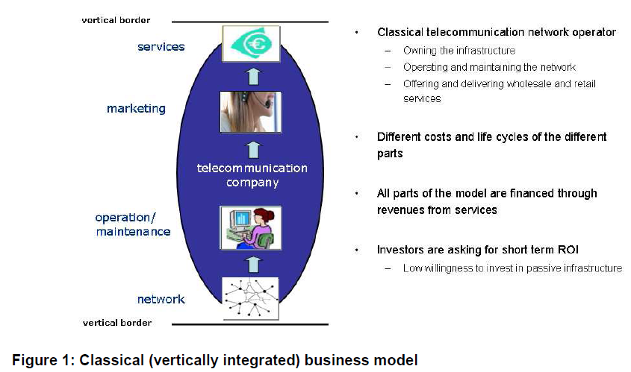

The commonly offered services today are telephony, IPTV and Internet access. The most important fact in running a classical telecommunication business is the usage of **own** infrastructure for providing **own** services to its **own** customers. The investments in infrastructure and operation of the network are paid back mainly by revenues generated through (retail and wholesale) service provisioning.

On the other hand, new business models are developing based on the segmentation of the classical model or separation of functions, shown in Figure 2.

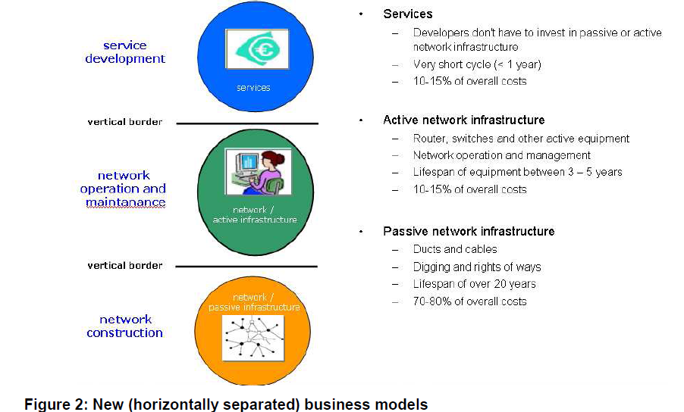

In this way we can clearly see the three main layers of which any telecommunication business and by this also an optical network, comprises of:

-Infrastructure consisting of corridors, ducts, cables and buildings commonly denoted as passive infrastructure

-Equipment necessary for conveying data including O&M, commonly denoted as active infrastructure

-Service and application which are what the consumers demand. Typical services are telephony, internet access or IPTV. This part is commonly denoted as service provisioning.

The **first option** Government/Regulaor/Governemnt owned public service company’s business model is to copy the vertically integrated business model of traditional / historic telecommunication operators (“Incumbents”) and to be in charge for all three parts of the network. The advantage of this model is the full control over all three layers and a possibly shorter payback time period. The draw back is that one has to run the network and provide the services, i.e. it has to substitute a private run business activity and becomes a “market player” itself.

The **second option** is to invest and take care of the passive and active infrastructure (passive AND active part) and to leave only the service provisioning to other providers (“Integrated Open Access”). Regarding the source of financing, the infrastructure can also be constructed together with a private company (PPP – private public part-nerships). The model is denoted as “integrated” because passive and active infrastructures are provided by the same entity. In this business model it is important to establish an open access policy for service providers, whereby the network operator is not discriminating between any of the service providers, allowing access under the same condition for each of them. If more than one service provider is providing a specific service, there will be competition and therefore a better quality of the specific service and a lower price. The advantage for the Government/Regulator/Government owned public service company of this model is not to have to take care of service provisioning. The disadvantage can be found in reduced revenues (but also lower investments than in the previous model) and longer pay-back time. The problem is that in this approach usually the reduction in revenues is bigger than the reduction in investment compared to the first option.

The **third option** is building only the passive part of the infrastructure (ducts and cables) and leaving the active part and the services to other providers (“Passive Open Access”). Also in this model a PPP approach can be realised for building the passive infrastructure. This model is known as provision of “dark fibre” whereby the passive infrastructure is rented to other network operators in a non-discriminatory way. The operators who are renting the fibres need their own active equipment for providing services. The advantage of the passive open access model for the municipality is to concentrate only on building the network and leaving the operation of the network and the service provisioning to other companies.

The **fourth option** for the Government/Regulator is to build the passive part of the infrastructure (ducts and cable) and leaving the active part to exactly one network operator (“Government/Regulator Open Access”). The difference to the previous model is that the operator of the network can not be a service provider – he is only operating the network in a non-discriminatory manner for each of the service providers on top of it. Also in this model the PPP model for financing the passive infrastructure is an option worth considering. The advantage of this model is again that the only part the Government/Regulator/Government owned Public service company is in charge of is the roll-out of the passive network. By leaving the management to only one company which must not provide end-user services the Government/Regulator is ensuring non-discrimination towards service providers. This model is also more attractive for service providers because they do not have to care about running a network.

**Building the NGA Business Case**

Consumer eagerness for broadband services is only half of the equation, however. Before deciding to deploy a new access network and choosing the kind of technology to use, a telecommunications operator must construct a solid business case. Digging trenches to install new duct and fiber infrastructure is labor intensive and therefore expensive (typically up to 80 percent of the cost of a FTTH project), and creating a business case with a return on investment (ROI) that is acceptable to investors can be challenging. Nevertheless, many enterprises in the telecommunications market are already deploying fiber networks, proving that there are plenty of viable business cases.

How that business case is assembled varies greatly from country to country and from region to region, but the common factor that underlies all the business cases is a confluence of circumstances: compelling services that people want to buy, a competitive environment that creates urgency, and a regulatory environment that is conducive to investment.

In Europe, FTTH began to emerge by 2005, although 95 percent of all fiber customers were located in just four countries at that time. For each of those four countries, a unique combination of factors helped nurture the development of new access networks. The experiences of the early adopters illustrate how diverse the factors that advance business cases can be:

● Denmark (infrastructure synergy): Danish utility companies decided to roll out fiber to consumers as they worked to meet a national directive to bury their overhead power lines.

● Italy (market opportunity): Telecommunications operator e.Biscom joined forces with local utility company AEM to create FastWeb, an alternative operator that wanted to enter the nascent IPTV market, starting in Milan.

● The Netherlands (competitive pressure): Competitive pressure from a highly developed cable TV market (nearly 100 percent coverage) and the high population density of the country made the Netherlands a unique laboratory for the development of new FTTH projects.

● Sweden (political support): The first country in Europe to issue a broadband policy, Sweden provided strong public support for construction of citywide optical networks, called “stadsnät”.

Many incumbent telecommunications operators originally decided in favor of fiber-to-the-cabinet (FTTC) and very-high-speed digital subscriber line (VDSL) technologies because these allowed them to boost broadband speeds while continuing to get good use of their existing assets. Deutsche Telekom was the first incumbent to announce a large-scale FTTC and VDSL plan: €3 billion investment to deploy a FTTC and VDSL system in 10 cities by the end of 2006 and in 50 cities by the end of 2007. As competition for services has intensified, however, incumbents all over Europe have started rolling out FTTH, and in August 2011 Deutsche Telekom announced the creation of a new subsidiary dedicated to FTTH deployment.

Some business plans are created in direct response to a competitive threat, which is often triggered by a technology or regulatory development. Completion of a new cable standard in 2006 (DOCSIS® 3.0) paved the way for cable operators to start offering broadband speeds of 160 Mbps or higher, effectively surpassing the capabilities of many incumbents at the time. Cable operators had already invested heavily (in response to the emergence of satellite TV providers during the 1990s) to upgrade their networks from unidirectional analog systems to two-way digital by deploying additional fiber in their networks. In this respect, the cable operators already owned a network that was similar to the FTTC architecture that the incumbents were starting to deploy, making them direct competitors.

Other business cases are advanced primarily by positive factors: the possibility of creating and monetizing new services. Most FTTH operators offer the standard “triple-play” package of telephony, broadband, and TV, while some also offer a broader menu of services that customers can choose through online portals, such as cloudbased data backup, home security, and mobile phone offload (e.g., femtocells). Content is central to the franchise model of Lyse Tele, owner of the Altibox (all-in-one box) brand in Norway, which is a good example of a successful business model. Franchise partners, typically utility companies, deploy the FTTH network, and Lyse Tele supplies the content and services, including local TV channels and news, which is delivered with the franchise partner’s branding.

Broadband prices have fallen in recent years. The eagerness of consumers to try new services does not always match consumers’ willingness to pay. The number of subscribers on a network is a critical element of the business case. For this reason, FTTH operators expanding into new areas often set a “trigger level” for subscriptions before they begin rolling out the network. One FTTH operator, Hong Kong Broadband Networks, took the bold step of offering 1-Gbps broadband at utility prices, rather than at the premium rates normally associated with high-end products, with excellent results: the operator now has more than 1.1 million subscriptions in a market of about 2 million households and businesses. Adjacent (nonconsumer) business areas can help an operator create a robust business case. Health insurance companies, for example, have the financial resources needed to pay for HD video conferencing for patient monitoring, and they may invest if they can save money over the long term. Likewise, utility companies may be able to exploit the synergy between smart grid technology and the installation of mass market fiber broadband.

The challenge is getting all the players in the ecosystem to cooperate and to share the value, while also having a critical mass of end users who are willing to consume and pay a reasonable incremental fee for such services. All of these examples fall under a free-market model, where the new access network is being deployed by private companies, with the government sometimes acting as a catalyst. A different approach is being taken in countries such as Australia, New Zealand, and Singapore, which have adopted national broadband plans in which the government is the main actor and uses public money to build a national FTTH network. In these countries, there is a firm belief in the value that such a network can create, both in terms of economic growth and savings arising from better government services such as healthcare. Governments are able to consider a longer investment horizon and to reap financial benefit from factors external to the network such as better citizen engagement.

**New Business Models That Spread Investment Risk**

New business models are imperative to spread investment risk. Under the traditional model of broadband access delivery, an end-to-end integrated telecommunications provider offered broadband services over its own infrastructure. The telecommunications provider invested across the value chain with attractive medium-term return prospects, despite market uncertainties and regulatory obligations. That vertically integrated model, however, may not be sustainable in the long term. It could fail to align the risks associated with large-scale infrastructure investments in a highly uncertain regulatory environment with traditionally expected returns. It also inhibits operators from pursuing new revenue opportunities in high-risk application and content ventures. An alternative new horizontal business model approach, which separates the layers of traditional service delivery and establishes three different plays, would allow risk to be more appropriately tied to rewards and ensure investment sustainability.

The top layer would have a number of “ServiceCos” operating in an extremely competitive and lightly regulated market consisting of multiple application and content providers. ServiceCo businesses would compete on their ability to develop deep market and customer understanding, deploy advanced marketing techniques, and innovate continuously.

Businesses in the middle layer, “ActiveCos,” would lease infrastructure from “PassiveCo,” the infrastructure business, and add intelligent elements to provide differentiated services to both application providers and end users. ActiveCos would compete on their ability to provide high-quality network and enablement services to application and content providers as well as end users. These businesses would operate in a competitive market, with regulations on service levels, quality, and pricing.

PassiveCo would focus on deploying passive infrastructure across the country, leveraging economies of scale and functioning like an infrastructure utility business—similar to gas and water utilities. PassiveCo is likely to be a natural monopoly and would be heavily regulated.

Adopting horizontal business models yields significant benefits for the stake-holders. It enables traditional operators to reduce regulatory risks in the bottom layer, which incentivizes investment in infrastructure for the long term in return for low-risk, utility-like returns. Horizontal business models also broaden operators’ return prospects in the top two layers by allowing them to compete in areas with higher risk profiles but potentially higher returns. Policymakers benefit from increased private-sector investments, accelerated broadband infrastructure deployment, greater innovation in applications and content, and further socioeconomic contributions from the sector.

**2.3 Sustainability And Other Issues For Broadband Development**

For private, commercial network operators, infrastructure deployment and service provision decisions are based on evaluation of the potential profitability (ROI) of each project;

The market will provide coverage up to some boundary, known as the “Market Efficiency Frontier”, beyond which further deployment would be unprofitable. The location of this Frontier is constantly shifting, but is typically well beyond the point of current service availability, especially in a growing market.

We understand that especially outside of metropolitan areas, communications networks require significant costly ongoing management, maintenance and investment simply to remain operational. It is understandable that unless these operational costs can be covered all upfront network investment will ultimately be wasted. The thrust of communications policy since deregulation has been to encourage or at least anticipate facilities-based competition. Yet despite government efforts – including in some cases direct funding of capital items - in many parts of the world this policy has not produced any widely available alternative infrastructure. In fact no competitive network operators have been able to establish a significant presence in such areas and few have been able to operate beyond isolated geographic niches.

An examination of similar sparsely populated and geographically large markets in other parts of the world presents similar stories. Especially in the last many years there has been much activity in many of these markets but few new entrants have been able to find scalable and sustainable business models.

As a consequence, the experience elsewhere demonstrates that in many markets the delivery of modern communications services can only be achieved at the lowest social cost by a single network operator.

2.4 **Access: Availability, Affordability, Adoption – And Sustainability**

From the providers’ perspective, access to broadband requires sufficient incentives to invest in infrastructure (capital expenditure or capex) and sustainability to generate sufficient revenues for ongoing operating expenses (opex). Access from the providers’ perspective access can be defined in terms of houses passed (for wireline technologies such as optical fiber and coax or hybrid fiber/coax or copper) and coverage for wireless technologies.

However, from the user perspective access may be viewed differently:

* Household access
* Personal access
* Using mobile phones, PDAs, laptops, netbooks, e-pads, etc.
* Institutional access
* For government agencies, public safety, health care facilities, etc.
* Public access
* Single national model (e.g. post offices);
* Variety of public access models (telecenters, cybercafés, other shops, post offices, NGOs, etc.);
* Schools and libraries;
* Other institutions, such as community centers
* Geographic access
* Within specified distance of access point
* Other criteria
* Administrative function (e.g. district center, county seat), size of population, etc.

The criteria above refer primarily to availability. From the users’ perspective, access to

broadband requires not only availability but also affordability, plus relevant applications and the skills to put them to use in order to achieve adoption.

Policymakers need to address sustainability requirements for rural and remote areas,and affordability for low income populations or high cost regions. The stimulus programs in various countries are aimed at increasing availability, through funding infrastructure investments primarily in rural and remote regions. Reforms of universal service policies in many countries are needed to address the issues of sustainability for service providers in high cost regions. These countries also include user subsidies for schools and libraries, which in turn provide funding for operators to extend services to these anchor tenants in rural communities.

Affordability is addressed in these countries through subsidies for voice services for low income

customers. The regulators are considering expanding the service offerings to include broadband.

The next steps in closing the digital divide and deriving socio-economic value from infrastructure investments are to increase adoption and to develop and implement applications that address social and economic needs for information, e-services, access to markets, consultation with specialists, etc. Data from many countries show lower levels of broadband adoption among lower income, rural, and some minority populations.

Among non-adopters, lack of relevance is cited as main reason for not having broadband at home. Research is needed in each country or region to increase understanding of reasons for nonadoption, to develop strategies to encourage adoption, and to identify or develop relevant applications for users with limited ICT or language skills.

**CHAPTER 3**

**BAACKHAUL AND ACCESS NETWORKS FOR BROADBAND**

**3.1 Mobile/Fixed Backhaul Network**

A few years after the deployment of HSPA, the volume of mobile packet data traffic has exploded to the point where it has now exceeded circuit-switched traffic. Furthermore, with the coming deployment of LTE and 4G mobile systems, it is expected to increase even more. To cope with the changed traffic composition, operators need to migrate their legacy TDM networks to packet-switched backhaul networks capable of supporting high volumes of packet traffic while maintaining low OPEX. Inspection of the different migration options shows that there is no silver bullet solution or single migration path that fits all types of networks. Operators need to make careful analysis of their deployed networks, present and future traffic demands, link technologies, and capability to support TDM, packet, and hybrid traffic.

The backhaul can be considered to be the portion of the network that connects the BTS (and air interface) to the BSCs and mobile core network. The backhaul can consist of a group of cell sites that are aggregated at a series of hub sites. The generic model for the newer backhaul networks consists of a cell, hub sites, or both connected to aggregation devices that in turn can either belong or be connected to a Metro network.

Backhaul network spans from the Cell Site Transport Gateways, ‘Last Mile’ domain, Aggregation Domain, through to the Metro Network Domain and ending with the Core Network Transport Gateways. Transport Nodes reside at the border of each of the domains and they provide traffic management capabilities such as switching and performance monitoring. Backhaul network can use a variety of physical transmission technologies including optical fibre, microwave radio, copper DSL and occasionally satellite.

There is more variety of physical transmission in the Last Mile and Aggregation domains with microwave radio having a majority share, whilst the Metro and Core networks predominantly employ high capacity WDM optical transmission.

**3.2 Different Technologies and Backhaul Network Support**

The connectivity type offered by the backhaul network is influenced by the technology used in the RAN and factors such as geographical location of the cell site, bandwidth requirements, and local regulations. The amount of available frequency spectrum and spectral efficiency of the air interface influence the bandwidth requirements of a cell site. Hence, the backhaul network can consist of either one or a combination of different physical media and transport mechanisms. Selecting between the different options available depends upon the type of radio technology, applications that are expected to be used, and transport mechanism. Table.1 lists the different technologies and the corresponding base station support.

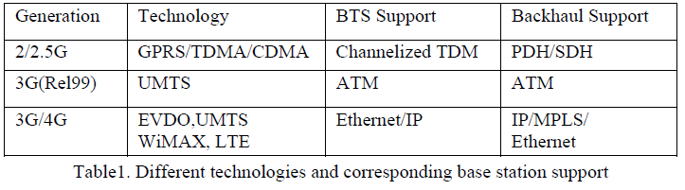

**3.3 Mobile Backhaul for Long Term Evolution**

Existence of different strategies for the rollout of Radio Access Network and corresponding backhaul deployment strategies may at first suggest divergent set of requirements that will be difficult to address with a common approach to backhaul transport. However, backhaul requirements are consistent between the two evolutions strategies described. This convergence of requirements is due to the fact that regardless of the starting point today, all operators have the same end objective which is a LTE based network for mobile broadband. Related network evolution steps will be common and the difference will lie in whether all operators will experience all of the transformation stages or whether some can accelerate or side step one or two of the stages. The challenge lies in the complexity of managing the transition to packet backhaul whilst maintaining existing high quality of legacy services.

With today’s hybrid approaches packet data traffic is either carried encapsulated into TDM transport or alternatively it is transported separately over a public internet. Hybrid approaches of tomorrow will reverse the hierarchy by carrying TDM traffic encapsulated over packet based transport. And eventually 2G networks will be turned off allowing for the pure packet transport network for Mobile Broadband. The gradual transition from hybrid architecture to pure packet protocol architecture as shown in Fig.3 is the driving force behind key trends in Mobile Backhaul transport evolution.



Fig.3: Migrations from hybrid architecture to pure packet protocol stack.

**3.4 Flat IP Network Architecture**

To support multi-service traffic with cost effectively, to increasing transport bandwidth capacity for dataservices by widening frequency band of carriers, maximizing efficiency for bandwidth utilisation, providing carrier grade manageability and survivability and architectures like Flat IP network architectures are the main requirements in mobile backhaul network.The term flat IP architecture can be applied to a network where all the nodes can reach each other via IPconnectivity. A flat IP architecture can be applied to a network where the radio and routing functionality is pushed to the edge of the network. The end-to-end connectivity is achieved through a packet-based corenetwork. Technologies such as LTE are based on a flat IP architecture. One of the main advantages of using IP-based networks is the capability to transport different traffic types over a common IP/MPLS-based infrastructure in addition to providing QoS guarantees and security requirements, low latency, low cost thus reducing total volume of equipment used. The table 2 below presents a estimation of global IP traffic from 2011-2016. This indicates the capability of the IP networks.

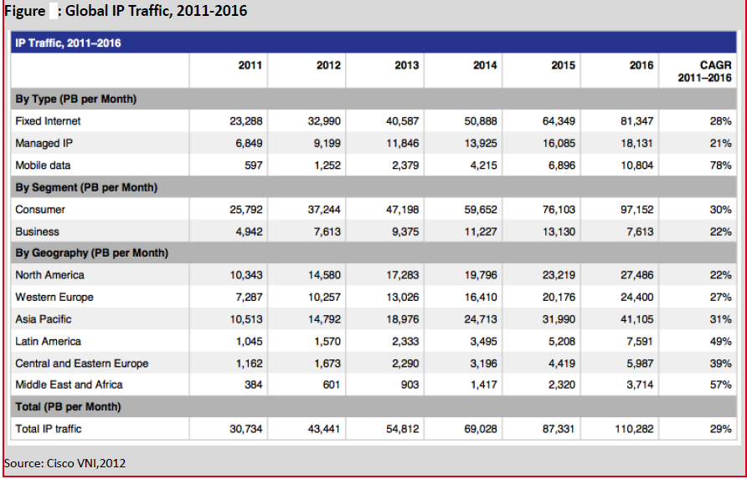

Table 2: Global IP Traffic 2011-2016

**3.5 Evolution of Wireline Access Technologies**

Every Internet connection relies on optical fiber connectivity to carry the traffic generated or consumed by individual customers or groups of customers. The differences between the various network architectures and their respective performance depend on the termination point of the fiber (whether central office, street cabinet, building, or home) and the technology employed on the medium that extends to the customer (ADSL or VDSL on copper pairs; DOCSIS over coaxial cable; or Ethernet, passive optical network (PON), or DOCSIS over fiber, for example).

An important factor that determines the cost of an access technology is the availability of the transmission media.

While telephone-grade copper and coaxial cable are usually considered to be readily available (these media were deployed long ago to support traditional services such as analog telephony and cable TV, and the cost has already been absorbed), the use of fiber is associated with significant investment because, in the vast majority of cases, fiber needs to be deployed starting from scratch.

This section of this document discusses these various high-speed access technologies and their capabilities and likely evolutionary paths to help understand their suitability for future service needs and thus how well certain technologies really can meet the requirements of the future.

3.5.1 DSL Technology

Digital subscriber line (DSL) technologies are a group of technologies for broadband access over telephone-grade copper pairs. The technologies that are relevant for the mass market share a common modulation scheme:

discrete multitone (DMT) modulation. DMT is characterized by the use of individual frequency carriers, which are spaced at about 4-kHz intervals, and each carrier is individually modulated. The highest frequencies used on the medium determine the different types of DSL: ADSL, ADSL2, ADSL2+, VDSL, VDSL2, etc. The maximum achievable aggregate bit rate for upstream and downstream traffic is roughly proportional to the number of carriers employed, and thus to the overall bandwidth used on the medium, if interference is neglected. Carriers are grouped in bands for upstream and downstream transmission. Typically, much more spectrum is allocated to downstream traffic, which makes most DSL implementations highly asymmetric.

The medium used by DSL - the telephone-grade copper pair - was originally defined for the transport of analog voice with a maximum frequency of 3.4 kHz. All DSL versions exceed this maximum frequency by several orders of magnitude: for example, ADSL2+ supports frequencies of up to 2.2 MHz, and VDSL2 supports frequencies of up to 30 MHz. Consequently, DSL is affected by two kinds of impairments: attenuation (the gradual loss of signal intensity) and crosstalk (signals transmitted over one copper pair influence the signals on other copper pairs).

Attenuation grows exponentially with the length of the medium, and logarithmically with the frequency. Crosstalk grows with the frequency, the power of the signal, and the number of active pairs in a cable.

DMT is a highly effective modulation scheme, and its performance is considered to be close to the theoretical limit given by the Shannon theorem, which determines the maximum achievable bit rate over a medium as a function of the frequency-specific signal-to-noise ratio (SNR) values. The SNR decreases with increasing attenuation and increasing noise from crosstalk. Therefore, higher bit rates require higher frequencies, which in turn increase attenuation and crosstalk. As a result, high bit rates can be achieved only over short distances. Commercial deployments of DSL2+ with 16 Mbps (downstream) are typically limited to 1.5 to 2.5 km, depending on the diameter of the copper wires, and those of VDSL2 with 50 Mbps (downstream) to few hundred meters. VDSL2, therefore, is usually provided by a DSL access multiplexer (DSLAM) located in a street cabinet close to the customer.

Although attenuation is determined by the physical characteristics of the medium, crosstalk can be mitigated by a range of technologies, called dynamic spectrum management (DSM), which consider all the signals in a cable jointly, adapting power levels and use of carrier frequencies and compensating for crosstalk using estimation algorithms (vectoring). These technologies promise to increase the achievable bit rates per copper pair to 100 Mbps over a few hundred meters.

To increase DSL bit rates even further, bonding of multiple pairs and phantom pairs (that is, pairing wires taken from different twisted pairs) can be used in combination with vectoring. Some vendors have reported combined bit rates of up to 900 Mbps (upstream and down) with four physical pairs over a few hundred meters in a laboratory environment. Whether these bit rates are achievable depends primarily on the availability of multiple pairs between the DSLAM and the subscriber.

While DSL is clearly more limited in capacity and distance than all-fiber approaches, these technology developments will extend the lifespan of telephone-grade copper cables for some years to come.

**3.5.2 Cable Technology Evolution**

Cable MSOs have a hybrid fiber and coaxial (HFC) infrastructure in which signals are transmitted bidirectionally between the cable modem termination system (CMTS) located at the head end (the master site where the TV signals are received) and the fiber node, at which point they are converted onto coaxial cable that reaches the customer premises.

A typical coaxial cable spectrum ranges from 100 to 750 MHz in the downstream direction, and from 5 to 65 MHz in the upstream direction, but the range can go higher: to 1 GHz (downstream) and 85 MHz (upstream). The cable plant is segmented: a group of 500 or more homes is connected to a single fiber and coaxial segment. The spectrum must be shared by the group of homes connected to the same segment, and encryption helps ensure that customers receive only the data intended for them.

DOCSIS is the standard protocol for broadband services over cable. DOCSIS divides signals in the downstream direction into frequency slots of 8 MHz (European version); each slot is used to transport one or more analog TV,digital TV, or DOCSIS broadband services. In the upstream direction, there are frequency slots with a maximum of 6.4 MHz for uplink communication. Quadrature amplitude modulation (QAM) is used to increase the spectrum efficiency of the digital signals in the downstream (up to QAM256) and upstream (up to QAM64) directions, achieving a maximum of 50 Mbps and 30 Mbps, respectively, for each channel.

Previous versions of DOCSIS allocated the frequency equivalent of one TV channel for downstream broadband transmissions. DOCSIS 3.0 is the latest standard for cable data services, enabling the bonding of multiple downstream and upstream channels to create high-bandwidth pipes. DOCSIS 3.1 has already been declared however. Using DOCSIS 3.0, data is striped across multiple QAM channels, forming a single logical channel that aggregates the capacity of the individual QAM channels. DOCSIS 3.0 has no limit on the number of QAM channels aggregated; the limit will arise from the CMTS and customer premises equipment (CPE) capabilities. Current DOCSIS 3.0 technology provides:

● Downstream bonding capacity of more than 1 Gbps (20 or more channels) on the CMTS and 400 Mbps (8 channels) on the DOCSIS CPE

● Upstream bonding capacity of 240 Mbps (8 channels) on the CMTS and 120 Mbps (4 channels) on the DOCSIS CPE

The use of HFC spectrum still has much inefficiency, however. Multiple fiber nodes, each serving up to several hundred homes, are often connected over the same fiber, and analog TV channels occupy significantly more cable spectrum than the equivalent digital service. As a result, operators needing to upgrade the cable plant to cope with bandwidth growth are segmenting the network into smaller sharing groups of 500 homes, and even only 250 or 100 homes in some cases, by:

● Connecting individual fibers to each fiber node

● Dividing the fiber nodes into two or more smaller fiber nodes

● Bringing fiber to the last coaxial amplifier (FTTLA), connecting to a smaller group of homes

On top of the HFC segmentation, services are converging onto all-IP-based networks, so the cable industry expects all services to be delivered over DOCSIS in the future. Analog TV will disappear as more subscribers get a set-top box (STB) or use TV sets with an IP interface, and this change will release spectrum to carry new TV channels or additional broadband capacity.

Of the overall bandwidth capacity of cable’s HFC spectrum, a maximum of 6 Gbps is available in the downstream direction (100 MHz to 1 GHz), and a maximum of 300 Mbps (5 to 85 MHz) is available in the upstream direction, which is shared by the homes connected to the same fiber and coaxial segment. As the cable plants are segmented into smaller groups of homes (particularly when the number of homes on each shared segment is 100 or fewer), analog TV disappears, and the silicon density in the CPE increases, cable networks will move onto a model of full DOCSIS spectrum for all CPEs sharing the same fiber and coaxial segment, enabling these devices to access the significant bandwidth pool of 6 Gbps downstream and 300 Mbps upstream.

In terms of downstream capacity, cable is very competitive with some of the shared FTTH technologies such as Gigabit PON (GPON). In terms of upstream capacity, cable is more limited; however, the cable industry is discussing ways to increase the upstream bandwidth: for example, by introducing an upstream and downstream frequency split in the middle, at 200 MHz, or using some of the existing downstream spectrum to increase the upstream capacity. This approach will require a new DOCSIS standard and changes to the physical components used to build the HFC network (optical transmitters and receivers, fiber nodes, amplifiers, taps, and splitters), but it is a viable option if needed.

Another opportunity that cable operators are exploring is the evolution of HFC into FTTH. Generally, cable MSOs that want to upgrade their networks first look to DOCSIS 3.0 and HFC segmentation, deploying FTTH only in new areas. However, radio frequency (RF) over glass (RFoG) technology is an upgrade option that is getting some attention from cable operators because it allows operators to offer FTTH-class services while reusing the existing back-end and customer premises equipment, including the CMTS and cable modems, while retaining the well known engineering and operations of the HFC network.

RFoG technology delivers DOCSIS, digital video, and analog TV services across an optical access network based on specialized optical transmitters and receivers and an RFoG optical network termination (ONT), which provides an RF interface to the customer, allowing customers to connect any standard cable customer equipment (TV with analog tuner, DOCSIS modem, or cable STB).

Using RFoG, FTTH networks can be built in segments of 32 or 64 homes. This approach mimics GPON technology, but adds the flexibility to build RFoG segments with more than 64 homes initially and perform virtual node optical splitting at the head end without the need for a major equipment upgrade, and to allocate DOCSIS downstream and upstream channels per FTTH RFoG segment according to bandwidth needs. The combination of DOCSIS 3.0, HFC segmentation, and various RFoG FTTx technologies will allow the cable industry to remain competitive in the delivery of broadband and entertainment services for many decades.

**3.5.3 FTTH Technology Evolution**

Fiber in the access network is the long-term goal because it can provide almost unlimited bit rates for any perceivable future services. It can be classified as fiber to the home (FTTH), which brings the fiber directly to the residence, or fiber to the building (FTTB), with the fiber terminating in the basement of a multidwelling unit (MDU), from which information is transported to individual apartments using copper-based cabling in the building.

Fiber can be deployed in various topologies, and it can use various transmission technologies. In fiber-based access networks, only single-mode fiber (SMF) plays a role, except in in-home cabling, for which multimode fiber (MMF) and polymer optical fiber (POF) also are being used.

Fiber is typically deployed in one of two topologies: point to point (P2P) or point to multipoint (P2MP), as shown in Figure 4. In the past, ring topologies have also been used, although these are not generally favored today because they do not scale readily.

In P2MP topologies, a fiber from the optical line terminal (OLT) in the point of presence (POP) leads to an aggregation device in the field, typically in a splicing enclosure, a street cabinet, or the basement of a building.

This aggregation device can be as simple as a passive optical splitter, or it can represent an active device: an Ethernet switch or a DSLAM. In contrast, a P2P topology uses dedicated fibers all the way between the POP and the customer.

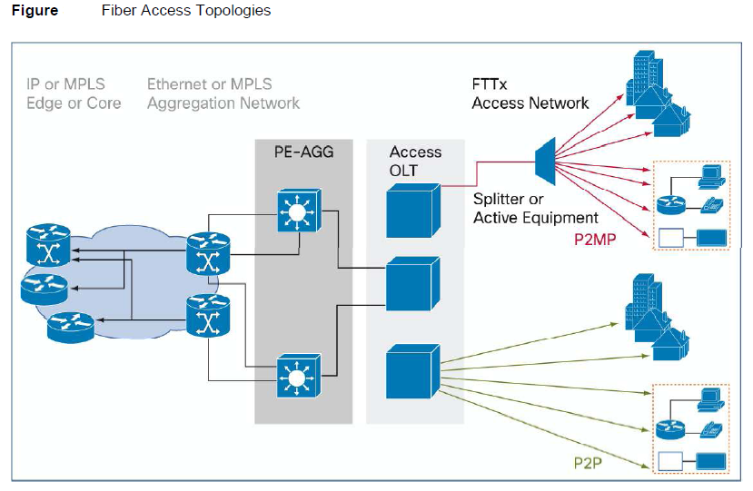

Figure 4: Fiber Access Technologies

The technologies used on the fiber can be divided into three broad categories: Ethernet; PONs with time-division multiplexing (TDM) access-control protocols (TDM-PONs); and PONs using individual wavelengths per customer employing wavelength-division multiplexing (WDM-PONs).

Recent innovations such as bend-insensitive fiber and preterminated cables, new installation techniques such as microtrenching, and regulation that opens up access to ducts continue to reduce the cost of deploying fiber, helping lower the barriers to FTTH deployment.

**3.6 Wireless as a Complementary Technology**

In the public debate on broadband, wireless broadband technologies are often considered to compete against wireline technologies. Advertised wireless broadband speeds based on third-generation (3G) and fourthgeneration (4G) technologies are well in the order of magnitude of today’s typical DSL offerings.However, marketing messages usually neglect a number of factors:

● Every wireless access technology is based on a shared medium: the air interface. The spectrum on this air interface is shared among all the customers in a cell. Therefore, the more customers who are active in such an access domain, the lower the average bit rate per customer. Recent evidence shows that many mobile wireless networks, consequently, have become victims of their own success as air interfaces have become overloaded.

● Wireless technologies are distance dependent and deliver maximum throughput only when the user is adjacent to the transmitter. This behavior is a consequence of the fact that wireless transmission technologies have already been optimized to make the most efficient use of spectrum (which is a scarce resource) and operate close to the Shannon limit.

● Latency on mobile broadband networks is typically two to three times higher on a 3G mobile network than on a DSL network, and it can be much higher on older second-generation (2G) and 2.5G networks. This latency negatively affects the end-user experience for mobile data services, and it can make real-time applications such as gaming and cloud-based services impractical to use. In fact, the Broadband Quality Study (BQS)[2] also shows that although mobile broadband quality has indeed improved in the past few years with the deployment of 3G technologies, on average the quality of mobile broadband is far from that of fixed-line broadband, and about 90 percent of users have quality experiences significantly below those with fixed-line broadband. Even the worldwide country leaders in mobile broadband quality, Sweden and Denmark, have mobile BQS ratios that are below 50 percent of their wireline equivalents.

The speed and latency of wireless network technologies will continue to improve. However, the demands placed on these networks by consumers will also continue to increase. The Cisco VNI global data traffic forecast for 2009-2015 predicts that mobile data traffic volumes in 2015 will grow to 26 times what they were in 2010. Sixtysix percent of this traffic will be mobile video, with its high bandwidth and quality of service (QoS) demands. Traffic will grow faster than revenues, with enormous pressure on the network from over-the-top (OTT) video.

Far from being competitors, however, high-capacity wireless and fiber networks will actively support each other.The technologies will be highly complementary in two main situations:

● Fiber networks can provide transport capacity and ease of deployment for radio access network (RAN) infrastructure. Next-generation wireless base stations will have to handle several hundreds of megabits per second (more if they use multiple sectors), so the requirements for backhaul capacity will grow accordingly.

The most straightforward way to connect such base stations to the aggregation network is through fiber.Therefore, obvious synergies exist in the build-out of fiber-based access networks for wireline access and wireless backhaul. Wired networks can provide alternative backhaul capabilities to meet the increase in mobile data demand.Service providers are seeing an upsurge of data traffic across their networks by users who increasingly expect ready access to online services that consume large amounts of data without being limited to a fixed location. The rapid increase in 3G wireless broadband services, combined with the proliferation of dual mode 3G and Wi-Fi smartphones, affordably priced data plans, and new online services, has stimulated data traffic by wireless users. One way to cope with this increase is to offload mobile traffic using Wi-Fi or femtocells onto existing wireline access networks. Because a very large proportion of mobile data traffic is actually consumed in mobile subscribers’ homes or at the workplace, this approach is very compelling. With this approach, not only will the cost of delivering mobile data traffic be greatly reduced, but a valuable asset, the licensed spectrum, will be preserved.

**CHAPTER 4**

**INTERCONNECTION**

**4.1 IP-Based Interconnection**

Interconnection of diff erent networks is critical to ensure a competitive communications market. It is fundamental for service providers to ensure that their users have the ability to connect with users of any other network or service provider. As the Internet expands and becomes more geographically ubiquitous and as traffi c increases, more effi cient IP-based Internet interconnection will be required. This is especially relevant for developing countries, where lack of interconnection facilities means that Internet traffic originating there is mostly subject to “tromboning” (that is, using international transit facilities to deliver local traffic).Policies to facilitate national or regional Internet exchange points (IXPs), the physical infrastructure where Internet service providers (ISPs) exchange Internet traffic between their networks, will play a crucial role in ensuring more efficient and cost eff ective Internet interconnection in these countries.

Similarly, as the transition toward IP-based NGNs proceeds, questions will arise regarding the manner and terms under which IP-based interconnection will take place between diff erent types of networks and at different functional levels of the network. Especially relevant are issues relating to future wholesale charging mechanisms that may apply to converged broadband networks. The following sections address current trends and expected regulatory developments relating to these issues.

**4.1.1 Internet Interconnection and IXPs in Developing Countries**

Historically, the exchange of Internet traffi c has been focused in developed countries. In the early years of the Internet, traffi c was routed and exchanged mainly in the United States. As Internet access has expanded and the amount of content available has increased, the exchange of Internet traffic has been distributed to other developed countries in Europe and Asia through the creation of national and regional IXPs. In the case of developing countries, while IXPs have been progressively implemented and peering is occurring at the national level, the amount of traffic that is exchanged within developing regions is still very small. Most of the traffi c is still hauled out of the region for switching and then sent back into the region for delivery. IXPs in developing countries are important for Internet interconnection for several reasons. By providing an interface for the exchange of local and regional traffic, IXPs facilitate a more efficient and cost effective management of international bandwidth. Because of their small volume of traffic, ISPs in developing countries mostly have to rely on transit agreements, since the largest providers do not have incentives to enter into shared-cost peering agreements with them. Due to the charging mechanisms for international Internet transit, this means that the developing-country ISP will ultimately bear the costs of outbound and inbound traffic. Local peering through IXPs at the national or regional level helps to resolve this problem and reduces the costs of Internet access for consumers in developing countries.More local interconnection, in turn, allows for the provision of more reliable services, with lower latency that then can support multiple, innovative, time-sensitive applications. For example, for African ISPs, tromboning adds an estimated 200 to 900 milliseconds to each transmission. This added latency can impede the development of new services, such as Internet telephony, streaming audio and video, video conferencing, and telemedicine.

By interconnecting at a local IXP, two ISPs (located near to each other) can overcome this problem and route traffi c to each other’s networks in 5 to 20 milliseconds.As noted, IXPs are now being implemented in some developing countries.

Before 2002, there were only two IXPs in Africa, with this number increasing to 10 by 2003. By December 2010, there were 20 IXPs distributed among African countries. While this represents significant progress, the great majority of Internet traffic from Africa, around 85 percent, still relies on connections to Europe; just 1 percent of the traffi c being exchanged stays within the region.

From a regulatory perspective, a series of barriers can hinder Internet interconnection and the establishment of IXPs in developing countries. Internet interconnection has developed under market-based mechanisms and without the need for regulatory intervention. However, regulators’ attempts to extend their mandates to encompass Internet interconnection may result in unwarranted regulation and create disincentives for the deployment of IXPs. These include, for example, legal restrictions that prohibit the deployment of nonregulated ICT facilities, such as IXPs. Unduly restrictive or burdensome licensing regimes may also limit the deployment of IXPs. Similarly, exclusive rights for the provision of international connectivity, which some countries maintain, can also impede effi cient Internet interconnection. In some cases, lack of appropriate regulation of the inputs required to implement eff ective IXPs, such as national backbone connectivity, may result in above-cost rates for wholesale services. For example, high costs of leased lines can signifi cantly aff ect an IXP’s viability. In addition, defi ciencies in regional broadband connectivity play a role in the continued low levels of intraregional Internet traffi c exchanged in developing regions, like Africa. Lack of relevant local content also affects the extent to which traffic is peered within national or regional IXPs.

**4.1.2 IP-Based Interconnection: Wholesale Charging Arrangements**

Despite the increasing physical and logical integration between legacy public switched telephone networks (PSTNs), public land mobile networks (PLMNs), and all-IP networks, two separate models are still typically used for exchanging traffi c in these networks. Internet traffic is exchanged using IP-based interconnection and relies on privately negotiated peering and transit agreements. PSTN and PLMN traffi c, however, may be exchanged using a combination of switched and IP-based interconnection, but it is normally subject to regulation and typically falls within two main wholesale charging arrangements: calling party network pays (CPNP) and bill and keep (BAK).

As convergence toward NGNs advances, these diff erences create potential arbitrage pportunities between regulated and unregulated services and lead to potential competitive distortions. Regulatory authorities are therefore considering what reforms in wholesale charging mechanisms, if any, should be implemented at the national level for termination services to enable IP-based services and broadband further. While it is not clear which wholesale charging arrangements will prevail, some authorities are expecting that a uniform wholesale charging mechanism for IP-based interconnection may emerge in the future.

**4.2 Regulating Bottlenecks in the Broadband Supply Chain**

Supplying broadband services involves a combination of network elements, processing, and business services that can be thought of as the broadband supply chain. This supply chain can be divided into four main components: (a) international connectivity, (b) domestic backbone, (c) metropolitan connectivity, and (d) local connectivity.

Bottlenecks in any of the links of the chain will stifl e competition and the development of broadband. Hence, effective regulatory frameworks must identify and address such instances of market failure in a timely and effective manner.

**4.3 Regulating Interconnection**

Telecommunications carriers are obliged to interconnect their services and networks with each others’ to ensure any-to-any connectivity (“A2A Connectivity”). Terms and conditions for interconnection between carriers may be established by (a) bilateral agreement as a result of commercial negotiations between the carriers; (b) tariff published by the carrier which is open to all parties seeking to interconnect; or (c) determination made by the Telecommunications Regulator Interconnection between telecommunications networks is a critical requirement in promoting fair and effective competition in a multi-network environment. In most of the countries after the introduction of competition , a regulatory framework for interconnection between networks are established. These guidelines or frameworks give guidance to the industry on the forms of interconnection available and the principles for the determination and settlement of interconnection charges between network operators. These guidelines were formulated mainly for the interconnection between networks for “narrowband” services which are for voice and medium speed data communications.

With the development of a high value-added, knowledge-based economy in most of the countries “narrowband” services would no longer be able to cope with the anticipated demand for the exchange of huge volumes of information at high speeds for work and leisure. It is important for the Governments to promote investments in broadband telecommunications infrastructure and at the same time facilitate access to such infrastructure for the provision of all kinds of broadband services.

Accordingly, it is necessary for the governments and regulators to review the existing regulatory framework for interconnection to ensure that it is still appropriate and adequate to achieve the policy objectives of the Government in broadband services.

The key policy objectives of the Governments on broadband services includes but not limited to the following-

(a) to promote investment in broadband infrastructure, as the infrastructure is the backbone of the telecommunications and information technology industries underpinning the service sector.

(b) to promote effective competition and consumer choice at affordable prices, through ensuring unrestricted access to, and interconnection between, broadband telecommunications networks;

(c) to maintain a fair and competitive market environment in broadband services, through transparent and non-discriminatory interconnection arrangements (whether they are achieved preferably through commercial negotiations or determination by the Governments or Regulators); and

(d) to promote inter-operability between broadband services provided by different service providers in order to enhance competition and consumer choice.

**CHAPTER 5**

**INFRASTRUCTURE SHARING**

5.1 Passive Infrastructure Sharing in Telecommunications

Increasing competition, along with investments in ever-changing technology,has been pushing telecom operators towards new ways of maintaining margins.Considering that building and operating infrastructure is a significant cost for operators, it is the ideal way to find quick wins.Telecoms infrastructure for operators primarily consists of-(as shown in figure 5).

* Active infrastructure (such as spectrum, switches, antennae)
* Passive infrastructure (such as towers, BTS shelters, power)
* Backhaul.

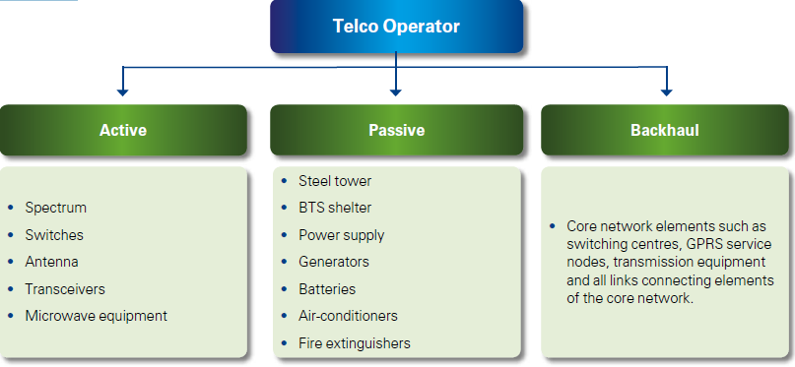

Figure 5: Telecoms infrastructure for operators

Infrastructure sharing can take different forms, as operators choose to share network components that are either active or passive. Telecom operators’ spending is divided almost equally between passive and active components, but this balance is expected to change over time, given the declining cost of telecom equipment and the constant increase in the cost of passive components, including property acquisition and construction materials. In a few years, the cost of passive components is expected to rise significantly, further justifying increased sharing. Another element of infrastructure sharing is the distinction between the main forms of sharing and their variations. The three dominant forms—site sharing, network sharing, and spectrum sharing—have been joined over time by three variations—mobile virtual network operators (MVNO), national roaming, and tower companies.

**5.1.1 Site Sharing**

In this basic form of sharing, operators agree to share available infrastructure, including site space, buildings and easements, towers and masts, power supply, and transmission equipment. Site sharing is suitable for densely populated areas with limited availability; expensive sites, such as underground subway tunnels; and rural areas with high transmission and power costs. Site sharing is the simplest form of infrastructure sharing and is most likely to be accepted by competing operators. The key challenges are for incumbent operators to accept the opening of the infrastructure to other players and for new operators to trust that incumbents will provide them with the appropriate access to sites without deliberate tactical delays to prevent them from rolling out their networks effectively. Enforcing such cooperation is a major challenge to regulatory authorities.

**5.1.2 Network Sharing**

Sharing base station equipment and sharing common networks, both circuit-switched and packet-oriented domains, are other forms of infrastructure sharing. Operators typically share the RBS, RNC, mobile services switching center/ visiting location register (MSC/VLR), and serving GPRS support node (SGSN). Each operator, however, has its own individual home network that contains the independent subscriber databases, services, subscriber billing, and connection to external networks. Network sharing requires additional planning and deployment efforts to accommodate each participating operator’s capacity needs.

**5.1.3 Spectrum Sharing**

Spectrum sharing, also known as spectrum trading, is a model that has recently developed in mature, regulated environments and that entails operators leasing their spectrum to other operators on commercial terms. Because spectrum is a scarce resource that is often underutilized by one operator in a given area, sharing is a viable option for two or more operators.

**5.1.4 MVNOs**

MVNOs typically have no network and no rights to spectrum. Although some advanced MVNOs will build parts of their core network needs, they typically rely on infrastructure sharing to get access to subscribers and offer services. MVNOs clearly demonstrate the positive impact of infrastructure sharing on competition, given that the advent of MVNOs intensified competition and led to more innovation and better customer service.

**5.1.5 National Roaming**

Mandatory national roaming is a form of infrastructure sharing that allows new operators, while their networks are still being deployed, to provide national service coverage by means of sharing incumbents’ networks in specific areas. While national roaming is generally introduced with a sunset clause, it could be made permanent in specific locations. National roaming accelerates competition by allowing new players to launch their services within shorter time frames.

**5.2 Tower Companies**

Infrastructure problems can also be addressed by the growth of existing tower management companies and the launch of new ones. The tower companies’ business model consists of acquiring wireless infrastructure for operators and managing it. The economics are strongly driven by co-location of operators on sites. Tower management companies usually enjoy scalable and long-term recurring revenues with contracted annual escalations. They also benefit from low churn rates and low operating and capital costs. Tower management companies thus can ensure fair treatment of new entrants while providing financial benefits to the incumbents by buying the latter’s infrastructure and managing it, hence lowering operating expenses in the long run. The telecom market in its various stages of liberalization, from monopoly to full liberalization, may leverage different forms of infrastructure sharing. Site sharing, network sharing, and national roaming are relevant in the early stages of liberalization, when a new entrant is building its network; these initiatives facilitate rollout and allow the new entrant to significantly reduce time to market. As markets develop, other forms of sharing might become equally relevant—namely spectrum sharing, MVNOs, and tower companies—to prompt a new wave of growth in the telecom sector. Nevertheless, in mature markets, all different forms of sharing may simultaneously coexist and contribute to the overall efficiency of telecom operators.

Currently the most commonly shared infrastructure among operators is passive infrastructure, as it is easier to contract its set-up and maintenance. Sharing passive infrastructure only, means that newer operators still need to set up their own transceivers and other transmission equipment. This limits the advantage for new operators, which means existing operators save in the long term, and still protect their interests in the short term.

**5.2.1 Conditions that promote tower sharing**

Market conditions that make tower sharing more likely are:

* Mature networks: Network maturity is a very important aspect that drives tower sharing. In countries where the war to gain a customer is still being fought on the grounds of better network coverage, operators will not be willing to share tower assets as it would mean giving away the advantage of a wider/better network
* Growing market: Growing markets mean an ever-increasing need to expand network for the operators. If operators have the ability to share towers, they will typically be able to roll networks out much faster
* High cost regional/rural areas still being rolled out: Operators tend to have a rollout obligation as part of their licenses. This could mean several unprofitable investments as certain sparsely populated rural areas might need every operator to set up a network. Tower sharing can be a good option for such rollouts as all operators can rely on a single set of infrastructure for their network
* New entrants looking to build scale: Because towers take time to build, new entrants can increase their speed of network rollout by sharing towers with existing operators
* Pressure on costs: In an increasingly competitive market, low cost is the key to profitability, and operators can save on Capex and Opex by sharing towers. Policymakers and regulators must strike a balance between their hope to offer better services at affordable prices through increased competition and their desire to create favorable conditions for attracting investments. While some may perceive strong competition as an inhibitor of investment, others tend to link competition to investments insofar as without the right investments,service offerings will not develop as they otherwise would in a competitive state.

The policymakers and regulators resort to different models of infrastructure sharing to meet the following set of imperatives:

*Shift the focus to service innovation instead of network deployment.* By alleviating the pressure of network deployment from a financial and an operational perspective, infrastructure sharing allows operators to turn their attention to improved innovation, better customer service, and eventually better commercial offerings and healthier competition.

*Expand investments to less dense areas and meet universal service targets.* Infrastructure sharing helps operators undertake network expansion in rural areas, using the savings generated by investing less in denser areas. This also has an important policy dimension, given its significant contribution to meeting preset universal service targets.

*Optimize the use of scarce national resources, namely rights of way.*

Infrastructure sharing in its simpler forms will lead to better use of scarce national resources, such as rights of way, and in its more complex forms will allow a better use of spectrum.

*Reduce negative environmental impact.* Although environmentalists show limited support for telecom network deployment, infrastructure sharing typically receives the backing of many conservation groups because less network buildup means fewer negative environmental impacts.

*Reduce investment requirements.*Investment is spread over the operators sharing their infrastructures rather than being sustained by only one operator. Optimized investment will contribute to better ustainability of telecom operators and will justify higher investments in the long term, given the lower risk. Telecom equipment vendors estimate that sharing may reduce infrastructure costs for operators by as much as 40 percent.

*Offer a new source of revenues.* In liberalizing markets, incumbent operators could generate significant revenues from infrastructure sharing, which in certain cases can exceed 15 percent of operators’ total revenues.

*Release capital for strategicinvestments.* Spinning off the network into an independent company allows incumbents to focus on customerfacing activities while releasing cash for new strategic investments.

*Decrease the barriers to market entry for new players.* When infrastructure sharing is enforced, markets become significantly more attractive to new players. Such players can enrich competition while investing effectively.

**5.2.2 Tower sharing – various business models**

Tower businesses can be structured in several ways. There are two main business models:

**Inter-operator tower sharing**

Operators generally use bilateral arrangements to execute Inter-operator sharing of passive infrastructure. Typically, bilateral agreements are on an ‘in-kind’ basis, with no payments made between the parties. The two parties agree to install BTSs on each other’s towers. Inter-operator sharing is an operational method adopted to cut down on network costs. This makes network operations more economical by:

* Reducing network deployment costs
* Reducing time for roll-out
* Creating the potential for generating additional income through rentals earned from other operators using the towers (depending of the structure of the contract).

We note that these types of deals tend to benefit operators who already have established networks.This model does not typically help new entrants.

**Third-party tower companies**

Independent companies assume responsibility for tower deployment and maintenance, entering agreements with operators that allow them to install their BTSs on the towers.In this model, the ownership of passive infrastructure equipment lies with the tower company. The decision to outsource tower operations to third-party tower companies typically involves a strategic shift to focus on service innovation and improving customer experiences. This aspect becomes critical in highly competitive telecom markets.A separate company focusing on the passive infrastructure business results in savings through several other means, as has been observed in geographies as disparate as the United States and India.

Third-party tower companies can be one of two types:

* Joint ventures between operators
* Third-party vendor tower companies.

**Suitability**

These business models have shown varying degrees of success. Regional operators need to evaluate their strategic direction to determine which of the two suits them best.Here, we present a snapshot of the pros and cons of each in table 2.

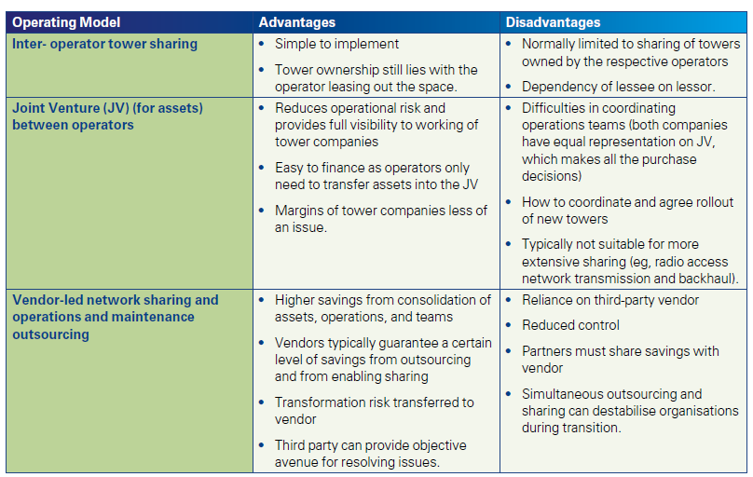

Table 2: A snapshot of the pros and cons of infrastructure sharing business models

**5.2.3 Challenges for tower companies**

As passive infrastructure business has evolved into a separate industry around the world, many tower companies in the telecom industry face several challenges. These include-High capital requirement,Regulatory clearances,Operational cost optimization,Handling of local issues etc.

**5.3 Global Examples of Infrastructure Sharing**

Infrastructure sharing started materializing officially in 2001 with a few deals reaching successful conclusions. With the hype of 3G licensing in Europe and the big investments made in license acquisition, many operators were under pressure to share deployment costs and thus share infrastructure. More recently, infrastructure agreements have started developing at a faster pace both within and outside the European zone. Interesting supplementary examples of infrastructure sharing include the buildup of infrastructure by independent third parties for lease and use by different operators. A relevant case in the mobile domain is the work of a major telecom equipment vendor in Tanzania. The vendor opted for a groundbreaking move and is building infrastructure in rural areas for use by the country’s four mobile operators: Vodacom, Millicom, Zantel, and Celtel.

Table 3 provides the examples of Mobile Infrastruture sharing.

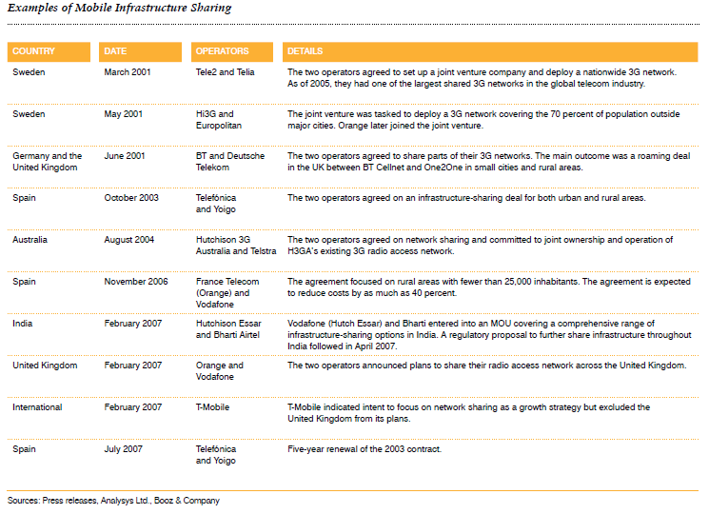

Table 3: Examples of Mobile Infrastruture sharing

National roaming offers another example of a trend that is on the rise, as illustrated by many European examples. This trend is also developing in the Middle East, where legal provisions mandating national roaming have already has been introduced in Egypt, Jordan, Morocco, Oman, Saudi Arabia, Turkey, and the United Arab Emirates.

The following tables table 4-7 provide a comprehensive summary of the international practices in different types of infrastructure sharing.

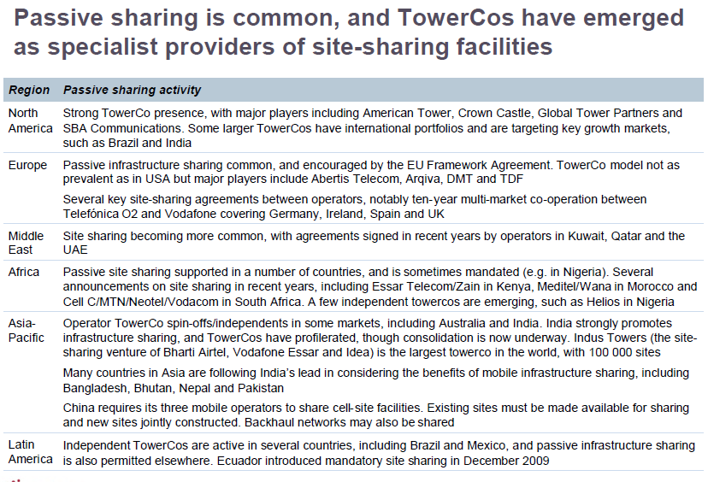

Table 4: Passive sharing activity

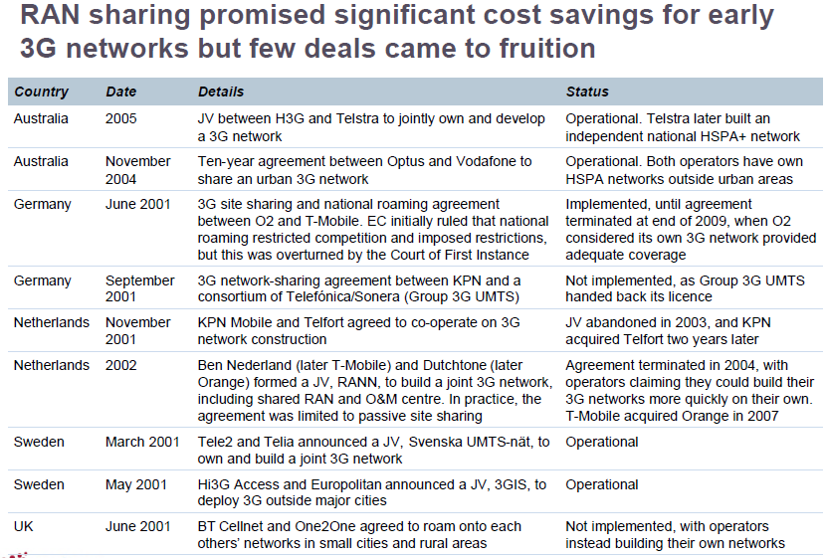

Table 5: RAN sharing activity

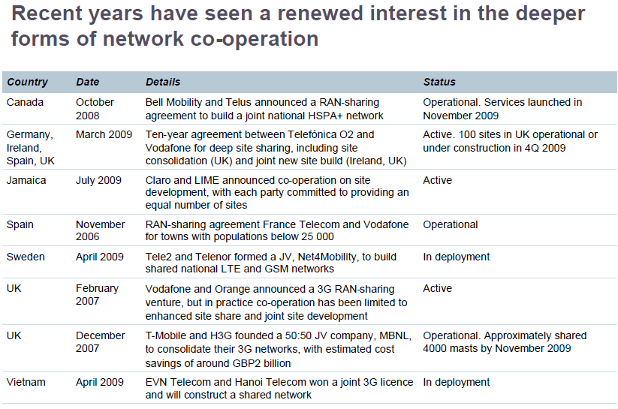Table 6: Network Cooperation Examples

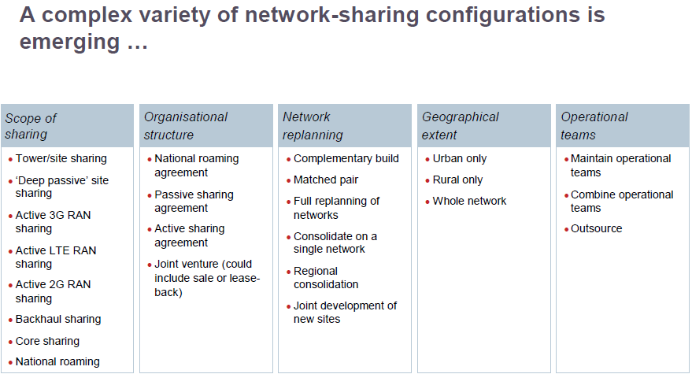

Table 7: Emerging Network sharing configurations

**5.4 CAPEX/OPEX Analysis**

Cost saving is the main driver when considering infrastructure sharing. The following analysis give an idea of what the most important items for CAPEX cost savings are for a Mobile operator, both for developed markets and for emerging ones . The data below is an average observed values. The data is shown in Figures 6 and 7 respectively for Capex in developed markets and Capex in emerging markets.

Figure 6 : CAPEX analysis for infrastructure costs in developed markets



Figure 7: CAPEX analysis for infrastructure costs in emerging markets

From Figures 6 and 7, we can observe that the pertinent CAPEX items for sharing are not similar for developed and emerging markets. This largely influences the sharing models for emerging markets when compared to the models in developed markets. In emerging countries, the 3 most important items which can be shared represent 87 % of the costs are civil and site acquisition and design (41%), power (31%), and BTS/NodeB (15%). Compared to that, in developed markets, the most important cost item is civil and site acquisition costs which amounts to 52% of the cost, where as other costs turn to less important. The power becomes clearly the main cost item in emerging countries. The access to electrical network is difficult and its coverage is weaker compared to developed countries. As a conclusion, infrastructure sharing is the most interesting choice in terms of improving CAPEX costs for new entrant operators in emerging markets. Passive sharing and maintenance will be ideal choice with joint ventures for outsourcing the site maintenance to local collaborators which can considerably reduce the CAPEX costs for new entrant MNOs in emerging markets.



Figure 8: OPEX analysis for network operation costs in emerging and developed markets

Similar to CAPEX analysis, the following Figure 8 gives an idea of what the most important items for OPEX cost savings are for a mobile operator, both for developed and emerging markets. In emerging countries, the 4 most important items which can be the sharing represent 69 % and are hardware and software support (20%), power (20%), land rent (15%) and backhaul (14%). The OPEX is more shared between different OPEX in developing countries, whereas in developed countries the land rent (site) represents 42 % of the OPEX. That explains why the developed countries try to share the site so as to reduce OPEX. From the analysis of CAPEX and OPEX costs, the sharing items where costs saving (CAPEX and OPEX) can be achieved in a network in emerging countries are at the site (Civil and Site Engineering, Renting), power (Electricity, Diesel and Solar), RAN with BTS/eNodeB (Hardware and Software), and backhaul.

Where passive sharing (mainly through site sharing) is largely used particularly in emerging countries, Active sharing is however even more complex to achieve owing to the choice and complexity of the technical solutions (to find an agreement about infrastructure manufacturers technologies, frequencies) and the complexity associated to operating a shared RAN network (to find an agreement about network design, radio optimization, software level, release level, QoS etc.). Careful negotiations with relative simplicity, trust and transparency are important goals to achieve agreements for RAN sharing. As an example, RAN sharing is realized in Spain between the operators, Orange and Vodafone .

**5.5 Emerging countries characteristics**

Some general recommendations for infrastructure sharing in emerging countries are drawn as discussed in the following:

* Rural sharing is strongly recommended (both 2G and 3G),
* Sub-urban sharing could be recommended in some cases,
* Urban sharing is not recommended for 2G, where as 3G sharing could be recommended in some cases,
* Co-locate 3G sites with existing 2G infrastructure sites.
* However, a lot of parameters shall be taken into account. Most of these parameters are depending on the local situation and constraints. Therefore, there is no generic case: practically, each case needs to be considered as a specific situation.

**5.6 Best Practices For National Infrastructure Sharing**

Given the multiple ways in which infrastructure sharing can be undertaken and how varying levels of market maturity and investment imperatives will affect these decisions, it is difficult to give a template “best practice” for implementation. In addition, in some countries, the regulatory functions rest with the policy makers, in which case the principles outlined below can be adapted to the entity responsible for implementation. Some guidance may be offered as a starting point as follows:

* Establish clear, objective and transparent policy goals involving network sharing
* Establish clear guidelines for the conclusion of voluntary sharing agreements, including time limits to conclude agreements and to provide actual access.
* Create efficient dispute settlement mechanisms and judicial review, including specialized dispute settlement bodies.
* Allow and stimulate self regulation.
* Consider network sharing, in particular site sharing and national roaming, in rural and remote areas.
* Make thorough and objective assessment of the competitive situation, including research on consumer preference and consumer choice.
* Consider whether an open access model (such as the entry of MVNOs) or even functional separation would be viable, depending on the actual situation
* Regulators and policy makers should consider providing subsidies related to network sharing in rural and remote areas calculated to cover real costs and distributed in a competitive fashion.

**National policy-makers need to**:

* Decide on the direction of the market and impose enabling laws and regulations that can facilitate the build out of national infrastructure. This could include revising licensing and authorization policies to enable joint ventures and cooperatives and other non downstream market players that offer open access;
* Co-ordinate with other government departments to ensure that where possible, a country’s infrastructure (for non telecoms purposes), is leveraged to facilitate telecommunications network deployment;
* Design policy to speed up increased infrastructure investment.
* Reflect the political will to enable change through clear, directed, proportional regulation that will bring about the desired outcomes;
* Where there is an absence of market players, design incentives that will direct investment into infrastructure in under-served and non-served areas through for example, tax exemptions or rebates;
* Consider policy that will separate retail and wholesale functions within national infrastructure providers;
* Act as a clearinghouse for rights of way approval.

**Local Government bodies need to:**

* Where responsible for rights of way, assist operators with facilitating rights of ways and access to ducts and poles;
* Set up a clearing point for rights of way if multiple agencies are responsible for rights of way at different parts of the network;
* Provide information such as site surveys and geographic information systems for public land;
* Speed up the processes for granting rights of way;
* Reduce the costs to operators for obtaining rights of way;

**Regulators need to:**

* Where access regimes do not currently allow for sharing, embark upon consultation processes to assess the market and where intervention would be most appropriate, directed and proportional;
* Implement licensing/authorization frameworks to allow open access providers and create incentives for those who have spare capacity on their networks to share that capacity;
* Design regulatory interventions that are based on the technical reality of access at multiple levels of the network;
* Create incentives to promote infrastructure sharing on commercial terms;
* Improve transparency requirements for operators to publish relevant information for infrastructure sharing;
* Decide whether to approve or require publication of reference sharing offers covering issues such as provision of collocation space and connection services, power supply, air conditioning, access to collocation facilities for maintenance, etc.;
* Establish where bottleneck facilities are and whether it is economically, technically or environmentally possible to duplicate such facilities;
* Where necessary, establish the cost methodology (cost plus a fair rate of return) upon which access is going to be mandated;
* Where the regulator is not responsible for rights of way, establish who is responsible and assist operators coordinate the complexities associated with dealing with multiple agencies; Establish sound monitoring and enforcement for implementing infrastructure sharing, including speedy dispute resolution among operators;
* Require the publication of reference interconnection offers (RIO’s) or similar instruments by operators with significant market power that specify the terms of access; sub-licensing if necessary; charges, billing, dispute resolution, etc.;
* Use competitive bidding processes or auctions when authorizing municipal or backhaul providers;
* Coordinate the trenching and ducting works between operators and service providers. And provide mechanisms for monitoring duct upgrading to ensure that service providers remove obsolete cabling to allow the introduction of third-party fibre;.
* Publish a list and identify critical infrastructure sites (with or without any further policy intervention, as the case may be);
* Establish a Dispute Resolution mechanism for addressing disputes that might arise.

**Industry players need to:**

* Assess the business case for sharing, rather than duplicating infrastructure;
* Move away from the assumption that excluding access to network elements is the only way to secure revenue;
* Co-operate with regulatory/policy processes;
* Improve transparency and publish on their websites the details of existing as well as future infrastructure installations available for sharing by other service providers;
* Implement regulatory coordination of trenching and ducting works between operators and service providers and those of other utilities.

**CHAPTER 6**

**SUSTAINABLE BROADBAND NETWORK DEVELOPMENT IN SATRC COUNTRIES**

**6.1 Broadband policy, plan or strategy**

Afghanistan in the year 2008 formulated Afghanistan National Development Strategy-(2008 – 2013). Bangladesh in 2009 brought Broadband National Policy Act 2009. Bhutan brought National Broadband Master Plan Implementation Project (NBMIP) in 2008. India had formulated Broadband Policy in 2004 and has developed National Optical Fibre Network plan in 2011. India now has constituted a Special Purpose Vehicle for implementation the National Optical Network Plan. Iran formulated TAKFA Plan in 2002. Maldives and Nepal do not have such specific plans and policies related to broadband. Pakistan formulated its National Broadband policy in 2004 and developed National Broadband Programme in 2007.Sri Lanka in 2012 formulated e- Sri Lanka, 2012 - HSBB National Broadband Plan.

**6.2 Universal Broadband access programs**

Bhutan has established Community Information Centre ( telecentres).India has used Universal Service Obligation Fund (USOF) Scheme for providing Broadband Connectivity in Rural Areas through the Wire Line Broadband Scheme as well as the Rural Public Service Terminal. Government of India in September 2006 approved a scheme for setting up of 104881 internet enabled Common Service Centers (CSCs) in rural areas under the National e-Governance plan (NeGP) in a Public Private Partnership (PPP) mode. As on 31st October 2012, a total of 96,411 CSCs are operational in thirty three States/Union Territories (UTs). Iran has created aTelecommunication Infrastructure company which is government owned company and all of the duties related to the installation of broadband system for end user is under its job. Nepal has mandadted the government owned incumbent operator to provide rural broadbane access thrugh the use of WiMax technology and has also established several telecentres in different parts of the countr thorough different agencies.

**6.3 Broadband Targets**

India through its National Telecom Policy-2012 announced by the Government mentions the following targets for broadband:

* + Provide affordable and reliable broadband-on-demand by the year 2020 at minimum 2 Mbps download speed and making available higher speeds of at least 100 Mbps on demand.
  + Provide high speed and high quality broadband access to all villages and habitations by 2020.

Iran also has development of broadband forecast in its Fifth Development Law applicable till 2015.

Nepa is in the process of formulating a national broadband policy and national broadband plan.

Bangladesh has formulated a forward looking “Digital Bangladesh 2021” vision. It sets direction for broadband as well.

**6.4 Wire-line Access technologies utilized to provide broadband services**

The data related to wire- line technologies in 5 countries under study (Bhutan, India, Iran, Sri lanka and Nepal) is summarized below. Other countries did not provide data.

|  |  |  |  |  |  |  |
| --- | --- | --- | --- | --- | --- | --- |
| Country | ISDN | xDSL | Cable | E1/T1 | Fiber | Power Line |
| Afghanistan |  |  |  |  |  |  |
| Bangladesh |  | × | × | × | × |  |
| Bhutan |  | × |  | × | × | × |
| India |  | × | × | × | × |  |
| Iran |  | × | × |  | × |  |
| Maldives |  |  |  |  |  |  |
| Nepal | × | × | × | × | × |  |
| Pakistan |  |  |  |  |  |  |
| Sri Lanka |  | × |  |  | × |  |

**6.5 Wireless Access technologies utilized to provide broadband services**

The data related to wireless technologies in 5 countries under study (Bhutan, India, Iran, Sri lanka and Nepal) is summarized below. Other countries did not provide data.

|  |  |  |  |  |  |  |
| --- | --- | --- | --- | --- | --- | --- |
| Country | Satellite and if so what time of system | Terrestrial IMT-2000 standards based solutions and if so which variant/s | IEEE 802.16-2004 standard based Fixed and Nomadic Broadband Wireless Access (BWA) | IEEE802.11 Wireless Local Area Network based systems | Proprietary BWA systems | other |
| Afghanestan |  |  |  |  |  |  |
| Bangladesh |  |  | × | × |  |  |
| Butan |  | × |  | × |  |  |
| India | × |  | × | × |  |  |
| Iran |  | × | × |  |  |  |
| Maldive |  |  |  |  |  |  |
| Nepal | × |  | × | × | × |  |
| Pakistan |  |  |  |  |  |  |
| Serilanka |  | × | × | × |  |  |

**6.6 Competition**

The data related to Broadband competition in 6 countries under study Bangladesh, Bhutan, India, Iran, Sri lanka and Nepal ( other three countries in SATRC did not provide data) are shown in table below. The comparision is based on four aspects namely-

* Internet access services
* Local loop
* Among differing broadband technologies in the same geographical area
* Different gender to broadband access

|  |  |  |  |  |
| --- | --- | --- | --- | --- |
| Country | Is competition permitted in the provision of Internet Access services | Is there competition in the local loop (local loop unbundling)? | Is there competition among differing broadband technologies in the same geographic area? (ex. xDSL, cable, broadband wireless, etc...) | Are there any gender barriers to broadband access (i.e. political, economic, social, etc.)? |
| Afghanestan |  |  |  |  |
| Bangladesh | Yes | Yes | Yes | No |
| Butan | Yes | No | Yes | No |
| India | Yes | No | Yes | No |
| Iran | Yes | Yes | Yes | No |
| Maldive |  |  |  |  |
| Nepal | Yes | No | Yes | Yes |
| Pakistan |  |  |  |  |
| Serilanka | Yes | No | Yes | No |

**6.7 Pricing and usage:**

The price of communications services of SATRC countries are compared. It helps us to calculate the lowest possible monthly price at which a consumer could meet the usage requirements of pre-defined baskets of services.

**Price**

|  |  |
| --- | --- |
| **Country** | **Average price for internet dial up (USD)** |
| Afghanistan |  |
| Bangladesh | 0.025 USD per Mb |
| Bhutan | No dial up services |
| India | 0.02 USD per minute including internet access and PSTN access charges |
| Iran | 0.002 USD per minute |
| Maldive |  |
| Nepal | 0.04 USD per minute including internet access and PSTN access charges |

|  |  |  |
| --- | --- | --- |
| **Country** | **Average monthly price for broadband services (USD) between 64-512 Kbit/s** | **Average monthly price for broadband services (USD) in excess of 512 Kbit/s** |
| Afghanistan |  |  |
| Bangladesh | 7-8 $ | 8-15 $ |
| Bhutan | 7.25 $ | 27.25 |
| India | 10 | From 12 USD to 200 USD depending on speed and data usage |
| Iran | 3 | 10 |
| Maldive |  |  |
| Nepal | 17.5 | 23.25 |
| Pakistan |  |  |
| Sri Lanka |  | 3.07 for fixed  1.96 for moblle |

**Usage**

|  |  |
| --- | --- |
| **Country** | **Most common usage/pricing plan for broadband** |
| Afghanistan |  |
| Bangladesh | Pay per use is the most Common usage broadband plan. 0.025 $ / Mb |
| Bhutan | Prepaid broadband for home with the price 7.25 $ |
| India | No data available |
| Iran | The plan is cost based and priced cap. It is prepaid and post paid and nearly 3 $ per month |
| Maldive |  |
| Nepal | No |
| Pakistan |  |
| Sri Lanka | Entry Level broad band package |

**6.8 Financial assistance for operators to provide broadband:**

|  |  |
| --- | --- |
| **Country** | **Affordable loans/other financial assistance** |
| Afghanistan |  |
| Bangladesh | No |
| Bhutan | No such specific loans  Telecom operators take loan from financial institute for the over-all network deployment including broadband. |
| India | loans for their business activities from any government/ private/ other financial organization. |
| Iran | Yes, government loans |
| Maldive |  |
| Nepal | No |
| Pakistan |  |
| Sri Lanka |  |

**6.9 Infrastructure sharing**

India, Pakistan, Bangladesh and Sri Lanka all have already embarked up on mobile infrastructure sharing.

Indian Cellular, basic service and unified access services licences had passive infrastructure sharing and when India started Consultation with the objective of taking appropriate regulatory steps to promote Passive infrastructure sharing in 2007, it was found that 25 % of base station sites were already being shared. India decided to include active infrastructure sharing and backhaul sharing in2007.

Bangladesh formulated guidelines of passive infrastructure sharing in 2008 but actual sharing seem to have commenced from 2010.

Pakistan started consultation in August 2007 with draft guidelines and certain principle on which both passive and active infrastructure sharing including back haul infrastructure sharing could be started. The news item date 2010 indicates that MOU was signed between PTA and all the 5 cellular operators to increase the site tenancy level to 1.5 in 3 years from 1.02 in 1010. Pakistan has proposed active elements (Radio Access Network which including Base station equipment and Backhaul similar to Indian case) for sharing in their Consultation document

Sri Lanka also brought guidelines out in 2010 on design standards of tower structures, safe emission levels and allowing new tower structures in well defined antenna tower structure farms only with capability of sharing,. It gives the impression that these antenna structures are to be shared and to be built by TISP (Telecom Infrastructure Service Provider). TRCSL said that prices to pay for use of these structures will be fixed by discussion between TRCSL and TISP. No sharing of spectrum and core network facilities is permitted as of yet.Most of countries seem to leave infrastructure sharing to operators and considered that mandating would raise issues and will be seen as highly interventionist in nature. Therefore, incentivisation of infrastructure sharing has been considered more effective and useful.

**CHAPTER 7**

**POLICY AND REGULATORY FRAMEWORK FOR THE DEVELOPMENT OF SUSTAINABLE BROADBAND NETWORK**

As the world moves to a converged information and communication technology (ICT) environment, countries are revisiting their traditional legal and regulatory frameworks and crafting new laws and regulations to address some of the supply and demand issues associated with developing broadband networks and services.

On the supply side, certain key legal and regulatory issues are being considered,such as determining how legal and regulatory licensing frameworks may facilitate voice, video, and data off erings. Other issues are related to spectrum management reforms, Internet interconnection, and infrastructure access policies. On the demand side, legal and regulatory issues are also arising. As more of our social, political, and economic transactions occur

online, it becomes critical to ensure user trust and confi dence. Policy makers are therefore considering measures to ensure users’ privacy and rights online.At this time, the legal and regulatory responses to address many of these issues are still being debated around the world. As broadband expands and its full potential is realized, a clearer picture may emerge. This chapter discusses the key policies and regulatory approaches that are being considered

and implemented by policy makers and regulatory authorities to address some of these issues.

**7.1 Licensing and Authorization Frameworks**

Technological convergence in the telecommunications and broadcasting markets is hastened by the growth of broadband networks, since the higher speeds and larger capacities of broadband create new opportunities for operators to off er an array of services, including voice, data, and video. For example, two of the largest broadband network operators in the world, Comcast and Time Warner, began as cable television (TV) operators, but now derive substantial revenues from Internet and voice services, as well as from pay TV, particularly through their “triple-play” packages..Broadband also supports the expansion of markets and competition as well as helping to reduce prices, improve the effi ciency of service provision, and increase the variety of off erings for subscribers. To facilitate the supply of emerging wireline and mobile broadband networks, an enabling licensing framework is necessary.Convergence and the distributed nature of networks and communications have unleashed a disruptive force across traditionally segregated industries that demands new, fl exible, enabling responses.Traditional, service-specific regulatory frameworks have typically required separate licenses for wireline, wireless, and broadcasting networks as well as for diff erent types of services. In many instances, operators have beenprohibited from offering services outside their traditional, rigidly defined industry—even though new digital broadband technologies make this easily possible. For example, Internet Protocol television (IPTV) was restricted in the Republic of Korea until the IPTV Business Act of 2008 permitted telecommunications operators to offer television programs in real time over their broadband networks.

As this and similar cases demonstrate, distinctions between types of network infrastructure are becoming increasingly impractical in a converged environment. Thus policy makers and regulators in both the developed and developing worlds are enacting reforms to transform legacy regulatory regimes so that they can effectively address converged networks and services.

These efforts generally have two key elements: (a) the introduction of the principles of technology and service neutrality and (b) the establishment of greater flexibility in key aspects of licensing and authorization frameworks, particularly the authorization of a wide range of networks and services under a single license. At the same time, there is expected to be greater reliance on broad competition law and regulation, as the historic restrictions contained in licenses and authorizations are progressively reduced.

**7.2 Technology and Service Neutrality**

Technology neutrality is based on the premise that service providers and network operators should be allowed to use the technology that best meets the needs of their network and the demands of their customers; such choices should not be dictated by governments. In the licensing context, technology neutrality means that diff erent technologies capable of providing similar or substitute services should be licensed and regulated in a similar way.3 In the broadband context, this means that broadband service providers abide by similar licensing processes and conditions regardless of whether they deliver services via wireless, digital subscriber line (DSL), fi ber, cable modem, or other technology. However, a licensing framework that is generally considered technology neutral does not have to treat all providers in exactly the same way; it may treat certain broadband technologies or services diff erently. For example, the promotion of nascent services (for example,voice over Internet Protocol, or VoIP) using a light-handed regulatory approach may warrant departure from technology neutrality, at least on a temporary basis, to promote the development of those technologies. This also may be the case for wireless vs. wireline broadband technologies due to the need for separate spectrum authorizations and other spectrum-related matters, such as capacity constraints and interference.

Service neutrality is based on the similar premise that network operators should be allowed to provide whatever services their technology and infrastructure can deliver. In the past, due to the limitations of technology, networks were “purpose built.” As information and communications became increasingly digitized, however, it became possible for diff erent networks to support similar or substitute services. Thus, both cable and telecommunications networks can now support a wide range of voice, data, and video services.More relevant for developing countries, mobile service providers are increasingly able to off er such services as well. Given this convergence, constraining network operators’ services based on old conceptions of technology is no longer appropriate. Adoption of more liberal licensing regimes allows companies to provide a wide range of services under a single license or authorization, which thereby enables the operator to take “cues from the market as to which services are most in demand or most cost-eff ective”..For example, Botswana, Ghana, Kenya, South Africa, Tanzania, and Uganda have already implemented technology- and service-neutral licensing frameworks. In Tanzania, the Electronic and Postal Communications Act, 2010, specifically incorporates both principles into the converged licensing framework, providing that “a licensee is authorized to provide any electronic communication service” (that is, service neutrality) and allowing the licensee to “use any technology for the provision of electronic communication services” (that is, technology neutrality). Together, technology and service neutrality recognize and facilitate technological convergence and promote new and innovative services and applications by reducing the number of licenses that an operator must obtain and expanding the variety and breadth of services an operator may provide.Neutrality may also contribute to reducing unnecessary or even contradictory regulatory obligations, such as different reporting standards and requirements provided under service-specific regimes. However, a country’s licensing regime often requires substantial reforms from traditional service-specific licensing to a more unified licensing framework capable of accommodating technology and service neutrality.

**7.3 New Authorization Options and Their Implications for Broadband**

In light of the regulatory implications that flow from convergence and the transition to a next-generation network (NGN) environment, regulators have begun to adopt more unified frameworks based generally on one of the following approaches: (a) unified or general authorization or (b) multiservice authorization Establishing some form of converged licensing framework that includes technology and service neutrality can be a key step for developing countries to foster the supply of broadband,increase investment, and improve the uptake of broadband.

***Unified or General Authorizations***

In principle, these authorizations are technology and service neutral, allowing licensees to provide all forms of services under the umbrella of a single authorization and permitting them to use any type of communications infrastructure and technology capable of delivering the desired service.

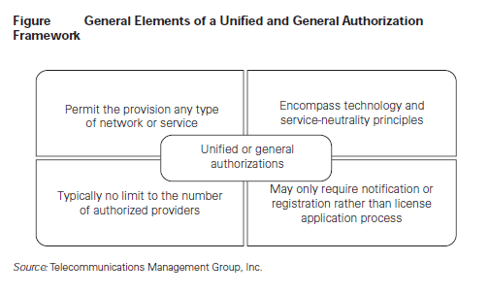

Figure 9: General Elements of a Unified and General Authorization Framework

This is the most flexible approach, and it typically permits any number of operators to be authorized, except where scarce resources, such as spectrum, are involved. In addition, this type of framework may only require registration or notification in order for the operator to begin offering services. The general authorization regime established by the European Union (EU) Authorization Directive in 2002, as amended in 2009, characterizes this type of framework .Under that regime,a provider may off er any type of electronic communications network or service with a simple notifi cation to the relevant national regulator. No license application or approval process is generally required.

***Multiservice Authorizations***

A multiservice licensing framework allows operators to offer a wide range of services under a single authorization and may also permit certain categories of licensees to use any type of communications infrastructure and technology capable of delivering the licensed services. However, the multiservice authorization framework is generally not as flexible or as streamlined as a general authorization approach: (a) there are multiple license categories rather than a single license category; (b) the various license categories may limit the number and types of services that may be provided; (c) licensees may be required to hold multiple licenses; and (d) rules may bar licensees from holding more than one type of license, which may stifle convergence if,for example, a telecommunications licensee is not permitted to hold a broadcasting license and therefore cannot offer video services.

Singapore has adopted a simplified variation of the multiservice licensing framework, which is based on two main types of licenses: facilitiesbased operator (FBO) and services-based operator (SBO) ;

.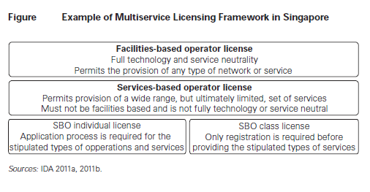

Figure 10: Examples of Multiservice Licensing Framework in Singapore

**7.4 Spectrum Management to Foster Broadband**

In the past, as new technologies and services developed, legal and regulatory frameworks often evolved in a piecemeal fashion, with regulators often charging diff erent fees, using diff erent assignment mechanisms, and imposing diff erent conditions on the various types of spectrum authorizations or licenses. However, these practices do not facilitate converged service off erings or maximize the value and use of spectrum, since new technologies enable multiple services and applications to be provided over one network,allow multiple services to be provided using the same spectrum, and enable the spectrum to be used more effi ciently and intensively.As a result, policy makers and regulators are looking to replace narrowly defined technical and service rules with more flexible assignments that allow providers to match their network and service. In today’s broadband environment, access to spectrum is particularly relevant, given the anticipated likelihood that for many countries, particularly developing ones,wireless will be the primary vehicle for deploying broadband networks. For example, in Morocco, third-generation (3G) mobile broadband connections surpassed asymmetric DSL (ADSL) wireline connections in September 2009 and represented over 76 percent of the total Internet connections in the country as of March 2011 (Morocco, ANRT 2011). As a result of this trend, regulatory authorities and policy makers in many countries are looking at legal and regulatory reforms as necessary to facilitate the supply of wireless broadband services and the build-out of networks. Such policies include spectrum allocation and licensing, license terms and conditions (for example, coverage obligations), license renewals, and procedures to reclaim and reuse spectrum (for example, the transition from analog to digital television).

**7.5 Spectrum Refarming and the Digital Dividend**

In order to maximize the ability to off er wireless broadband, particularly where spectrum is intensively used, many countries are engaging in spectrum refarming, whereby existing spectrum users are moved out of a band to allow for new broadband uses. The refarming process is often lengthy and costly, since it typically involves negotiations with existing private and public spectrum holders and potential licensees and may also include compensation for the existing licensees to change spectrum bands. As such, it is important to conduct a thorough spectrum inventory to identify unused or underutilized spectrum as well as heavily used bands before implementing a refarming process. In many developing countries, refarming may be less necessary in the near future since available spectrum may be suffi cient and more easily allocated for wireless broadband services. One of the most promising and active areas of spectrum refarming is the result of the transition from analog to digital television. As countries around the world prepare for or complete the transition to digital terrestrial television (DTT), they are examining procedures for reallocating the spectrum that becomes available as broadcasters vacate the 700 MHz or 800 MHz bands, depending on the region. This freed-up spectrum, which is widely known as the “digital dividend,” off ers excellent propagation characteristics for mobile broadband services by providing an ideal balance between transmission capacity and distance coverage. This means that the digital dividend spectrum is well suited to providing mobile services to rural areas as well as to providing eff ective in-building performance in urban areas. For countries where rural coverage is an important policy goal, this is a notable advantage. However, given the various timelines for the DTT transition—some countries have completed the transition, while others are planning for the analog switch-off (ASO) between 2011 and 2020)—many countries are only beginning to consider rules and timeframes for refarming digital dividend spectrum. Many countries are waiting to award digital dividend spectrum until after the ASO is completed and the spectrum is no longer encumbered by broadcasters. However, some countries, such as the United States,Colombia, and Peru, have awarded or are planning to award the digital dividend ahead of their ASO dates. Regardless of the approach, considerable international and regional harmonization is under way, including by the EU and the Asia-Pacifi c Telecommunity.

**7.6 Government and Regulatory intervention**

A comprehensive summary of the selected investment plans for ICT infrastructure and national stimulus plans is presented in the table below for easy reference.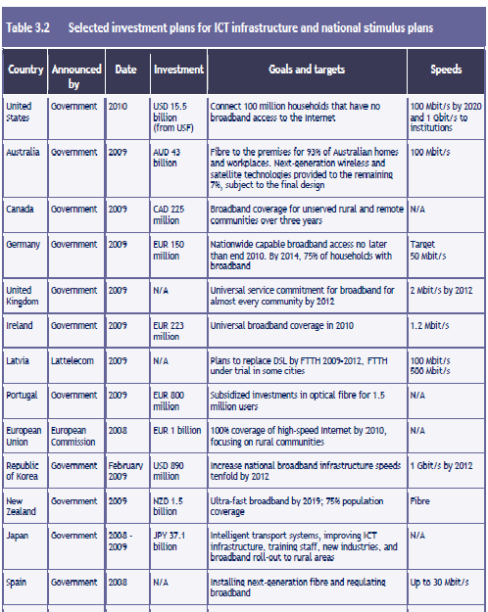

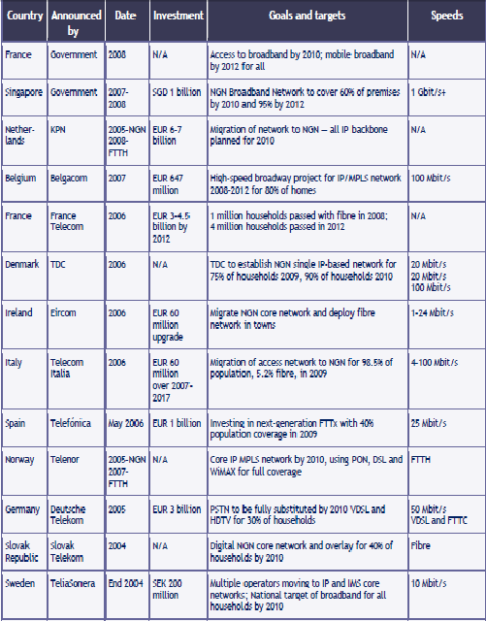

Table 8: Selected ICT Investment Plan for ICT infrastructure and stimulus plan

*Sources*: Christine Zhen-Wei Qiang (2009), OECD (2009), Dr Vaiva Lazauskaite (2009), Booz & Company (2009).

*Note*: The data were compiled for the ITU report “Confronting the Crisis: ICT Stimulus Plans for Economic Growth"(2009)

The table 8 above indicates that a definite and timely intervention from the government and regulators are needed to develop broadband networks.

**CHAPER 8**

**CHALLENGES AND THE WAY FORWARD**

**8.1 Observations**

Sustainable societies, in which all citizens have a voice, must provide the means for everyone’s voices to be heard—and increasingly, those means are digital. As such, broadband is no longer a telecommunications sector issue that industry leaders should solve. Its relevance has transcended the industry and its impact reaches deeply into socioeconomic issues. Broadband thus mandates attention from policymakers and regulators as well as from the telecommunications industry. This is not an easy task for any of them. Ensuring broadband access requires radical shifts in thinking, shedding decades-old business models, changes in regulatory policy, and bold moves by government to spur development. The issues involved span from developing infrastructure to interconnection, infrastructure sharing to adopting to new business models that reduces the cost and maximizes the revenues.

For all stakeholders, time is of the essence—and not only because consumers want faster service. The quicker a country can provide comprehensive access to broadband, the quicker that country can reap a variety of economic benefits. It is important that govern¬ments and the private sector realize that access for all is paramount. Broadband is so vital that those nations that do not offer high-speed access to their populations will have a serious disadvantage in the global economy. This is true for all economies—developed as well as emerging nations. For developed nations, broadband is critical to accelerating economic recovery, creating business opportunities, and reinforcing competitiveness. For emerging economies, broadband does all that and more, accelerating inclusion in the global economy by democratizing business, culture, health, and education.

Government and industry leaders will need to demonstrate their foresight in this regard to maintain their competitiveness with global peers. Doing so will require them to fundamentally change the way they think about broadband access.

Extensive study has been carried out that relates to the business viability or the sustainability of the broadband networks and infrastructure development in global as well as regional perspectives. It has been realized that a specific government and regulator interventions and initiatves are required to ensure sustainability of such networks. The focus has also to be given to bridge the digital divide that manifests in multiple dimentions such as rural-urban, rich-poort, able and disable, age etc. This necessitiates new business models that ensures sustainability of operations and adoption of broadband services.

Along with the massive infrstarture development for international bandwidth thorugh under-sea cable construction by private companies, the national and regional networks need to be constructed utilizing both the appropriate wired and wireless technologies taking into consideration the emergence of all IP network and services. All forms of traffic media such as voice, data and video will be carried by IP networks in the future. So preparation for the development of NGA networks is imperative.

Interconnection will always be an issue to be discussed in the era of broadband networks. Particularly the co-existence of legacy TDM network along with IP based packet networks will pose some difficulty from legal, regulatory as well as business perspectives. The telcos should understand and adopt the future of IP based network and be ready to embrace the disruptive nature of IP technologies and make revenue out of such opportunities.

For a number of reasons greatly explained in the corresponding chapter-infrastructure sharing in its various forms need to be encouraged and implemented. Governments and regulators can play a role to promote such mechanisms. A sustainable industry structure in many areas of our coutries is unlikely to include competitive infrastructure providers. A sustainable structure for many areas is unlikely to include more than one service installation and maintenance organization as well. A sustainable structure for many areas is certain to involve extensive use of wireless technology.

For a number of reasons, regional infrastructure has to be developed to minimize the use of International Internet bandwidth therby reducing the cost as well. Internet Exchange Points ( IXPs) is an innovative structure to support such a move. Eventhough Regulators set a requirement for any-to-any connectivity (A2A) to protect voice telephony users in a network system. But the Internet has shown us that: a voluntary system of peering and transit can work equally well and over time the model can mutate to the benefit of all – e.g. regional peering and IXPs. The Internet has shown us another model – dynamic markets find their own equilibrium over time, without regulatory intervention. There is increasing evidence that interconnection of broadband networks can do the same (e.g. recent agreement between Google and Orange).

**8.2 Challenges**

Despite the widespread recognition of broadband’s benefits, most of world’s households today lack access to an adequate broadband connection. Legacy policies, regulations, and business models are limiting the ability of the public and private sectors to make the timely and adequate investment in necessary infrastructure to ensure universal access.

Because there is such a long way to go to make broadband a universally available asset, all stakeholders will need to collaborate and solve crucial issues. Three inhibitors are preventing governments and the private sector from collaborating to ensure adequate investments in national broadband infrastructure: the sheer magnitude of these investments, revenue prospects, and regulatory uncertainty.

Investments in national broadband infrastructure are significant, front-loaded, and irreversible . As a result, investors are cautious, tempted to hold back on investments until they have sufficient clarity about their ability to make an adequate return on their investments. Uncertainty surrounding future broadband revenue streams and regulatory obligations are making it difficult for operators to gauge the level of investment risk.

The emergence of powerful application and service providers is another critical factor driving uncertainties around future broadband revenue streams for investors. These providers compete with operators for telecommunications service revenues and stand to profit from broadband—yet they do not have to build the network. This growing competition between operators and application providers marks a fundamental disruption to the sector’s prevalent revenue model, in which operators typically capture the bulk of the revenues generated by the access connection.

Finally, regulators have not established a clear framework targeted at broadband networks. The infrastructure-sharing models mandated by legacy networks may not be replicable for next-generation broadband. Regulatory authorities have developed a number of tools based on existing technical architecture: these tools include interconnect pricing controls based on per-minute rates and infrastructure sharing mandates such as local loop unbundling derived from legacy copper based network architectures. Furthermore, as the distinction between traditional service providers (i.e., operators) and application providers (such as Skype and Google) blurs, regulators need to develop new tools to regulate application providers, which neither are licensed nor have specific service obligations imposed on them in terms of access and quality. Until regulators define a new regulatory regime, operators will lack confidence in their ability to monetize their investments in national broadband infrastructure, further dampening interest.

**8.3 The Way Forward**

In order to break the gridlock that has stalled investment and ensure the future viability of the sector, governments/regulators and operators need to consider a new paradigm characterized by three attributes.

1. **Broadband: A National Imperative**

Broadband must be recognized as a national imperative, not simply a telecommunications industry mandate. To date, most governments have considered broadband an important telecommunications service with revenue potential for the information and communications technology (ICT) sector, and have regulated the business from that perspective. However, given the economic and social benefits that broadband offers, it must be considered a national imperative—and driven accordingly. Governments must elevate broadband from merely another regulatory concern to a top issue on the national strategic agenda. This outlook on broadband will prompt policy makers to take a long-term view and develop consensus among all stakeholders, removing myopic short-term revenue and profitability pressures.

Some countries have already taken giant strides in recognizing broadband as an essential service. France’s highest court declared in June 2009 that broadband is a human right, cementing its role as a national strategic issue. Finland did the same in October 2009 by making broadband a legal right.

1. **A Proactive Public Sector**

The public sector needs to be proactive in securing universal broadband. Because national broadband networks have significant socioeconomic benefits, governments have a vested interest in their creation. Rolling out infrastructure at the national level, however, may not be the best fit for operators’ strategies. Therefore, governments need to play an active role in the sector’s development, despite the fact that this represents a significant shift away from the long-standing trend toward government disengagement and privatization.

Just as public–private partnerships (PPPs) have become the norm in the development of vital energy and transportation infrastructure, effective PPPs are needed as a model for the telecommunications sector in developing national broadband networks. Governments have several options to consider in establishing successful PPPs: subsidizing infrastructure, providing tax concessions to private operators, or triggering demand for broadband services. The ideal PPP model for any country hinges on the dynamics of the broadband ecosystem in that country.

1. **The Legacy Mind-Set Challenge**

To adapt to this new paradigm and spur the creation of national broadband networks, all stakeholders need to adapt their current thinking and accommodate essential changes in policy, regulations, and business models.

**Shifting the Government Mind-set**

For decades, the global trend has been to minimize the role of government in the telecommunications sector. Governments typically have migrated from owning incumbent networks to investing passively in them and finally to simply regulating them. As telecommunications regulators, governments have primarily focused on competition, which has been introduced as a mechanism to ensure market efficiency. Effective competition has indeed been a crucial enabler of rapid telecommunications growth in the past decade. However, to address the three inhibitors to investment in national broadband, governments need to rethink their role and consider taking the bold steps necessary to facilitate investments and ensure the sector’s long-term sustainability. Governments have played a major role in the development of vital infrastructure sectors—roads, bridges, and power plants. Policymakers now need to explore mechanisms to foster the development of national digital highways.

Governments created most telecommunications regulatory authorities based on the principle that the consumer had to be protected from the monopolistic activities of incumbent operators. For the past two decades, most regulatory authorities have pursued the singular strategy of preserving customer welfare by introducing competition in the various telecommunications markets—including mobile, fixed, Internet, broadband, and international. In cases where it was apparent that operators were too dominant to allow effective competition, policymakers established a range of regulatory measures to ensure competition efficacy and consumer welfare. These encompass breaking up incumbents (such as AT&T in the United States), ordering functional separation (BT in the United Kingdom), and mandating shared infrastructure (local loop unbundling across Europe).

A single-minded regulatory focus on introducing competition will not suffice to generate the magnitude of investment necessary to create national broadband networks. Instead, governments must seek a more balanced approach to regulation that ensures consumer welfare while simultaneously guarding the sector’s efficiency and long-term sustainability.

**Shifting the Operator Mind-set**

For operators, broadband revenues based on access charges have undergone a rapid decline . Relying solely on these revenues will neither support the magnitude of investments needed in national broadband infrastructure nor provide operators with sustainable growth opportunities in the future. Operators need to diversify their revenue streams by seeking scale in their provision of access services and capturing a larger share of application and content providers’ revenues.

Additionally, traditional vertically integrated models, which emphasize infrastructure expansion and management, impair operators’ ability to compete in the new market structure by promoting a focus on these areas to the exclusion of others. Success in changing markets requires operators to alter their business and operating models from vertical integration to horizontal plays. Operators need to focus on building scale and cost efficiency in the utility-like infrastructure layer and offering reliability and affordability in the service layer, while competing on innovation and speed in the application layer.

Finally, operators need to be proactive in both adopting the new horizontal approach and engaging the government on suitable implementation approaches. Traditionally, operators have viewed regulatory initiatives with suspicion, because in the past regulatory moves have in some cases depressed incumbents’ returns. Operators need to engage regulators to accelerate national broadband infrastructure deployment because this not only increases the potential market for operators but also provides the basis for sector sustainability.

**Imperatives for the Public Sector**

In order to broaden access to broadband service, governments need to consider adopting three immediate imperatives: establish a national broadband policy, create a regulatory environment that supports operators’ horizontal business models, and facilitate investments in the sector.

**Establish a National Broadband Policy**

As a necessary first step to enabling universal broadband access, governments need to establish a consistent, coherent, and shared national broadband vision, embedded in a national broadband policy. This policy not only must put forth a national aim for the speed and coverage of the broadband infrastructure, but also provide guidance on how regulators, operators, and application and content providers will work together in achieving that aim.

Several countries have already defined or are in the process of establishing a national broadband policy, with their different goals highlighting the varying levels of aspiration and government involvement. Establishing a national broadband policy should involve an open dialogue with industry participants. This must include an objective assessment of the demand for broadband infrastructure: how widespread and immediate is the demand? Once established, a common policy will serve as an important tool to continue the dialogue with industry stakeholders and ensure that everyone remains aligned on goals. Governments intent on building national broadband infrastructures need to undertake this dialogue immediately.

**Create a Regulatory Environment That Supports Horizontal Business Models**

Existing regulatory frameworks emphasize competition via a series of mandates for vertically integrated incumbents. As the industry moves away from vertically integrated models to horizontal ones, regulatory tools need to be adapted and new ones developed to ensure consumer welfare and effective competition.

Regulators need to encourage the move toward horizontal business models by adapting existing regulatory regimes, especially at the infrastructure and service layers. Incumbent operators should be incentivized to open their network infra-structure, to put their knowledge and existing assets to the best use, and to keep the cost of national broadband infrastructure under control. At the same time, regulators could impose stringent sharing and ownership restrictions on infrastructure players, ensuring fair and equal access to all providers upstream. Regulators must also assess the need to grant exclusivities in the infrastructure layer, as competition at that level affects the ability of these entities to generate an adequate return on their investment.

**Facilitate Investments in the Sector**

Some governments recently have reversed past privatization efforts and have invested in the telecommunications sector, recognizing the significant benefits and national competitive advantages derived from broadband. These investments have ranged from direct investment in broadband companies, as in Australia, and grants to private-sector players as in Singapore, to end-user subsidies, as in South Korea and Japan.

Governments, in concert with the private sector, need to evaluate their role and the magnitude of investment required in the sector, while identifying the right investment mechanism.

Governments should also help stimulate demand for broadband services. The Korean government, for example, has done so by establishing education centers to train housewives to use the Internet. Egypt has launched a successful IT club initiative that provides fully equipped computer labs and broadband access at schools, clubs, youth centers, and universities. Governments can also stimulate demand by ensuring that all public-service provisioning be handled over broadband networks.

**The Role Of The Private Sector**

In anticipation of policy and regulatory changes, private-sector operators need to take three proactive, immediate steps to better position themselves. Operators must open their infrastructure business, start building capabilities for double-sided business models, and capture further returns by sharpening their focus on application innovation.

**Adopt Open Infrastructure Plays**

Operators have in the past resisted attempts by regulators to separate the infrastructure layer from the others, driven by concerns regarding loss of synergies and marketing power. However, the situation facing the sector today is different: the long-term sustainability of the sector is at risk unless vital investments in national broadband infrastructure are secured in a timely manner. Operators, facing a decline in their traditional revenue bases, are unable to capitalize on growth opportunities provided by broadband, because on their own they do not have the incentive to undertake long-term investments under existing regulatory regimes.

If operators proactively evolve toward a horizontal model and adopt a more open approach to sharing infrastructure, up to considering separation if needed, they can reap significant benefits while strengthening the sector’s future sustainability. These measures relax the regulatory obligations that have been imposed on operators by their current vertically integrated operating model. They reduce operators’ costs for infrastructure deployment by allowing operators to share those costs with the government or with other private players. Finally, they enhance returns on infrastructure investment, driven by higher asset utilization and efficiency as well as the higher premium allotted to infrastructure companies by the investment community.

By cooperating with their governments and even proactively steering them in the direction of infrastructure plays, operators stand to reap considerable benefits. SingTel, for instance, worked closely with the Singapore government to establish a new horizontal model in the sector, bidding as a part of a winning consortium to operate the infrastructure entity. In doing so, SingTel monetized its existing passive assets, which would otherwise have been rendered redundant by the new infrastructure entity; it also benefited significantly from a subsidy of $750 million in governmental grants, which is accelerating the creation of the universal broadband market and hence providing new growth opportunities for SingTel in the retail market. Similarly, BT acted quickly to accept the mechanisms to separate its infrastructure into a different business, Openreach, a move that ensured regulatory goodwill and led to reduced retail regulation. Pursue

**Double-sided Business Models**

Having opened the infrastructure layer, operators need to pursue growth opportunities outside of providing end-user access services. Building double-sided business models will allow operators to augment service revenues by selling enabling services to numerous application and service providers. Such enabling services could include hosting services, managed services, and transaction support services . Operators would need to leverage the assets and capabilities they built over the years of providing telecommunications services to end users. These include network management skills, ongoing financial relationships with clients, and the ability to operate large IT and network systems. Taking advantage of these assets would enable operators to pursue new growth opportunities in providing wholesale services, enabling transactional support to application providers (billing and location services), and providing managed and hosted services to enterprises and application providers.

Proactive operators are already testing double-sided business models. For example, the Spanish multinational Telefónica is building a cloud-computing service intended to host enterprise data and services while continuing to provide telecommunications services to its subscriber base. Recently, United Arab Emirates–based Etisalat announced a cloud service that allows companies to deploy IT services on a pay-per-use basis.

**Sharpen Focus on Application Innovation**

Finally, having opened the infrastructure layer and built a double-sided business model, operators need to enhance their ability to innovate in and extract value from the application and content layer, which is likely to be the fastest-growing layer in a multilayer market. Competition in this layer would be intense and dominated by current application giants such as Google, Yahoo, and Facebook, all of which have high brand recognition and a larger user base than most national operators.

Operators need to undertake an objective and pragmatic assessment of their capabilities in this space and focus on niche areas where they are likely to succeed. For example, operators can take advantage of their ability to influence consumers’ device and equipment purchases, as well as their ability to develop scalable and reliable services, to compete in niche markets such as Internet Protocol television (IPTV), smart homes, and location-based advertising services. Emerging technologies such as telemetry and embedded radio-frequency identification (RFID) could provide lucrative opportunities for operators, as these technologies require deep network understanding combined with smart customer insights—an area where operators are best positioned to compete.

Success in the application space would be contingent on an operator’s ability to invest smartly, establish focused business units, and leverage its existing scale, as seen in the relatively successful efforts of the British multinational Vodafone, the French Orange, and Telefónica.

**8.4 Recommendations**

1. Sustainability must be the primary consideration in the rollout of new services and in the design of a new regulatory framework for all countries in this region.
2. Every country in our region should have national broadband network rollout project focusing particularly those areas where such networks are not likely to be built without specific intervention from the governments or regulators. A special agency needs to be created charged with the delivery of services to such areas. It would provide a full suite of voice and broadband products and services on a wholesale basis.
3. Regulators should extend A2A beyond voice services if and only if three tests are met:
4. There is supply-side dominance; There are substantial network externalities; The benefits of any-to-any outweigh the costs.
5. On QoS regulatory forbearance is required because-
   1. It is difficult to set economically optimum QoS standards via regulation
   2. Retain minimum (benchmark) standards for circuit-switched voice
   3. Encourage industry to define and apply suitable standards for IP networks
6. Regulation must strike a careful balance to stimulate demand as well as investment. Allow the market to establish interconnection arrangements within a principle of any-to-any connectivity.
7. It is not wise to extend circuit-switched regulation to IP networks unless justified and proportionate and interconnection regulation should be kept as simple as possible to avoid unintended consequences.
8. It is recommended to Establish “bill and keep” or “free peering” wherever possible
9. It is safer to regulate primarily on an ex-post basis and to retain ex-ante cost-based regulation for broadband infrastructure access (and backhaul in remote areas).
10. The government and regulators should create a policy and regulator framework that encourages and incentivize different forms of infrastructure sharing starting from passive to active infrastrcutre sharing.

**Annex-1: Questionnaire**

**Sustainable Broadband Network for SATRC Countries: Addressing the Issues of Interconnection, Backhaul Capacity and Infrastructure Sharing**

**General Questions**

1. What is the minimum data rate that the national authorities consider as constituting broadband service? (in kbit/s, Mbit/s or hertz)
2. kbit/s

1. Physical subscriber network

Fibre-optic      %

Copper      %

Coaxial      %

Wireless       %, including      % terrestrial and      % satellite

for a total of       broadband subscribers.

1. For each category of subscribers above, indicate the speed in kbit/s or Mbit/s.

Fibre-optic 128 kbit/s

Copper 128 kbit/s

Coaxial 128 kbit/s

Wireless, terrestrial 128 kbit/s

Wireless, satellite 128 kbit/s

1. Are there public forms of broadband access?

1. Within the authorized frequency bands, what are the permitted bandwidths (in kilohertz)? Speed, in kbit/s?

     kHz

     kbit/s

**Regulatory Aspects**

1. Do your regulations use the concept of broadband in the context of universal access?

1. Is there legislation on interconnection between operators to facilitate broadband universal access making it possible to provide services to the end-user?
2. Are there incentives, particularly those involving tax or duty, intended to promote broadband universal access?

1. Do national regulations take into account regional directives regarding broadband

universal access?

1. Do national regulations take into account, for broadband universal access, the specific needs of disadvantaged people, in particular the disabled?
2. In cases where legislation permits broadband subscriptions, what are the amounts and the durations?

1. Are there regulatory incentives for operators to make investments in the infrastructure with a view to extending broadband to rural communities?

**National experiences**

1. Can the administration or the national operator provide a significant case study on the installation in the country of a broadband system for end-users, either via direct connection or through a telecentre? (Should include regulatory, financial and economic information.)
2. Can the administration provide forecasts or prognosis for the future development of broadband universal access?

**Technology related Questions**

1. What wire-line technologies are utilized to provide broadband services?

____ xDSL

____ Cable (excluding fiber)

____ Fiber (FTTX)

1. What wireless technologies are utilized to provide broadband services?

**Competition**

1. Is competition permitted in the provision of Internet Access services?

1. Is there competition in the local loop (local loop unbundling)?
2. Is there competition among differing broadband technologies in the same geographic area? (ex. xDSL, cable, broadband wireless, etc...)
3. Are there any gender barriers to broadband access (i.e. political, economic, social, etc.)?

**Pricing and Usage**

1. What is the average price[1] for Internet dial up access (please specify per time unit or data unit)?
2. What is the average monthly price1 for broadband service (including Internet access)?

1. Do operators offer unlimited usage plans?
2. Describe the most common usage/pricing1 plan for broadband. (Please specify per time unit or data unit)
3. Do you have any preference to any scheme for pricing and why?

**Barriers to Broadband Access Deployment**

1. What are the major barriers to the deployment of broadband service? (Mark all that apply)

Regulatory issues in general

High cost for the subscriber either in terms of up front or monthly charges for access

High cost of user terminals

1. Are there affordable loans/ other financial assistance for operators to provide broadband to last mile customers?

If yes, please describe (government, private, other organizations).

1. How difficult (scale of 1-5; 5 being the most difficult) is it for operators to receive licences for broadband build out?

**Miscellaneous**

28. Is there a plan for coverage of those areas where broadband is not available? If yes, please explain.

29. Do public centers (schools, libraries, hospitals, government office building complexes, telecenters, etc) offer broadband service?

If yes, are the services generally free of charge?

30. If services are not free, is there a special price?

31. Which broadband technology is growing the most quickly? (Wireless, xDSL, cable modem or other)

Please insert the additional information related to the Broadband in your country:

1. Preferably in US dollars