APT REPORT ON

REGULATORY APPROACHES FOR SHARING, TRADING AND
LEASING OF SPECTRUM

Edition: October 2023

The 24th Meeting of South Asian Telecommunication Regulators’ Council (SATRC-24)
3 – 5 October 2023
Dhaka, Bangladesh

(Source: SATRC-24/OUT-07)

No. SAPVIII-REP-07

Adopted by

24th Meeting of South Asian Telecommunication Regulators’ Council (SATRC-24)
3 - 5 October 2023
Dhaka, Bangladesh
(Source: SATRC-24/OUT-07)

Contents

CHAPTER-I: INTRODUCTION 3
CHAPTER-II: REGULATORY ASPECTS OF SHARING, TRADING AND LEASING OF SPECTRUM 5
A. SPECTRUM SHARING 5
a) Pooling of Licensed Spectrum 5
b) Licensed/ Authorised Shared Access (LSA/ASA) 7
c) Licensed Assisted Access (LAA) 11
d) Dynamic Spectrum Sharing (DSS) 11
B. SPECTRUM TRADING 13
a) About spectrum trading 13
b) Benefits of Spectrum Trading 13
c) Issues that need to be addressed by the NRAs 13
C. SPECTRUM LEASING 15
a) Spectrum leasing among TSPs 15
b) Spectrum leasing to enterprises for localized captive non-public networks (CNPN) 16
CHAPTER-III: INPUTS FROM SATRC MEMBER COUNTRIES 18
CHAPTER-IV: CONCLUSION 36
ANNEXURE-I: SHARING, TRADING, AND LEASING OF SPECTRUM IN INDIA 38
ANNEXURE-II: QUESTIONNAIRE 47

CHAPTER-I: INTRODUCTION

- Background and Purpose
  - Radio frequency spectrum is a scarce natural resource. With growing data usage, digitalization of services and uptake of video consumption over cellular network, demand for spectrum has increased significantly. Considering the growing demand for spectrum by not only the telecom Service Providers (TSPs) but also by other users such as Defence, Space, Railways, public sector undertakings (PSUs), captive users etc., it has become necessary for the Government to ensure efficient and optimal utilization of spectrum. Any amount of frequency spectrum, if not used optimally and efficiently, results not only in financial loss to the Government, but also hinders socio-economic development of the country. It is crucial that policy framework should promote optimal utilization of spectrum. Some of the tools available with the Regulatory Authorities are:

  - Efficient utilization of spectrum has been the focal point for the country administrators while deciding on any spectrum-related policy. Keeping this in mind, many countries have permitted the mobile service providers to share exclusively assigned access spectrum among themselves. The basic objective of spectrum sharing is to provide an opportunity to the TSPs to pool their spectrum holdings and thereby improve spectral efficiency. Sharing can also provide additional network capacities in places where there is network congestion due to a spectrum crunch. Many countries have also permitted spectrum trading and opened up a secondary market. However, with the passage of time, newer spectrum sharing techniques such as Licensed Shared Access, Licensed Assisted Access, leasing of spectrum, etc. have become prevalent in many geographies.
  - With the deployment of 5G technology, there are different kinds of possible use cases covering almost all the economic verticals. One of the primary requirements, for the deployment of different 5G use cases, is the availability of sufficient spectrum in globally harmonized bands. For the success of 5G, it is important that infrastructure sharing including spectrum sharing and spectrum leasing are enabled to a great extent.
- Objective and Scope of the Study
  - Objective of this study is to assist SATRC members in creating a policy environment to promote spectrum efficiency and maximize the economic beneﬁts from the implementation of 5G use cases. The scope of the study includes but not limited to the following:
      - Benefits of spectrum sharing, spectrum trading and spectrum leasing
      - Examination of spectrum sharing, spectrum trading and spectrum leasing regime in SATRC member countries
      - Diﬀerent techniques of spectrum sharing to examine how best these techniques can be used in meeting the increasing spectrum demands, particularly for 5G services.
      - Spectrum leasing to meet the demand for spectrum for localized captive use such as Industry 4.0
      - International practices
  - The output shall assist SATRC members in creating a policy environment to promote spectrum efficiency and maximize the economic benefits from effective utilization of spectrum.

- Methodology
  - The study was carried out in consultation with the Experts from SATRC Member countries on the subject. Therefore, in order to pursue the study, a questionnaire was prepared and circulated to the member countries. The questionnaire broadly included questions relating to licensing regime, access spectrum for mobile services, backhaul spectrum, unlicensed spectrum, regime for spectrum sharing, trading and leasing.

- Structure of the Report
  - This chapter provides background information. Chapter-II provides details on the spectrum sharing, trading and leasing, the benefits, regulatory concerns and approaches, international scenario. Chapter-III summarizes the inputs to the questionnaire provided by the member countries. Chapter IV covers the conclusion and recommendations.

CHAPTER-II: REGULATORY ASPECTS OF SHARING, TRADING AND LEASING OF SPECTRUM

- SPECTRUM SHARING
  - Spectrum sharing is a way to optimize the use of spectrum by enabling multiple categories of users to safely share the same frequency bands. In other words, by use of spectrum sharing, spectral efficiency can be increased.
  - Implementation of sharing of frequencies varies from relatively simple ways such as geographical separation between users of the same frequencies to very complex ways which are still evolving. Regulators are following diverse approaches to facilitate sharing of spectrum such as allowing in-band sharing/pooling of spectrum, permitting market-based spectrum methods such as leasing/trading and promoting use of unlicensed spectrum combined with the use of low power radios and/or advanced radio technologies. Spectrum sharing can be broadly divided under following categories:

- Pooling of Licensed Spectrum
  - The basic objective of spectrum sharing between Telecom Service Providers (TSPs) is to enhance spectral efficiency by combining/ pooling the spectrum holding of two or more TSPs. If two TSPs pool their licensed or exclusive spectrum holdings, spectral efficiency increases non-linearly. For illustration, data rates achievable with 10 MHz of spectrum is much higher than two times the data rate achievable individually with 5 MHz of spectrum. Spectrum sharing can provide additional network capacities in places where there is network congestion due to spectrum crunch. Spectrum sharing makes use of carrier aggregation to achieve higher data rates; thus, it also involves sharing of Radio Access Network.
  - Spectrum sharing could be of the following types:
      - Intra-Band Spectrum Sharing: The TSPs holding spectrum in a frequency band, pool their spectrum holdings in that frequency band. In case the spectrum holdings of the TSPs are non-contiguous, intra-band carrier aggregation is used.
      - Inter-Band Spectrum Sharing: The TSPs holding spectrum in two different frequency bands, pool their spectrum holdings and use inter-band carrier aggregation.
  - Shared networks can provide an answer for TSPs facing very diverse market conditions. For instance, coverage is the primary consideration for radio network deployment in remote or rural areas, and significant CAPEX savings are easily achievable for TSPs if they share the radio access network (RAN). Network roll-out and time-to-market also speed up, since only one set of new sites needs to be acquired and built. Restricted site availability is a big driver for TSPs in urban areas, where sharing sites can be the only feasible way to increase capacity. TSPs can remain competitors in other aspects of their businesses but generate major savings by sharing network resources. It may be difficult for rivals to work together effectively, so setting up a separate joint venture entity is often the favoured solution. Some joint venture partners go further and bring in a neutral third party host to deploy and operate the shared network in a managed services deal.
  - Radio Access Network (RAN) and Core Network are the two main components of any wireless network. Spectrum is the vital component of RAN. To avoid duplicity of the infrastructure elements, to reduce the cost and to ensure fast rollout of the network, many National Regulatory Authorities (NRAs) allow sharing of infrastructure elements. However, the depth of sharing may differ in different sharing models.
  - If sharing of spectrum is permitted, then both licensees can pool their spectrum and it shall be complete sharing of RAN. It shall result in the most optimal use of spectrum. However, there shall not be individual control of the licensees over the use of their radio resources.
  - Report on infrastructure sharing, by Body of European Regulators for Electronic Communications (BEREC), provides a provisional analysis of infrastructure sharing arrangements, which are currently in place in many European countries. The report includes various scenarios of sharing arrangements, benefits and challenges, as well as future evolution of sharing arrangements due to 5G. The report indicates that as per the figures provided by some National Regulatory Authorities (NRAs), the cost saving is as shown in Table given below:

Cost Saving from Infrastructure Sharing
Cost saving from passive infrastructure sharing | 16%-35% CAPEX | 16%-35% OPEX
Cost saving from active infrastructure sharing (excluding spectrum) | 33%-35% CAPEX | 25%-33% OPEX
Cost saving from active infrastructure sharing (including spectrum) | 33%-45% CAPEX | 30%-33% OPEX

  - Network sharing agreements may help operators to make the service available and leave TSPs to compete on more important parameters from a consumer perspective, such as brand, price and customer service. This applies in particular to rural and remote areas. On the flip side, TSPs collaborating on network development may behave like partners and not competitors, resulting in lessening of choice for the consumers. Regulatory authorities must assess the competitive situation and they may like to aim to ensure that all TSPs comply with the applicable regulatory obligations, including coverage.
  - Further, there could be regulatory concerns regarding a few TSPs getting into spectrum sharing arrangements to have control over majority of the spectrum resulting in market dominance, which otherwise may not be permitted in a country. Regulatory authorities while permitting spectrum sharing must ensure that the policy does not create any loopholes which could be abused by the mobile network operators to distort the competition.
  - Pooling of spectrum, particularly inter-band spectrum pooling, could have some concerns regarding adverse impact on the dynamics of spectrum auction. The TSPs could collaborate and may decide to bid for different spectrum bands, which could result in difficulty in arriving at market determined price of the spectrum. However, some suitable conditions can be put in place such as some minimum lock-in period from the date of its acquisition by a TSP for becoming eligible for pooling of spectrum among TSPs, could be prescribed.
  - From the responses received from the SATRC member countries, it is seen that presently, spectrum sharing is permitted in India and Iran.
  - India permitted intra-band spectrum pooling among TSPs in the year 2015. The guidelines issued by India including the conditions to address the regulatory concerns have been included as a case study for guidance for the SATRC member countries in the Annexure-I.
  - Iran permitted spectrum sharing in the year 2020, wherein the terms and conditions include that (i) the total portion of frequency resources of contract parties, after sharing, must not be more than 25% of total portion of frequency resources assigned to the other license holders and (ii) at least half of the frequency bandwidth intended for sharing must be used in own network.
  - Internationally, spectrum sharing (pooling of licensed spectrum) is generally treated as a part of active infrastructure sharing. As per the data available on ITU website, spectrum sharing is permitted in 109 countries, including Australia, Canada, China, Finland, France, Germany, Hong Kong, Iran, Japan, Korea, New Zealand, Norway, Pakistan, Philippines, Saudi Arabia, Singapore, South Africa, Spain, Sweden, United Kingdom, United States. However, the information provides no distinction between the kind of spectrum sharing (intra-band sharing, or inter-band sharing) permitted in these countries.

- Licensed/ Authorised Shared Access (LSA/ASA)
  - Many times, certain quantum of frequency spectrum in IMT identified bands is assigned to Government/ other users, the utilization of which, may not necessarily be optimum (entire spectrum, at all places, at all times may not be in use). There could be scenario where spectrum band assigned to such agencies is later on identified for IMT, which may be difficult to get vacated. To make available such frequency spectrum to the TSPs on secondary basis, some countries have permitted Licensed shared access (LSA) of spectrum. LSA involves the concept of primary and secondary users, wherein a secondary user can use the same frequency spectrum when the primary user is not using it.
  - Moreover, considering the increasing data usage owing to increasing digitalization, uptake of data hungry applications, proliferation of IoT based solutions, there may be a need to explore putting in place a regime for authorised shared access of spectrum, wherein the spectrum assigned/ earmarked for Government/ other users on primary basis could be used by the access service providers on secondary basis.
  - LSA based shared use of the spectrum is allowed based on an individual authorization. It enables the secondary users to dynamically share the frequency spectrum, whenever and wherever it is unused by the incumbent users.
  - Some countries have already implemented spectrum sharing between different type of users, involving the concept of primary and secondary users, wherein secondary user can use the same frequency spectrum wherever and whenever the primary user is not using it. In Europe, such authorisation given to the mobile network operators is termed as Licensed Shared Access (LSA) and in USA, it is termed as Spectrum Access System (SAS).
  - LSA technique implemented in Europe: In Europe, LSA technique has been implemented to enable mobile network operators to deploy their mobile broadband networks in 2.3 GHz band, in which the incumbents (Government users etc.) were already operating. The LSA technique facilitates spectrum sharing between a mobile network operator and the incumbents with licensing conditions and rules. LSA is a repository-based method where the spectrum usage of primary users is stored in databases. This information is then used to guarantee interference-free transmission to the primary users. The LSA controller computes spectrum availability in the spatial, frequency and time domains. More specifically, the LSA controller computes exclusion, protection and restriction zones that are geographical areas within which the secondary users are not allowed to have active radio transmitters, areas within which incumbent receivers will not be subject to harmful interference and areas within which secondary users are allowed to operate radio transmitters with restrictions, respectively. Secondary users use an operation, administration and management (OAM) system to manage the use of licensed spectrum based on the LSA controller information.
  - SAS technique implemented in the USA: In 2015, Federal Communications Commission (FCC) adopted rules for shared commercial use of the 3550-3700 MHz band (3.5 GHz band). FCC established the Citizens Broadband Radio Service (CBRS) and created a three-tiered access and authorization framework to accommodate shared federal and non-federal use of the band. The three tiers of users for this spectrum are as below:
  - Incumbent Access, such as the United States Navy and fixed satellite;
Incumbent Access users include authorized federal users in the 3550-3700 MHz band, Fixed Satellite Service (space-to-Earth) earth stations in the 3600-3650 MHz band, and, for a finite period, grandfathered wireless broadband licensees in the 3650-3700 MHz band. Incumbent Access users receive protection against harmful interference from Priority Access Licensees and General Authorized Access users.
  - Priority Access
The Priority Access tier consists of Priority Access Licenses (PALs) that will be licensed on a county-by-county basis through competitive bidding. Each PAL consists of a 10 megahertz channel within the 3550-3650 MHz band. PALs are 10-year renewable licenses. For purposes of the PAL service, counties are defined using the United States Census Bureau’s 2017 counties. Up to seven PALs may be licensed in any given county, subject to a four PAL channel aggregation cap for any licensee. PALs must meet a substantial performance requirement by the end of the initial license term. PALs must protect and accept interference from Incumbent Access users but receive protection from General Authorized Access users.
  - General Authorized Access (GAA) such as unlicensed enterprises that utilize this spectrum for private networks.
The GAA tier is licensed-by-rule to permit open, flexible access to the band for the widest possible group of potential users. GAA users can operate throughout the 3550-3700 MHz band. GAA users must not cause harmful interference to Incumbent Access users or Priority Access Licensees and must accept interference from these users. GAA users also have no expectation of interference protection from other GAA users.
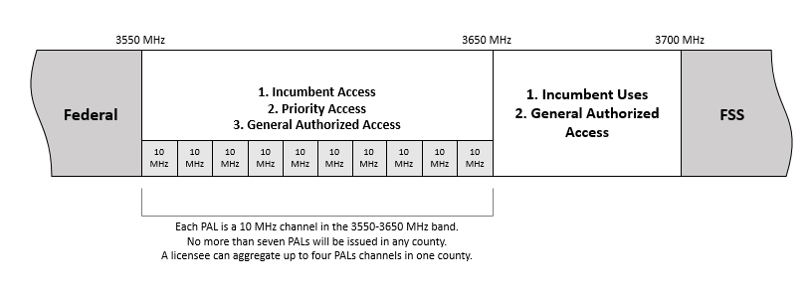
  - Because these tiers concurrently share CBRS spectrum amongst them, the FCC requires that GAA users cannot interfere with PAL or incumbent users, and PAL users cannot interfere with incumbent users. Access and operations are managed by an automated frequency coordinator, known as a Spectrum Access System (SAS). When managing spectrum access, SAS may incorporate information from an Environmental Sensing Capability (ESC), a sensor network that detects transmissions from Department of Defence radar systems and transmits that information to the SAS. Both SAS and ESC are approved by the FCC.
  - It is worth mentioning that LSA and SAS techniques have been adopted in Europe and the USA respectively for specific frequency band(s) which were directly not available to mobile network operators for IMT use. For example, Europe has adopted LSA based implementation for 2.3 GHz band, and FCC has used SAS based implementation for CBRS in 3.5 GHz band.
  - Therefore, first step could be to identify the IMT spectrum bands in which spectrum has been assigned to government/other agencies and assessment of level of spectrum utilization by such agencies. This necessitates conducting of spectrum audit or having a mechanism for periodic monitoring of utilization of assigned spectrum to know how well the spectrum assigned to such users is being utilized. In case the spectrum audit shows that the entire spectrum is not being used at all places and/or at all times, there could be a case of implementation of LSA technique of spectrum sharing. A formal spectrum audit or spectrum utilization monitoring mechanism would help the regulatory agencies to implement LSA based spectrum sharing as otherwise the incumbent users may not be willing to share the spectrum resource held by them. Considering the advantage that can be drawn from secondary use of a band, the regulatory agencies can also examine and decide to adopt some measures to encourage and motivate the incumbent users for participation in the spectrum sharing regime.

- Licensed Assisted Access (LAA)
  - Licensed assisted access (LAA) is a feature that leverages the frequency spectrum in unlicensed bands (such as the Wi-Fi spectrum in 5 GHz frequency band) in combination with the spectrum in licensed frequency bands. LAA uses carrier aggregation to combine unlicensed spectrum with the licensed spectrum. The carrier aggregation of spectrum provides a fatter pipe with faster data rates and more responsive user experience. By maintaining a persistent anchor in the licensed spectrum that carries all the control and signalling information, the user experience could be made seamless and reliable. With LAA, a licensed carrier can be thought of as an anchor that stays connected as unlicensed carriers are added to or dropped from the combination of carriers in use between a device and the network.
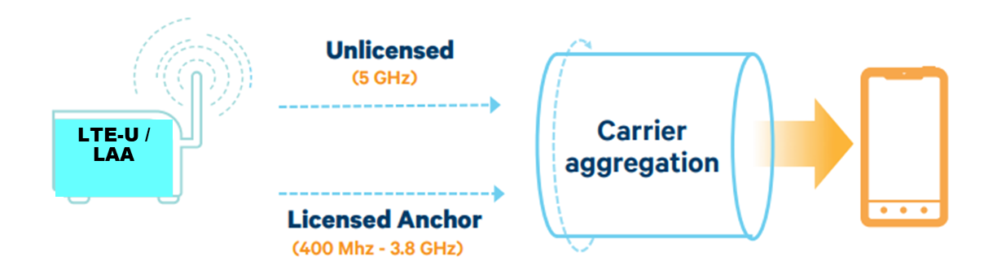
  - LAA has been standardized by the 3GPP in its Release-13. LAA adheres to the requirements of the Listen Before Talk (LBT) protocol. Several countries such as USA, Thailand, Russia, Hong Kong, Italy, Turkey have already deployed LAA networks. As per GSA report of March 2020, 38 operators were investing in LAA across 21 countries; nine of them were understood to have deployed or launched LAA in six countries and 131 devices were identified that supported LAA from 33 vendors.

- Dynamic Spectrum Sharing (DSS)
  - Dynamic spectrum sharing refers to an antenna technology that allows 4G LTE and 5G cellular wireless technologies to be used in the same frequency band, while dynamically allocating bandwidth based on user demand. This allows mobile network operators to slowly allocate more spectrum resources to new technology as more users switch to 5G. Therefore, it provides a very useful migration path from LTE to NR.
  - The alternative to DSS would require the network operator to split their spectrum in half through a technique called static refarming. For example, an operator with 20 MHz of spectrum would have to assign 10 MHz to 4G LTE and use the other half for 5G. This leaves both networks with less spectrum availability in total, impacting the performance of both networks.
  - Operators can choose to purchase more spectrum, but obtaining licensed spectrum can be quite expensive and time-consuming.
  - DSS lets operators use their existing spectrum to serve both 4G and 5G customers.
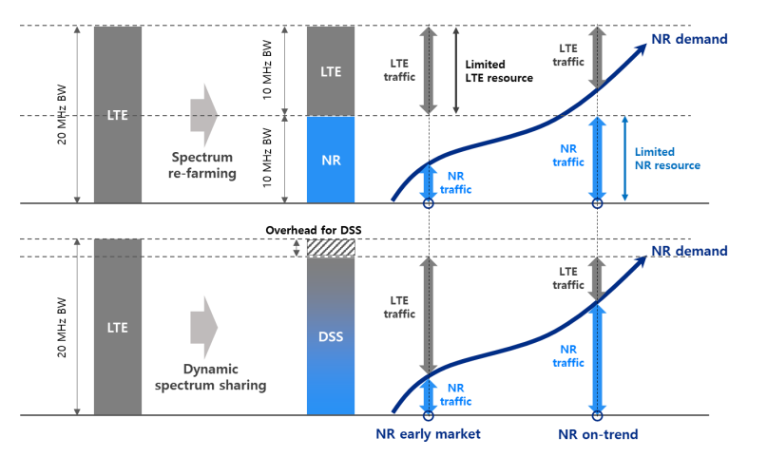
  - As depicted in the above figure, in early NR market, traffic demand of NR may not be explosive enough to require all of the available resources from the re-farmed band. Therefore, this can lead to underutilization of resources in the re-farmed band that could otherwise be used for LTE traffic. This is to say that so long as LTE traffic dominates the market, some resources will be left unused. On the other hand, when demand for NR surpasses that of LTE, in a re-farming scenario, there will be insufficient NR resources to handle all the NR traffic demand while some resources allocated to LTE will be left idle as LTE traffic demand subsides. DSS overcomes this setback by dynamically allocating resources according to traffic demands between LTE and NR across the entire band.
  - DSS slightly impacts the performance of both 4G LTE and 5G NR by approximately 25% and 15% respectively. This performance reduction is often well worth having the full spectrum available for both networks.
  - To enable the TSPs to deploy DSS in the existing FDD bands, the regulatory policy should be such that access spectrum assigned to the TSPs could be used for any technology. This would provide flexibility to the TSPs for implementation of DSS on need basis.
- SPECTRUM TRADING

a) About spectrum trading
  - Spectrum trading refers to the transfer of rights to use of spectrum. When a block of spectrum is traded, the associated rights and obligations of the spectrum block stands transferred from the seller to the buyer. Spectrum trading does not alter the original validity period of spectrum assignment.
  - Spectrum trading is a mechanism whereby rights and any associated obligations to use spectrum can be transferred from one party to another by way of a market-based exchange for a certain price. In contrast to spectrum re-assignment, in a spectrum trade, the right to use the spectrum is transferred voluntarily by the present user either in full or in part of its total holding in exchange of its monetary value.

b) Benefits of Spectrum Trading
  - While spectrum auctions initially help to achieve an economically efficient allocation of spectrum, spectrum trading seeks to ensure that operators are constantly encouraged to target optimal use of the spectrum because incentive for selling unused spectrum is always available to them.
  - Spectrum trading contributes to more economical and efficient use of frequencies. This is because a spectrum trading will only take place if the spectrum is worth more to the new user than it was to the old user, reflecting the greater economic benefit the new user expects to derive from its use. It allows the present user to decide when and to whom the spectrum authorisation will be transferred and what sum it will receive in return. The market, not the regulator, determines the value. Spectrum trading makes it possible for companies to expand more quickly than would otherwise be the case. It also makes it easier for a new market entrant to acquire spectrum in order to enter the market. As such, trading is likely to result in more efficient use of spectrum. Spectrum trading may facilitate optimal use of spectrum by way the consolidation of spectrum or by encouraging the licensees to retain the required quantum of spectrum with it and trade the rest.
  - Secondary trading in spectrum can overcome inefficiencies in the initial allocation of spectrum. Operators will be more willing to invest in spectrum with the knowledge that they have the opportunity to sell the spectrum rights, in case their business models are not successful. It also allows flexibility and speedy re-assignments between users helping the facilitation of new services being launched. In short, spectrum trading may lead to greater competition, provide incentives for innovation, greater certainty to service providers over their rights on spectrum, access to spectrum by those who value it most, greater return to service providers, better/new services being available to consumers at cheaper tariffs, greater choice to consumers, etc.

c) Issues that need to be addressed by the NRAs
  - The success of spectrum trading depends on appropriate institutional framework that precisely determines how rights of use of spectrum are transferred. There are some concerns that need to be addressed through appropriate measures while permitting the spectrum trading. Main regulatory concern is related to competitive issues. By spectrum trading, the spectrum may be concentrated in the hands of few players. Operators may resort to spectrum hoarding in order to restrict the entry of new players. By allowing companies to purchase more spectrum, trading could lead to the acquisition of market power both in the market for a particular type of spectrum, and in related services. Anti-competitive market behaviour needs to be regulated for successful spectrum trading. Hence, there will be a need to define the conditions including safeguards to check monopolistic practices, duties. There may be other issues such as possibility of too much fragmented spectrum, high transactional cost or interference issues. Therefore, it is necessary to lay down rules of spectrum trading.
  - Spectrum trading needs to be designed to work within the constraints, that current and future international arrangements impose, regarding the harmonised use of spectrum, interference management particularly in the bordering areas and other international commitments.
  - In many countries, allocation of the spectrum is associated with certain obligations on the part of license. These obligations may be related to the roll out of network in the remote areas, primarily with the aim to ensure better coverage to the uncovered areas especially for rural population. In such a case, issue for consideration would be whether licensees who have not fulfilled their roll-out obligations be permitted spectrum trading. One view may be that unless a licensee transfers the entire spectrum assigned, the unmet roll-out obligations of the seller should continue to hold. Penalties, if any, liable to be paid by the seller prior to the date of the sale will remain payable by the seller. In case of sale of full spectrum holding, no further penalties should be imposed on the seller after the date of the sale for unmet roll-out obligation.
  - Trading allows a telecom service provider to transfer usage rights to another TSP and in case spectrum is technology neutral, it provides the transferee TSP the flexibility to change technologies and alter their service provision. If the use of spectrum is not technology neutral, the transferee TSP will have to deploy the same type of services and technologies as the transferor TSP.
  - As per the data available on ITU website, spectrum trading is permitted in over 50 countries across the globe including Australia, Canada, France, Germany, India, Mexico, New Zealand, Poland, South Korea, Sweden, UK and the USA.
  - From the responses received from the SATRC member countries, it is seen that presently, spectrum trading is permitted in India and Iran. India permitted spectrum trading among TSPs in the year 2015. The guidelines issued by India including the conditions to address the regulatory concerns have been included as a case study for guidance for the SATRC member countries in the Annexure-I. Iran permitted spectrum trading in the year 2016.

- SPECTRUM LEASING
  - In Spectrum leasing, an entity, having exclusive spectrum usage rights, leases part of or entire spectrum holding to another entity for a specified period but ownership, including the obligations, remains with the original rights holder. For such specified time, the rights gets transferred to the transferee entity and reverts to the transferor after expiry of such period.
  - Broadly, spectrum leasing can be divided into two categories, viz. (i) among telecom operators and (ii) telecom operator leasing spectrum to enterprises for localized captive non-public (private) networks.

a) Spectrum leasing among TSPs
  - Spectrum leasing between TSPs could facilitate the TSPs to lease out their unused spectrum to other TSPs for a specified period of time, resulting in efficient use of spectrum resource. It promotes efficient use of spectrum and may particularly be needed among telecom operators for short-term events. To illustate:
- There could be a scenario that consequent upon acquisition of spectrum, the TSP may decide to roll out selectively based on the business decision and if spectrum leasing is permitted, the TSP could lease out such spectrum to other TSPs in the geographical areas where it is yet to roll out its network.
- Spectrum leasing could be beneficial for short-term basis in venue-specific geography in case some large-scale event such as games, fairs etc. is taking place. In such a venue, one of the TSPs may get the rights to deploy a mobile network for the duration of the event. Considering the huge footfall, there may be a need for large quantum of spectrum and short-term leasing could be used to meet the capacity requirement. Other TSPs could enter into a roaming kind of arrangement to facilitate their subscribers to take benefit by latching onto the deployed network. Therefore, a short-term leasing arrangement could result in a win-win situation for all the TSPs.
  - Considering that the use of long-term and short-term spectrum leasing could be very different, there may be a need to prescribe different set of rules for both the scenarios i.e., long-term and short-term spectrum leasing.
  - Short-term leasing is less likely to have regulatory concerns, therefore, there could be a simpler guideline, wherein spectrum cap could be relaxed, approval process could be simpler.
  - On the other hand, long-term spectrum leasing could have similar concerns as applicable for spectrum trading. Therefore, while permitting and framing the rules for long-term spectrum leasing, the competition concerns and the likely impact on the dynamics of spectrum auction should be looked into by the NRAs. Therefore, there may be a need to introduce some conditions so that there is no potential misuse of the provisions for leasing of spectrum such as a detailed approval process, a lock-in period could be prescribed, spectrum leased from other TSP may be counted for the purpose of spectrum cap.
  - Some of the countries such as Canada, Malaysia, USA have permitted leasing of access spectrum to other TSPs.
  - FCC has permitted both long-term and short-term spectrum leasing. A short-term lease, which has an individual or combined term of no longer than one year, and 2) a long-term lease, which has an individual term, or a series of combined terms, of more than one year. Parties to a short-term Spectrum Lease must file 10-days prior to commencing a short-term Spectrum lease. Parties to a long-term Spectrum lease must file it 21 days prior to commencing a long-term Spectrum lease.
  - From the responses received from the SATRC member countries, it is seen that presently, spectrum leasing is permitted only in Iran.

b) Spectrum leasing to enterprises for localized captive non-public networks (CNPN)
  - Industry 4.0 is one of the key 5G uses case, wherein an Industrial unit, interested to have its own localized 5G based network that will not be connected to any public network, will require access spectrum.
  - Private 5G is arriving with a lot of promise about enabling new, innovative use cases that will bring great value to enterprises across different industries such as manufacturing, mining, logistics, transport, healthcare, agriculture, education, entertainment etc.
  - To reap the benefits of 5G, it is important that suitable measures are created by the NRAs to promote 5G deployment for Industry 4.0. The requirement of private networks could be met through the following options:
a) Private network through TSPs using a Network Slice from TSP’s PLMN network.
b) Enterprise may request TSPs to establish an independent isolated private network in enterprise’s premises using the TSP’s spectrum.
c) Enterprise may obtain the spectrum on lease from TSPs and establish their own isolated Captive Non-Public Network (CNPN).
d) Enterprise may obtain the spectrum directly from the Government and establish their own isolated CNPN.
  - Isolated Private LTE and 5G networks for enterprises bring distinct benefits over the use of public networks especially for business-critical and security-critical applications:
- Superior service security through SIM-based authentication
- Improved control and management of connectivity with better reliability, resiliency, and predictability
- Full control over the enterprise’s own operating processes as the enterprise itself operates the mobile network infrastructure.
- Enhanced data security as data is segregated and processed locally and separately from public 5G networks
- Controlled latency enables near real-time communication, a crucial factor in applications such as public safety or robotic motion control.
  - For deployment of CNPN, spectrum will be required. Spectrum can either be allocated for such local usages to such entities or the TSPs could be allowed to lease the spectrum allocated to them to such private entities for localized captive use.
  - In case regulatory agencies decide to assign spectrum directly to the enterprises for CNPN, some quantum of spectum may have to be set aside for such use. Since the spectrum will be used in limited geographies, such a set-aside of spectrum may result in inefficient use of spectrum. The TSPs may argue that in case spectrum is set aside from the IMT band, it may create artificial scarcity of spectrum for the TSPs leading to increase in price of spectrum. The solution to this issue could be to assign spectrum for CNPN on a coexistence basis in the bands where IMT ecosystem exists but the same has been assigned to users other than TSPs. For this, satellite uplink bands could be explored, where CNPN could coexist easily.
  - Other option is to permit the TSPs to lease the spectrum held by them to enterprises for CNPN. However, the flip side could be that the enterprises will be dependent on the TSPs. Moreover, the possibility of TSPs charging unreasonably from the enterprises for CNPN deployment could also be there.
  - In case NRA decides to open all the options, spectrum leasing by TSPs to enterprises for CNPN may eventually emerge as the most attractive option as the fee charged by the NRAs for direct spectrum assigned for CNPN will indirectly act as a ceiling for spectrum leasing charge levied by the TSPs. However, while permitting spectrum leasing for CNPN, NRAs may have to put in place some conditions such as how much spectrum can be leased out so that the public network quality of service to the telecom consumers is ensured.
  - India permitted mobile operators to lease their spectrum holding for captive non-public networks in the year 2022. The key features of the guidelines issued by India are included as a case study for guidance for the SATRC member countries in the Annexure.

CHAPTER-III: INPUTS FROM SATRC MEMBER COUNTRIES

In order to pursue the study, a questionnaire was prepared and circulated to all the expert members of the SATRC Working Group on Spectrum for their inputs. The questionnaire aimed to seek the information and details about the Licensing regime, Mobile Services in the country – spectrum assigned to mobile operators, technologies deployed, subscriber and usage details, spectrum caps, delicensed spectrum, policy on spectrum sharing, trading and leasing. Inputs have been received from all the member countries. Inputs received from the SATRC Member countries are analyzed in this chapter. A copy of the questionnaire is placed at Annexure-II.
- Licensing regime
- Requirement of Service license for oﬀering mobile services and tenure of such license
All the member countries require Mobile operators to acquire a service license for offering mobile services in the country. Tenure of the service licence for Mobile services in the member countries is tabulated below:
Country | Licence Tenure
Sri Lanka | 10 years
Iran | 14 years
Afghanistan, Bangladesh, Bhutan, Pakistan and Maldives | 15 years
India | 20 years
Nepal | Maximum tenure of the license is 25 years. The initial license period is 10 years, and it can be renewed three times with duration of each renewal being five years.
- Mobile license - national operation or regional basis
In Afghanistan, Bangladesh, Bhutan, Iran, Maldives, Nepal, Pakistan and Sri Lanka, mobile service licence is issues for nation-wide operation. In India, mobile services licences are issued on Licensed Service Area (LSA) basis; currently there are 22 LSAs in the country.
- If Access spectrum is assigned along with the service license (in bundled manner),
- how much spectrum is assigned along with the license?
- what is the mechanism to acquire additional spectrum?
- what is the validity period of service license and spectrum?

Countries where access spectrum is delinked from the service license and the same is assigned separately | Countries where access spectrum is assigned along with service licence in a bundled manner
India, Bhutan, Sri Lanka and Bangladesh | Iran, Afghanistan, Nepal, Maldives

Country | Access Spectrum is bundled with service Licence? | Quantum of spectrum assigned along with the service license | Method of assignment of additional spectrum  And  validity period of service license and spectrum
Afghanistan | Yes | ATRA give access frequencies to the mobile network on the base of new assignment procedure (Auction). | The validity period for service license is 15 years and for spectrum license is 1 year.
Iran | Yes | About IMT license, the most spectrum was assigned to the first mobile operator and after that, the rest of spectrum can be assigned to other operators | All spectrum identified to IMT by ITU will be assigned through beauty contest or auction.  The average validity of each IMT license is about 14 years and is extendable. This period may be reduced for negligence in fulfilling the obligations. Also According to answer of Q.A (3) the validity of spectrum assigned to each mobile operator by CRA is not more than the validity of mobile operator’s license.
Maldives | Yes | There is no allocated amount. | Only on administrative basis.  As long as the licence is valid, the frequency validity remains.
Nepal | Yes | Usually, the mobile licensee is assigned 6 MHz bandwidth in 900 MHz or 9 MHz in 1800 MHz along with a license | Previously, additional spectrum has been assigned using administrative procedures according to mobile licensee demand. Now, an additional spectrum is assigned to the licensee only through spectrum auction. The validity period of a mobile service license is 25 years. Spectrum is bundled with license tenure
Pakistan | Depends upon spectrum availability and auction results | Auction process | 15 Years
- If spectrum assignment is delinked with the service license, when was it done and how is access spectrum assigned and for what period
Spectrum assignment was delinked from the service license by Afghanistan and India in 2012. In Bangladesh, delinking was done in 2018. In Bhutan and Sri Lanka, spectrum assignment was never linked with the service license.
In Bangladesh and India, spectrum is assigned through auction for a period of 15 years and 20 years, respectively. In Sri Lanka, spectrum is assigned on the request of the operator based on a spectrum assignment methodology and spectrum is assigned for 10 years period subject to annual renewal.
In Afghanistan, service license (along with spectrum) was assigned based on equal assignment for 15 years and 10 years. Currently the licenses are technology neutral.
- Spectrum is technology speciﬁc or technology agnostic and the procedure to change the technology in case spectrum is technology specific
Access Spectrum assigned to mobile operators is technology neutral in Afghanistan, Bangladesh, Bhutan, Iran, India, Maldives, Nepal and Pakistan.
Access Spectrum assigned to mobile operators is technology specific in Sri Lanka. In Sri Lanka, on the request of the operator, the Regulator will allow changing the technology after a survey of customer base of existing technology and the analysis of the impact on QoS of the existing service due to the unavailability of spectrum band.
- Spectrum bands used for mobile backhaul purpose and its assignment mechanism
Backhaul spectrum is being assigned administratively in all the member countries. However, India is reviewing the assignment policy.
Link-to-link basis assignment is being followed by Afghanistan, Iran, Nepal and Pakistan, Sri Lanka. In India, Link-to-link basis assignment is being followed for lower bands (6 and 7 GHz) used for the microwave backbone network (link distance >=10 Km), and other bands (13,15,18,21 GHz and E-band are being assigned on a block (exclusive) basis.
Bangladesh, Bhutan and Maldives are following block (exclusive) basis assignment. In Bangladesh while assignment is on block basis, charging is based on the number of links
Details of the spectrum bands being used for microwave backhaul for mobile services are given below:
Country | Traditional backhaul bands | High capacity bands
Afghanistan | 6 GHz to 38 GHz | E-band  (71-76/ 81-86 GHz)
Bangladesh | 7, 13, 17, 23, 38GHz | 60 GHz and 70 GHz
Bhutan | 7, 8, 13, 15 and 18 GHz | -
Iran | 2.4 and 5.8, 8, 11, 13, 15, 18, 24, 26, 28, 38 GHz | 60 & 80 GHz
India | 6, 7, 13, 15, 18, 21 GHz | E-band  (71-76/ 81-86 GHz)
Nepal | 6, 7, 8, 13, 15, 18, 23, 38 GHz | 60 & 80 GHz
Pakistan | 10, 11, 12, 18, 22, 38 GHz | 70~80 GHz
Sri Lanka | 4, 6, 8, 11, 13, 15, 18, 23, 28, 38  GHz | -
Maldives | 7 and 8 GHz
- Whether there is a demand for more access spectrum by mobile operators
All the member countries except Iran and Maldives, have responded that Mobile operators keep demanding more access spectrum in different bands.
Iran administration (CRA) based on study of ICT market and amount of traffic/erlang that is consumed in the country, decides when or which spectrum band(s) will offer.
- How is the mobile quality of service rated in your country
As such, Regulators do not rate the quality of services of the mobile operator. However, most of the Regulators have prescribed QoS standards (parameters and benchmarks). The countries also have a mechanism to monitor the quality of service on a periodical basis. Some countries also carry out drive tests in their countries and the results are shared with MNOs for taking corrective measures and uploaded on website for information of the public.
However, the benchmarks are assessed over the entire service area on a periodical basis; therefore, even in the networks which have met benchmarks, there may be few pockets or few days where these benchmarks may not be met. In such cases, India imposes financial disincentive. In addition, Nepal is also assessing the quality of experience of the customers via online and physical surveys.
- Status or plans for the launch of 5G services
5G services have been launched in Maldives, Bhutan and India. Bhutan and India launched the services in December 2021 and October 2022, respectively. In Maldives, as of September 2023 5G covers 53 percent of population.
In Bangladesh, Nepal, Pakistan and Sri Lanka, 5G trials have been done and are being done. In Iran, a pilot model of the 5G mobile services has been launched. In Bangladesh, 5G services are expected to be launched in the year 2023 and Sri Lanka is expected to assign spectrum for 5G in 2024.
Afghanistan is currently planning to implement 4G services.

- Mobile Services in the country

Country | Name of the operator | Area(s) of operation | Quantum of Access spectrum held in |  | Mobile technology(ies) being offered | No. of mobile subscribers (in million) | Average mobile data usage per subscriber per month in MB
 |  |  | FDD bands (paired) | TDD bands (unpaired)
Afghanistan | AFTEL | Nationwide | 26.8 | - | 2G/3G/4G | 1.9 | 20012
 | AWCC | Nationwide | 26.8 | - | 2G/3G/4G | 3.6 | 4997
 | Etisalat | Nationwide | 26.8 | - | 2G/3G/4G | 2.2 | 11050
 | MTN | Nationwide | 26.8 | - | 2G/3G/4G | 6.4 | 6193
 | Roshan | Nationwide | 26.8 | - | 2G/3G/4G | 4.5 | 6222
Bangladesh | Banglalink | Nationwide | 40 | 40 | 2G, 3G, 4G, 5G (Trial) | 38.48
 | Grameenphone | Nationwide | 47.4 | 60 | 2G, 3G, 4G, 5G (Trial) | 84.08
 | Robi | Nationwide | 44 | 60 | 2G, 3G, 4G, 5G (Trial) | 54.77
 | Teletalk | Nationwide | 25.2 | -- | 2G, 3G, 4G, 5G (Trial) | 6.71
Bhutan | Bhutan Telecom Limited | National | 110 | 40 | 2G/3G/4G/5G | 0.77
 | Tashi InfoCom Limited | National | 110 | 40 | 2G/3G/4G/5G
India | Airtel | Pan – India (22 Licensed service areas) | 33/LSA | 932/LSA | 2G, 4G,5G | 238.96 | 19,061
 | BSNL |  | 15/LSA | 13/LSA | 2G, 3G, 4G | 24.03 | 4,861
 |  |  | (additional spectrum being assigned) | (additional spectrum being assigned)
 | Reliance Jio |  | 33/LSA | 1151/LSA | 4G, 5G | 419.24 | 18,932
 | Vodafone Idea |  | 31/LSA | 301/LSA | 2G, 3G, 4G | 135.29 | 14,432
Iran | Mobile Telecommunication Company of Iran | Nationwide | 217.3 | 40 | 2G, 3G, 4G | 75.44 | 6,944.92
 | Irancell | Nationwide | 186 | 40 | 2G, 3G, 4G | 60.73 | 8,654,1
 | Rightel | Nationwide | 70 | 0 | 2G, 3G, 4G | 5.28 | 8,645.10
Maldives | Dhiraagu | Whole country | B8, 1& 3 | B41 | 2G, 3G, 4G & 5G
 |  |  |  | (Lower Portion)
 | Ooredoo | Whole country | B8, 1& 3 | B41 | 2G, 3G, 4G & 5G
 |  |  |  | (Upper Portion)
Nepal | Nepal Doorsanchar Company Limited | National | 104.1 | 10 | 2G,3G,4G/LTE/LTE-A | 21.7
 | Ncell Axiata Ltd. | National | 89.2 | - | 2G,3G, 4G/LTE | 16.82
 | United Telecom Ltd. | National | 39 | - | 2G ( Not in operation) | -
Pakistan | Jazz | Nationwide | 47.2 | - | - | 75.47 | 6,139
 | Ufone | Nationwide | 27.6 | - | - | 23.28 | 3,227
 | Telenor | Nationwide | 28.6 | - | - | 44.19 | 10,082
 | CMPak | Nationwide | 33.6 | - | - | 49.98 | 5,900
 | SCO | Azad Jammu & Kashmir Gilgit Baltistan | 30 | - | - | 1.66 | 3,075
 | Total |  | 167 | - | - | 194.58 | 6,836
Sri Lanka | Bharti Airtel Lanka (Pvt) Ltd | Island wide | 27.5 | 20 | 2G & 4G | 2.87 | 6,872
 | Dialog (DAP) | Island wide | 47.5 | 40 | 2G/4G | 13.72 | 9,395
 | Dialog (DBN) | Island-wide |  | 75 | 4G-Fixed | 1.42 | 29,096
 | Hutchison Telecommunications Lanka (Pvt) Ltd | Island wide | 45 |  | 2G/3G/4G | 2.75 | 7,091
 | Mobitel Private Limited | Island wide | 105 |  | 2G, 3G, 4G | 8.2 | 8753.78

- Applicable spectrum cap for access spectrum
Country | Applicable Spectrum Cap
Afghanistan | Not yet, will be included in upcoming spectrum auction
Bangladesh | No spectrum cap has been prescribed for any access spectrum band. However, spectrum cap was prescribed during auctioning.
Bhutan | No spectrum cap
India | Following spectrum caps are prescribed:  a) A Cap of 40% on the combined spectrum holding in the sub-1 GHz bands i.e., 600 MHz (APT 600 Option B1), 700 MHz, 800 MHz and 900 MHz bands, including existing spectrum holding of TSPs in these bands.  b) A Cap of 40% on the combined spectrum holding in 1800 MHz, 2100 MHz, 2300 MHz, and 2500 MHz bands, including existing spectrum holding of TSPs in these bands.  c) A Cap of 40% on the total spectrum put to auction in 3300 MHz band (Rounded off considering the block size in this band).  d) A Cap of 40% on the total spectrum put to auction in 26 GHz band (Rounded off considering the block size in this band).
Iran | It has not been specified by CRA
Nepal | Spectrum cap for access spectrum bands is as follows:  Spectrum Band Available Bandwidth Maximum Bandwidth  700 MHz 2x45 MHz 2x15 MHz  800 MHz 2x10 MHz 2x10 MHz  850 MHz 2x10 MHz 2x6 MHz  900 MHz 2x35 MHz 2x9.6 MHz  1800 MHz 2x75 MHz 2x20 MHz  2100 MHz 2x60 MHz 2x15 MHz  2300 MHz 100 MHz 30 MHz  2600 MHz 190 MHz 2x25 MHz, 15 MHz (TDD)  3300 MHz 100 MHz 30 MHz  3400 MHz 200 MHz 40 MHz  3600 MHz 200 MHz 40 MHz
Pakistan | There is no generic cap on specific bands; however, a spectrum cap could be defined for a competitive spectrum auction in all or available spectrum bands.
Sri Lanka | Not yet. Willig to introduce in future with new rules.

- Spectrum Sharing Policy
Spectrum sharing is permitted for mobile operators in India and Iran. However, in India only intra-band spectrum sharing is permitted i.e., two mobile operators having spectrum in a particular band are permitted to pool their spectrum holding and share the spectrum by implementing a common RAN.
 | India | Iran
a) when was it permitted? | 2015 | 2020
b) what type of spectrum sharing is permitted? | Intra-band spectrum pooling | Multiple Operator Core Network (MOCN)
c) what are the key terms and conditions? | Spectrum sharing will be done on band LSA basis and the spectrum to be shared must be either auction acquired or liberalized among other conditions as per guidelines.  Spectrum sharing is allowed between only two MNOs, where both the MNOs are utilizing the spectrum in same band subject to the condition that there will be at least two independent networks provided in the same band.  For the purpose of applying the prescribed market caps, 50% of the spectrum held by the other licensee in Spectrum band being shared is counted as the additional spectrum being held by the licensee. | Must comply to the framework and requires approval of the CRA.  Must comply to all licensing, QoS conditions.  The total portion of frequency resources of contract parties, after sharing, must not be more than 25% of total portion of frequency resources assigned to the other license holders.  At least half of the frequency bandwidth intended for sharing must be used in its own network.
d) whether there is any regulatory financial levy post spectrum sharing? If yes, kindly share details. | Earlier Spectrum usage charge of 0.5% of Adjusted gross revenue was levied on the MNOs sharing spectrum. However, this levy has been done away with in the year 2021. | No
e) How has been the uptake of spectrum sharing? | There have been some cases of spectrum sharing. | Two telecom operators in I.R of Iran have experience of spectrum sharing and they have been succeeded in providing services, so that the spectrum usage has been optimal and accordingly spectrum sharing has been beneficial.
f) Kindly share a copy of the spectrum sharing guidelines in your country | Guidelines are available at the URL | -
g) Is spectrum sharing permitted among more than two operators? | No | No

In other member countries, spectrum sharing is not permitted so far.
 | Afghanistan,  Bangladesh,  Bhutan,  Nepal | Pakistan | Sri Lanka
a) whether telecom operators have ever demanded for permitting spectrum sharing? | No | Yes | Yes  TRCSL has been formulating new rules for allowing spectrum sharing
b) whether the need for spectrum sharing has been examined? | No | The draft is in its final stage and will soon be issued for implementation after securing necessary approval | TRCSL already realised that the spectrum sharing is needed as a solution for spectrum scarcity as well as to increase the efficiency of the utilisation of the spectrum.
c) whether permitting spectrum sharing among telecom operators in plan? | No |  | Yes, spectrum sharing is planned to share among telecom operators only.

Nepal has further mentioned that spectrum sharing is prohibited by the spectrum policy because the telecom market is not considered fully mature and competitive.
BTRC, Bangladesh has further mentioned that they are considering the issue for future opportunities.

- Policy on Spectrum Trading
Spectrum trading has been permitted by India and Iran
 | India | Iran
a) when was it permitted? | 2015 | 2016
b) what is the eligibility criteria? | Spectrum trading will be done on band LSA basis between service providers having access service authorization and the spectrum  to be traded must be either auction acquired or liberalized among other conditions as per guidelines. | The spectrum holder (seller) who transfers the benefits of the frequency spectrum, must not be exempt from spectrum charges, and not have any contravention as determined by CRA, also before transferring the benefits of the frequency spectrum, the seller must pay its debt to CRA for spectrum charges, and the privilege right to use of spectrum.
c) what are the key terms and conditions? | Mobile operator is allowed to trade its spectrum only after 2 years of date of assignment of spectrum or trade of spectrum (lock-in period of 2 years) | The available spectrum must first be notified to CRA, then traded between the seller and the approved buyer under the framework set by CRA, furthermore CRA must set regulation in such a way that the balance of ICT market is observed.
d) whether there is any regulatory financial levy upon spectrum trading? | A non-refundable transfer fee of 1% of the transaction amount of the  trade or 1% of the prescribed market price, whichever is higher is  imposed on the spectrum trade transactions to cover the administrative  charges incurred by the government in servicing the trade. | No, there is no financial levy for spectrum trading in I.R of Iran
e) How has been the uptake of spectrum trading? | TSPs have been permitted for trading of spectrum as and  when requested as per prevailing guidelines.  There have been some cases where mobile operators have traded access spectrum. Overall, spectrum trading has been successful. | The three mobile operators in I.R of Iran have done spectrum trading, and they have been succeeded in providing services, so that the spectrum usage has been optimal and accordingly spectrum trading has been beneficial.
f) Kindly share a copy of the spectrum trading guidelines in your country | Guidelines are available at the URL | -
g) Is change of spectrum use (technology) permitted upon transfer? | Any liberalized spectrum can be used in a technological  agnostic manner | Yes, the change of spectrum use is permitted upon transfer, but a buyer who receives the benefits of the frequency spectrum, must obtain the agreement of CRA before concluding a frequency contract

Spectrum trading is currently not permitted in Afghanistan, Bangladesh, Bhutan, Nepal, Sri Lanka and Pakistan
 | Afghanistan, Bangladesh, Bhutan, Nepal | Sri Lanka | Pakistan
a) whether telecom operators have ever demanded for permitting spectrum trading? If yes, kindly share details | No | No | No
b) whether the need for spectrum trading has been examined? What was the outcome? | No | No | The Ministry of Information Technology & Telecommunication is in process of consultation with stakeholders and a draft National Broadband policy is under process. Spectrum Trading requirement is being re-examined by the ministry which will be reflected in the mentioned policy once issued.
c) whether permitting spectrum trading among telecom operators in plan? If yes, kindly share details | No | No
d) whether telecom operators are permitted to surrender spectrum before the expiry of the validity period of right to use of spectrum? If yes, kindly share details as well as a copy of the guidelines. | Yes | No | No

Nepal has further stated that the operator has the option to request the return of spectrum prior to the end of the spectrum's legal tenure. Depending on network growth and service quality, NTA has the exclusive right to make decisions on their request.

- Policy on spectrum leasing
In Iran, spectrum leasing among MNOs has been permitted. However, mobile operators are not permitted to lease their spectrum to non-licensed private entities. On the other hand, in India, spectrum leasing between MNOs is not permitted in India. However, telecom operators are permitted to lease their spectrum for private networks, as per the guidelines dated 27.06.2022 for Captive Non-Public Network (CNPN) License
 | India | Iran
a) when was it permitted? | 2022 (spectrum leasing for CNPN) | Same as spectrum trading
b) what is the eligibility criteria? | The spectrum held by the licensee acquired through an auction can be leased to CNPN licensee.
c) what are the key terms and conditions? | No interference should be caused to public network or any other licensed spectrum user.
d) whether there is any regulatory financial levy upon spectrum leasing? | No
e) How has been the uptake of spectrum leasing? | Spectrum leasing has been recently permitted for CNPN. No application for leasing has been received till date.
f) Kindly share a copy of the spectrum leasing guidelines in your country | Guidelines are available at the URL
g) Is change of spectrum use (technology) permitted upon leasing? | Any liberalized spectrum can be used in a technology-agnostic manner

As of now, spectrum leasing among TSP is not permitted in Afghanistan, Bangladesh, Bhutan, Nepal, Sri Lanka, Pakistan and India.

 | Afghanistan, Bangladesh, Bhutan, Nepal, Sri Lanka | Pakistan | India  (Spectrum leasing among MNOs is not permitted)
a) whether telecom operators or private entities have ever demanded for permitting spectrum leasing? If yes, kindly share details | No | No
b) whether the need for spectrum leasing has been examined? What was the outcome? | No | Spectrum leasing is considered as an integral part of the draft Spectrum Trading Framework. | Being examined through a consultation paper.
c) whether permitting spectrum leasing in plan? If yes, kindly share details | No
d) whether there is a demand from private entities for spectrum for captive use, particularly for Industry 4.0? If yes, kindly share details | No  Sri Lanka has further mentioned that demand will be expected with the introduction of 5G technology | No | Spectrum leasing for CNPN is already permitted

CHAPTER-IV: CONCLUSION

  - While spectrum sharing, trading, and leasing provide clear benefits, there could be some regulatory challenges that the NRAs need to examine and put in place sufficient measures to overcome the challenges. It is for the National Regulatory Authorities (NRAs) to examine the need for permitting sharing, trading, and leasing of spectrum and decide on the framework as per the conditions prevailing in the country w.r.t. spectrum, level of completion, financial situation of the MNOs, spectrum prices etc. Having said that it may be kept in mind that the requirement of spectrum is going to increase with increasing uptake of newer technologies, digital transformation, uptake of innovative 5G use cases, convergence of broadcasting and telecommunication services, etc.
  - To assess the need for spectrum sharing, trading, and leasing in any country, two-stage examination could be followed:
  - Stage-1: Examine the existing spectrum holding of MNOs. Some of the issues that need examination are:

      - Whether the existing spectrum is sufficient to provide quality services to the consumers.
      - Whether there is an excess, unutilized or under-utilized spectrum
      - Whether network congestion is being experienced in some areas
      - Whether spectrum demand exists for Industry 4.0
      - Whether some spectrum in IMT bands has been assigned to other users including government entities. If so, conduct a spectrum audit to assess how well the spectrum is being utilized i.e., how much spectrum is being used, and whether it is being used in all places and at all times.
      - Whether sufficient additional spectrum in existing and new bands is available to meet the existing and future requirements of the MNOs.

  - Stage-2: Consultation with MNOs
      - Need for spectrum sharing, trading and leasing may be consulted with the MNOs
      - For Industry 4.0, consultation may be held with other industry verticals

  - In case the need to permit spectrum sharing, trading and leasing (any or all) is felt, clear implementation guidelines including process and other terms and conditions, may be prepared to address the regulatory concerns. Some of the key regulatory concerns (as detailed in the Annexure on Sharing, Trading, and Leasing of spectrum in India) are listed below:
- Sufficient competition in terms of availability of different Networks
- Market dominance through spectrum holding
- Impact on dynamics of spectrum auction
- Prevention of speculative behavior by mobile operators
- Fragmentation of spectrum
- Eligibility conditions for spectrum acquisition should not be compromised
- Dues of the Government should be ensured before permitting sharing, trading, or leasing of spectrum
- Roll Out Obligations should be met
- Quality of Service should be ensured

  - It is expected that this paper will help the NRAs in flagging the regulatory issues in sharing, trading and leasing of spectrum and also in framing the policy guidelines for the same.

ANNEXURE-I: SHARING, TRADING, AND LEASING OF SPECTRUM IN INDIA

Spectrum Sharing in India

Intra-band Spectrum Sharing was permitted in India on 24th September 2015 with the objective to provide an opportunity for the TSPs to pool their spectrum holdings and thereby improve spectral efficiency and provide additional network capacities in places where there is network congestion due to a spectrum crunch.

The inception of ‘Spectrum Sharing’ amongst the TSPs in the country paved the way for better utilization of the spectrum and other infrastructure created by TSPs.

            - Salient Features of the Guidelines

            - Regulatory concerns and conditions prescribed to overcome them:

- Sufficient competition in terms of availability of different Networks

As can be seen from the above salient features, India decided to permit only intra-band sharing between only two mobile network operators subject to a condition that post sharing, at least 2 independent networks should be operating in that band. This condition was put in place to avoid a situation where a single network could become a single point of failure for mobile services. This also ensures that the customers have choice in terms of network so that Quality of services remains the focus of the network providers.

Both the mobile service providers entering into spectrum sharing agreement are individually required to fulfill the specified roll-out obligations, meet the specified QoS norms and fulfill all the terms and conditions of the license agreement.

- Market dominance through spectrum holding

Initially, India had prescribed intra-band and well as overall spectrum cap for access spectrum. With the passage of time, the regime has been changing and spectrum caps have been relaxed. Spectrum caps applicable in the current scenario are given below:

Spectrum bands | Applicable spectrum cap on access spectrum
Sub-1 GHz bands (600 MHz, 700 MHz, 800 MHz and 900 MHz) | Combined cap of 40%
1800 MHz, 2100 MHz, 2300 MHz and 2500 MHz | Combined cap of 40%
3.5 GHz | Band specific cap of 40%
26 GHz | Band specific cap of 40%

In case two MNOs decide to share their spectrum in a band, for the purpose of applying the prescribed market caps, 50% of the spectrum held by the other licensee in Spectrum band being shared is counted as the additional spectrum being held by the licensee. This provision has been created so that spectrum sharing is not exploited to hold or use spectrum more than the applicable spectrum cap to become a dominant player in the market.

For instance, Licensee ‘A’ and ‘B’ have spectrum in quantum X and Y respectively in a band, in which they decide to share their spectrum. The spectrum holding in that band subsequent to sharing, only for the purpose of applying the stipulated spectrum cap, shall be considered as per the following table.

 | Quantum of spectrum in a band before sharing | Quantum of spectrum after sharing that will be counted as the spectrum being held in this band for the purpose of applying the stipulated spectrum cap
Licensee ‘A’ | X | X+(Y/2)
Licensee ‘B’ | Y | Y+(X/2)

- Financial implications
Initially, considering that sharing of spectrum by the MNOs will benefit by them enhanced capacity, spectrum usage charges were enhanced by 0.5% of the AGR for the spectrum sharing MNOs.

However, in 2021, as part to telecom reforms, to promote spectrum sharing the additional SUC has been done away with.

- Partial spectrum sharing

For the purpose of provision of mobile services and spectrum assignment, India has been divided into 22 Licensed Service Areas (LSAs).

For spectrum sharing, both the MNOs will be required to have a common RAN only in respect of sites being shared. It is up to the MNOs to decide the actual area/BTSs in the LSA where they want to pool and share their spectrum resources as per their requirement and mutual agreement. However, it is simply not possible to monitor the quantum of spectrum being shared at each site and to segregate the AGR site-wise/area-wise. Therefore, for the purpose of charging Spectrum Usage Charges (SUC) and computation of spectrum cap, it is treated that entire spectrum is being shared in the entire LSA.
- Impact on dynamics of spectrum auction
Intra-band spectrum sharing is permitted after one year of acquisition of such spectrum.
Pooling of spectrum, particularly inter-band spectrum pooling, could have some concerns regarding the adverse impact on the dynamics of spectrum auction. The TSPs could collaborate and may decide to bid for different spectrum bands, which could result in difficulty in arriving at market-determined price of the spectrum.
Inter-band spectrum sharing is presently not permitted in India. However, TRAI has recently floated a consultation paper in this regard. Based on the outcome of the consultation process, TRAI will make its recommendations to the Indian Government.

            - Uptake of intra-band spectrum sharing in India

Intra-band spectrum sharing was permitted in 2015. In 2016, first arrangement between two TSPs began in 800 MHz band. Thereafter, another two TSPs entered into spectrum sharing arrangements in 1800 MHz and 2100 MHz bands.

However, in the past decade, Indian Mobile market has undergone a phase of consolidation. In the year 2012, there were about 10-12 MNOs in each LSA. After consolidation, presently, four mobile service providers are providing services in each LSA. As a result of market consolidation paired with additional spectrum being made available in existing as well as new spectrum bands, the MNOs do not have any intra-band spectrum sharing arrangement. However, industry has been requesting to permit inter-band spectrum sharing and leasing of spectrum among telecom service providers.

Spectrum Trading in India
Earlier spectrum trading was not allowed primarily on the ground that Telecom Service Providers (TSPs) had obtained spectrum through an administrative process without paying its market price. Therefore, allowing such TSPs to trade in spectrum would have resulted in unearned windfall gains to such TSPs. That concern has been taken care of because the Government has decided that all TSPs will have to a pay one-time charge at a market-determined price for their existing spectrum holding beyond 4.4 MHz/2.5MHz for GSM/CDMA for the remaining validity period of the licenses.
In October 2015, Spectrum Trading was permitted in India. Guidelines for spectrum trading was issued on 12th October 2015. Accordingly, Mobile operators have been permitted to transfer the rights to use of spectrum to another mobile operator. When a block of spectrum is traded, the associated rights and obligations of the spectrum block shall stand transferred from the seller to the buyer. Spectrum trading does not alter the original validity period of spectrum assignment.
The inception of ‘Spectrum Trading’ amongst the TSPs in the country paved the way for better utilization of the spectrum, provided exit option and helped in consolidation of mobile industry. At that point of time, there were about 12 mobile operators in each Licensed Service Area (LSA), which has now optimized to 4 mobile operators in each LSA.

- Salient Features of the Guidelines

- Regulatory concerns and conditions prescribed to overcome them:

- Impact on dynamics of spectrum auction
Spectrum trading could have some concerns regarding adverse impacts on the dynamics of spectrum auctions.
To prevent collusion of TSPs making it difficult to determine the market price of spectrum through auction, a TSP is permitted to trade any spectrum which it has acquired any spectrum through auction or trading after a lock-in period of 2 years from the effective date of acquisition of spectrum.
- To prevent speculative behavior
Any speculative behavior, wherein a TSP could acquire spectrum in a band at a lower price and when the value of the spectrum increases, trades at a higher price is prevented because of the following financial conditions imposed on the buyer and seller.

A non-refundable transfer fee of one percent (1%) of the transactional amount or one percent (1%) of the latest market-determined price for the balance validity period of spectrum, whichever is higher is imposed on all spectrum trade transactions. If the auction-determined prices are more than one year old, the last auction-determined market price is made applicable after due indexing. The transfer fee is paid by the buyer (transferee) to the Government.

For the seller, the amount received from trading becomes part of its adjusted gross revenue, on which a License fee of 8% and spectrum usage charges (as applicable) is levied.

- Market dominance through spectrum acquisition by way of trading
Spectrum acquired through trading is also subjected to the applicable spectrum caps.
The buyer should be in compliance with the prescribed spectrum caps declared from time to time. Spectrum acquired through trading is counted towards the spectrum cap by adding to the spectrum holding of the buyer. This results in increase of spectrum holding of the buyer and reduction in spectrum holding of the seller.
- Fragmentation of spectrum
A TSP is permitted to sell either its entire spectrum holding in a spectrum band or a part of it. However, for providing any meaningful service to the customers, minimum spectrum that can be acquired by a TSP is prescribed by way of block size. Therefore, spectrum trading is permitted in the block size specified at the time of spectrum auction in each spectrum band.
- Eligibility conditions for spectrum acquisition are not bypassed
Spectrum buyer is required to fulfill all the eligibility conditions such as net worth and paid-up equity capital of the buyer, required to be fulfilled for spectrum acquisition through auction.
- Dues of the Government
The seller is required to clear its spectrum usage charges (SUC) and its instalment of payment (in case seller had acquired the spectrum through auction and opted for deferred payment) till the effective date of spectrum trading.
- Roll Out obligations
If the buyer acquires entire spectrum holding of the seller in a spectrum band, then it shall fulfill the associated roll-out obligations within the balance time period for compliance subject to a minimum period of 2 years.

If the buyer is acquiring a part of the spectrum holding of the seller in a spectrum band, then both buyer and seller will have spectrum holding in that band after the trade in such a scenario both will be responsible for the roll-out obligations. There is no change in the roll-out obligations prescribed for the seller even if it is holding a lesser quantity of spectrum in that band post trade. In addition, the buyer is also required to fulfill entire roll-out obligations. Since there is no change in the roll-out obligations of seller, and there will be additional roll-out obligations for buyer, the buyer is given entire time duration to fulfil the roll-out obligations.

If the buyer has met some or all of its roll-out obligations through its prior spectrum holding in that band, it shall be taken into account and buyer will not be required to repeat the required testing for roll-out obligations it has already met.

- Uptake of spectrum trading in India

Spectrum trading was permitted in 2015. In 2016, first spectrum trading took place in 800 MHz band. Thereafter, many spectrum trading proposals materialized in various spectrum bands. In a nutshell, it may not be incorrect to say that spectrum trading has been successful in India.

Spectrum Leasing in India
Broadly, spectrum leasing can be divided into two categories, viz. (i) among telecom operators and (ii) telecom operator leasing spectrum to enterprises for localized captive non-public (private) networks.
In India, presently, spectrum leasing among telecom operators is not permitted. However, the telecom operators have been demanding to permit spectrum leasing among themselves. TRAI, India has already floated a consultation paper to examine the issues involved. The consultation is still going on.
As regards spectrum leasing for CNPN is concerned, Industry 4.0 is one of the key 5G uses case, wherein an Industrial unit may like to have its own localized 5G based network that will not be connected to any public network, will require access spectrum. Private Captive Metworks can play a key role in automation and Industry 4.0 by providing secure, ultra-reliable, low latency and high throughput communication using advanced technologies.
Considering that the capabilities of IMT/5G technologies can be effectively leveraged for increasing productivity of enterprises and ushering in new and emerging technologies such as Industry 4.0, Artificial Intelligence, Internet of Things and M2M, enterprises need to be provided with suitable access to the radio frequency spectrum necessary for this purpose. India decided to open up all four possible methods to meet the requirement of private networks, viz.
- Mobile operators may provide private networks as a service to an enterprise by using network resources such as through network slicing over its PLMN public network.
- Mobile operators may establish isolated captive non-public networks for the enterprises using IMT spectrum acquired by them.
- Enterprises setting up private captive networks may obtain the spectrum on lease from mobile operators and establish their own isolated network.
- Enterprises setting up private captive networks may obtain the spectrum directly from the Government and establish their own isolated network.
The guidelines for CNPN were issued on 27.06.2022, wherein the above four options have been included. While the first 3 options are already open for implementation, the last option wherein the enterprise may obtain the spectrum directly from the Government and establish their own isolated CNPN, is still being examined and is yet to be practically made available.
As regards spectrum leasing for CNPN, mobile operators in India have been permitted to lease their spectrum holding to CNPN licensees. The guidelines for spectrum leasing to CNPN were issued on 27.06.2022.

Salient Features of the spectrum leasing Guidelines

ANNEXURE-II: QUESTIONNAIRE
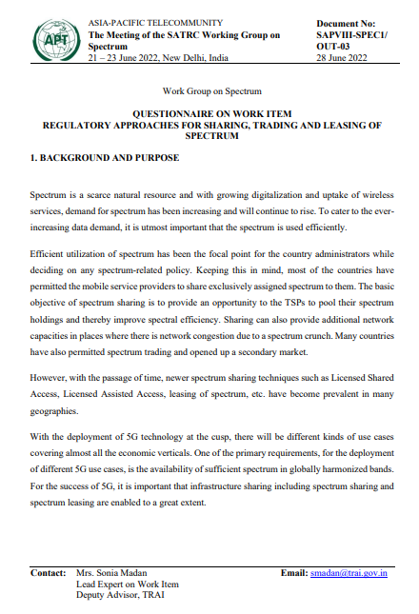

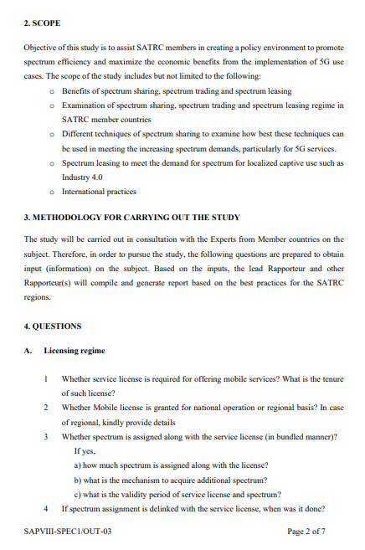

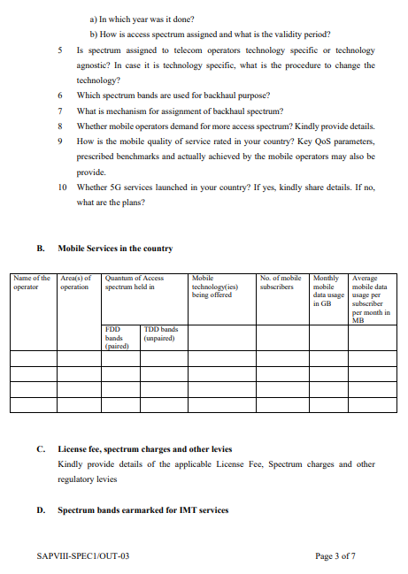

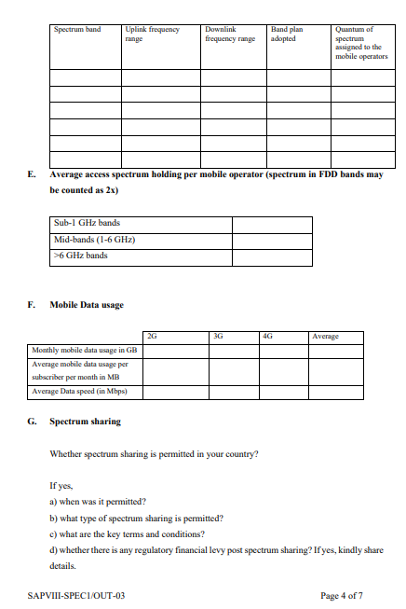

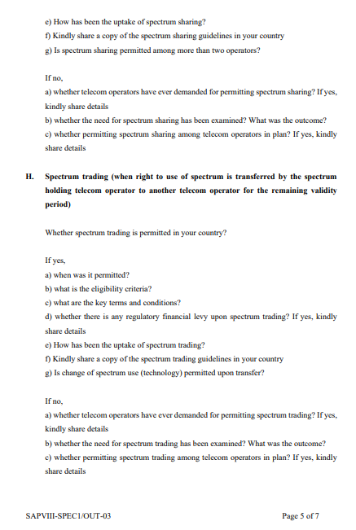

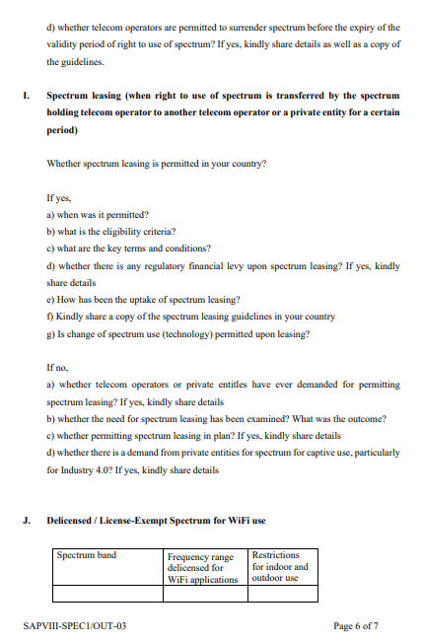

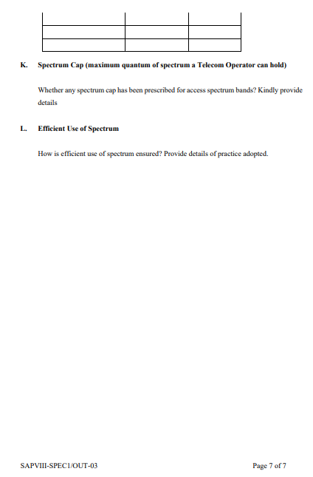

https://www.berec.europa.eu/sites/default/files/files/document_register_store/2018/6/BoR_%2818%29_116_BEREC_Report_infrastructure_sharing.pdf
Source: https://www.itu.int/net4/itu-d/icteye#/query
https://www.oulu.fi/en/theses/special-applications-and-spectrum-sharing-lsa
https://dot.gov.in/sites/default/files/Sharing%20Guidelines%2011%20Oct%202021.pdf?download=1
https://dot.gov.in/sites/default/files/2015_10_13%20Trading-WPC_0.pdf?download=1
https://dot.gov.in/sites/default/files/Spectrum%20leasing%20guidelines%20dated%2027062022.pdf

