

APT REPORT ON

SMART CITIES AND SOCIETIES: EXPERIENCE AND CASE STUDIES IN SATRC COUNTRIES IN DEPLOYING IOT, BIG DATA AND SIMILAR TECHNOLOGIES

Edition: November 2025

The 26th Meeting of South Asian Telecommunication Regulators’ Council (SATRC-26)
5 – 7 November 2025
Islamabad, Pakistan

(Source: SATRC-26/OUT-06)

No. SAPIX-REP-06

Adopted by

26th Meeting of South Asian Telecommunication Regulators’ Council (SATRC-26)
5-7 November 2025
Islamabad, Pakistan

(Source: SATRC-26/OUT-06)

Table of Content

Executive Summary 3
1. Introduction: 4
2. Modern Technologies Powering Smart Cities 5
2.1 Internet of Things (IoT) 5
2.2 Big Data and Analytics 6
2.3 Artificial Intelligence (AI) and Machine Learning 7
2.4 5G/6G and Beyond 8
2.5 Blockchain for Smart Cities 9
2.6 Edge Computing 10
2.7 Digital Twins 11
3. Case Study of Smart City Deployment in SATRC Countries 13
3.1 Bangladesh 13
3.2 Bhutan 13
3.3 India 14
3.4 Iran 14
3.5 Pakistan 15
3.6 Sri Lanka 16
3.7 Nepal 16
4. Deployment Challenges and Successes 16
4.1 Technical Barriers 16
4.2 Socio-Economic Factors 17
4.3 Policy and Governance 17
5. Future Prospects 17
5.1 Emerging Trends 17
5.2 Opportunities for South Asian Countries 18
5.3 Global Collaboration 18
6. Recommendations 19
7. Conclusion 19

Executive Summary

The SATRC member countries are experiencing rapid urbanization, which has intensified demands on infrastructure, public services, and environmental management. To address these pressures, governments are turning to smart city approaches that make use of emerging technologies such as IoT, Big Data, advanced connectivity, blockchain, edge computing, and digital modelling. These tools are being applied to improve traffic control, energy efficiency, waste management, and disaster preparedness while also strengthening service delivery to citizens.

Across the region, progress is visible but uneven. India has established a structured framework for IoT and launched the Smart Cities Mission, though gaps remain in data governance and standards for new technologies. Iran has invested in AI development and spectrum planning for IoT but still faces challenges in regulatory coordination. Pakistan has introduced policies for IoT and cloud computing, with safe city projects underway, yet funding remains a constraint. Bangladesh has advanced through its Smart Bangladesh Vision and 5G rollout, but lacks comprehensive guidelines for AI and Big Data. Sri Lanka, Nepal, and Bhutan are at earlier stages, with pilot projects and policy discussions in place, though limited infrastructure, financial resources, and technical expertise slow progress.

Common challenges across SATRC countries include unreliable power supply, underdeveloped data centers, cybersecurity risks, and right-of-way disputes for urban projects. Socio-economic factors, such as funding shortfalls and limited public participation, further complicate implementation. Weaknesses in policy and governance are also evident, with most countries lacking complete frameworks for AI, Big Data, and smart city development.

Despite these constraints, new opportunities are emerging. IoT applications in transport, agriculture, and energy are expanding, supported by the rollout of 5G networks. Data-driven systems are being tested in disaster management, healthcare, and citizen services. Regional cooperation could reduce costs and improve consistency through shared spectrum planning, coordinated standards, and collaborative research. Partnerships with international organizations and private sector players can also help address funding and expertise gaps, while regional initiatives on cybersecurity and ethical use of technology would build greater trust in digital systems.

In summary, SATRC countries are taking important steps toward modernizing their cities and public services through practical use of new technologies. While progress varies across the region, the collective experience highlights both the opportunities and the obstacles that lie ahead. A stronger focus on governance, infrastructure investment, and regional cooperation will be essential in moving from pilot projects to sustainable and inclusive city systems.

- Introduction:
The 21st century has witnessed an unprecedented wave of urbanization, with more than half of the global population now residing in cities. This rapid urban growth has brought with it a host of challenges, including overcrowding, resource depletion, environmental degradation, and inefficient public services. In response, the concept of smart cities has emerged as a transformative solution, using cutting-edge technologies to create sustainable, efficient, and livable urban environments. At the heart of this transformation are Internet of Things (IoT), Big Data, and a suite of modern technologies such as Artificial Intelligence (AI), 5G, blockchain, and digital twins. These technologies enable cities to collect, analyze, and act on vast amounts of data in real time, optimizing resources, enhancing governance, and improving the quality of life for citizens.

The South Asia Telecommunication Regulatory Council (SATRC) countries i.e. Afghanistan, Bangladesh, Bhutan, India, Iran, Maldives, Nepal, Pakistan, and Sri Lanka are no strangers to these challenges. With some of the fastest-growing urban populations in the world, these nations face unique pressures to modernize their infrastructure, address socio-economic disparities, and build resilience against climate change and natural disasters. However, they also possess immense potential to leapfrog traditional development pathways by adopting smart city technologies. This report explores how SATRC member countries are deploying IoT, Big Data, and other modern technologies to build smart cities and societies, drawing on real-world case studies to highlight successes, challenges, and lessons learned.

The term smart city refers to an urban area that uses technology and data-driven solutions to enhance the efficiency of services, reduce costs and resource consumption, and improve the overall quality of life for its residents. While the concept is not new, its implementation has gained significant momentum in recent years due to advancements in IoT, Big Data, and AI. These technologies enable cities to monitor and manage everything from traffic and energy consumption to waste management and public safety, creating a seamless and interconnected urban ecosystem.
In SATRC countries, the push toward smart cities is driven by a combination of factors. Rapid urbanization, coupled with limited infrastructure and resources, has created an urgent need for innovative solutions. For example, cities like Dhaka (Bangladesh), Delhi (India), and Lahore (Pakistan) are grappling with severe traffic congestion, air pollution, and inadequate public services. At the same time, governments in the region are increasingly recognizing the potential of digital technologies to address these challenges and drive economic growth. Initiatives such as India’s Smart Cities Mission, Pakistan’s Safe City Projects, and Sri Lanka’s IoT based smart-grid solution are testament to this growing commitment.

However, the journey toward smart cities in SATRC countries is not without its hurdles. Limited digital infrastructure, funding constraints, and a lack of technical expertise pose significant challenges. Moreover, the socio-economic diversity of the region ranging from highly urbanized areas to remote rural communities requires tailored approaches that address the unique needs of each context. Despite these challenges, the region has made notable strides in adopting smart city technologies, offering valuable insights for other developing nations.

Rapid uptake of IoT technology is evident from the fact that GSMA Intelligence forecasts that the global IoT market will reach 38.7 billion connections by 2030, growing at a CAGR of 8% during 2023-2030. Having surpassed consumer connections in 2022, the number of enterprise connections is forecast to double, accounting for 63% of total IoT connections by 2030.
Big data and Artificial Intelligence (AI) are closely related to various applications. AI systems require vast amounts of data to learn from and make decisions. There are many applications involving the use of Big Data and AI, health care being an important area. Cloud computing provides the infrastructure for storing, processing and analyzing big data. Therefore, Big data, AI and cloud technology have close relationship. Given the pace of development of AI, PwC estimates that, over the next 5 years, 150 million people could be positively impacted by mobile Big data and AI solutions.

Under this work item, data, case studies and experience related to promotion/adoption of IoT, AI, Big Data, Cloud Computing and similar technologies, for development of smart cities & smart societies, are collected from SATRC member countries through a questionnaire.

- Modern Technologies Powering Smart Cities
The development of smart cities relies on a suite of advanced technologies that enable the collection, analysis, and application of data to improve urban living. These technologies ranging from the Internet of Things (IoT) to Artificial Intelligence (AI), blockchain, and beyond are transforming how cities operate, making them more efficient, sustainable, and responsive to the needs of their citizens. This section explores the key technologies powering smart cities, their applications, and examples from around the world.
  - Internet of Things (IoT)
The Internet of Things (IoT) is the backbone of smart cities, enabling the interconnection of devices, sensors, and systems to collect and exchange data in real time. Generally, infrastructure of IoT platform can be categorized in three main components:
- Sensors: Devices that collect data from the environment (e.g., temperature, humidity, motion).
- Actuators: Devices that perform actions based on data (e.g., turning on streetlights, adjusting traffic signals).
- Gateways: Intermediate devices that connect sensors and actuators to the cloud or central systems for data processing.
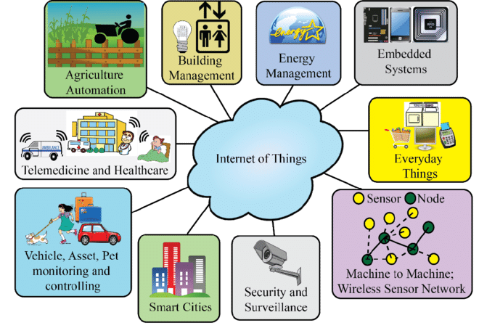
Internet of Things (IoT) in Smart Cities

The Internet of Things (IoT) plays a pivotal role in enhancing the functionality of smart cities through various applications. In smart grids, IoT-enabled energy systems optimize electricity distribution, minimize outages, and seamlessly integrate renewable energy sources, as demonstrated by Barcelona, where IoT has reduced energy consumption by 30%. For waste management, IoT sensors installed in waste bins alert authorities when they are full, streamlining collection routes and cutting operational cost. Copenhagen, Denmark, serves as a prime example . The city has implemented a smart waste management system where IoT-enabled sensors monitor bin fill levels and optimize collection routes. This initiative has reduced operational costs by 20% while significantly lowering carbon emissions.
  - Big Data and Analytics
Big data refers to extremely large and complex data sets that cannot be easily managed or analyzed with traditional data processing tools, particularly spreadsheets . Big data includes structured data, like an inventory database or list of financial transactions; unstructured data, such as social posts or videos; and mixed data sets, like those used to train large language models for AI generally generated by IoT devices, social media, and other sources. Analytics involves processing this data to extract actionable insights. Together, they form the backbone of data-driven decision-making in smart cities. Key components in a Big Data Platform are listed below:
- Data Collection: IoT sensors, cameras, and mobile apps collect data on traffic, weather, energy usage, and more.
- Storage: Cloud-based platforms and data lakes store vast amounts of data for analysis.
- Processing: Advanced analytics tools, including machine learning algorithms, processing data to identify patterns and trends.
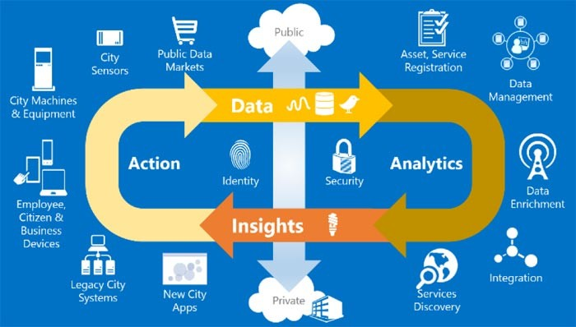
Uses of Big Data in Smart Cities

Big Data analytics are transforming smart cities by enabling data-driven solutions across various domains. In flood forecasting, advanced Big Data models predict potential flooding events and issue early warnings, significantly mitigating damage. ​Jakarta's innovative flood control system, which utilizes big data analytics to predict and manage flooding, has significantly improved the city's disaster response capabilities . Additionally, Big Data plays a crucial role in energy optimization, where analytics are used to monitor and optimize energy consumption in buildings and streetlights. Copenhagen has actively integrated big data analytics into its energy management strategies to enhance sustainability and efficiency. The city has implemented a platform that aggregates data from various sources—including demographics, energy consumption meters, air quality sensors, and traffic sensors—to support functions like green infrastructure planning, traffic management, and energy usage optimization .
  - Artificial Intelligence (AI) and Machine Learning
Artificial Intelligence (AI) and Machine Learning (ML) enable smart cities to automate processes, optimize resources, and improve decision-making. AI algorithms analyze data from IoT devices and other sources to provide insights and predictions.
Artificial Intelligence (AI) is revolutionizing smart cities by optimizing resources, improving mobility, and enhancing citizen services. In energy optimization, AI algorithms analyze consumption patterns to reduce energy usage in buildings and streetlights. For instance, Google’s DeepMind has successfully cut energy consumption in data centers by 40% using AI. Similarly, in traffic prediction, AI systems analyze real-time data to forecast traffic patterns and recommend optimal routes, significantly reducing congestion. Singapore, for example, has implemented AI-driven traffic management systems that have decreased travel times by 15%. Additionally, AI-powered citizen services, such as chatbots and virtual assistants, provide residents with seamless access to information and services, including reporting issues or paying bills, enhancing overall urban living experiences.
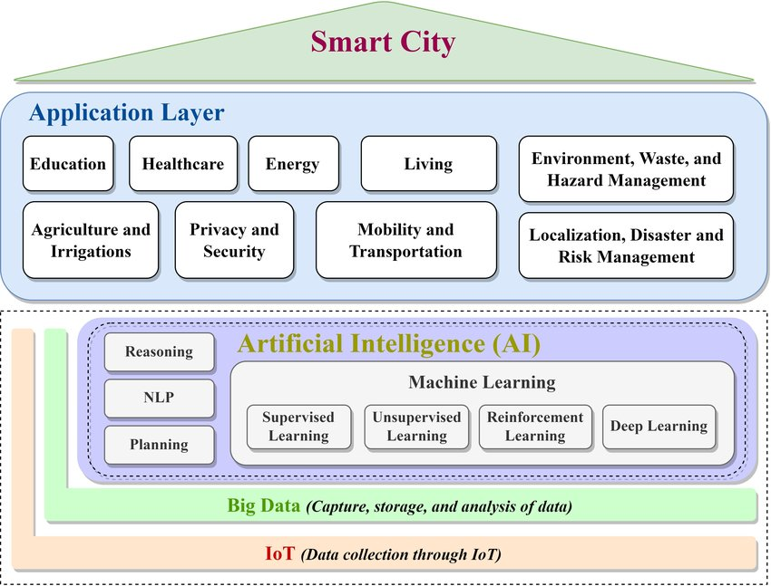
Conceptual AI Based Smart City Framework
A notable case study is Singapore’s AI-driven public transport scheduling system, which has transformed urban mobility. By utilizing real-time data from buses and traffic sensors, the system dynamically adjusts routes and schedules, reducing waiting times and improving efficiency. This innovative use of AI not only enhances the reliability of public transport but also contributes to reducing traffic congestion and pollution.
  - 5G/6G and Beyond
5G, the fifth generation of mobile networks, represents a significant leap forward in connectivity, offering ultra-high speeds, minimal latency, and the capacity to connect millions of devices simultaneously. This technology is a cornerstone for the development of smart cities, enabling seamless communication and data exchange across various urban systems. While 5G is already transforming industries, 6G, which is still in the research and development phase, promises even faster speeds, greater reliability, and enhanced capabilities, paving the way for more advanced and interconnected urban ecosystems.
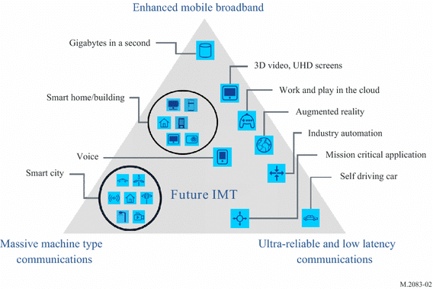
Usage scenarios of 5G

The role of 5G and 6G in smart cities is multifaceted. One of the most critical applications is real-time data transmission, which allows IoT devices to communicate instantly, ensuring swift responses to emergencies such as traffic accidents or power outages. Additionally, the high-speed connectivity of 5G and 6G supports advanced IoT applications, including autonomous vehicles, remote healthcare, and augmented reality. These technologies not only improve efficiency but also enhance the quality of life for residents by enabling smarter infrastructure and services.
Examples of 5G and 6G in action highlight their transformative potential. In South Korea, Seoul has integrated 5G into its smart traffic management and public safety systems, significantly improving urban mobility and security. Meanwhile, China is at the forefront of 6G development, with cities like Shanghai testing the technology for ultra-high-speed data transmission and IoT connectivity.
  - Blockchain for Smart Cities
Blockchain, a decentralized, secure, and transparent ledger technology, is revolutionizing smart city applications by enhancing trust, efficiency, and accountability. Its potential lies in enabling secure and tamper-proof systems across various domains. Key applications include:
- Transparent Governance: Blockchain can streamline processes like land registries, voting systems, and public procurement, reducing corruption and increasing transparency.
- Secure IoT Data Exchange: By ensuring the integrity and security of data exchanged between IoT devices, blockchain prevents tampering and unauthorized access, making IoT networks more reliable.
- Dubai Blockchain Strategy: A prime example is Dubai’s ambitious plan to become the world’s first blockchain-powered city, using the technology for land registries, visa applications, and energy trading, showcasing its transformative potential in urban management.
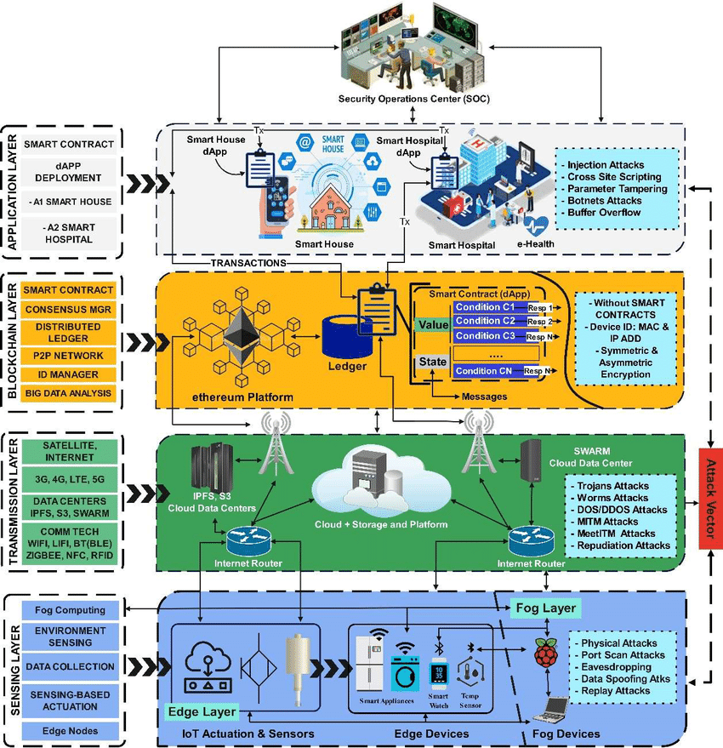
Architecture For Blockchain based Smart City

  - Edge Computing
Edge Computing is a transformative approach that involves processing data near its source, such as IoT devices, rather than relying on centralized cloud systems. By minimizing the distance data must travel, edge computing significantly reduces latency and bandwidth usage, making it ideal for real-time applications that require immediate responses. This technology is particularly valuable in smart cities, where speed and efficiency are critical for managing complex urban systems.
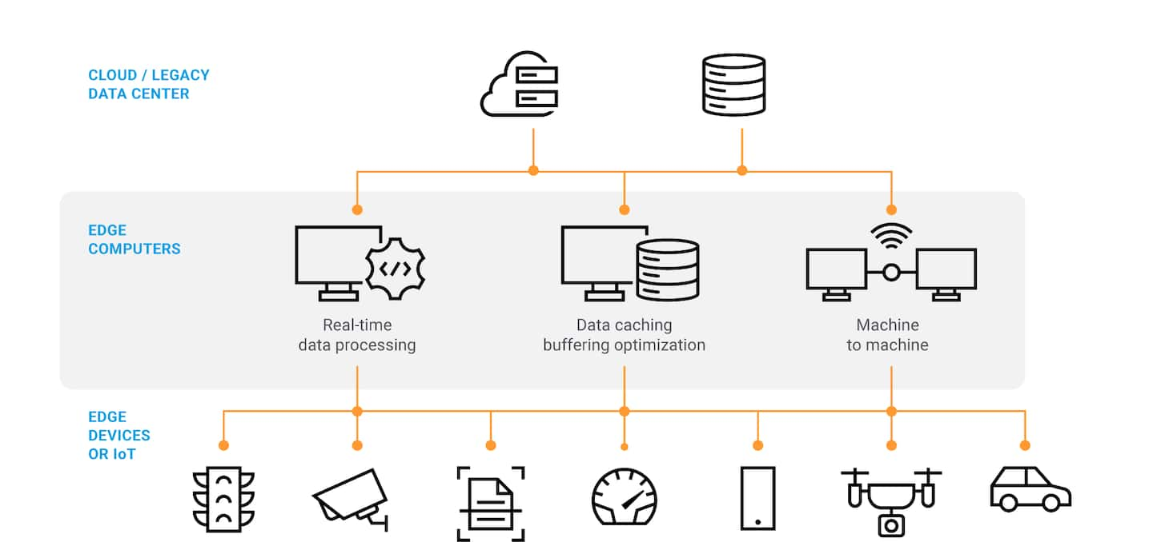
Edge Computing Overview

In smart cities, edge computing finds practical applications in areas like smart surveillance cameras, where it enables real-time video analysis for enhanced security and traffic monitoring. It also plays a crucial role in autonomous vehicles, as edge devices process data from sensors and cameras in real time, allowing for quick and accurate decision-making. A notable example is New York City’s smart traffic lights, which use edge computing to analyze data from traffic cameras and sensors, effectively reducing congestion and improving road safety. These applications highlight how edge computing is driving innovation and efficiency in urban environments.
  - Digital Twins
A Digital Twin is a virtual representation of a physical city, built using data from IoT sensors, Geographic Information Systems (GIS), and other sources. This technology enables city planners to simulate, analyze, and optimize urban systems in real time, providing valuable insights for decision-making. In urban planning, digital twins allow planners to visualize the potential impact of new infrastructure projects, ensuring more efficient and sustainable development. Additionally, they play a critical role in disaster management, where cities can use digital twins to simulate natural disasters and develop effective response strategies.

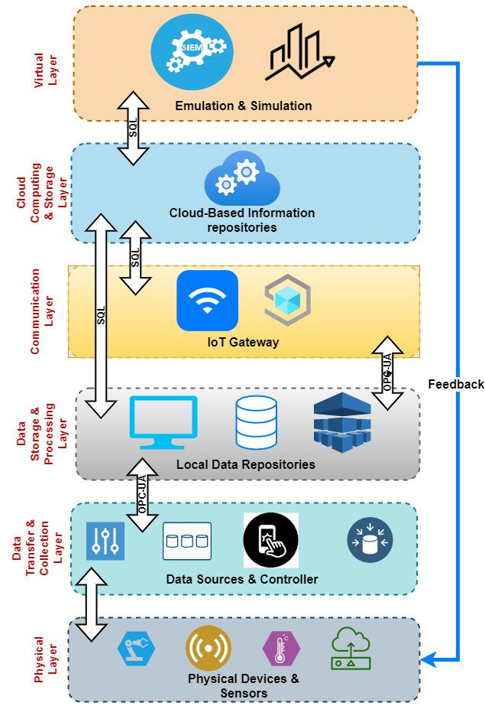
Six-layer Conceptual Architecture of Digital Twin Model

- Case Study of Smart City Deployment in SATRC Countries
The study on smart city deployment in SATRC countries was conducted through a comprehensive questionnaire distributed to member countries, including Afghanistan, Bangladesh, Bhutan, India, Iran, Maldives, Nepal, Pakistan, and Sri Lanka. The questionnaire aimed to gather data on policy frameworks, regulatory environments, technological adoption, and practical implementations of IoT, AI, Big Data, and Cloud Computing in smart city projects. The responses were analyzed to identify common trends, challenges, and successes across the region
  - Bangladesh
Bangladesh has made significant strides in promoting the adoption of IoT, AI, Big Data, and Cloud Computing as part of its Digital Bangladesh and Smart Bangladesh visions. The country has developed a policy framework for IoT, with the Bangladesh Telecommunication Regulatory Commission (BTRC) publishing guidelines for the importation of IoT devices. Additionally, Bangladesh has allocated 5G spectrum to Mobile Network Operators (MNOs) to support the development of Smart Cities and Smart Societies, with specific rollout obligations being formulated to ensure timely deployment. However, the country currently lacks specific policies for AI, Big Data, and Cloud Computing, although the National ICT Policy of 2018 indirectly supports these technologies by focusing on ICT growth. The licensing framework for IoT requires entities to be enlisted with the BTRC, with a fee of 100,000 BDT plus 15% VAT for commercial purposes, valid for two years. The enlistment process ensures compliance with BTRC regulations, including the need for permission for each IoT device import and the provision of customer support. Despite these efforts, Bangladesh faces challenges in funding smart city projects, limited technical expertise, and the absence of a comprehensive regulatory framework for AI and Big Data. The country’s infrastructure is evolving to support big data technologies, with investments in data centers and initiatives under the Smart Bangladesh Vision 2041. However, challenges such as inconsistent power supply and limited rural infrastructure hinder the full-scale deployment of these technologies. Bangladesh’s smart city initiatives, such as the Jolshiri project, are in the early stages, with a focus on integrating modern facilities with green infrastructure. The government is also exploring the use of IoT and AI for traffic management, waste management, and public safety, but the lack of a dedicated government department for smart city development and limited multi-stakeholder collaboration pose significant challenges.
  - Bhutan
Bhutan’s approach to smart city technologies is still in its early stages, with limited policy frameworks and regulatory guidelines in place. The country has developed a SIM-based IoT numbering plan and has started an AI readiness assessment study, with plans to develop a National AI Strategy. However, there are no specific policies or frameworks for Smart Cities, Big Data, or Cloud Computing, although these technologies are highlighted in the Digital Strategy. The Bhutan Information Communications and Media Authority (BICMA) issues licenses for IoT service providers, but the duration and fees for these licenses are yet to be decided. Bhutan’s regulatory framework for IoT is primarily governed by the Telecommunications Act of 2001, with no specific regulations for community IoT networks or roaming of IoT devices. The country’s infrastructure for supporting big data technologies is still under development, with plans to enhance data center capabilities. Bhutan has not yet deployed any smart cities, but the government is exploring the use of IoT for safety, security, and agriculture. The lack of technical expertise, funding constraints, and limited infrastructure are significant barriers to the deployment of smart city technologies in Bhutan. The government is pushing for a common duct to connect buildings with fiber optic cables, which is expected to facilitate the development of smart cities. However, the absence of a comprehensive regulatory framework for AI and Big Data, along with limited collaboration between stakeholders, poses challenges for the country’s smart city ambitions.
  - India
The National Digital Communication Policy (NDCP) forms the foundation for IoT development, emphasizing the creation of robust digital infrastructure and the adoption of next-generation technologies. The IoT framework includes a detailed roadmap for Machine-to-Machine (M2M) communications, with guidelines for KYC processes for M2M SIMs, the use of embedded SIMs (e-SIMs), and a 13-digit numbering scheme for M2M SIMs. It also promotes national standards for IoT based on OneM2M Release 2 standards and introduces a code of practice for securing consumer IoT devices. The government has allocated an additional spectrum in the unlicensed band (865-868 MHz) to support IoT deployments and established a new licensing regime under the Unified Licensing framework, which includes specific categories for M2M service providers. These measures aim to streamline the registration and operation of M2M service providers and WPAN/WLAN connectivity providers, ensuring a harmonized approach to IoT adoption. In contrast, the policy framework for Artificial Intelligence (AI) is still under development, indicating that India is in the early stages of formulating guidelines for AI deployment. While AI holds significant potential for applications in smart cities, disaster management, and public services, the absence of a formal regulatory framework poses challenges in terms of standardization, ethical considerations, and data privacy. This contrasts with IoT, where a more mature regulatory environment exists. The lack of a defined policy for AI highlights the need for a structured approach to govern its development and deployment responsibly.
The Smart Cities Mission is a key initiative aimed at promoting sustainable urban development through the application of smart solutions. The mission focuses on creating cities with core infrastructure, a clean environment, and a decent quality of life for citizens. Core infrastructure elements include water supply, electricity, sanitation, urban mobility, affordable housing, IT connectivity, and good governance. The mission adopts a multi-stakeholder approach, with Special Purpose Vehicles (SPVs) responsible for planning and executing projects at the city level. Public-private partnerships (PPPs) play a significant role, with over 200 PPP projects undertaken across more than 50 cities, covering areas such as multi-modal transit hubs, smart lighting, waste-to-energy, and public utilities. However, challenges related to right-of-way issues, public participation, and financial sustainability remain, requiring continuous efforts to ensure successful implementation. Regarding Big Data and Cloud Computing, there is currently no specific licensing or authorization framework. However, the Digital Personal Data Protection Act, 2023, notified in August 2023, aims to regulate the processing of digital personal data, ensuring privacy while allowing lawful data processing. The act mandates that structured data must be handled with individual consent, with special provisions for minors' data. While cloud-based services are not regulated, the Telecom Regulatory Authority of India (TRAI) has recommended the establishment of self-regulatory organizations for cloud-based telecom services, reflecting the need to address data security and cyber threats. India's infrastructure for supporting big data technologies is rapidly evolving, with significant investments in data centers. The country’s data center capacity is expected to grow exponentially from 1.4 gigawatts (GW) in 2024 to 9GW in 2030. This growth underscores India's commitment to building a robust digital infrastructure to support big data technologies, particularly for smart city projects and IoT deployments.
  - Iran
Iran has taken significant steps to promote the adoption of IoT, AI, Big Data, and Cloud Computing as part of its seventh development plan. The government has implemented the national program for AI development, which focuses on establishing technical, social, ethical, and legal infrastructures for AI. The Information Technology Organization of Iran has also developed RF and EMC tests for IoT devices and is working on a governance document for IoT services. The country has allocated licensed RF bands for IoT deployment, including IMT bands for mobile network operators, and unlicensed bands for long-range non-cellular IoT applications like LoRa and Sigfox. However, Iran lacks specific regulations for roaming of IoT devices and satellite-based IoT, although the BTRC is working on establishing a regulatory framework for these areas. The country’s telecommunications infrastructure is relatively extensive, with investments in fiber-optic networks and data centers to support big data technologies. However, challenges such as limited access to certain technologies, regulatory hurdles, and the need for specialized training programs hinder the full realization of big data capabilities. Iran’s smart city initiatives focus on intelligent transportation, public security, and production factors, with IoT playing a key role in these areas. The government is also exploring the use of blockchain for secure IoT data exchange and transparent governance. Despite these efforts, the lack of a comprehensive regulatory framework for AI and Big Data, along with limited collaboration between stakeholders, poses challenges for the country’s smart city ambitions.
  - Pakistan
The Pakistan Telecommunication Authority (PTA) has introduced the "Regulatory Framework for SRD & IoT Services in Pakistan" in 2022, which enables the development of IoT ecosystems through the use of unlicensed/shared bands for Low Power Wide Area Networks (LPWAN) on a non-interference basis. The framework also allows for the use of exclusively assigned/licensed frequency bands for IoT technology. Additionally, Pakistan has developed the National Cyber Security Policy (2021) and the Pakistan Cloud First Policy (2022), which provide guidelines for cybersecurity and cloud computing adoption. However, there is no specific policy framework for AI, Smart Cities, or Big Data, indicating that these areas are still in the early stages of regulatory development. The absence of a comprehensive policy for AI, in particular, highlights the need for a structured approach to govern its ethical use, data privacy, and standardization. In terms of licensing, Pakistan currently requires a license only for the deployment of LPWAN IoT devices, issued by the PTA, which is valid for five years. There is no licensing regime for AI, Big Data, or Cloud Computing, suggesting a more relaxed regulatory environment for these technologies. Licensees for IoT must comply with obligations related to the clearance of cell sites as per the Standard Operating Procedures of the PTA and the Frequency Allocation Board. This indicates a focus on ensuring that IoT deployments do not interfere with existing telecommunications infrastructure. However, the lack of licensing requirements for AI and Big Data may pose challenges in terms of oversight, particularly in areas such as data security and ethical AI use. The ongoing development of the DIGITAL NATION PAKISTAN ACT, 2024, which aims to establish a National Commission and Authority for regulating digital services, data governance, cybersecurity, AI, and virtual assets, suggests that Pakistan is moving towards a more comprehensive regulatory framework for emerging technologies.
The Smart Cities initiative in Pakistan is still in the planning phase, with a focus on Smart Safe Cities that utilize IoT and connected devices to enhance security in residential areas. The Safe City Authority is responsible for planning and developing these projects, with multi-stakeholder collaboration between government departments and private developers. However, the primary challenge remains funding, as the government is the main investor in these projects. The lack of a specific policy or guidelines for resolving Right of Way (RoW) issues for smart city development further complicates implementation. Despite these challenges, progress has been made in resolving RoW issues with key stakeholders such as the National Highway Authority (NHA) and Pakistan Railways, indicating a collaborative approach to infrastructure development. Pakistan's infrastructure for supporting big data technologies is in the development stage, with the establishment of data centers and increasing availability of internet and cloud services. However, challenges such as inconsistent power supply and economic hurdles hinder the full-scale deployment and efficiency of big data solutions. Efforts are underway to address these issues, with ongoing investments in telecommunications and data infrastructure. Local cloud service providers like Garaj (Cloud Platform by Jazz), PTCL Smart Cloud, and Transworld Cloud are expanding their offerings, reflecting a growing capacity to support big data technologies. Despite these advancements, the country still faces significant challenges in achieving the necessary infrastructure to fully use big data, AI, and IoT technologies. In conclusion, Pakistan has made initial strides in developing a regulatory framework for IoT and cloud computing, with the introduction of the SRD & IoT Regulatory Framework and the Cloud First Policy. However, the absence of specific policies for AI, Smart Cities, and Big Data indicates that these areas require further attention. The ongoing development of the DIGITAL NATION PAKISTAN ACT, 2024, and the focus on Smart Safe Cities suggest that Pakistan is moving towards a more comprehensive approach to regulating and adopting emerging technologies. Nonetheless, challenges related to funding, infrastructure, and regulatory gaps remain, requiring continued efforts to ensure the successful implementation of smart city projects and the adoption of advanced technologies.
  - Sri Lanka
Sri Lanka’s approach to smart city technologies is still in its early stages, with limited policy frameworks and regulatory guidelines in place. The country has developed a 13-digit numbering scheme for M2M SIMs and identified spectrum for IoT deployment, but there are no specific policies for AI, Big Data, or Cloud Computing. The Telecommunications Regulatory Commission of Sri Lanka (TRCSL) requires spectrum compliance and approval for IoT device importation, but there are no licensing requirements for AI and Big Data. Sri Lanka’s infrastructure for supporting big data technologies is evolving, with adequate telecommunications infrastructure but limited data center capabilities. The country has not yet deployed any smart cities, but there were initiatives like the Smart Gampaha project, focusing on smart waste management, traffic monitoring, and public safety. However, the lack of a comprehensive regulatory framework for AI and Big Data, along with limited funding and poses significant challenges. However, a dedicated regulatory framework for smart cities and related matters like community IoT networks is vital for developments in that area.
  - Nepal
Nepal has made progress in promoting the adoption of IoT, AI, Big Data, and Cloud Computing through frameworks like the Digital Nepal Framework 2019, National ICT Policy 2015, and E-Government Master Plan 2015. The country has allocated spectrum for IoT under the unlicensed regime and requires type approval for radio IoT devices. However, Nepal lacks specific policies for AI, Big Data, and Cloud Computing, although these technologies are promoted under the broader ICT framework. The Nepal Telecommunications Authority (NTA) regulates IoT deployment, but there is no specific licensing framework for AI and Big Data. The country’s infrastructure for supporting big data technologies is still in the early stages, with limited data center capabilities and technical expertise. Nepal has not yet deployed any smart cities, but the government is planning to develop smart cities in Kathmandu and Lumbini using a public-private partnership model. The Ministry of Urban Development oversees these initiatives, but funding constraints and regulatory hurdles pose significant challenges. The country is exploring the use of IoT for traffic management, waste management, and disaster management, but the lack of a comprehensive regulatory framework for AI and Big Data hinders the adoption of these technologies. Nepal’s efforts to resolve Right of Way (RoW) issues for smart city development involve key stakeholders like the Ministry of Urban Development, local municipalities, and the Department of Roads. However, the absence of a dedicated regulatory framework for community IoT networks and limited collaboration between stakeholders pose challenges for the country’s smart city ambitions.

- Deployment Challenges and Successes
  - Technical Barriers
The deployment of emerging technologies such as IoT, AI, Big Data, and Cloud Computing across South Asian countries faces significant technical barriers. While various countries have made significant progress in deployment of Smart Cities and adoption of emerging technologies, challenges such as inconsistent power supply, limited data center capacity, and the need for robust cybersecurity measures remain intact.
Almost all SATRC countries struggle with inconsistent power supply and economic hurdles, which hinder the full-scale deployment of big data solutions. Bangladesh, despite its progress in IoT and 5G spectrum allocation, lacks specific policies for AI and Big Data, leading to gaps in standardization and interoperability. Nepal while making strides in IoT and smart city initiatives, face challenges in data center infrastructure and technical expertise, limiting their ability to fully support big data technologies. Bhutan and Sri Lanka, though in the early stages of IoT deployment, lacks a comprehensive regulatory framework for AI and Big Data, which could slow down technological adoption. These technical barriers highlight the need for significant investments in infrastructure, cybersecurity, and technical training to overcome these challenges.
  - Socio-Economic Factors
Socio-economic factors play a critical role in the deployment of emerging technologies in South Asia. In India, the Smart Cities Mission aims to address urban challenges through multi-stakeholder collaboration, but issues such as public participation, funding, and right-of-way (RoW) disputes pose significant hurdles. Similarly, in Pakistan, the primary challenge for smart city projects is funding, as the government is the main investor. Bangladesh’s smart city initiatives, such as the Jolshiri project, rely heavily on cooperative funding models, which may not be scalable for larger urban centers. Nepal faces socio-economic challenges such as funding constraints and regulatory hurdles, which slow down the implementation of smart city projects. Sri Lanka is in the final stage in the preparation of AI strategy for the country while facing funding constraints similar to other countries in the region. Bhutan, with its limited resources, is in the early stages of developing a national AI strategy, indicating a need for greater investment and public awareness. These socio-economic factors underscore the importance of public-private partnerships, community engagement, and innovative funding models to drive technological adoption.
  - Policy and Governance
Policy and governance frameworks are crucial for the successful deployment of emerging technologies. India has made significant progress with its National Digital Communication Policy and Smart Cities Mission, but gaps remain in AI regulation and data privacy. Pakistan has introduced frameworks for IoT and cybersecurity but lacks specific policies for AI and Big Data. Bangladesh has made strides with its IoT import regulations and 5G spectrum allocation but needs comprehensive policies for AI and Big Data. Nepal and Sri Lanka are in the early stages of developing regulatory frameworks for IoT and smart cities, with a focus on public-private partnerships. Bhutan is beginning to develop a national AI strategy but lacks a comprehensive regulatory framework for emerging technologies. These policy gaps highlight the need for harmonized regulatory frameworks, stronger governance structures, and multi-stakeholder collaboration to ensure the successful deployment of IoT, AI, Big Data, and Cloud Computing technologies across the region.

- Future Prospects
  - Emerging Trends
The future of emerging technologies in South Asia is being shaped by several transformative trends. IoT adoption is accelerating, driven by smart city initiatives, industrial automation, and agricultural innovations. In India, IoT is being integrated into transportation, energy, and healthcare, while Pakistan focuses on IoT-enabled public safety systems. Bangladesh is using IoT for smart metering and traffic management. The rise of 5G networks across the region, particularly in India, Pakistan, and Bangladesh, will further enhance IoT scalability and connectivity, enabling real-time data processing and advanced applications like autonomous vehicles and smart grids.
Artificial Intelligence (AI) is another key trend, with countries like India exploring AI for disaster management, healthcare, and urban planning. India’s focus on AI-driven predictive analytics highlights its potential, but the lack of comprehensive AI policies in countries like Pakistan, Bangladesh, and Nepal poses challenges. Big Data and Cloud Computing are also gaining traction, with India investing in data centers and cloud infrastructure. Bangladesh’s Smart Bangladesh Vision 2041 and Nepal’s Digital Nepal Framework aim to harness these technologies for e-governance and public service delivery. Sustainability is a growing focus, with IoT and AI being used for energy efficiency, waste management, and climate resilience. For instance, India’s smart cities incorporate green energy solutions, while Bangladesh explores IoT for water management. Edge computing is emerging as a critical trend, enabling faster data processing at the source, which is particularly relevant for IoT applications in remote areas of Nepal and Bhutan.
  - Opportunities for South Asian Countries
South Asian countries have immense opportunities to capitalize on emerging technologies for economic growth and societal development. India, with its robust ICT infrastructure and skilled workforce, can lead in AI innovation and IoT deployment, particularly in smart cities and healthcare. The country’s data center expansion and 5G rollout provide a strong foundation for scaling Big Data and Cloud Computing applications.
Pakistan can capitalize on its IoT Regulatory Framework and Cloud First Policy to drive digital transformation in agriculture, public safety, and energy. By adopting public-private partnerships, Pakistan can address funding gaps and accelerate smart city projects. Bangladesh’s focus on IoT and 5G presents opportunities for smart urban solutions, such as traffic management and waste monitoring. The country’s growing IT sector and young population offer a talent pool for AI and Big Data innovation. Nepal and Sri Lanka, though in early stages, can adopt IoT for precision agriculture, disaster management, and tourism. Nepal’s Digital Nepal Framework and Sri Lanka’s 5G plans provide a roadmap for integrating emerging technologies into public services. Bhutan’s emphasis on fiber-optic expansion and AI readiness assessments positions it to explore AI-driven governance and sustainable development.
Regional collaboration presents a significant opportunity. Shared challenges like cybersecurity, data privacy, and infrastructure gaps can be addressed through joint initiatives. For example, a South Asian IoT consortium could harmonize spectrum allocation and regulatory frameworks, while cross-border AI research hubs could drive innovation. Additionally, partnerships with global tech giants and multilateral organizations could provide funding, expertise, and technology transfer, enabling the region to leapfrog traditional development pathways
  - Global Collaboration
Global collaboration is essential for South Asian countries to overcome challenges and harness the full potential of emerging technologies. Knowledge sharing with technologically advanced nations can bridge gaps in AI, IoT, and Big Data expertise. For instance, partnerships with countries like South Korea, Japan, and Singapore could provide insights into smart city development and AI governance. Multilateral organizations like the United Nations, World Bank, and ITU can play a pivotal role in funding and capacity-building initiatives. Programs focused on digital literacy, cybersecurity, and infrastructure development could empower countries like Nepal, Bhutan, and Bangladesh to accelerate their digital transformation.
Cross-border collaborations within South Asia can enhance regional innovation. A unified IoT regulatory framework, similar to the EU’s approach, could streamline spectrum allocation and reduce barriers to deployment. Joint AI research initiatives could address shared challenges in healthcare, agriculture, and disaster management. For example, India’s expertise in AI-driven predictive analytics could complement Pakistan’s focus on IoT for public safety, creating synergies that benefit the entire region.
Public-private partnerships (PPPs) with global tech companies like Google, Microsoft, and Amazon can drive innovation and infrastructure development. These collaborations could focus on building data centers, expanding cloud services, and developing AI-driven solutions tailored to local needs. For instance, Microsoft’s AI for Good initiative could be expanded to include South Asia, addressing challenges like climate change and healthcare access.
Cybersecurity collaboration is critical, given the region’s vulnerability to cyber threats. Establishing a regional cybersecurity task force, supported by global experts, could enhance data protection and build trust in digital systems. Similarly, joint efforts to develop ethical AI frameworks could ensure that emerging technologies are deployed responsibly and equitably.

- Recommendations
To advance smart city development, SATRC countries should adopt a three-dimensional strategy combining regulatory reforms, infrastructure readiness, and regional collaboration.

- Policy and Regulation: Member states should establish comprehensive frameworks for IoT, Big Data, AI, and cloud computing. Regulations must clarify spectrum allocation, data privacy, and cybersecurity, while simplify licensing and enable pilot projects. A regional guideline on interoperability would help solutions scale across borders and avoid fragmented approaches.

- Infrastructure and Capacity: Reliable electricity, broadband expansion, and secure data centers must be prioritized as the backbone of smart city systems. Cybersecurity measures should be strengthened to safeguard public trust, and investments in training for regulators, municipal authorities, and technical professionals should ensure that expertise keeps pace with deployment. Incentive schemes, smart city funds, and structured public–private partnerships can help overcome financing barriers.

- Regional and Global Collaboration: SATRC countries should work together on shared research centers, joint testbeds for IoT and AI, and coordinated approaches to data governance. A regional task force on cybersecurity and ethical technology use could strengthen resilience. Engagement with global partners and development institutions will bring additional resources and knowledge transfer to complement regional efforts.

Following collaborations amongst SATRC countries could boost South Asia’s digital economy by an estimated $1–1.5 trillion by 2030 through improved efficiency, innovation, and cross-border collaboration:

- Joint effort to establish comprehensive Policy & Regulatory frameworks for IoT, Big Data, AI, Cloud Computing and Cyber Security.
- A unified IoT regulatory framework, similar to the EU’s approach, could streamline spectrum allocation and reduce barriers to deployment.
- Joint AI research initiatives could address shared challenges in healthcare, agriculture and disaster management.
- Public-private partnerships (PPPs) with global tech companies like Google, Microsoft, and Amazon can drive innovation and infrastructure development.
- These collaborations could focus on building data centers, expanding cloud services, and developing AI-driven solutions tailored to local needs.
- Microsoft’s AI for Good initiative could be expanded to include South Asia, addressing challenges like climate change and healthcare access
- Establishing a regional cybersecurity task force, supported by global experts, can enhance data protection and build trust in digital systems.
- Joint Cybersecurity measures should be strengthened to safeguard public trust
- Joint efforts for training & capacity enhancement for realization of smart cities.
- SATRC countries should work on partnerships with countries like South Korea, Japan and Singapore which could provide insights into smart city development and AI governance.
- Multilateral organizations like the United Nations, World Bank, and ITU can play a pivotal role in funding and capacity-building initiatives

- Conclusion
SATRC countries stand at an important point in their journey toward smarter and more resilient cities. While gaps in infrastructure, funding, and governance remain, the region has already demonstrated practical progress through pilot projects and national programs. By putting in place clear regulations for IoT, Big Data, cloud services, and emerging digital tools, strengthening infrastructure and technical capacity, and fostering both regional and global collaboration, member states can gradually move from isolated initiatives to integrated smart city systems. The experiences captured in this report show that with steady investment, effective policies, and cooperative approaches, South Asia can build urban environments that are more efficient, inclusive, and better prepared for future challenges.

https://www.ibm.com/think/topics/smart-city
https://time.com/6318377/traffic-by-city/
https://www.iqair.com/world-air-quality-ranking
Zaidi, Shehla, Prasanna Saligram, Syed Ahmed, Egbert Sonderp, and Kabir Sheikh. "Expanding access to healthcare in South Asia." Bmj 357 (2017).
https://www.gsmaintelligence.com/research/iot-market-forecast-to-2030-connections-by-region-and-vertical
https://www.gsma.com/solutions-and-impact/connectivity-for-good/external-affairs/gsma_events/unwdf2020/
https://www.ibm.com/think/topics/internet-of-things
Mohanty, Saraju. (2016). Everything You Wanted to Know About Smart Cities. IEEE Consumer Electronics Magazine. 5. 60-70. 10.1109/MCE.2016.2556879.
https://minnovation.com.au/smart-cities-2/example-of-a-smart-city-a-case-study-into-barcelona/
https://recyclinginside.com/recycling-technology/instrumentation-and-control/internet-of-things-iot-integration-in-waste-management-revolutionizing-recycling-with-the-internet-of-waste/
https://www.oracle.com/big-data/what-is-big-data/
https://www.linkedin.com/pulse/big-data-enables-development-smart-cities-olugbenga-jola-olukoya
https://www.beritajakarta.id/en/read/44735/jakartas-flood-control-system-wins-at-wsis-prizes-2022
https://stateofgreen.com/en/news/copenhagen-looks-to-big-data-to-deliver-a-sustainable-future
(World Bank, McKinsey Global Institute MGI 2018–2021, ADB (Asian Development Bank) Digital Strategy 2030).

