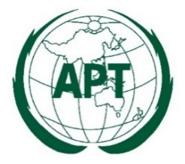

APT REPORT ON

SPECTRUM APPROACHES AND REGULATORY REQUIREMENTS TO ENABLE SATELLITE - IMT INTEGRATION

Edition: November 2025

The 26th Meeting of South Asian Telecommunication Regulators’ Council (SATRC-26)
5 – 7 November 2025
Islamabad, Pakistan

(Source: SATRC-26/OUT-09)

No. SAPIX-REP-09

Adopted by

26th Meeting of South Asian Telecommunication Regulators’ Council (SATRC-26)
5-7 November 2025
Islamabad, Pakistan

(Source: SATRC-26/OUT-09)

Contents

Chapter - I: Introduction 3
Chapter - II: Overview of Satellite-IMT Integration 8
Chapter - III: Inputs from SATRC Member Countries 20
Chapter - IV: Spectrum and Regulatory Approaches for Satellite-IMT Integration 27
Chapter - V: Conclusion, Recommendations, and Way Forward 49
Annexure 52
List of Acronyms 55

Chapter - I: Introduction

- Background and Purpose

  - Mobile connectivity is a key enabler of economic growth, social inclusion, and digital empowerment. It bridges the digital divide by extending access to financial services, digital platforms, and e-governance to unserved and underserved region. Mobile connectivity also ensures resilience during emergencies and disasters by providing continuity of communication and access to vital information. Ensuring universal mobile connectivity is necessary for achieving Sustainable Development Goals (SDGs) and fostering inclusive digital transformation.

  - The International Telecommunications Union (ITU) in its report on ‘Mobile digital developments - Facts and Figures 2024’ mentions about mobile network coverage that “3G or better is now available to 96 per cent of the world population. Bridging the “coverage gap”, that is, covering the remaining four per cent that lie beyond the reach of a mobile broadband signal, is proving difficult: since crossing the 90 per cent threshold in 2018, global 3G coverage has increased by only five percentage points. The largest coverage gap is in Africa, where 14 per cent of the population still does not have access to a mobile broadband network and therefore cannot access the Internet. LDCs and LLDCs, having 15 and 14 per cent of their population, respectively, beyond the reach of mobile broadband, are falling short of target 9.c of Sustainable Development Goal 9: to “significantly increase access to information and communications technology and strive to provide universal and affordable access to the Internet in least developed countries by 2020.”

  - The report further mentions that “Areas without any mobile broadband coverage whatsoever (i.e. where the best available standard is 2G or lower) are only found in rural regions. The proportion of the rural population affected by this coverage gap ranges from 2 per cent in Europe to 25 per cent in Africa. In LLDCs, 21 per cent of the rural population are not covered, while in LDCs it is 24 per cent. The biggest coverage gap is in rural areas of SIDS, where fully 39 per cent of the population are without any mobile broadband access whatsoever”. The population coverage by the type of mobile network for 2015-2024 is shown in figure 1.1.
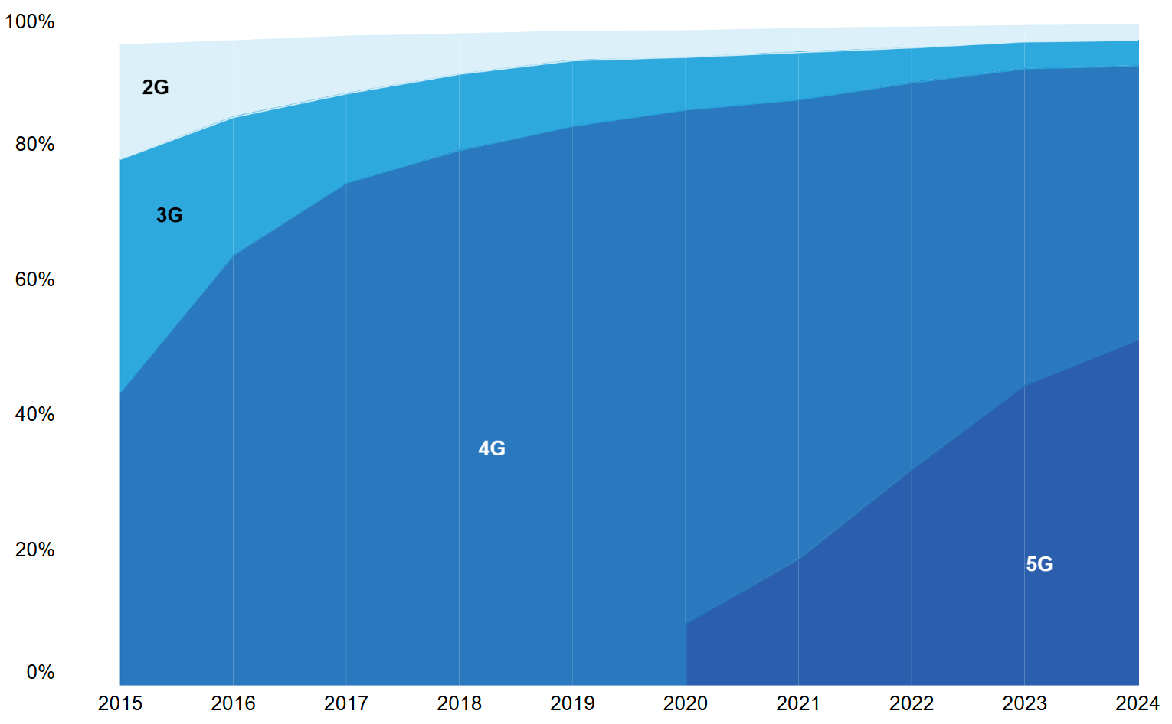

Figure: 1.1: Population coverage by type of mobile network, 2015-2024, ITU

  - The Global System for Mobile Communications Association (GSMA) in its report on ‘State of Mobile Internet Connectivity 2024’, also mentions that around 96% of global population is covered by mobile broadband networks (3G or higher), yet 350 million people, primarily in rural and low-income regions of Sub-Saharan Africa and South Asia, remain uncovered by any mobile broadband network. Mobile internet adoption continues to increase with 57% of the world's population (4.6 billion people) having mobile internet on their own device. Connectivity varies significantly by and within regions and countries, with 95% of those not using mobile internet living in Low- and Middle-Income Countries (LMIC). The mobile internet connectivity can deliver significant economic benefits, reduce poverty, mitigate impacts of crisis and transform people’s lives. In addition, mobile internet is associated with higher levels of wellbeing. The global mobile internet connectivity is shown in figure 1.2.

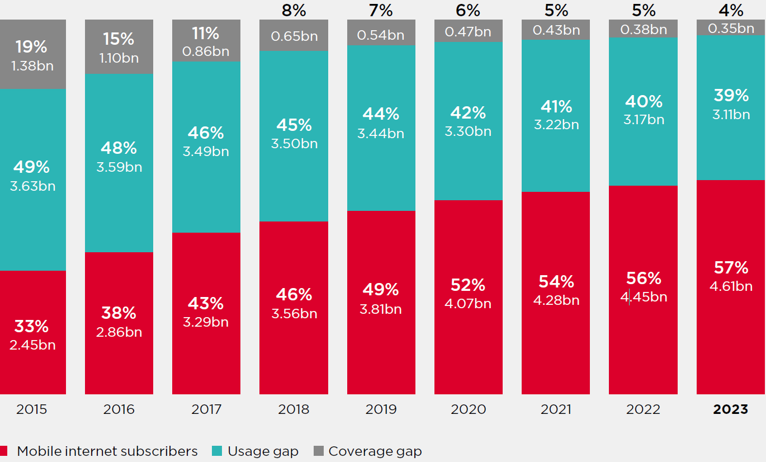

Figure 1.2: Global mobile internet connectivity, 2015–2023, GSMA
  - With 96% of the population covered by mobile networks, remaining 4% represent a significant population that is still without access to mobile services. For widespread and ubiquitous connectivity, integration of terrestrial International Mobile Telecommunications (IMT) network with Satellite network is one of the important means for extending coverage and closing the coverage gaps, as satellite communication network can complement IMT network where it is not available or impaired.

  - The core idea behind Satellite-IMT Integration is to leverage strengths of both terrestrial IMT networks and Satellite networks to create a more comprehensive and resilient communication network to provide mobile connectivity. In other words, the Satellite-IMT Integration provides an opportunity to address connectivity gaps, and to achieve truly ubiquitous connectivity. This will extend connectivity in remote and underserved areas while improving network reliability and uninterrupted service.

  - Within the broader concept of Satellite-IMT Integration, there are different terms that are used to represent models or building blocks to extend access of mobile services with the help of satellites. These terms include Non-Terrestrial Networks (NTN), Direct-to-Device (D2D, also called Direct-to-Cell (D2C) or Satellite-to-Phone or Satellite-to-Cellphone), Supplemental Coverage Service (SCS or NTN-SC), and Direct Connectivity between Mobile Satellite Service space station and IMT User Equipment (DC-MSS-IMT).

  - The Non-Terrestrial Networks (NTN) is umbrella framework defined by the 3rd Generation Partnership Project (3GPP) for integrating satellites, High Altitude Platforms (HAPS), and drones with IMT. 3GPP in its Release 17 introduced support for NTNs within 5G New Radio (5G NR) framework and introduced use of NR for satellite-based access. The ITU-R in Recommendation M.2160-0 (2023) described NTN as part of the IMT-2030 framework. In other words, NTN is used in conjunction with terrestrial IMT networks to provide ubiquitous and extended coverage. The scope of NTN includes that of all other models viz. D2D, SCS, and DC-MSS-IMT. NTN can make use of frequency bands identified for IMT and Mobile Satellite Service (MSS) . The NTN-capable user devices include NTN-capable user equipment, Internet-of-Thing (IoT) devices, Very Small Aperture Terminals (VSAT) etc.

  - Direct-to-Device communication (D2D) refers to a satellite-based connectivity model in which satellites communicate directly with consumer devices such as smartphone or IoT devices. In D2D model, satellite connect directly with either standard or modified user equipments. MSS-based D2D relies on MSS frequencies but require hardware in phones while IMT-based D2D uses IMT frequencies and aims to work with unmodified IMT User Equipment (UE). This often makes use of frequency bands identified for IMT, and sometimes MSS bands, if supported.

  - In Direct Connectivity between Mobile Satellite Service space station and IMT User Equipment (DC-MSS-IMT), the device has dual connectivity to the MSS satellites and terrestrial IMT, that is, this involves hybrid MSS and IMT operation. This makes use of frequency bands identified for MSS and are integrated with IMT. Therefore, such devices are dual mode devices supporting both MSS and IMT. This ensures service continuity and seamless fall back between networks.

  - In the Supplemental Coverage (SCS or NTN-SC), satellites provide coverage extension in IMT bands. In this, satellites act as a supplementary IMT layer and make use of IMT identified frequency bands, and satellites are used to fill the coverage holes. In such model, standard IMT devices benefit from such an extended coverage.

  - Thus, from the above it can be seen that there are multiple approaches towards Satellite-IMT Integration, but the basic intent is to provide access to IMT-based mobile services. However, achieving truly ubiquitous connectivity requires not only advancements in technologies and innovative network deployment models, but also clear spectrum and regulatory framework to enable Satellite–IMT Integration. This will ensure that widely available mobile handsets can access IMT services seamlessly, and benefit from IMT-based services.

  - For meeting the requirement of harmonised spectrum for Satellite-IMT Integration, ITU’s World Radiocommunication Conferences (WRCs) are crucial. In recently concluded WRCs, several agenda items (AI) were relevant for Satellite-IMT Integration, and next scheduled World Radiocommunication Conference 2027 (WRC-27) also has Agenda Item focussing on Satellite-IMT Integration.

  - To capitalize on the market potential of integrated Satellite and IMT network infrastructures for delivering IMT services across wider geographies, smartphone handsets are increasingly being equipped with MSS spectrum bands in their chipsets to communicate with the existing satellite systems. At the same time, satellite operators are collaborating with Mobile Network Operators (MNOs) to incorporate IMT spectrum bands into satellites, thereby enabling direct communication with mobile devices. This supports delivery of resilient services and generating significant social and economic benefits.

  - Given the developments, regulators and spectrum managers play a crucial role in facilitating Satellite-IMT Integration, ensuring efficient spectrum use through appropriate authorisation and policies. Some National Regulatory Authorities (NRAs) have made initiatives for authorising Satellite-IMT Integration. The role of regulators and spectrum managers is important to understand developments and issues involved relating to spectrum while framing policies to enable Satellite-IMT Integration.

- Scope

  - The study under the Work Item “Spectrum Approaches and Regulatory Requirements to Enable Satellite-IMT Integration” aims to analyse Satellite-IMT Integration, focusing on benefits and regulatory landscape, explore spectrum approaches for effective integration, identifying specific objectives and regulatory considerations necessary for seamless implementation. Additionally, the study examines integration strategies, market developments, and global initiatives. Insights gathered through the study will contribute in formulating recommendations for policymakers and industry stakeholders. The report focuses on spectrum strategies and regulatory frameworks in the access segment to support the expansion of IMT services and facilitate Satellite-IMT Integration.

  - The scope of the study on ‘Spectrum approaches and Regulatory requirements to enable Satellite-IMT Integration” is as below -
- Benefits and regulatory issues of Satellite-IMT Integration
- Spectrum approaches for Satellite-IMT Integration
- Examination of spectrum approaches to Satellite-IMT Integration in SATRC member countries
- International Regulation and Practices
- Conclusion, Recommendations, and Way Forward

- Methodology for carrying out the study

  - This study report has been prepared based on a comprehensive review of literature covering various aspects of Satellite–IMT Integration, including spectrum approaches, regulatory requirements, technical and operational considerations, enabling technologies and trends, policy recommendations from other administrations, and real-world implementations. In addition, a study of current practices in South Asian Telecommunication Regulators’ Council (SATRC) member countries was undertaken through a questionnaire. The findings and responses were analysed to assess the current scenario and to propose a way forward on ‘Spectrum Approaches and Regulatory Requirements to Enable Satellite–IMT Integration’ in SATRC countries. Furthermore, a set of additional recommendations relevant to the region has also been provided in this report.

- Structure of the Report

  - The report is divided into five chapters. Chapter I provides introduction with background information and purpose of the report. Chapter II provides overview of satellite communication, IMT, NTN, and Radio frequencies for satellite, IMT and NTN services. Chapter III provides information about the questionnaire and responses received from the member SATRC countries and their analysis thereof. Chapter IV provides spectrum and regulatory approaches and frameworks for Satellite-IMT Integration, and Chapter V provides conclusion, recommendations, way forward. The Report also includes Questionnaire on “Spectrum approaches and regulatory requirement to enable Satellite-IMT Integration” as Annexure and list of Acronyms.

Chapter - II: Overview of Satellite-IMT Integration

- Introduction

  - As discussed in Chapter I, with increasing demand for widespread and seamless connectivity, integrating satellite communications with terrestrial IMT networks is emerging as a key solution to extend coverage and close connectivity gaps. This approach harnesses the complementary strengths of terrestrial IMT and Satellite networks to build a more robust and far-reaching communication system. It enables reliable connectivity in remote and underserved regions while enhancing overall network resilience. Thus, Satellite-IMT Integration presents a vital opportunity to bridge digital divide and a move toward truly universal connectivity.

  - The following sections presents a brief overview of Satellite communication, International Mobile Telecommunications (IMT), Non-Terrestrial Network (NTN), and radio frequency bands for satellite, IMT, and NTN Service with focus on the access segment of the service.

- Satellite Communication

  - Satellite communication refers to any communication link that involves the use of an artificial satellite in its propagation path. A communications satellite relays and amplifies radio telecommunication signals via a transponder. There are many transponders on a typical satellite, each capable of supporting one or more communication channels.

  - Satellite-based communication systems can provide coverage to the remotest and most inaccessible areas of a geography. At present, many sparsely populated areas in the SATRC countries do not have terrestrial mobile coverage. Communication satellites have a potential to bridge this gap by providing telecommunication connectivity.

  - A typical satellite communication system consists of space segment, control segment, and ground segment as outlined below –
  - Space segment contains one of more satellites in space
  - Control segment consists of ground facilities for the control and monitoring of the satellites and for management of traffic and associated resources.
  - Ground segment consists of traffic earth stations, which include user stations, gateways, and service stations for distributing information.

  - The figure 2.1 shows key elements of a typical satellite communication system viz. satellite, satellite Earth station gateway and user station. The satellite Earth station gateway (also referred to as ‘gateway’), acts as a bridge (or gateway) between space-based communication network and terrestrial communication network.
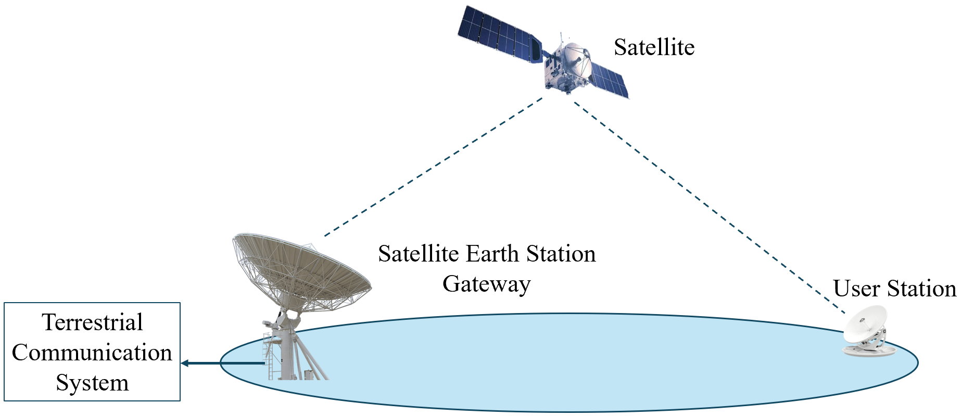

Figure 2.1: Key Elements of Satellite Communication Systems

  - The trajectory of a satellite around Earth is known as orbit. Satellites are classified based on satellite orbit around the Earth. The most common orbits followed by communication satellites are Low Earth Orbit (LEO), Medium Earth Orbit (MEO), and Geostationary Satellite Orbit (GSO). MEO and LEO satellites collectively are also called Non-Geo Stationary orbit (NGSO) satellites.

  - GSO satellites are at a distance of about 36,000 kilometres above the Earth, a place from where they appear to be fixed in the sky, when observed from the ground. They are commonly used for communication, weather monitoring, broadcasting, and internet provisioning. NGSO satellites at MEO altitudes are between 8,000 and 20,000 kilometres above the Earth and LEO altitudes are between 400 to 2,000 kilometres above the Earth. Since NGSO satellites move across the sky during their orbit around the Earth, NGSO operators deploy a fleet of satellites, generally called ‘constellations’, to provide continuous service from these altitudes. NGSO constellations intend to cover the globe providing high-bandwidth connectivity and processing high volumes of data with minimal delay. The figure 2.2 depicts the orbital altitudes and coverage areas of GSO and NGSO systems.

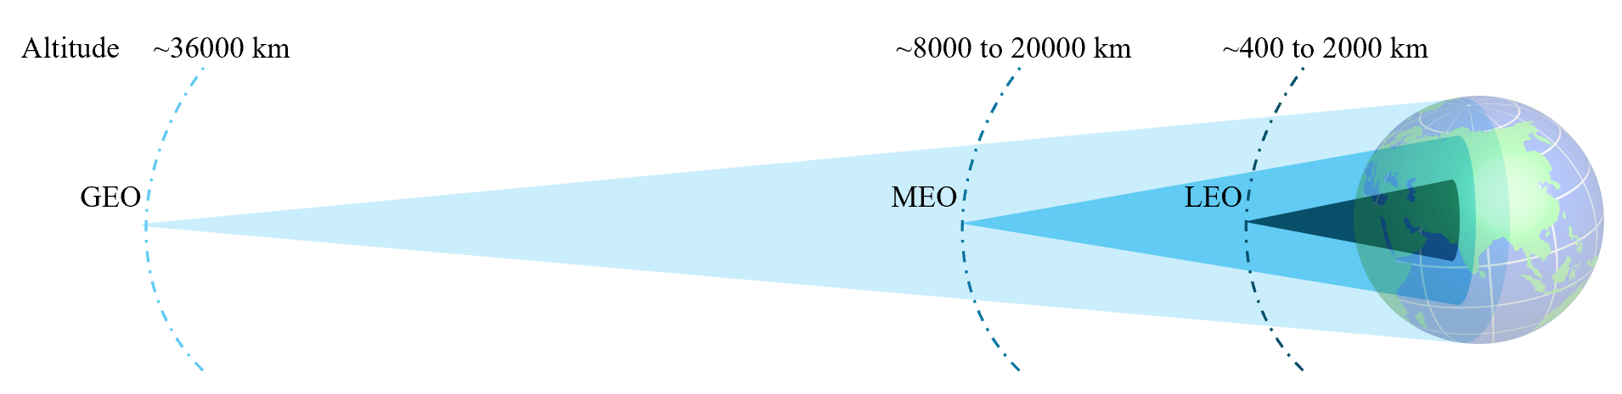

Figure 2.2: Schematic diagram of orbital altitudes and coverage areas of satellites

  - The ITU publication titled ‘The Last-mile Internet Connectivity Solutions Guide Sustainable connectivity options for unconnected sites 2020’, provides a comparison of GEO, MEO and LEO characteristics. Some of the characteristics are given in the table 2.1.

Table 2.1: Characteristics of GEO, MEO and LEO Satellite

Satellite category | Altitude | Orbital period | Latency (round-trip) | Number of satellites to span globe
GEO | 35,786 km | 24 hours | 477 ms | 3-4
MEO | 8,000 to 20,000 km | 127 minutes to 24 hours | 27 to 477 ms | 5 to 30
LEO | 400 to 2,000 km | 88 minutes to 127 minutes | 2 to 27 ms | 100s or 1000s

  - Many satellite communication systems make use of High-Throughput Satellites (HTSs). A HTS provides significantly more throughput than a conventional satellite for the same amount of radio frequency spectrum. While a conventional satellite utilizes a broad single beam (usually in the order of thousands of kilometres) to cover wide regions or even entire continents. HTS employs frequency re-use and spot beam technology which enables frequency re-use across multiple narrowly focused spot beams (usually in the order of hundreds of kilometres), as in cellular networks. Together, these features help HTSs to provide significantly higher throughputs as compared to conventional satellites.

  - Initially, HTS systems used GSO satellites. However, with GSO satellites, the propagation delay for a round-trip transmission can exceed 500 milli-second which is detrimental to many digital connectivity applications. As a result, the focus for HTS systems is increasingly shifting to the MEO and LEO satellites. These NGSO satellite systems provide significant latency advantages compared to traditional GSO satellites.

  - Amongst satellite communication services, Fixed-Satellite Services (FSS) and Mobile-Satellite Services (MSS) are the most prominent services. These services are defined in 2024 edition of ITU Radio Regulations as below:

“fixed-satellite service: A radiocommunication service between earth stations at given positions, when one or more satellites are used; the given position may be a specified fixed point or any fixed point within specified areas; in some cases this service includes satellite-to-satellite links, which may also be operated in the inter-satellite service; the fixed-satellite service may also include feeder links for other space radiocommunication services.”

“mobile-satellite service: A radiocommunication service:
– between mobile earth stations and one or more space stations, or between space stations used by this service; or
– between mobile earth stations by means of one or more space stations. This service may also include feeder links necessary for its operation.”

  - In other words, Fixed Satellite Service (FSS) supports communications from one fixed point to another fixed point, such as Very Small Aperture Terminal (VSAT). This can also be used for connectivity with mobile platforms such as aircraft and ships. While MSS supports communication between mobile devices, such as handsets and mobile platforms. Satellite phones are important examples of MSS.

- International Mobile Telecommunications (IMT)

  - International Mobile Telecommunications (IMT) is the global framework developed by the ITU-R to facilitate globally harmonized mobile communication systems. IMT defines the technical requirements, spectrum needs, and performance objectives for mobile networks, ensuring interoperability and consistency across countries. By providing a structured evolution path, it facilitates governments, regulators, and industry stakeholders to align their mobile communication strategies and promotes international spectrum coordination.

  - The IMT is the generic term used by the ITU to designate broadband mobile systems. It encompasses IMT-2000, IMT-Advanced, IMT-2020 and IMT-2030 collectively, respectively called 3G, 4G, 5G and 6G by the market. Since the introduction of IMT-2000’s radio interfaces support features and design parameters of IMT-2000 in Recommendation ITU-R M.1457, it has undergone continuous enhancements and it has been periodically updated to incorporate new features and technologies, further enhancing its capabilities and performance.

  - The first generation under the IMT framework, IMT-2000 (3G) was standardized around the early 2000s. It represented a major leap from analog (1G) and digital (2G) systems and laid the foundation for 3G services which enabled mobile internet, basic multimedia, and data transfer with peak speeds up to 2 Mbps.

  - IMT-Advanced (4G) systems included new capabilities of IMT which provide advanced mobile services. This introduced technologies which provided high-speed broadband, seamless IP-based services, and support for video streaming and mobile applications. It offered significantly higher data rates, all-IP architecture, and reduced latency. This generation is widely adopted for data-intensive applications such as video streaming, mobile gaming, and cloud services. Recommendation ITU-R M.2012 provides radio interface specifications for IMT-Advanced.

  - IMT-2020 (5G) is characterized by ultra-low latency, massive connectivity, and enhanced mobile broadband, paving the way for new industrial and societal applications. ITU-R published detailed specifications of the radio interfaced of IMT-2020 in February 2020. It is designed to be a flexible and scalable platform for digital transformation across all sectors; and enabled services under diverse usage scenarios such as enhanced Mobile Broadband (eMBB), massive Machine Type Communications (mMTC) and ultra-Reliable and Low Latency Communications (uRLLC).

  - IMT framework continues to evolve, and work on next-generation framework, that is, IMT-2030 (6G), has begun which is expected to be standardized by 2030. While still in early stages, it envisions integrating artificial intelligence, supporting holographic communications, and achieving even lower latency and higher energy efficiency. IMT-2030 is expected to build on the 5G foundation and address future needs in areas such as sustainability, global connectivity, and human-machine collaboration. In November 2023, ITU published Recommendation ITU-R M. 2160 on ‘Framework and overall objectives of the future development of IMT for 2030 and beyond’.

  - In simple terms, IMT system has three main components:
(a) Access Network: The part of the system that connects subscriber devices (e.g. mobile handsets) to the rest of the telecom network. It provides the “last-mile” connectivity through radio links (mobile towers, antennas, RAN).
(b) Core Network: The central part of the mobile network. It handles subscriber authentication, service provision (voice, data, messaging), routing, mobility management, and connects to external networks.
(c) Backhaul Network: The transport links between the access network and the core network (or between nodes inside the network). It carries traffic from base stations/ cell towers to the core network, using technologies like fibre, microwave, etc.

  - Figure 2.3 below illustrates a typical mobile communications network showing interrelation of these components.

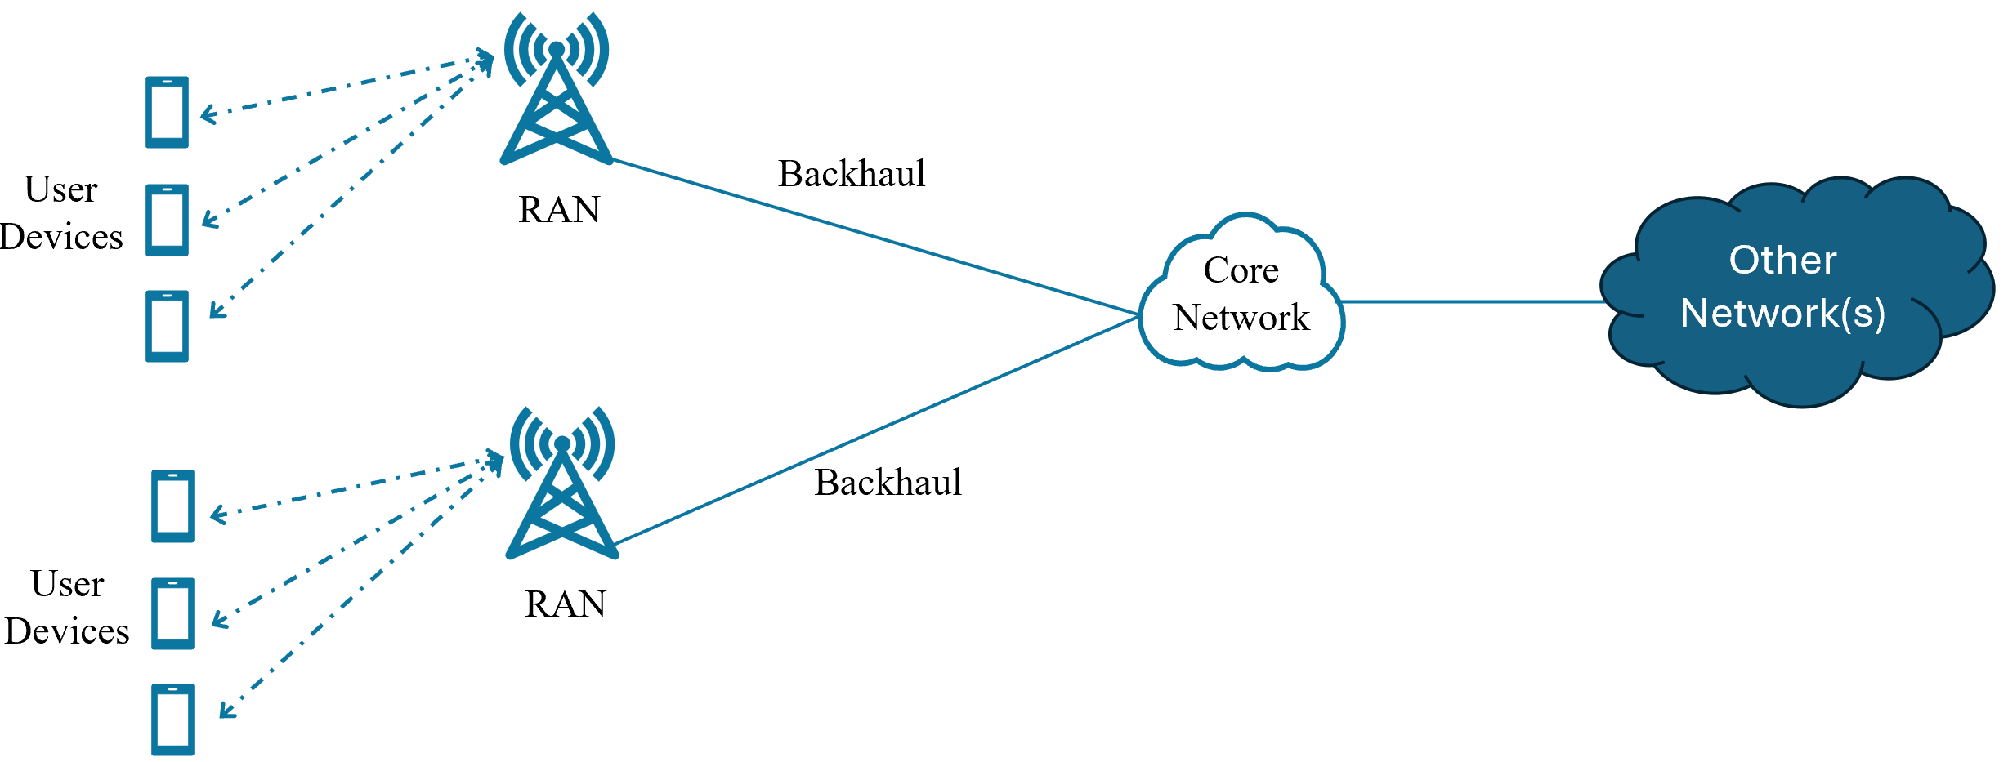
Figure 2.3: Typical mobile communication network

- Non-Terrestrial Network (NTN)

  - To provide service in areas where terrestrial IMT coverage is not existing or is limited, communication networks that uses space or sky-based platforms to provide connectivity can be very useful. These space or sky-based platforms may include satellites such as LEO, MEO, and GEO or High-Altitude Platforms (HAPS) such as balloons, drones, or solar power-powered aircraft that function similar to mobile towers in the sky. Such an extended network is called Non-Terrestrial Network (NTN).

  - According to the 3GPP, NTN are networks or segments of networks that use either Uncrewed Aircraft Systems (UAS) operating typically between altitudes of 8 and 50 kilometres, including HAPS or satellites in different constellations to carry a transmission equipment relay node or a base station.

  - An NTN that makes use of satellites that may carry a transmission equipment which act as a relay node or a base station. This enables standard mobile devices to seamlessly connect not only with terrestrial cellular base stations but also with satellite systems, which effectively act as ‘satellite base stations’ in areas where terrestrial networks are unavailable. This ensures continuous connectivity, improving global reach, supporting emergency communication, and enhancing network resilience. These technologies play a crucial role in ensuring seamless connectivity, particularly in remote regions where traditional terrestrial IMT networks are unavailable.

  - Figure 2.4 depicts different types of Non-Terrestrial Networks.

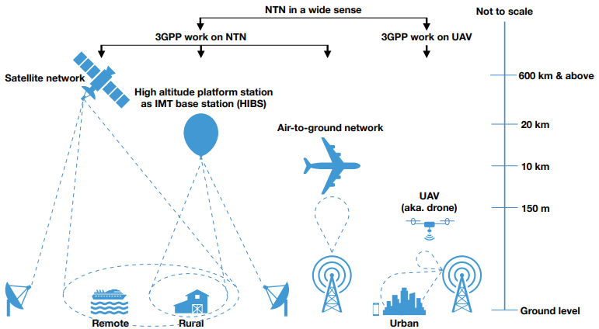
Figure 2.4: Different types of non-terrestrial networks, IEEE

  - The standardization of NTN is rapidly evolving, driven primarily by the 3GPP, and influenced by the ITU. 3GPP in the Release 17 has laid the foundation for 5G NR based satellite access, focusing on transparent payloads, wherein satellites act as repeaters. In the Release 18, 3GPP introduced enhancements for operations at higher frequency bands, resulting in improved mobility and service continuity. In Release 19, 3GPP focused on increasing satellite downlink coverage, supporting User Equipment (UE), with higher output power, and incorporating Reduced Capability (RedCap) device support. It also aims to further integrate NTN into the 5G system and includes features that enhance network performance, energy efficiency, and support for new use cases.

  - Some satellite networks use 3GPP-defined NTN technology. Deployment of 3GPP technology, as well as radio access networks, began in late 2023 with Release 17 chipsets having NTN capabilities and is continuing in 2025. Table 2.2 outlines the proposed road map for the process.
Table 2.2: The 3GPP radio access network road map, GSA

Releases | Approach | End of release | Initial Deployment
Release 15 | Introduction of the subject | June 2018 | 2020
Release 16 | Assessment of issues | March 2019 | 2022
Release 17 | Definition of market enabling features | March 2022 | 2023 and 2024
Release 18 | Definition of first set of enhancements | September 2023 | 2025
Release 19 | Definition of second  set of enhancements | 2025 | 2027
Release 20 | Contribution to initial  6G network | 2027 | 2029

  - Regarding architectural developments, the standardization process has seen a shift from traditional proprietary satellite systems towards seamless integration with terrestrial IMT networks, leveraging 3GPP standards. NTN architectures are standardized to accommodate different types of payloads. There are primarily two architectures – transparent architecture and regenerative architecture, as described below:

    - Transparent Architecture: The base station (gNodeB or gNB) is located on the ground behind the gateway, and the main purpose of the satellite here is to act as a repeater. The only processing that can be performed on the satellite is radio frequency processing such as frequency conversion, amplification and beam management. Here a transparent payload does radio frequency filtering, frequency conversion and amplification. Figure 2.5 depicts networking-RAN architecture with transparent satellite.

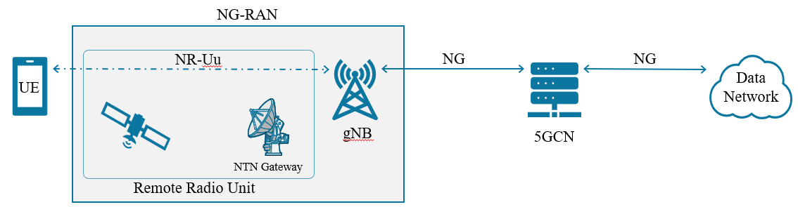
Figure 2.5: Networking-RAN architecture with transparent satellite

    - Regenerative Architecture: The satellite carries either an entire gNB or parts of it, which makes it possible to decode and process packets on the satellite. In this type of architecture, a regenerative payload does the radio frequency filtering, frequency conversion and amplification, as well as demodulation/ decoding, switch and/or routing, coding/modulation. This architecture provides more flexibility, better performance and global coverage due to the ability to support Inter-Satellite Links (ISL). This is effectively equivalent to having all or part of base station functions (e.g., gNB) on board the satellite. Figure 2.6 depicts regenerative satellite architecture without ISL and gNB processed payload.

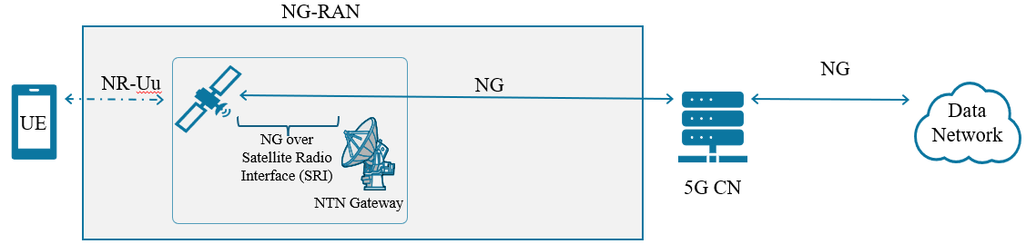
Figure 2.6: Regenerative satellite without ISL, gNB processed payload

- Radio Frequency bands for Satellite, IMT, and NTN Services

  - Radio Frequency (RF) bands are the backbone of access connectivity for Satellite, IMT, and NTN services as they define how end users connect to the wider communication infrastructure. For enabling services provided by the Satellite, IMT, and NTN to the consumers, access spectrum plays a pivotal role as it ensures frequency resources to support diverse communication needs. From the MSS perspective, satellites’ access spectrum is typically allocated in L-band and S-band because these bands offer better coverage and signal penetration. IMT networks on the other hand, primarily use sub-1 GHz bands for wide-area coverage, mid-bands (1–6 GHz) for capacity, and mmWave bands (above 24 GHz) for ultra-high-speed services in dense areas. With the emergence of NTN, IMT access spectrum is increasingly being extended to accommodate access services to the mobile handset. It uses a blend of MSS and IMT frequency ranges to extend IMT-like access to underserved and remote regions. Thus, the choice and management of access spectrum directly shape the efficiency, quality, and reach of these services, making RF band harmonization and coexistence essential for global connectivity. Therefore, coordinated spectrum access across these domains is essential to avoid interference, maximize efficiency, and ensure seamless interoperability between terrestrial and non-terrestrial systems. The following sections, briefly discuss important radio frequency bands for Satellite, IMT, and NTN Services.

    - Satellite-based services

  - At the global level, ITU manages radio-frequency spectrum and satellite orbit resources to ensure interference free operations of space-based communication services. ITU Radio Regulations (ITU-RR) governs the use of radio frequencies and satellite orbits and also defines frequency coordination process that aims to develop new orbit-spectrum assets and protecting the rights to use such resources. ITU-RR, in addition, provides a technical and regulatory framework to mitigate radio-frequency interference between different radio systems that uses the same frequency.

  - Satellite communication uses a variety of radio frequency bands. More commonly used radio frequency bands for satellite-based services include:

- L-band: It ranges from 1 GHz to 2 GHz and is used for MSS and Global Positioning System (GPS) navigation signals.

- S-band: It ranges from 2 GHz to 4 GHz and is used for MSS, as well as weather and air traffic control applications.

- C-band: It ranges from 4 GHz to 8 GHz and is commonly used for FSS such as television and radio broadcasting, telephony, and data transmission.

- Ku-band: It ranges from 10 GHz to 15 GHz and is used for both FSS and MSS. It is commonly used for Direct-to-Home (DTH) television broadcasting and satellite internet services.

- Ka-band: It ranges from 17 GHz to 31 GHz and is used for FSS and MSS applications. It is commonly used for high-speed broadband.

- Q/ V-band: It ranges from 37.5-51.4 GHz and is used for both FSS and MSS. It is commonly used for high-speed broadband services and in-flight connectivity.

  - For Satellite-IMT Integration, MSS is of more interest, as FSS supports communications from one fixed point to another fixed point while MSS supports communication between mobile devices.

  - For user link (access part) of MSS L-band and S-band are more suitable because they provide reliable communication with small, mobile user terminals even under challenging conditions. These lower frequency bands are less affected from atmospheric absorption, rain fade, and blockage by vegetation or buildings, as compared to higher frequency bands such as Ku- or Ka-band. Their longer wavelengths also allow for better signal penetration through obstacles. These bands also support omnidirectional or low-gain antennas, which are practical for handheld devices. In contrast, higher frequencies require larger, more directional antennas, and are more vulnerable to weather-related disruptions, making L-band and S-band the optimal choice for robust and ubiquitous MSS connectivity. The frequency ranges identified for MSS in L-band and S-band are given below in table 2.3.

Table 2.3: Frequency ranges identified for MSS in L and S bands

S. No. | Frequency Range | Link
 | 1.5250-1.5590 GHz | Space to Earth
 | 1.6100-1.6605 GHz | Earth to Space
 | 1.9800-2.0100 GHz | Earth to Space
 | 2.1700-2.2000 GHz | Space to Earth
 | 2.4835-2.5200 GHz | Space to Earth
 | 2.6700-2.6900 GHz | Earth to Space

- IMT Services

  - ITU through World Radiocommunication Conferences (WRCs) identifies specific frequency bands, inter-alia, for IMT systems and promotes harmonization to ensure global compatibility, reduce cross-border interference, and facilitate international roaming. It also publishes technical reports and recommendations such as ITU-R M.1036 and ITU-R M.2083 that guide the use and development of IMT technologies.

  - National administrations assign frequencies to mobile operators through spectrum auctions, administrative licensing, or unlicensed access frameworks. They set policies related to spectrum pricing, refarming of legacy bands, technology neutrality, and roll-out obligations to ensure efficient and equitable use. They also monitor usage, manage interference, enforce license conditions, and enable innovations such as dynamic spectrum sharing, spectrum trading, and local/ private networks. Thus, while the ITU provides the global framework, national administrations tailor and execute spectrum management to suit local regulatory, market, and socio-economic needs.

  - IMT relies on a wide range of frequency bands to deliver mobile services across the globe. These bands are harmonized internationally to ensure interoperability, roaming, and economies of scale in equipment manufacturing. IMT frequency bands span from sub-1 GHz low bands to mid- and high-frequency ranges, each serving distinct purposes in balancing coverage, capacity, and performance requirements for evolving mobile technologies such as 4G, 5G, and beyond.

  - To meet diverse coverage and capacity, IMT needs access to broad range of radio frequencies. IMT spectrum is generally categorized into low-band (below 1 GHz), mid-band (1–6 GHz), and high-band (above 6 GHz, including mmWave). These bands are allocated and deployed in a complementary manner. Low-frequency IMT bands such as 700 MHz and 800 MHz offer wide-area coverage and deep indoor penetration. Their long wavelengths enable signals to travel longer distances with fewer base stations, making them highly effective for rural and suburban connectivity. Mid-frequency IMT bands such as 1.8 GHz, 2.1 GHz, 3.5 GHz range provide a balance between coverage and capacity and are widely used for urban 4G and 5G services, supporting high data rates. High-band spectrum, especially in mmWave such as 26 GHz range supports ultra-high data rates and low latency applications, though it is limited in coverage due to higher path loss, susceptibility to rain fade, and reduced penetration through buildings. Some of the IMT frequency bands identified by ITU in different regions are given in table 2.4.

Table 2.4: ITU Identified IMT Frequency Bands (Examples)

Low Band (<1 GHz) | Mid-band (1-6 GHz) | High Bands (< 24 GHz)
450-470 MHz  470-960 MHz | 1.427-1518 GHz  1.710-2.200 GHz  2.300-2.400 GHz  2.500-2.690 GHz  3.300-3.700 GHz  4.800-4.990 GHz | 24.25-27.50 GHz  37.00-43.50 GHz  45.50-47.00 GHz  47.20-48.20 GHz  66.00-71.00 GHz

- Spectrum bands for NTN

  - NTNs are increasingly recognized as a crucial complement to terrestrial 5G networks and are expected to be a fundamental component of 6G (IMT-2030), enabling global coverage and connectivity.

  - It is noteworthy that all frequency bands are not suitable especially satellite component of NTN for Satellite-IMT Integration, due to a variety of technical, regulatory, and environmental factors. As discussed earlier, higher frequency bands have high path loss in free space and are more susceptible to rain fade, cloud attenuation, and atmospheric absorption. Further, higher frequency bands require line-of-sight, which is harder to guarantee over long satellite links. On the other hand, lower frequency bands provide better penetration and longer range, but are crowded and scarce, and thereby less available for new satellite uses.

  - Many of the lower frequency bands are already assigned to terrestrial mobile, broadcasting, radar, navigation, and other services. The co-existence of satellite and terrestrial IMT is complex due to potential interference. Also, both the ITU and national regulators maintain different rules for IMT service and MSS. As a result, some bands are exclusively for either terrestrial or satellite systems. For Satellite-IMT Integration, one option is that the MSS frequency bands such as L band and S band are made available in the mobile handset chipsets so that handsets can receive signals directly from satellites.

  - 3GPP in its Release 17 has identified two bands in Frequency Range 1 (FR1) for user equipment with existing MSS allocations for 5G NTN. Further, in Release 18, another MSS band is added. These bands are tabulated in the table 2.5, as below:

Table 2.5: Frequencies for NTN from MSS bands

Band | Uplink Frequencies (MHz) | Downlink Frequencies (MHz)
n254 | 1610 - 1626.5 MHz | 2483.5 - 2500 MHz
n255 | 1626.5 - 1660.5 MHz | 1525 - 1559 MHz
n256 | 1980 - 2010 MHz | 2170 - 2200 MHz

  - Another possible approach is to enable satellites to use IMT spectrum bands so that they can communicate directly with standard mobile devices. Since IMT frequencies are already supported in most handsets, this would allow satellites to connect with existing smartphones without needing special or dedicated devices. To make this happen effectively:
- Certain IMT bands would need to be allocated or designated explicitly for NTN usage but still remain under the IMT regulatory framework to ensure compatibility with terrestrial IMT systems.
- Harmonization across jurisdictions would be necessary so that device manufacturers and operators can follow global standards, ensuring device interoperability.

  - This method offers several advantages such as cost savings, compatibility with existing devices, and smoother global roaming or adoption. However, careful coordination is essential to prevent interference with terrestrial networks, possibly using techniques such as:
- Beamforming / directionality control,
- Geographic isolation of satellite-served regions,
- Time-division access or other scheduling methods.

  - Another complementary strategy is to have dedicated or shared IMT-compatible spectrum for non-terrestrial use. This might include:
- Newly harmonized bands for NTN, as proposed or supported by the ITU and to be considered in upcoming WRC agenda items.
- Deployment of dynamic spectrum sharing mechanisms. For example, intelligent beam management, frequency reuse, coordinated scheduling. So that terrestrial IMT services and non-terrestrial services can coexist with minimal disruption.

  - This hybrid model, where satellites extend coverage beyond terrestrial IMT reach, can help provide more continuous coverage (5G, 6G and beyond), especially in remote or underserved areas. To enable this Satellite-IMT Integration, multiple spectrum and regulatory interventions may be needed, such as:
- Updating national regulations to permit “Direct Connectivity between MSS and IMT UEs” (DC-MSS-IMT), which is under discussion in ITU-R.
- Defining and protecting interference thresholds, licensing modalities, out-of-band emissions, geographic/temporal constraints.
- Ensuring device chipsets support the relevant bands and radio technologies.

  - The next chapter presents an analysis of the responses received from members of the SATRC Working Group on Spectrum, compiled through a questionnaire circulated to obtain their inputs on “Spectrum Approaches and Regulatory Requirements to Enable Satellite-IMT Integration”.

Chapter - III: Inputs from SATRC Member Countries

  - To pursue the study about the current status and position of Satellite-IMT Integration in the SATRC countries, a questionnaire (Annexure-I) was prepared and circulated to all the expert members of the SATRC Working Group on Spectrum for their inputs. The questionnaire was designed to capture information on several key areas, including the status and licensing regime for MSS, the implementation of the Open Sky Policy, potential for commercial use of MSS, and the measures adopted to prevent its misuse. It further sought details on the availability of frequency bands for MSS, recent amendments to the MSS licensing framework, frequency bands allocated for IMT, regulatory provisions governing the use of IMT spectrum bands with NTN, the role of mobile handsets in satellite-based emergency services, and ongoing efforts to enable the integration of terrestrial networks with NTN systems.

  - Based upon the information provided by the SATRC member countries, the summary is presented in the following sections:

- Status and Licensing Regime for Mobile Satellite Service (MSS)

  - Mobile Satellite Service (MSS) is operational in seven SATRC member countries viz. Afghanistan, Bangladesh, India, Iran, Nepal, Pakistan, Sri Lanka, while MSS is not yet operational in Bhutan, and Maldives.

Countries | Whether MSS Operational | Licensing Regime for MSS
Afghanistan |  | - Fixed frequency fee and fixed registration fee.
Bangladesh |  | - BTRC* is overseeing MSS
Bhutan
India |  | - The GSPS* is operated by the State carrier BSNL* under the Sui-Generis License using Inmarsat satellite services. In addition, the provision of GMPCS license also exists which can provide MSS. As on 31.08.2025, three licenses for GMPCS* have been issued.
Iran |  | - There is a type of license, and licensee can offer services such as FSS and MSS.
Maldives
Nepal |  | - GMPCS* license
Pakistan |  | - GMPCS* license
Sri Lanka |  | - License is required under Section 17 B and Section 22 of the Sri Lanka Telecommunications Regulatory Act no 25 1991, as amended.
*BTRC - Bangladesh Telecommunication Regulatory Commission; GSPS - Global Satellite Phone Service; BSNL - Bharat Sanchar Nigam Limited; GMPCS - Global Mobile Personal Communications by Satellite.

- Frequency bands/ ranges assigned or earmarked for MSS for user terminals

  - The frequency bands assigned or earmarked for MSS for user terminals in SATRC member countries are as below:

Countries | L-Band | S-Band | Ku-Band
Afghanistan
Bangladesh | As per NFAT* of BTRC
India | Uplink: 1616-1660.5 MHz  Downlink: 1525-1559 MHz | Uplink: 2655-2690 MHz  Downlink: 2500-2535 MHz
Iran
Nepal | Uplink 1626.5-1660.5 MHz  Downlink: 1525-1559 MHz
Pakistan | Uses internationally assigned frequencies to Thuraya
Sri Lanka
* NFAT - National Frequency Allocation Table

- Spectrum assignment mechanism and recipient for MSS

  - The summary of spectrum assignment mechanism and recipient for MSS in SATRC member countries is as below:

Countries | Spectrum Assignment Mechanism and Recipient for MSS
Afghanistan | To register the handset, frequency requests come from the users.
Bangladesh | Spectrum is assigned to entities authorized by the BTRC. These include government entities for national security and disaster management, embassies, international organizations involved in development activities, and Bangladeshi carriers for aeronautical and maritime operations beyond national territory.  Permissions are granted on a case-by-case basis, considering the requirements and obtaining necessary clearances from relevant ministries.
India | Spectrum has been assigned to the State carrier BSNL for GSPS by using Inmarsat satellite services under the Sui-Generis License. No spectrum has been issued for GMPCS under GMPCS Authorisation.
Iran | After issuing ICT license as satellite access provider, based on which satellite operator is contracted by the licensee, and related spectrum, according to NFAT, is assigned to the operator.
Nepal | Spectrum is assigned to the licensed GMPCS service provider. The range is specified in the license.
Pakistan | Spectrum is assigned for GMPCS to the local service provider (PTCL*) by the Frequency Allocation Board ensuring compliance with ITU Regulations and also taking into consideration of national usage and requirements.
Sri Lanka | Spectrum is assigned to the licensed satellite operators who owns license under section 17 B of the Sri Lanka Telecommunications Regulatory Act No 25 of 1991, as amended.
* PTCL - Pakistan Telecommunication Company Limited

- Status of Open Sky Policy

  - An open sky policy generally refers to a framework that allows use of both domestic and foreign satellites to provide services, often with the goal of promoting competition and reducing costs for users. This contrasts with situations where only a state-owned or specific satellite operator is authorized to provide services. In other words, service licensee is permitted to tie up directly with foreign satellite operators.

  - The summary of status on open sky policy in SATRC member countries is as below:

Countries | Status | Remark on Open Sky Policy
Afghanistan |  | -
Bangladesh | Not fully permit policy | The use of satellite phones and services must be approved by the BTRC, and users must obtain permission through the concerned ministries.
India | Policy yet to evolve | The Indian Space Policy, 2023 provides level playing field to NGEs* in the space sector by enabling their participation across the entire value chain of space activities in an end-to-end manner.
Iran |  | Open sky policy is forbidden.
Nepal |  | The service licensee is permitted to tie up directly with foreign satellite operators. However, such agreement should be officially submitted to NTA*.
Pakistan | - | Recently introduced National Space Policy and Pakistan Space Activity Rules, 2024.
Sri Lanka |  | The service licensee is permitted to tie up directly with foreign satellite operators.
* NGE - Non-Government Entities; NTA - Nepal Telecommunications Authority

- Availability of MSS for Commercial Use

  - Summary on availability of MSS for commercial use by the general public or government users, or both in SATRC member countries is as below:

Countries | Commercial Use of MSS | Remark
Afghanistan |  | Not Yet
Bangladesh |  | Restricted to government entities, specific organizations involved in national security, disaster management, and international development activities, as well as certain aviation and maritime carriers. Any other entity requires special permission from the BTRC.
India |  | Only Government users/ agencies are allowed.
Iran |  | Available as commercial use by the general public and Government users.
Nepal |  | Available for commercial use. There is no specific provision to government users.
Pakistan |  | Both to general public and Government users
Sri Lanka | - | -

- Measures to prevent misuse of satellite-based services

  - Summary on the measures to prevent misuse of satellite-based services, in SATRC member countries is as below:

Countries | Remark about the measures to prevent any misuse
Afghanistan | Not Applicable
Bangladesh | - Several measures are adopted to prevent the misuse of satellite-based services. These include –  - Users must obtain prior permission and NOC from the relevant authorities.  - Service providers are required to maintain detailed records of usage, including call details, SMS logs, and internet usage logs, for at least six months.  - Information must be provided to the BTRC and law enforcement agencies as required.  - Lawful interception capabilities must be established.  - Strict control and monitoring are enforced by both the BTRC and law enforcement agencies to ensure compliance and security.
India | - As per the license conditions, the licensee shall establish Land Earth Station Gateway in India for the purpose of providing GMPCS Service.  - GMPCS Service may be provided using one or more Satellite Systems provided that the Land Earth Station Gateway Switch is established separately in India for each Satellite System.  - The operation and maintenance centre of the GMPCS Gateway shall also be located in India.  - Only Government users/ agencies are allowed.
Iran | - For the space communication retailer market, the administration has issued licenses to several SAP* for lawful provision of FSS and GMPCS services.  - The administration published Landing Right regulation for those satellite constellation owners who wish to provide bandwidth of SAPs.  - Moreover, providing DTH via satellite is forbidden.  - Other types of space communication services are being processed case-by-case.
Nepal | - The licensee is responsible for preventing misuses.  - The licensee shall keep updated KYC, retain detailed CDR, prevent unauthorized use, and adhere to the Government directives.
Pakistan | - Licenses have obligations and conditions on misuse.
Sri Lanka | - Under the licensing rules lawful interception is mandatory for law enforcement authorities.
* SAP - Satellite Access Providers

- Status of ‘3GPP identified bands for NTN’ for MSS

  - 3GPP in Release 17 identified two bands in FR1 with existing MSS allocations (L and S bands) for 5G NTN. These bands are n255 (Uplink:1626.5-1660.5 MHz and Downlink: 1525-1559 MHz) and n256 (Uplink: 1980-2010 MHz and Downlink: 2170-2200 MHz). Further, in Release18, another MSS allocation as n254 is identified (L-band: Uplink:1610 - 1626.5 MHz, S-band: Downlink: 2483.5-2500 MHz).

  - Summary on the status of allocation and availability of n255 and n256 bands for MSS in SATRC member countries is as below:

Countries | n255 for MSS | n256 for MSS | Remark
Afghanistan |  |  | Not Yet
Bangladesh |  |  | Allocated and made available for MSS
Bhutan |  |  | As per the frequency allocation plan, allocated for MSS.
India |  |  | Both n255 and n256 bands are not open for satellite component of IMT/ NTN use so far
Iran
Maldives |  |  | Not allocated for MSS
Nepal |  |  | Other bands and frequency ranges are not allocated for any services.
Pakistan
Sri Lanka |  |  | Uplink of n256 band is kept as a duplex gap of 3GPP band 1 allocated for terrestrial cellular service.

- Changes proposed or contemplated in the MSS licensing framework to support Satellite-IMT Integration

  - Summary on the Changes proposed or contemplated in the existing MSS licensing framework to support Satellite-IMT Integration in SATRC member countries is as below:

Countries | Changes proposed or contemplated to support Satellite-IMT Integration
Afghanistan | -
Bangladesh | Licensing framework is now under consideration by the BTRC. At present there is no such licensing framework available for MSS Service in Bangladesh.
Bhutan | -
India | Regulations on satellite-IMT Integration is yet to evolve.  Momentum on the same is likely to pick up after WRC-27 decision of Agenda Item 1.13.
Iran | Currently, the framework of Unified Network and Service Provider (UNSP) licenses that support Satellite-IMT merger has been issued but not initiate to service yet.
Maldives | -
Nepal | Satellite-IMT Integration is being studied.
Pakistan | Shall be explored later.
Sri Lanka | Satellite-IMT Integration is being under consideration.

- Frequency bands allocated for IMT

  - Summary on the Frequency bands allocated for IMT in SATRC member countries is as below:

Countries | Frequency bands allocated for IMT
Afghanistan | 900 MHz, 1800MHz, 2100MHz, 2600MHz
Bangladesh | 900 MHz, 1800 MHz, 2100 MHz, 2500 MHz, 3700 MHz
Bhutan | 700 MHz, 850 MHz, 900 MHz, 1800 MHz, 2100 MHz, 2300 MHz, 3.5 GHz and 26 GHz
India | 600 MHz, 700 MHz, 800 MHz, 900 MHz, 1800 MHz, 2100 MHz, 2300 MHz, 2500 MHz, 3300 MHz, 26 GHz.  In addition, 37-40 GHz and 42.5-43.5 GHz is also identified for IMT.
Iran | 900 MHz, 1800 MHz, 2100 MHz, 2300 MHz, 2600 MHz, 3500 MHz, 3700 MHz
Maldives | 700 MHz, 800 MHz, 850 MHz, 900 MHz, 1800 MHz, 2100 MHz, 2300 MHz, 2600 MHz, 3700 MHz, 26000 MHz
Nepal | 700 MHz, 800 MHz, 850 MHz, 900 MHz, 1800 MHz, 2100 MHz, 2300 MHz, 2600 MHz, 3700 MHz, 26 GHz
Pakistan | 700 MHz, 850 MHz, 900 MHz, 1800 MHz, 2100 MHz, 2300 MHz, 2600MHz, 3500MHz, 26 GHz, 39GHz
Sri Lanka | 850MHz, 900MHz, 1800MHz, 2100 MHz, 2300MHz, 2600MHz, 3500 MHz, 27 GHz

- Regulatory provision to use IMT spectrum bands with NTN networks

  - Summary of status about the regulatory regime that permits use of frequency spectrum bands assigned/ earmarked for mobile services with NTN networks, is as below:

Countries | Status | Regulatory provisions to use IMT spectrum
Afghanistan |  | Not Applicable
Bangladesh |  | Up to now, do not permit
Bhutan |  | Not Permitted
India |  | Yet to evolve. Momentum likely after WRC-27 decision
Iran |  | No request from the operators. However, it is considerable
Maldives |  | Not Permitted
Nepal |  | No regulation that explicitly permit such use
Pakistan |  | Up to now, no arrangement
Sri Lanka |  | No such regulatory regime

- Use of Mobile Handsets for Satellite-based emergency service

  - Considering that some of the mobile handsets available in the market are capable of providing satellite-based emergency service, the status of such service is as below:

Country | Use of mobile handsets for satellite-based emergency service
Afghanistan | Not yet
Bangladesh | Instructions for the use of satellite phones are published. Based on these, user may submit the application for further necessary approval.
Bhutan | There are only a few satellite-phones which foreigners import when they visit and export when they leave.
India | Currently, not permitted.
Iran | Currently, not permitted. Only considered, if emergency response units or crisis management organizations requests.
Maldives | Study needed
Nepal | Studies underway
Pakistan | Currently, not permitted. Services shall be considered later.
Sri Lanka | Some operators are requesting trials on the use of SMS and IoT applications. Regulator is considering to make regulatory framework to allow such services.

- Efforts for integration of Terrestrial Networks and Non-Terrestrial Networks

  - Summary of efforts being taken or are considered for the integration of Terrestrial Networks (TN) and Non-Terrestrial Networks (NTN), is as below:

Country | Efforts for TN and NTN integration
Afghanistan | Not Applicable
Bangladesh | Planning to have discussion with stakeholder regarding integration process, where service providing modality, cost modelling, spectrum assignment process, licensing conditions etc. will be under consideration and further necessary planning.
Bhutan | No efforts have been taken yet.
India | Regulations on Satellite-IMT Integration is yet to evolve.  Momentum likely to pick up after WRC-27 decision of AI 1.13.
Iran | The framework of Unified Network and Service Provider (UNSP) licenses that support Satellite-IMT merger has been issued but service, yet to initiate.
Maldives | Study needed
Nepal | Studies underway
Pakistan | Still to be considered
Sri Lanka | Studies underway

  - From the above summary of responses, Satellite-IMT Integration process in the very early stage in the SATRC member countries. Some administrations are yet to consider Satellite-IMT Integration while some are studying, analysing, and waiting for the decisions of WRC-27 for framing policies.
  - The next chapter presents the spectrum, and regulatory approaches and frameworks for Satellite-IMT Integration.

Chapter - IV: Spectrum and Regulatory Approaches for Satellite-IMT Integration

- Introduction

  - As discussed in Chapter-I, the integration of Satellite and IMT leverage strength of both terrestrial IMT networks and Satellite networks to create a more comprehensive and resilient communication network to provide IMT-based connectivity. However, the Satellite-IMT Integration can take multiple forms. This can range from service-level integration where satellites extend IMT coverage into underserved areas, to network-level integration enabling seamless interoperability and handover between satellites and standard IMT handsets or IoT devices. Spectrum-level integration focuses on the harmonized or shared use of MSS and IMT bands. Core network integration ensures unified management of authentication, billing, and quality of service. Application-level integration supports use cases such as emergency communications, disaster recovery, and IoT backhaul. Business and operational integration through partnerships between mobile network operators and satellite providers enable joint service delivery and new business opportunities.

  - As discussed in Chapter 1, within the broader concept of Satellite-IMT Integration, different models are emerging such as Non-Terrestrial Networks (NTN), Direct-to-Device (D2D, also called Direct-to-Cell (D2C) or Satellite-to-Phone or Satellite-to-Cellphone), Direct Connectivity between Mobile Satellite Service space station and IMT User Equipment (DC-MSS-IMT), and Supplemental Coverage Service (SCS or NTN-SC) which extend IMT services with the help of satellites.

  - As the report focuses on spectrum strategies and regulatory frameworks in the access segment to support the expansion of IMT services through Satellite-IMT Integration, in general, the term Direct-to-Device (D2D) will be used to describe connectivity between satellites and mobile handsets. The use of satellite connectivity as part of a mobile network can supplement a terrestrial operator’s network coverage, and D2D infrastructure can also provide an added layer of network resilience.

- Spectrum Approach

  - Effective direct connectivity between MSS space station and IMT user equipment hinges on identifying spectrum bands that meet the distinct technical and operational needs of both the networks. One such aspect is spectrum allocation and harmonization. Spectrum allocation refers to the assignment of specific frequency bands for various radiocommunication services such as mobile services (MS), mobile satellite service (MSS). Spectrum harmonization means using the same frequency bands across multiple countries or regions for the same type of service. Harmonization of spectrum supports interoperability across borders, lowers device and infrastructure cost, and simplifies coordination and interference management.

  - Another aspect is spectrum sharing and coexistence, that is, the capability of multiple users or services to access and utilize the same radio frequency spectrum, either at the same time or opportunistically. In other words, two or more services or networks using the same frequency band either at the same time (co-channel sharing), in different locations (geographic separation), or in different timeslots (time-division sharing), with appropriate technical and regulatory mechanisms to avoid harmful interference. For example, IMT and FSS share and coexist in 6 GHz or Ka-band using beam shaping, dynamic coordination, or filters.

  - The requirement of spectrum in the access segment to support expansion of IMT services through Satellite-IMT Integration, that is, D2D can be achieved through two primary approaches viz. utilizing frequency spectrum allocated to the MSS or frequency spectrum allocated to the IMT. For MSS, lower frequency bands such as L-band and S-band are favoured due to their superior propagation characteristics, allowing signals to penetrate buildings and foliage, at the same time cover large geographic areas with fewer satellites. Also, the larger footprint of satellite beams compared to IMT cells and amount of spectrum available, limits the amount of data that can be delivered.
  - Effective spectrum management is crucial for promoting the D2D services. D2D services, depending on design can use either MSS or IMT frequency spectrum to send and receive signals from a connected satellite. Both spectrum allocations can enable use cases such as data and voice, but each approach presents a unique set of considerations.
  - MSS spectrum bands are harmonised and there are no cross-border issues. Local regulatory framework often exists to use MSS bands, and administrations may allow D2D using MSS bands. However, handsets require specific hardware for satellite bands that are currently only available in limited high-end devices, and reaching global economies of scale is a challenge. On the other hand, IMT spectrum offers benefits such as standard handsets can be used. Some countries have developed national frameworks which require partnerships between satellite operators and MNOs. However, technical coexistence and international regulations are still not firmed up.

- World Radiocommunication Conferences (WRCs)

  - The radio communication services rely on a structured framework of regulations and guidelines established by international bodies and national regulatory authorities. ITU through its Radiocommunication Sector (ITU-R) develops and maintains the Radio Regulations (RR). These regulations ensure equitable access and interference-free operations among various services, including both satellite and terrestrial IMT systems.

  - ITU-R allocate frequency bands through the Radio Regulations, which are revised at the WRCs. These WRCs are pivotal for aligning global strategies for spectrum usage, particularly considering emerging technologies. It ensures that frequency allocations for services such as satellite services and terrestrial IMT systems are clearly defined and internationally harmonized, thereby minimizing interference and facilitating global interoperability.

- World Radiocommunication Conference 2019 (WRC-19)

  - WRC-19 considered various technologies for enhancing connectivity. WRC-19 identified additional frequency bands for High-Altitude Platform Station (HAPS) systems operating in the stratosphere, aimed to provide wide-area telecommunications coverage, particularly in underserved areas. In addition, WRC-19 defined a plan of studies to identify frequencies for new components of 5G. For example, to facilitate mobile connectivity by High Altitude IMT Base Stations (HIBS) which may be used as a part of terrestrial IMT networks to provide mobile connectivity in underserved areas where it is difficult to be covered by ground-based IMT base stations at a reasonable cost.

  - WRC-19 also established a framework allowing Earth Stations in Motion (ESIM) to communicate with GSO satellites in the Ka-band (17.7-19.7 GHz and 27.5-29.5 GHz) to facilitate direct communication between these mobile platforms and satellites. WRC-19 also outlined studies on possible new allocations to the MSS for direct connectivity between space stations and IMT user equipment to complement terrestrial IMT network coverage. This implied future possibilities for direct communication between user devices and satellites to enhance coverage.

  - In summary, WRC-19 laid the groundwork for enhanced connectivity by allocating new frequency bands for technologies like HAPS and ESIM and initiating studies on supplemental coverage.

- World Radiocommunication Conference 2023 (WRC-23)

  - The WRC-23 took significant steps to support D2D. Some of the key items discussed during the WRC-23 included additional frequency bands for IMT including the use of HAPS as IMT base stations (HIBS); use of satellite technologies for broadband services; regulatory framework for the use of ESIM, among others.

  - WRC-23 acknowledged the importance of harmonizing spectrum and technical rules for D2D communication over MSS/ IMT networks. The Resolution 253 was adopted to initiate studies on possible new allocations to the mobile-satellite service for direct connectivity between space stations and International Mobile Telecommunications (IMT) user equipment to complement terrestrial IMT network coverage. WRC-23 also charted the path forward for WRC-27 Agenda Items, inter-alia, technical studies on spectrum sharing between satellites and terrestrial IMT in various frequency bands.

- World Radiocommunication Conference 2027 (WRC-27)

  - Among others, the WRC-27 will address Agenda Item relevant to the integration of Satellite and IMT systems. The key WRC-27 Agenda Item related to Satellite-IMT Integration in accordance with Resolution ​​253 (WRC-23) is Agenda Item 1.13 -

Studies on possible new allocations to the mobile-satellite service for direct connectivity between space stations and International Mobile Telecommunications (IMT) user equipment to complement terrestrial IMT network coverage.

Table 4.1: Frequency range in consideration under Agenda Item 1.13 in WRC-27

Frequency Range
694/698 MHz up to 2.7 GHz

  - Resolution 253 (WRC-23) invited studies for on possible new allocations to the MSS for direct connectivity between space stations and IMT user equipment (UE) to complement terrestrial IMT network coverage on secondary basis with respect to the mobile services, and ensuring the protection of incumbent services in accordance with the RR. MSS spectrum offers the advantage of global coverage with minimal interference. However, utilizing MSS frequencies requires modifications to user terminals, as these frequencies differ from those used in conventional terrestrial mobile networks.

  - Resolution 253 (WRC-23) proposed an alternative approach to leverage spectrum allocated for terrestrial mobile service spectrum for satellite communications. This option provides two key advantages: significantly greater bandwidth availability compared to MSS spectrum and compatibility with existing mobile devices, which are already designed to operate within these frequency bands. However, this approach also presents substantial challenges. Mobile Service (MS) spectrum is already extensively used by terrestrial mobile network operators, and current international regulatory frameworks do not permit satellite transmissions within these bands. Overcoming these regulatory and operational barriers would be necessary to enable satellite use of mobile service spectrum.

  - The DC-MSS-IMT systems under WRC-27 agenda item 1.13 is to complement the terrestrial IMT network coverage by directly connecting stations of the DC-MSS-IMT systems and IMT UEs using frequency bands identified for the terrestrial component of IMT. Moreover, the envisaged DC-MSS-IMT service would operate on a secondary status basis to the MS in the applicable frequency bands.

  - ITU-R Working Party (WP) 4C is the responsible group for Agenda Item1.13. According to the Annexure 7 of working document on sharing and compatibility studies under WRC-27 Agenda Item 1.13, list of the IMT candidate frequency arrangements and frequency bands are given in table 4.2.

Table 4.2: List of the IMT candidate frequency arrangements and associated frequency bands

Uplink  (MHz) | Downlink (MHz)
814/824-849 | 859/869-894
880-915 | 925-960
832-862 | 791-821
698-716  776-798 | 716-746  746-768
698-748 | 753-803
1427-1470 | 1475-1518
1920-1980 | 2110-2170
1710-1785 | 1805-1880
1850-1920 | 1930-2000
1710-1780 | 2110-2180
2000-2020 | 2180-2200
2010-2025 | 1880-1920
2305-2320 | 2345-2360
2500-2570 | 2620-2690

- Views of APT Members on WRC-27 Agenda Item 1.13:

  - The 2nd Meeting of the APT Conference Preparatory Group for WRC-27 (APG27-2) was held in July-August 2025 in Thailand. In the meeting, APT Members have expressed support to carry out necessary and appropriate studies to respond to the extent practicable, to the objectives of Resolution 253 (WRC-23).

  - The Resolution 253 (WRC-23), resolved to -
- studies on possible allocations to the MSS in the frequency range between 694/698 MHz and 2.7 GHz, taking into account the IMT frequency arrangements addressed in the most recent version of Recommendation ITU-R M.1036
- studies on spectrum requirements and on technical, operational and regulatory matters related to the implementation of the mobile-satellite service for direct connectivity to the IMT user equipment to complement the terrestrial IMT network coverage
- to conduct studies on sharing and compatibility between incumbent services, including in adjacent frequency bands, ensuring the protection of incumbent services in accordance with the Radio Regulations
- to study possible technical and operational measures to ensure that the stations in the MSS do not cause harmful interference to, or claim protection from, stations operating in the mobile service
  - Based on the preliminary views on WRC-27 on Agenda Item 1.13 during APG27-2, summary of APT Members’ views is given in the table 4.3:

Table 4.3: Summary of preliminary views of APT Members

Country | Summary of Views
Bangladesh | - Supports ongoing studies on possible new MSS allocations for DC-MSS-IMT to complement terrestrial IMT coverage, provided incumbent services are protected in line with the Radio Regulations.
Thailand | - Supports studies, emphasizing protection of incumbent services, including terrestrial IMT, in bands of ITU-R M.1036 and adjacent bands without adverse impact. Also calls for close coordination of studies under related WRC-27 agenda items 1.12, 1.13, 1.14, and 1.15 to ensure consistency and avoid conflicts.
Australia | - Values DC-MSS-IMT for enhancing regional and remote connectivity while recognizing the importance of existing MSS and terrestrial IMT services.  - It supports developing a regulatory framework for DC-MSS-IMT in 694/698 MHz–2.7 GHz aligned with ITU-R M.1036, including TDD bands.  - Sharing and coexistence studies with incumbent services (in-band and adjacent) are essential to ensure protection. CPE studies may be done as sensitivity analyses. Any MSS allocation should not cause interference to or claim protection from mobile services. No extra regulatory measures are needed for IMT UEs in potential MSS uplink bands if they follow existing terrestrial IMT technical conditions.
Indonesia | - Supports studies on possible new MSS allocations for DC-MSS-IMT to complement terrestrial IMT, while ensuring protection of existing primary services and adjacent band services in line with the Radio Regulations.
Tonga | - Supports studies and stress on the need for accurate system and mitigation modelling to ensure sound outcomes.  - Emphasizes protecting terrestrial IMT UEs through aggregate PFD limits (not per-satellite) and accounting for mitigation in multi-system studies without applying multi-system aggregation factors.  - Potential aggregate PFD limits to protect IMT UEs should not consider multi-system aggregation factors. Concept of EPFD does not apply to protection of IMT UE, since the UEs are not directional  - No need to develop any methodology to ensure compliance of a DC-MSS-IMT with applicable limits. National administrations have the responsibility to ensure operators comply with applicable limits to protect terrestrial IMT stations  - Supports aligning protection criteria with those being developed in WP5D.  - Countries may adopt different bilateral cross-border limits in addition to any agreed at WRC-27.
India | - Supports studies on possible new MSS allocations for DC-MSS-IMT within 694/698 MHz–2690 MHz but limits consideration to frequency bands and arrangements in ITU-R M.1036.  - Any new allocation must avoid harmful interference, not claim protection from, and not impose constraints on existing or future MSS, IMT, and BSS operations, while also ensuring protection of services in adjacent bands.
Singapore | - Highlights the widespread use of terrestrial IMT networks in the 694/698 MHz-2.7 GHz range and recognises the role of DC-MSS-IMT in supplementing them where deployment is difficult.  - Stresses the need to protect existing and future terrestrial IMT operations from harmful interference while supporting studies.  - DC-MSS-IMT should not claim protection from terrestrial IMT, should align transmission directionality with national IMT deployments, and that IMT user equipment may transmit to satellites using the same technical characteristics as for terrestrial IMT base stations.
Iran | - Believes that due to the complexity, lack of clarity, controversial issues, and lack of transparency of the agenda item, all technical, regulatory, and legal issues must be thoroughly studied and resolved.  - Key concerns raised:  - In addition to issues such as interference aggregation from multiple systems, cross-border coordination challenges, and the harmonization of protection criteria, specific national concerns require further examination. Furthermore, need to assess effectiveness of proposed mitigation techniques under local propagation conditions and network configurations. Additional information is required regarding the application of standardized antenna patterns and polarization schemes in domestic sharing studies.  - All issues related to current and future services in these bands need to be appropriately addressed and protected.  - Safeguarding secrecy of the telecommunication / ICT involved, that is, achieving objectives of Article 17 of the Radio Regulations.  - Preventing misuse and illicit use of DC-MSS-IMT  - Clarifying the application of Articles 18, Resolutions 22 and 25 to avoid unauthorized transmissions through DC-MSS-IMT from / within a country from which specific authorization has not been duly obtained.  - Ensuring only one notifying administration per DC-MSS-IMT system without any possibility of designating “associated administration”  - Defining Bureau and RRB’s response if an administration fails to act on reported unauthorized transmissions.
New Zealand | - Supports DC-MSS-IMT while ensuring technical characteristics accurately reflect current and future systems in 694/698 MHz-2.7 GHz and protecting terrestrial services.  - It prioritizes existing FDD bands (A5, A1, A2, B2, B1, C1) from ITU-R M.1036-7, and does not support TDD bands or unconventional configurations, and favours rationalizing rather than expanding the band list.  - Its detailed views are in WP 4C contributions.
Korea | - Supports studies on DC-MSS-IMT to protect incumbent services, requires DC-MSS-IMT to avoid interference and not claim protection from mobile service stations, and mandates that administrations ensure their satellites communicate only with authorized user terminals within their territories.
Japan | - Supports studies for new MSS allocations enabling DC-MSS-IMT to complement terrestrial IMT, provided incumbent services such as Space Operation Service (SOS), MSS, and broadcasting service are protected and technical/operational measures prevent interference to or protection claims from Mobile Service stations, including terrestrial IMT, HIBS, and 760 MHz ITS.
China | - Supports studies to protect incumbent services, including adjacent bands, advocates sharing and compatibility studies for IMT candidate bands within 694/698 MHz-2.7 GHz, and supports setting aggregate PFD limits per DC-MSS-IMT system to protect terrestrial IMT.
Viet Nam | - Stresses studies should protect existing investments in terrestrial IMT, avoid hindering future IMT development, safeguard incumbent services in the same and adjacent bands (MSS, IMT, FS, EESS, RAS, aeronautical), use realistic system parameters, and protect terrestrial IMT from aggregate interference from multiple MSS satellites.

  - In addition, some APT members expressed that relevant regulatory/ legal and technical issues should be studied and resolved in an appropriate manner. Some of these are also a part of the preliminary views of APT Members. These issues are listed below:

  - The Regulatory/legal Issues raised are as follows:
- Terms and Definitions;
- Applicability of expressions of complement/supplement;
- Applicability of unacceptable/harmful interference;
- Responsibilities and Roles of Satellite Network Operator (SNO)/ Mobile Network Operator (MNO) in the operation of the DC-MSS-IMT and their relations with the authorizing and responsible administration(s);
- Responsibility of SNO/MNO and its corresponding administration within a country that authorized the operation with respect to other countries which have not authorized the operation;
- Responsibility of authorizing administration of the filing of satellite system under which SNO operates;
- Responsibilities in case of unauthorized uplink access in unauthorized country;
- Coexistence challenges between satellite and terrestrial networks in-band and in the adjacent bands such as interference aggregation from multiple systems, cross-border coordination/operations, spectrum allocation, harmonization of protection criteria, specific national concerns, lack of agreement among concerned membership(s), discrepancies among various elements and interference management system/mechanism in particular, on cross boarder interference;
- Technical functionality to be taken into account in regulatory and legislation considerations including beam control and interference mitigation for properly managing the spectrum in particular, preventing cross-border interference and ensuring services are limited to authorized areas;
- Methodology to validate the compliance of a DC-MSS-IMT with applicable limits;
- Secrecy of the telecommunication/ ICT involved (Article 17 of the Radio Regulations);
- Preventing of illicit and misuse/unauthorized transmission of the DC-MSS-IMT (how Article 18 of the Radio Regulations, Resolution 22 (Rev. WRC-23) and Resolution 25 (Rev. WRC-23) to be applied, and what course of action(s) to be taken by the Bureau and RRB);
- Rules for notifying administration of DC-MSS-IMT satellite system(s), for instance there would be no more than one single administration as notifying administration of DC-MSS-IMT;
- Consideration of possible applicability of the approach contained in Resolution 76 (Rev. WRC-23) for multiple DC-MSS-IMT systems (e.g. considering d) and resolves 3)) taking into account that DC-MSS-IMT activities are much beyond consultation approach.

  - The Technical Issues raised are as follows:
- Definition and application of Power Flux Density (PFD) limits from a single/ multiple satellite system(s);
- Out-Of-Band Emissions (OOBE) and Adjacent Channel Leakage Ratio (ACLR);
- Antenna pattern assumptions;
- Polarization considerations;
- Duplexing mode conflicts (FDD vs TDD);
- Protection criteria for GSO/NGSO MSS systems based on consideration of single-entry and aggregate interference to protect incumbent services from any potential interference that may emanate from DC-MSS-IMT system(s);
- Study regarding Customer Premises Equipment (CPE) as a sensitivity analysis;
- Cross-border coordination;
- Overlapping frequency bands;
- Assessment of effectiveness of proposed mitigation techniques under local propagation conditions and network configurations;
- Protection of current and future services as the telecommunications/ ICT infrastructure which are currently operating or planned for allocation in the frequency band 694/698 MHz - 2.7 GHz, appropriately.

  - The preliminary views of Regional Groups on Agenda Item 1.13 are given in the table 4.4:
Table 4.4: Summary of Preliminary Views of Regional Groups

Region | Summary of Views
CEPT* | - Supports new MSS allocations for DC-MSS-IMT in the 694–2700 MHz range, aligned with ITU-R M.1036, to complement terrestrial IMT while protecting existing services.  - It stresses that terrestrial IMT operations must be safeguarded domestically, across borders, in territorial waters, and for fixed installations in Exclusive Economic Zones (EEZ) and Maritime Communication Vessel (MCV) operations in international waters.  - Stresses protection of terrestrial IMT operations both within the countries as well as in cross-border situations, including in the territorial waters.  - The protection of stations on fixed installations in EEZ or onboard ships in international waters (Mobile Communications onboard Vessels, MCV) also need to be addressed.
CITEL* | - Five administrations back studies on possible MSS allocations in 694/698MHz–2.7 GHz IMT bands for DC-MSS-IMT to complement terrestrial IMT, while protecting incumbents and aligning with ITU-R M.1036.  - Emphasise consistency across Agenda Items 1.12, 1.13, and 1.14, protection of existing terrestrial IMT from interference, and incorporation of MSS to extend coverage.  - No extra regulatory measures necessary for IMT UEs transmitting in MSS uplink, provided they follow existing terrestrial IMT technical conditions.  - Some administrations earlier expressed the following views:  - Any new MSS allocations should be on a secondary basis, given the complementary role and the primary status of terrestrial IMT.  - No additional studies are needed in bands already having co-primary MS/ MSS allocations with matching directionality to IMT arrangements.  - Sharing studies should account for different national frequency arrangements and duplex schemes (FDD/TDD), including cross-border scenarios.  - Protection of incumbent MS and other services must be guaranteed, with appropriate technical, operational, or regulatory safeguards.  - WP 4C’s broad list of frequency arrangements is sufficient; adding more could complicate studies. Any additions must be tied to MS allocations, IMT identification in the RR, and ITU-R M.1036 consistency.  - No new frequency bands are needed; efforts could be optimized by reducing bands, e.g., discarding TDD bands due to latency or those not aligned with ITU-R M.1036.
RCC* | - Support studies on possible new MSS allocations in 694/698 MHz–2.7 GHz, aligned with ITU-R M.1036 frequency arrangements and directions.  - Oppose use of 2110–2180 MHz, 2180–2200 MHz, 2305–2320 MHz, and 2345–2360 MHz due to heavy existing use and TDD operation in some bands.  - Stress protecting incumbent services, including terrestrial IMT in Region 1, and ensuring MSS-IMT compatibility, especially across borders with differing arrangements.  - Highlighted the need to consider Resolution 212 (Rev. WRC-23) and existing allocations to land mobile operators when defining compatibility conditions.
*CEPT - European Conference of Postal and Telecommunications Administration; CITEL - Inter-American Telecommunication Commission (Comisión Interamericana de Telecomunicaciones); RCC - Radiocommunications Committee Regional Commonwealth in the field of Communications

  - The preliminary views of Internation Organisation on Agenda Item 1.13 is given in the table 4.5:

Table 4.5: Summary of Preliminary Views of International Organisations

International Organisation | Summary of Views
IARU* | - Access to the Band 2300- 2400 MHz by amateur stations should not be constrained by any decision of WRC-27.  - Would oppose the use of a space component for direct connectivity to user IMT equipment if it will further restrict the opportunities for the operation and development of the amateur service in this band.
ICAO* | - Oppose any new allocations made, or regulatory actions taken, that overlap the frequencies used by civil aviation systems operating in parts of the frequency range 694-2700 MHz.  - To ensure bands adjacent to aeronautical systems operating in parts of the frequency range 694-2700 MHz would not reduce the protection of, or impose additional regulatory or technical constraints, on the multiple civil aviation systems operating in parts of the frequency range 694-2700 MHz, or the primary surveillance and weather radar adjacent to the upper end of 694-2700 MHz frequency range.
WMO* | - Does not oppose possible new MSS allocations for DC-MSS-IMT within 694 MHz–2.7 GHz IMT bands, provided they do not cause adjacent band interference to EESS (passive) at 1400-1427 MHz, MetSat at 1675-1710 MHz, EESS/SOS at 2025-2110 MHz, and meteorological radar at 2700-2900 MHz.
* IARU - International Amateur Radio Union; ICAO - International Civil Aviation Organization; WMO - World Meteorological Organization

  - From the above it can be seen that most APT members and regional groups support studies on potential new MSS allocations in the 694/698 MHz–2.7 GHz range to enable DC-MSS-IMT as a complement to terrestrial IMT. Their common priority is safeguarding incumbent services, particularly terrestrial IMT, in line with the Radio Regulations and ITU-R M.1036. Several members stress alignment with established IMT frequency arrangements and transmission directions, protection of adjacent services, and consistency across related WRC-27 agenda items. Some countries add technical conditions such as use of aggregate PFD limits, rationalization of band options, or excluding TDD bands, while Iran highlighted the need to resolve broader regulatory, legal, and security concerns before moving forward.

  - Regional and International Organizations have expressed more caution. CEPT, CITEL, and RCC support studies but with varying conditions: CEPT emphasizes protecting terrestrial IMT across borders and in maritime zones; CITEL calls for MSS on a secondary basis with no expansion beyond M.1036 bands; RCC opposes use of certain bands already being used heavily or in TDD operation. International bodies raise strong protection for their sectors: IARU seeks to preserve amateur use of 2300–2400 MHz, ICAO opposes any allocations that would affect aviation systems or radars, and WMO requires protection of EESS, MetSat, SOS, and meteorological radars in adjacent bands. Overall, while the value of DC-MSS-IMT is acknowledged, its progress is conditional on ensuring robust protections for incumbents and resolving technical, regulatory, and operational concerns.

- National Regulatory Approach

  - National spectrum management authorities play a decisive role in translating global ITU-R guidelines into practical and enforceable domestic policies. National regulatory approaches, however, can vary significantly in terms of spectrum licensing, coordination procedures, and technical compliance requirements. While some countries pursue technology-neutral or converged licensing strategies, others still maintain distinctions in technology specific spectrum usage. This divergence has implications for international service providers, satellite operators, and mobile network operators aiming to deploy hybrid solutions. As such, there is an increasing need for harmonization of spectrum policies, not only to facilitate global interoperability but also to enable economies of scale in equipment manufacturing and service provisioning.

  - Several countries have initiated or implemented regulatory frameworks to support satellite-based Direct-to-Device (D2D) services. These initiatives, while varying in scope and focus, offer valuable examples of mechanisms that regulators are adopting to develop national frameworks for D2D technologies. Below is an overview of key national regulatory efforts.

      - FCC, USA

  - In March 2023, the Federal Communications Commission (FCC), USA proposed a new regulatory framework to facilitate innovative collaborations between satellite operators and wireless companies to leverage the growth in space-based services to connect smartphone users in remote, unserved, and underserved areas. The Notice of Proposed Rulemaking (NRPM) proposed a framework through which satellite operators collaborating with terrestrial service providers would be able to obtain FCC authorization to operate space stations on certain currently licensed, flexible-use spectrum allocated to terrestrial services. The FCC proposed to add a mobile-satellite service allocation on some terrestrial flexible-use bands.

  - In March 2024, the FCC issued its “Supplemental Coverage from Space” (SCS) order to expand coverage for communication and emergency services. The framework prioritizes maintaining terrestrial network quality, protecting existing spectrum rights, and minimizing interference. It designated specific frequency bands for SCS, including the 600 MHz, 700 MHz, 800 MHz, Broadband PCS, and AWS-H Block on secondary MSS operation. Additionally, the FCC’s framework identifies new frequency bands for MSS allocations to support D2D services that do not rely on IMT spectrum.

  - This regulatory model exemplifies how to foster innovation, promote efficient spectrum management, and enable partnerships between D2D operators and MNOs without requiring separate satellite spectrum licenses. The rules also establish, on an interim basis, a requirement that terrestrial providers must route all SCS 911 calls to a Public Safety Answering Point using either location-based routing or an emergency call centre.

      - Brazil

  - In April 2024, Brazil’s National Telecommunications Agency (ANATEL) introduced a regulatory sandbox to facilitate D2D trials, and granted Authorization for the Temporary Use of Radio Frequencies that allows tests to be carried out for the use of satellite systems communicating directly with smartphones operating in the 800 MHz band, in applications known as Direct-to-Device (D2D). This allowed operators and MNOs to test D2D services in the 800 MHz band within a controlled environment. By doing so, ANATEL supported innovation and efficiency while addressing key challenges such as interference and interoperability. This approach served as a flexible mechanism for testing and refining D2D services before broader implementation, ensuring that regulatory frameworks evolve in alignment with technical and operational realities.

  - In April 2025, Viasat showcased mobile phones connecting directly to a geostationary satellite over L-band frequencies, bypassing terrestrial mobile networks.

      - Australia

  - In November 2023, Australian Communications and Media Authority (ACMA) started a consultation on “satellite direct-to-mobile services: regulatory issues” to know if the current regulatory environment is suitable for future satellite direct-to-mobile services. From a spectrum management perspective, there are 2 types of satellite direct-to-mobile services viz. MSS satellite direct-to-mobile services and IMT satellite direct-to-mobile services.

  - In September 2024, through “Operation of an IMT satellite direct-to mobile service: Regulatory guide”, ACMA confirmed that for MSS satellite direct-to-mobile service, the mobile earth station functionality is included in the mobile phone. Since an MSS satellite direct-to-mobile service uses frequency bands already planned for MSS (with allocations for MSS), operating this service can be authorised under their normal licensing process. In regard to IMT satellite direct-to-mobile services, spectrum of interest is mainly authorised Australia wide for use by MNOs under spectrum licences. Mobile phones used in this service can be operated under the current spectrum licensing framework, subject to the phone complying with all applicable licence conditions, without the need for explicit approval from the ACMA. It further mentions that the 700 MHz, 800 MHz, 850/900 MHz and 2.5 GHz spectrum-licensed bands are suitable for IMT satellite direct-to-mobile services and are licensed to MNOs under Australia-wide spectrum licences.

  - ACMA acknowledges that WRC-27 will also consider new allocations to MSS in bands identified for IMT agenda item 1.13, as a means of providing regulatory legitimacy for IMT satellite direct-to mobile communications. This agenda item will be of key interest to Australian government and industry stakeholders involved in the preparatory process for WRC-27.

      - Canada

  - In June 2024, Canada’s Innovation, Science, and Economic Development (ISED) initiated a consultation on a policy, licensing, and technical framework for the use of certain bands allocated to flexible use and/or commercial mobile services to support the expansion of coverage via satellite, which is referred to, hereafter, as Supplemental Mobile Coverage by Satellite (SMCS). ISED proposed 600 MHz, 700 MHz, 800 MHz cellular, Advanced wireless services (AWS)-1, AWS-3, Personal communication Systems (PCS) bands for SMCS framework

  - In February 2025, ISED decided for SMCS confirming the objectives of expanding mobile services, fostering investment and competition. ISED decided for 600 MHz (617-652 MHz/663-698 MHz), 700 MHz (698-756 MHz and 777-787 MHz), 800 MHz (824-849 MHz/869-894 MHz), PCS (1850-1915 MHz/1930-1995 MHz), AWS-1 (1710-1755 MHz/2110-2155 MHz) and AWS-3 (1755-1780 MHz/2155-2180 MHz) bands for SMCS. ISED intends to issue targeted consultations prior to applying the SMCS framework to other frequency bands used for commercial mobile services.
      - Saudi Arabia

  - Saudi Arabia’s Communications, Space, and Technology Commission (CST) in October 2024 initiated a consultation on Spectrum Outlook for Commercial and Innovative Use (2024-2027). CST identified several spectrum planning initiatives to support the growth of non-terrestrial networks (NTNs) and broader satellite spectrum use. By integrating spectrum management for NTNs within its strategic planning, Saudi Arabia exemplifies how long-term spectrum outlooks can support D2D technology adoption.

  - From the above overview it can be seen that some of the countries have introduced regulatory initiatives to enable satellite-based direct-to-device (D2D) services, focusing on remote and underserved areas. In the USA, the FCC proposed a framework in 2023 and followed with the 2024 Order on “Supplemental Coverage from Space”, allowing Satellite-MNO collaborations on flexible-use of spectrum while protecting terrestrial networks and emergency services. Brazil’s ANATEL implemented a regulatory sandbox in 2024 for D2D trials in the 800 MHz band and later demonstrated GEO satellite connectivity using L-band. Australia’s ACMA issued a regulatory guide permitting MSS and IMT satellite Direct-to-Mobile services under existing spectrum licenses, while Canada’s ISED launched consultations and finalized a Supplemental Mobile Coverage by Satellite (SMCS) framework covering multiple mobile bands. Saudi Arabia integrated non-terrestrial network planning into its 2024–2027 spectrum outlook. The information is further summarised in the table 4.6, as below:

Table 4.6: Summary of National Regulatory Approaches

Country | Summary
USA | USA’s Supplemental Coverage from Space (SCS) framework enables partnerships between satellite operators and mobile carriers to deliver D2D connectivity using terrestrial spectrum.
Brazil | Brazil is steering towards enabling D2D satellite communications through a flexible, test-driven regulatory approach and authorizing temporary spectrum use in the 800 MHz band and creating sandbox environments.
Australia | Australia allows satellite direct-to-mobile SCS under existing spectrum licenses, streamlining rollout. Its 2024 guidance designates 700 MHz, 800 MHz, 850/900 MHz, and 2.5 GHz bands as suitable, aligning with MNO holdings.
Canada | Canada has adopted a structured SMCS framework to expand connectivity and competition, initially applying to key mobile bands: 600 MHz, 700 MHz, 800 MHz, PCS, AWS-1, and AWS-3.
Saudi Arabia | Saudi Arabia’s 2024–2027 Spectrum Outlook embeds NTNs and satellite use, with plans for D2D, among others.

  - According to the Summary on Non-Terrestrial 5G Networks and Satellite Connectivity by Global mobile Suppliers Association’s (GSA), there are 42 countries and territories either planning, evaluating, testing, licensed for, or already having launched satellite-to-cellphone partnerships. Of these, Argentia, Brazil, Germany, Ghana, Greece, Nigeria, Philippines, South Africa, South Sudan, Switzerland, Ukraine and the United Kingdom are evaluating, testing or trialling, or have licences, with another 17 countries planning services. Figure 4.1 shows status of Countries and territories with D2D partnerships.

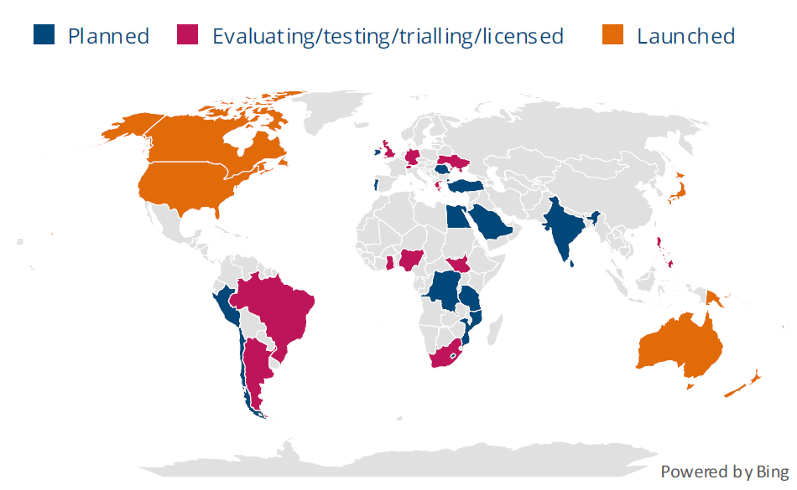

Figure 4.1 Countries and territories with D2D partnerships, GSA

- Market Developments

  - D2D connectivity services employ diverse approaches depending on the satellite constellations and spectrum utilized. As discussed in earlier section, satellite D2D communication can be achieved through two primary approaches viz. utilizing frequency spectrum allocated to the MSS or frequency spectrum allocated to the IMT.

  - Providers such as Viasat-Inmarsat leverage GSO satellite infrastructure utilizing MSS spectrum to deliver services directly to end-user devices. While providers such as Starlink, AST SpaceMobile, and Lynk Global utilise NGSO satellite constellations to deliver connectivity in partnership with mobile network operators (MNOs). These models provide various services, including text, voice, and data applications, demonstrating the potential to address coverage gaps in remote areas.

  - Some of the initiatives by service providers are given in the following section.

      - Viasat-Inmarsat

  - ViaSat is currently working with its partners, including BSNL in India, to expand satellite services on consumer and IoT devices. In October 2024, Viasat-Bharat Sanchar Nigam Limited (BSNL) – a Indian public sector service provider, announced successful demonstration of direct-to-device satellite connectivity at India Mobile Congress 2024 using L-band spectrum. In the trials, ViaSat demonstrated two-way messaging and SoS messaging using a commercial Android smartphone enabled for NTN connectivity. The outcome proved that satellite to cell phone connectivity is technically feasible using Viasat's satellite network.

  - The technology follows 3GPP release 17 standards which are currently being adopted by satellite operators, mobile network operators, handset and chipset manufacturers. For mobile network operators, using existing licensed satellite spectrum avoids tying up valuable cellular spectrum and avoids new regulatory approval processes. The D2D technology by BSNL aims to bridge critical communication gaps across India's diverse landscape, and includes emergency call capabilities, SOS messaging systems, and Unified Payments Interface (UPI) payment functionality in network-dark zones.

  - In April 2025, ViaSat successfully performed first successful direct-to-handset (D2H) communication test using D2D technology in L-band in Brazil. The demonstration showcased two smartphones connecting directly via satellite using 3GPP NTN standards without the involvement of other terrestrial infrastructure.

      - Starlink

  - Starlink Direct-to-Cell technology enable standard smartphones to connect directly to satellites without additional hardware. This technology leverages existing cellular standards while utilising LEO satellites to provide seamless connectivity. Starlink satellites with Direct-to-Cell capabilities enable ubiquitous access to texting, calling, and browsing. It works with existing LTE phones wherever the sky is visible. It requires no changes to hardware, firmware, or special apps. Starlink satellites with Direct-to-Cell capability have an advanced eNodeB modem onboard that acts like a cellphone tower in space, allowing network integration similar to a standard roaming partner. This enables connectivity in remote regions. In addition to expanding mobile coverage, Direct-to-Cell enable ubiquitous Internet of Things (IoT) connectivity outside of terrestrial coverage. Cellular providers using Direct to Cell have access to reciprocal global access in all partner nations.
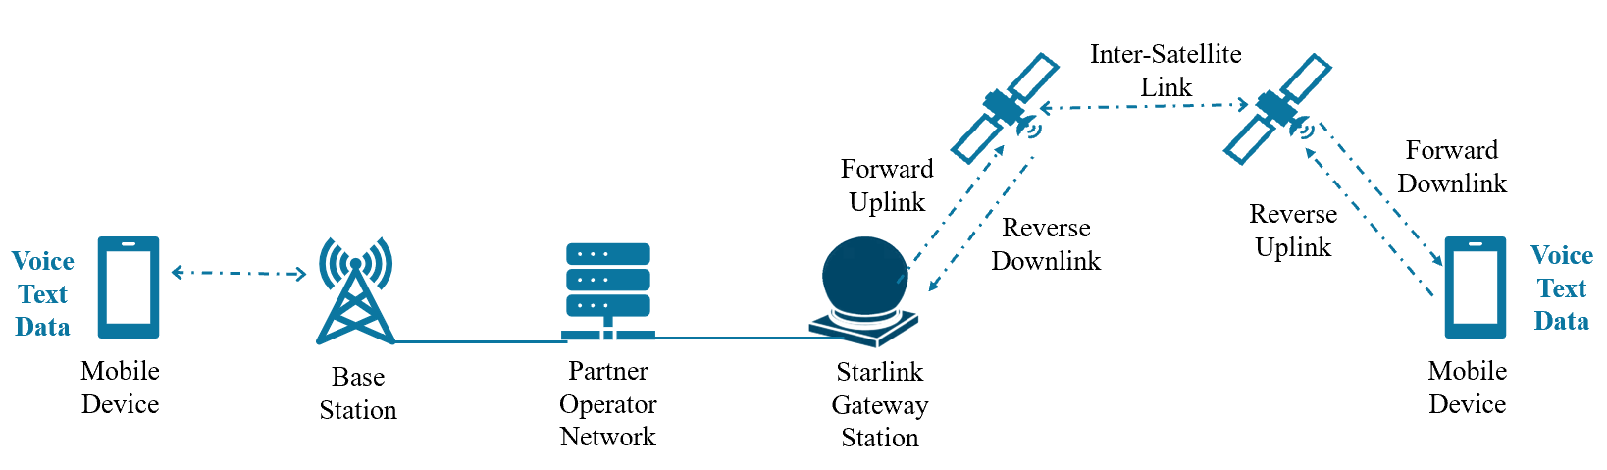

Figure 4.2: Starlink Direct-to-Cell Representation

  - In November 2024, FCC approved a license for T-Mobile and SpaceX to provide supplemental internet coverage from space. According to T-Mobile, 1.3 million square km of the United States are unreachable by towers because of the terrain, land-use restrictions and other factors. The goal of the partnership is to eliminate “dead zones” and provide coverage in remote areas.

  - To provide Direct-to-Cell services, Starlink has partnered with T-Mobile with USA, Rogers (Canada), Telstra and Optus (Australia), Salt (Switzerland), KDDI (Japan), and other MNOs. Partner MNOs operate terrestrial telecommunication networks and provide LTE spectrum in the 1.6-2.7 GHz range to transmit satellite signals. This allows Starlink to provide services directly to wireless subscribers.

      - AST SpaceMobile

  - AST SpaceMobile’s goal is to provide 4G and 5G connectivity to existing mobile phones without requiring hardware modifications or additional infrastructure. AST SpaceMobile took a major step forward in 2022 with the launch of the BlueWalker 3 satellite, a prototype that demonstrated the ability to provide direct connectivity to mobile devices. The first voice call was made over AT&T spectrum (850 MHz band) using a Samsung Galaxy S22 smartphone. In September 2024, it successfully launched first five commercial satellites, called BlueBirds. AST SpaceMobile is working with mobile network operators around the world to provide optional connectivity when needed. It has partnered with over 40 operators worldwide.

  - AST SpaceMobile LEO satellites, once operational, will use terrestrial spectrum from MNOs such as AT&T, Rakuten, Vodafone, and others to provide D2D connectivity. In January 2025, AST SpaceMobile announced that it has reached an agreement to secure long-term access to up to 45 MHz of lower mid-band spectrum in the United States for its direct-to-device satellite applications.

      - Lynk Global

  - In September 2022, Lynk Global was given operating approval by the FCC for a total of 10 LEO satellites to provide connectivity to existing GSM and LTE devices outside the U.S. via partnerships with MNOs. Lynk Global was given the permission to operate in bands ranging from 617-960 MHz (space-to-Earth) and 663-915 MHz (Earth-to-space) with earth stations outside the United States, as well as tracking and control at 20 and 30 GHz and in the 2 GHz band.

  - In June 2023, Lynk Global has partnered with Palau National Communications Corporation (PNCC), Palau’s MNO, to provide D2D texting services for residents across Palau’s remote islands. The partnership has enabled users to send and receive texts during three satellite overpasses per day, and Lynk and PNCC have plans to continue expanding availability and services for customers who previously relied on VHF radios for communication.

  - In March 2025, Lynk Global and Genç Turkcell conducted a successful trial in Türkiye to enable direct-to-device connectivity and in April 2025, the FCC granted Lynk Global a license modification, enabling it to provide commercial satellite-to-device service in the U.S.

      - OmniSpace

  - Omnispace is building a 3GPP‐standard, non-terrestrial 5G network that delivers voice, text, and data directly to everyday mobile devices via satellite, without special user hardware. The company holds around 60 MHz of licensed S-band spectrum (3GPP bands n255/ n256). In February 2023, it entered into an MOU with Ligado Networks to combine that with Ligado’s around 40 MHz of L-band spectrum in the U.S. and Canada. This partnership creates the largest aggregated licensed satellite spectrum portfolio dedicated to global D2D service.

  - Omnispace aims to deliver messaging, voice calls, and sufficient data throughput, and machine-type communications natively over a hybrid multi-orbit architecture (NGSO and GEO). Under this model, MNOs can integrate Omnispace’s coverage into their service offerings, enhancing connectivity in remote, maritime, rural or emergency environments.

      - Globalstar

  - Globalstar System consists of constellation of LEO satellites, global network of 28 gateway Earth Stations located in eighteen countries; and mobile devices and terminals operating over Globalstar's MSS network. In 2022, Apple Inc. announced direct-to-handset "Emergency SOS via satellite" feature using Globalstar's MSS network on Apple select iPhone family of devices. Apple's Emergency SOS via satellite feature allows users to initiate emergency communications through MSS transceivers contained in the Apple select iPhone family of devices. This satellite-enabled feature is now available in many countries including US, Canada, 12 European countries, Australia, New Zealand, and Japan. Emergency SOS via satellite feature is being used daily to request emergency assistance in the countries where the feature has been introduced. Most recently, Apple announced users in the United States and Canada will be able to send non-emergency messages via satellite, including texts, SMS, emoji and tap backs.

  - Globalstar leverage its licensed spectrum (1610–1618.725 MHz uplink / 2483.5–2500 MHz downlink) for D2D communication service. Globalstar operates a “bent-pipe” system with its satellites relaying messages between a global network of ground stations and millions of mobile earth terminals. D2D services aim to provide connectivity directly between satellites and consumer devices such as smartphones, enabling messaging and emergency communication in areas lacking terrestrial network coverage.

  - From the above, it can be seen that D2D satellite connectivity is advancing rapidly through different technical and regulatory approaches. Viasat-Inmarsat, with BSNL in India, has proven two-way messaging, SOS, and UPI payment over licensed MSS L-band, later replicating results in Brazil. Starlink’s Direct-to-Cell model uses MNO-licensed LTE spectrum (1.6–2.7 GHz) with eNodeB modems onboard LEO satellites, offering text, calls, browsing, and IoT without hardware changes. AST SpaceMobile relies on terrestrial mobile spectrum from MNO partners (e.g., AT&T, Vodafone, Rakuten), having demonstrated 4G/5G services with its BlueWalker 3 prototype and securing 45 MHz of mid-band spectrum in the U.S.

  - Other operators follow distinct spectrum and licensing strategies. Lynk Global, licensed by the FCC to operate in sub-1 GHz bands, has launched commercial messaging services in Palau and Türkiye, with recent U.S. approval for full D2D operations. Omnispace combines its licensed S-band (60 MHz) with Ligado’s L-band (40 MHz) to create a global NTN-5G spectrum portfolio, integrating voice, data, and IoT. Globalstar leverages its long-standing MSS spectrum rights (1.6/2.5 GHz bands) to power Apple’s “Emergency SOS via satellite” and expanded non-emergency messaging.

  - The licensing model, adopted by satellite operators is summarised in the table 4.7

Table 4.7: Summary of Spectrum Licensing Model

Operator | Spectrum Licensing Model
Viasat - Inmarsat | MSS spectrum
Starlink (SpaceX) | MNO’s IMT spectrum
AST SpaceMobile | MNO’s IMT spectrum
Lynk Global | MNO’s IMT spectrum
Omnispace | MSS Spectrum
Globalstar | MSS spectrum

  - In summary, while MSS-based operators (Viasat, Omnispace, Globalstar) depend on existing satellite allocations, others (Starlink, AST, Lynk Global) rely on terrestrial MNO spectrum sharing. This regulatory divergence reflects two parallel licensing pathways shaping the global D2D ecosystem.

  - According to the Summary on Non-Terrestrial 5G Networks and Satellite Connectivity by Global mobile Suppliers Association’s (GSA), as of August 2025, 12 partnerships have launched Satellite-to-Cellphone services and 24 are evaluating, testing, trialling or licensed to do so. Since March 2025, operators Salt in Switzerland and Kyivstar in Ukraine have announced trials with Starlink, and Lynk acquired a licence to provide service with Docomo Pacific in Guam and the Northern Mariana Islands. A further 28 are planning to launch. Figure 4.3 shows status of partnerships working on satellite-to-cellphone technology.

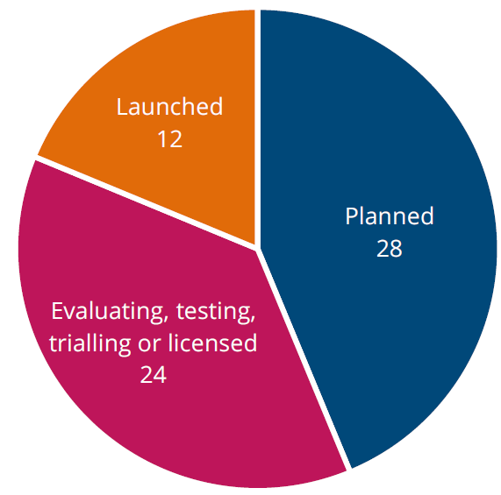

Figure 4.3: Partnerships working on satellite-to-cellphone technology, GSA

- Chip device ecosystem development

  - The device ecosystem is maturing around two parallel chip-centric models: (a) MSS-centric chips that operate in L- and S-bands and plug into existing satellite networks (used for emergency and messaging today), and (b) NTN/ IMT-centric chipsets that allow satellites to emulate terrestrial LTE/ NR base stations and talk to unmodified phones using MNO spectrum.

  - In February 2023, MediaTek announced the MT6825, a chipset that can provide global satellite coverage for mobile applications such as messaging, tracking, and emergency services, as well as IoT applications. This supports 3GPP Release-17 (IoT-NTN) at L-band and S-band frequencies.

  - Around the same time, Qualcomm announced satellite-based SOS and two-way messaging solution with Iridium in L-band, called Snapdragon Satellite which was later withdrawn in 2024 due to strategic refocus.

  - Samsung also announced 5G NTN modem technology to power smartphone-satellite communication in 2023. The Exynos Modem 5300 demonstrated two-way text messaging as well as image and video sharing. It supports 3GPP Release 17 and interoperability and scalability among services, and Sumsung plans to integrate this technology into Exynos modem solutions. By mid-2024, the Exynos Modem 5400 was certified for use with satellite D2D connectivity on the Skylo network. In June 2025, Skylo announced the certification of the Exynos 2500 for satellite D2D connectivity. This allowed Exynos-powered Android smartphones to connect to Skylo's network for satellite-based services.

  - Together, these developments show how the device ecosystem is steadily advancing. This evolution is laying the foundation for mainstream satellite–smartphone connectivity.

  - The next chapter presents the conclusion, recommendations, and Way Forward of the Report.

Chapter - V: Conclusion, Recommendations, and Way Forward

  - Effective spectrum management is vital for integrating satellite systems with IMT networks to guarantee both coexistence and optimal performance in terrestrial and non-terrestrial domains. Without clear spectrum planning and harmonized allocations, Satellite and IMT networks, there is a risk of harmful interference between satellite and IMT systems, inefficient use of frequency resources and operational conflicts. A forward-looking spectrum policy is therefore required in SATRC countries to enable IMT-based mobile services, unlocking opportunities for more ubiquitous access across the region.

  - To extend connectivity into remote, underserved, or currently uncovered areas—where terrestrial infrastructure is weak or absent— regulatory frameworks are required to enable and encourage flexible, shared, and dynamic spectrum access to foster innovation and accelerate deployment of Satellite-IMT services. Such remote or underserved and uncovered areas often lack terrestrial infrastructure, and satellite integration can offer a viable, scalable path to bridging the digital divide in such zones. Thus, policies that lower barriers to market entry, support investment, and empower service providers to deliver affordable, resilient connectivity are highly desirable.

  - Since Direct-to-Device (D2D) services may utilize MSS, IMT, or other designated frequencies, spectrum planning must adopt a holistic approach. Use of IMT spectrum for satellite-based D2D service introduces both interference and regulatory challenges. It is essential to establish robust mechanisms for interference management and to enable cooperation among operators (terrestrial, satellite, and D2D) to ensure harmonious spectrum usage.

Towards a Future-Proof D2D Policy Ecosystem

  - Interoperability lies at the heart of a resilient and scalable D2D ecosystem. To realize this, regulators should actively promote:
- Harmonized spectrum frameworks - alignment of frequency bands across jurisdictions to avoid fragmentation
- Adoption of international standards – Such as by ITU, 3GPP and other international bodies to ensure an interoperable equipment ecosystem

  - Beyond this, a robust regulatory regime for Satellite-IMT Integration can greatly enhance communication resilience—especially in emergencies or natural disasters when terrestrial IMT networks may falter.

  - Accordingly, regulators in SATRC member countries can assume a proactive role in crafting policies that not only protect spectrum rights but also future-proof telecommunications infrastructure to meet evolving demands. Although D2D regulatory regimes are still nascent, priorities may include:
- Efficient and flexible spectrum management
- Support for technological innovation and experimentation
- Mechanisms to bridge connectivity gaps and promote universal access
By doing so, the region can accelerate the growth of a robust, interoperable, and inclusive D2D ecosystem.

  - The Satellite-IMT Integration is still in a formative stage. According to the preliminary views of APT members for the Agenda Item 1.13 during the 2nd meeting of the APT Conference Preparatory Gorup for WRC-27 (APG27-2), several unresolved regulatory, legal, and technical issues have already been identified by the member nations, but substantive decisions are yet to be made. The WRC-27 conference scheduled for October 2027, is expected to decide on the Agenda Item 1.13 relevant to Satellite-IMT Integration, including the possibility of a new allocation to the MSS for direct connectivity between space stations and IMT user equipment (DC-MSS-IMT)..

  - Given that spectrum approaches, regulatory regimes, and implementation modalities for Satellite-IMT Integration remain under active negotiation and are not yet settled, it may be premature to conclude the current Work Item during the current phase of the SATRC Action Plan. It is anticipated that the results from WRC-27 will effectively inform or coincide with the timeframe of Action Plan Phase-X, thereby enabling alignment between the WRC decisions and national/ regional implementation. Therefore, it is proposed that this Work Item may be deferred until a more suitable juncture - namely, once WRC-27 has adopted binding decisions concerning DC-MSS-IMT and related regulatory provisions. At that point, this Work Item may be formally resumed, guided by the international outcome, to facilitate coordinated implementation across jurisdictions.

  - In view of above, presently, the following is recommended –

- Develop a SATRC-Aligned National Spectrum Strategy:

Each SATRC member country needs to formulate or update a national spectrum strategy that explicitly includes provisions for Non-Terrestrial Networks (NTN) and Satellite-IMT Integration. Such strategies should align with regional coordination efforts to ensure cross-border compatibility, reduce equipment costs, and enable spectrum harmonization across South Asia. This will help deliver seamless Satellite-IMT services throughout the region.

- Align National Spectrum Allocations with ITU-R & Regional Standards:

SATRC members need to ensure that their spectrum allocations reflect current ITU-R recommendations and relevant technical and regulatory guidelines. They should also participate in the SATRC Working Group on Spectrum to harmonize regional band plans and allocation frameworks. Harmonized allocation and usage across borders will facilitate roaming, minimize cross-border interference, and support regional equipment manufacturing and procurement.

- Build Institutional and Technical Capacity:

To manage the complexities of integrated Satellite-IMT networks, SATRC member countries can organize joint training programs, workshops, and technical assistance schemes. This will ensure that regulatory authorities are well equipped to develop spectrum policies that balance innovation, affordability, equitable access, and interference protection. Participation in international trainings (e.g. conducted by ITU Academy) on spectrum monitoring and management is recommended.

- Encourage Testing and Piloting of Emerging Technologies:

SATRC member countries can collaborate to promote pilot projects, trials, or testbeds for emerging Satellite-IMT technologies - especially direct-to-mobile satellite connectivity (DC-MSS-IMT). Such collaborative testing will help validate technical feasibility, uncover regulatory or spectrum sharing challenges, and generate empirical evidence to support policy decisions.

- Formalize Satellite-IMT Role in Disaster and Emergency Communications:

Given the South Asian region’s vulnerability to natural disasters, regulators can consider incorporating Satellite-IMT Integration into emergency communication frameworks. This can include pre-approval of spectrum for disaster events, contingency plans or fallback mechanisms that enable satellite connectivity when terrestrial IMT networks fail, and regulatory provisions that ensure minimal delay or regulatory obstruction in activating such services during crises.
- Taking up of the Work Item after Regulatory Decisions by WRC:
This Work Item relating to Satellite-IMT Integration may be taken up at a more appropriate stage, specifically after WRC-27 has finalized decisions on Direct Connectivity between Mobile Satellite Service space station and IMT User Equipment (DC-MSS-IMT) and associated regulatory provisions. Following these international determinations, the Work Item can be formally resumed to ensure coordinated implementation across SATRC member countries.

Annexure

Questionnaire on Spectrum approaches and regulatory requirements to
enable Satellite – IMT Integration

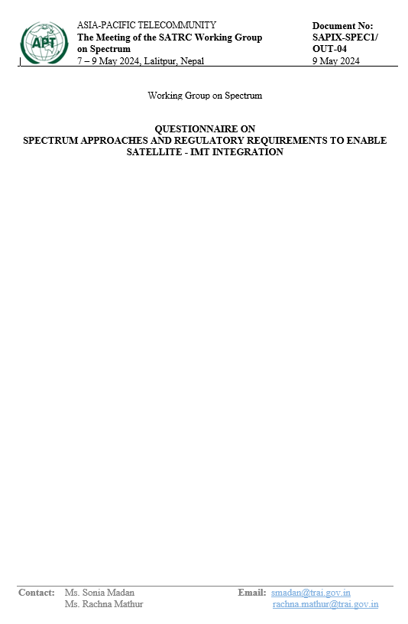
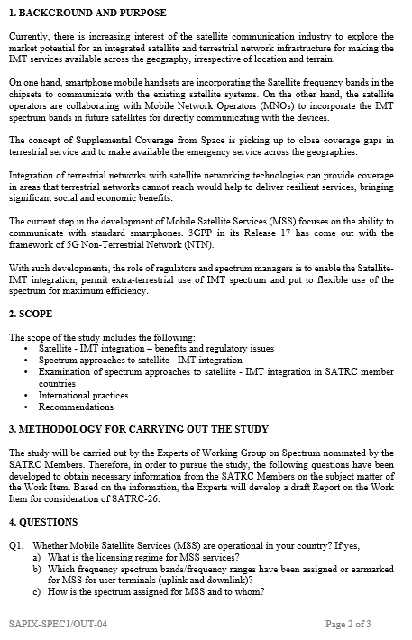

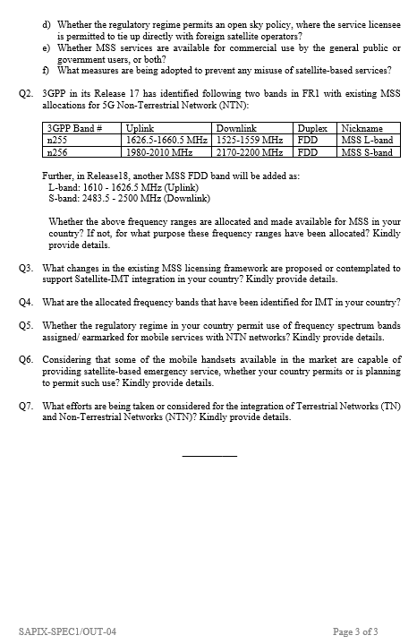

List of Acronyms

Acronyms | Description
2G | Second Generation
3G | Third Generation
3GPP | 3rd Generation Partnership Project
4G | Fourth Generation
5G | Fifth Generation
5G NR | 5G New Radio
6G | Sixth Generation
ACI | Adjacent Channel Interference
ACLR | Adjacent Channel Leakage Ratio
ACMA | Australian Communications and Media Authority
AI | Agenda Items
AI/ML | Artificial Intelligence/ Machine Learning
ANATEL | Agência Nacional de Telecomunicações (National Telecommunications Agency)
APG27 | APT Conference Preparatory Group for WRC-27
APT | Asia-Pacific Telecommunity
AWS | Advanced Wireless Service
BSNL | Bharat Sanchar Nigam Limited
BTRC | Bangladesh Telecommunication Regulatory Commission
CDMA | Code-Division Multiple Access
CDR | Call Detail Record
CEPT | European Conference of Postal and Telecommunications Administration
CITEL | Inter-American Telecommunication Commission (Comisión Interamericana de Telecomunicaciones)
CST | Communications, Space, and Technology Commission
D2C | Direct to Cell
D2D | Direct to Device
D2H | Direct to Handset
DC-MSS-IMT | Direct Connectivity between Mobile Satellite Service space station and IMT User Equipment
DTH | Direct To Home
EESS | Earth Exploration-Satellite Service
EEZ | Exclusive Economic Zones
eMBB | Enhanced Mobile Broadband
ESIM | Earth Stations in Motion
FCC | Federal Communications Commission
FDD | Frequency Division Duplex
FR1 | Frequency Range 1
FS | Fixed Service
FSS | Fixed Satellite Services
GEO | geostationary orbit
GHz | Gigahertz
GMPCS | Global Mobile Personal Communications by Satellite
gNB | Next Generation Node B
GNI | Gross National Income
GPS | Global Positioning System
GSA | Global mobile Suppliers Association
GSM | Global System for Mobile Communications
GSMA | Global System for Mobile Communications Association
GSO | Geosynchronous Orbit
GSPS | Global Satellite Phone Service
HAPS | High Altitude Platforms
HIBS | High Altitude IMT Base Stations
HTSs | High-throughput Satellites
IARU | International Amateur Radio Union
ICAO | International Civil Aviation Organization
ICT | Information and Communication Technology
IEEE | Institute of Electrical and Electronics Engineers
IMT | International Mobile Telecommunications
IN-SPACe | Indian National Space Promotion and Authorization Centre
IoT | Internet of Thing
ISED | Innovation, Science, and Economic Development
ISL | Inter Satellite Link
ITU | International Telecommunications Union
ITU-R | ITU Radiocommunication Sector
ITU-RR | ITU Radio Regulations
KDDI | Kokusai Denshin Denwa
KYC | Know Your Customer
LDC | Least Developed Countries
LEO | Low Earth orbit
LLDC | Landlocked Developing Countries
LMIC | Low- and Middle-Income Countries
LMS | Land Mobile Service
LOS | Line-of-sight
LTE | Long Term Evolution
Mbps | Megabits per second
MCV | Maritime Communication Vessel
MEO | Medium Earth orbit
MetSat | Meteorological Satellite
MHz | Megahertz
MIMO | Multiple Input Multiple Output
mMTC | massive Machine Type Communications
mmWave | Millimeter Waves
MNO | Mobile Network Operators
MS | Mobile Service
MSS | Mobile Satellite Service
NB-IoT | Narrowband Internet of Things
NFAT | National Frequency Allocation Table
NGEs | Non Government Entities
NGP | Norms, Guidelines, and Procedures
NGSO | Non-geostationary orbit
NOC | Network Operating Centre
NRA | National Regulatory Authority
NRPM | Notice of Proposed Rulemaking
NTA | Nepal Telecommunications Authority
NTN | Non-Terrestrial Network
NTN-SC | Non-Terrestrial Network – Supplemental Coverage
OOBE | Out-of-Band Emission
PCS | Personal Communications Service
PFD | Power Flux Density
PNCC | Palau National Communications Corporation
PTCL | Pakistan Telecommunication Company Ltd
RAN | Radio Access Network
RAS | Radio Astronomy Service
RCC | Radiocommunications Committee Regional Commonwealth in the field of Communications
RedCap | Reduced Capability
RRB | Radio Regulations Board
S2P | Satellite to Phone
SAP | Satellite Access Providers
SATRC | South Asian Telecommunication Regulators' Council
SCS | Supplemental Coverage from Space
SDG | Sustainable Development Goals
SIDS | Small Island Developing States
SMCS | Supplemental Mobile Coverage by Satellite
SMS | Short Message Service
SNO | Satellite Network Operator
SOS | Save Our Souls
SOS | Space Operation Service
TDD | Time Division Duplex
TN | Terrestrial Networks
UAS | Unmanned Aerial Systems
UAV | Unmanned Aerial Vehicle
UE | User Equipment
UNSP | Unified Network and Service Provider
UPI | Unified Payments Interface
uRLLC | ultra Reliable and Low Latency Communications
USA | United States of America
VSAT | Very Small Aperture Terminal
WCDMA | Wideband Code Division Multiple Access
WMO | World Meteorological Organization
WP | Working Party
WP5D | Working Party 5D (under Study Group 5)
WRC | World Radiocommunication Conference

Sustainable Development Goals (SDGs) were adopted by the United Nations in 2015 as a universal call to action to end poverty, protect the planet, and ensure that by 2030 all people enjoy peace and prosperity. The 17 SDGs are interconnected, apply to all countries, and need to be carried out by all stakeholders in a collaborative partnership. [Source: https://www.undp.org/sustainable-development-goals]
Source: https://www.itu.int/dms_pub/itu-d/opb/ind/d-ind-ict_mdd-2024-4-pdf-e.pdf
LDCs (Least Developed Countries) and LLDCs (Landlocked Developing Countries) are classifications used by the United Nations to categorize countries based on different development challenges. LDCs are nations with very low Gross National Income (GNI) per capita, low Human Assets, and high Economic and Environmental Vulnerability. LLDCs are nations that lack direct access to the sea, leading to unique developmental challenges related to trade and connectivity.
SIDS (Small Island Developing States) is another category of countries by the United Nations. These are island nations that are geographically isolated, vulnerable to climate change impacts, and have limited resources and small economies.
Source: https://www.itu.int/itu-d/reports/statistics/2024/11/10/ff24-mobile-network-coverage
Source: https://www.gsma.com/r/wp-content/uploads/2024/10/The-State-of-Mobile-Internet-Connectivity-Report-2024.pdf
The 3rd Generation Partnership Project (3GPP) unites seven telecommunications standard development organizations (ARIB, ATIS, CCSA, ETSI, TSDSI, TTA, TTC), providing their members with a stable environment to produce the Reports and Specifications that define 3GPP technologies. 3GPP specifications cover cellular telecommunications technologies, including radio access, core network and service capabilities, which provide a complete system description for mobile telecommunications. [Source: https://www.3gpp.org/about-us/introducing-3gpp]
A 3GPP Release is a milestone in its standardization process, where a set of technical specifications for mobile telecommunications technologies is frozen and finalized. Each release represents a distinct phase of development, introducing new features and enhancements to existing standards.
5G NR (5G New Radio) is the air interface standard developed by the 3GPP to define how 5G devices communicate with 5G networks.
Source: https://www.itu.int/dms_pubrec/itu-r/rec/m/R-REC-M.2160-0-202311-I%21%21PDF-E.pdf
Mobile Satellite Service (MSS) enables two-way communication via satellites for voice, data, and emergency services in remote and mobile environments. MSS is used for maritime, aviation, defence, disaster management, and remote area communication.
The term “satellite transponder” refers collectively to a transmitter-receiver subsystem on board the satellite that processes, amplifies, and retransmits a range of frequencies (the transponder bandwidth) to another location/ terminal/ antenna on the earth. [https://www.gartner.com/en/information-technology/glossary/transponder]
Non-geostationary orbit (NGSO) satellites occupy a range of orbital positions, and do not maintain a stationary position, but instead move in relation to the Earth's surface. During the last decade, the most prominent NGSO constellations planned are of Amazon Kuiper, Boeing, LeoSat, OneWeb, O3b, SpaceX Starlink, Telesat, and Viasat, among others.
Source: https://www.itu.int/dms_pub/itu-d/opb/tnd/D-TND-01-2020-PDF-E.pdf
Source: https://www.itu.int/en/itu-r/documents/itu-r-faq-imt.pdf
Source: https://www.itu.int/dms_pubrec/itu-r/rec/m/R-REC-M.1457-0-200005-S!!PDF-E.pdf
Source: https://www.itu.int/dms_pubrec/itu-r/rec/m/R-REC-M.1457-15-202010-I!!PDF-E.pdf
Source: https://www.itu.int/dms_pub/itu-r/opb/rep/R-REP-M.2516-2022-PDF-E.pdf
Source: https://www.itu.int/dms_pubrec/itu-r/rec/m/R-REC-M.2012-6-202312-I!!PDF-E.pdf
Source: https://www.itu.int/dms_pubrec/itu-r/rec/m/R-REC-M.2150-2-202312-I!!PDF-E.pdf
Source: https://www.itu.int/en/ITU-R/study-groups/rsg5/rwp5d/imt-2020/Pages/default.aspx
Source: https://www.itu.int/dms_pubrec/itu-r/rec/m/R-REC-M.2160-0-202311-I!!PDF-E.pdf
Source: https://www.3gpp.org/technologies/ntn-overview
Source: https://www.rohde-schwarz.com/nl/solutions/wireless-communications-testing/wireless-standards/5g-nr/non-terrestrial-networks-ntn/non-terrestrial-networks-ntn_256719.html#media-gallery-5
Source: F. Rinaldi et al., "Non-Terrestrial Networks in 5G & Beyond: A Survey", IEEE Access.
Summary: NTN 5G Networks and Satellite Connectivity (Sep 2025), GSA [Source: https://gsacom.com/paper/5g-satellite-connectivity-september-2025-summary]
gNodeB or gNB, is the 5G base station, acting as the radio access node in the 5G New Radio (NR) network. It facilitates communication between user equipment (UE) and the 5G core network
Source: https://www.trai.gov.in/sites/default/files/2025-05/Recommendtion_09052025.pdf
Source: https://www.itu.int/dms_pubrec/itu-r/rec/m/R-REC-M.1036-7-202312-I!!PDF-E.pdf
Source: https://www.itu.int/dms_pubrec/itu-r/rec/m/R-REC-M.2083-0-201509-I!!PDF-E.pdf
Source: https://www.itu.int/dms_pubrec/itu-r/rec/m/R-REC-M.1036-7-202312-I!!PDF-E.pdf
In 3GPP standards for 5G, Frequency Range 1 (FR1) and Frequency Range 2 (FR2) refer to two distinct frequency ranges. FR1, also known as "Sub-6 GHz," typically ranges from 410 MHz to 7125 MHz, and is used for most traditional cellular communication. FR2, or "mmWave," encompasses frequencies from 24.25 GHz to 71 GHz, and is focused on high-bandwidth, short-range applications.
Source: https://www.ericsson.com/en/reports-and-papers/ericsson-technology-review/articles/3gpp-satellite-communication
Beam shaping refers to the ability to control the direction, width, and intensity of a radio signal beam using technologies such as beamforming (especially in IMT systems with massive MIMO), high-gain directional antennas (used by satellite Earth stations). This allows both IMT and FSS systems to avoid pointing at each other, helping reduce interference even when operating in adjacent or overlapping spectrum.
Dynamic coordination refers to the real-time or near-real-time exchange of information between different spectrum users (e.g., IMT and satellite operators) to enable spectrum sharing while avoiding harmful interference. It typically uses databases, geolocation data, automated coordination tools, AI/ML-driven interference prediction (future-facing).
Filters are used to suppress or reject unwanted frequencies, typically out-of-band emissions (OOBE) that spill into adjacent bands, or Adjacent-Channel Interference (ACI) from nearby high-power transmitters. Filters are applied in transmitters to reduce emissions into neighbouring services (example, IMT base stations limiting spillover into satellite uplink), receivers to protect against adjacent IMT or FSS signals.
ITU Radiocommunication Sector’s (ITU-R) mission is to ensure the rational, equitable, efficient and economical use of the radio-frequency spectrum by all radiocommunication services, including those using satellite orbits, and to carry out studies and approve Recommendations on radiocommunication matters. Their primary objective is to ensure interference free operations of radiocommunication systems. This is ensured through implementation of the Radio Regulations and Regional Agreements, and the efficient and timely update of these instruments through the processes of the World and Regional Radiocommunication Conferences. Furthermore, radio standardization establishes 'Recommendations' intended to assure the necessary performance and quality in operating radiocommunication systems. It also seeks ways and means to conserve spectrum and ensure flexibility for future expansion and new technological developments. [Source: https://www.itu.int/en/ITU-R/information/Pages/default.aspx]
Frequency bands include 38-39.5 GHz globally and 21.4-22 and 24.25—27.5 GHz in Region 2.
Source: https://ieeexplore.ieee.org/document/8938175
Source: https://www.itu.int/hub/2020/01/wrc-19-identifies-additional-frequency-bands-for-5g
WRC-19 Final Acts, Source: https://www.itu.int/dms_pub/itu-r/opb/act/R-ACT-WRC.14-2019-PDF-E.pdf
ibid
ITU Magazine - Outcomes of the World Radiocommunication Conference 2023 [Source: https://www.itu.int/en/itunews/Documents/2024/2024-01/2024_ITUNewsMag01-en.pdf]
Source: https://www.itu.int/dms_pub/itu-r/oth/0c/0a/R0C0A0000100013PDFE.pdf
Source: https://www.itu.int/en/ITU-R/study-groups/rcpm/Pages/wrc-27-studies.aspx
Source: https://www.itu.int/dms_pub/itu-r/oth/0c/0a/R0C0A0000100013PDFE.pdf
Source: https://www.itu.int/dms_ties/itu-r/md/23/wp4c/c/R23-WP4C-C-0356!N07!MSW-E.docx
Source: https://apt.int/sites/default/files/file_tag/2025/08/APG27-1_APT_PV_AI1.13.docx
Source: https://apt.int/sites/default/files/file_tag/2025/08/APG27-1_APT_PV_AI1.13.docx
Source: https://apt.int/sites/default/files/file_tag/2025/08/APG27-1_APT_PV_AI1.13.docx
Implementation of International Mobile Telecommunications in the frequency bands 1885-2025 MHz and 2110-2200 MHz
Source: https://apt.int/sites/default/files/file_tag/2025/08/APG27-1_APT_PV_AI1.13.docx
Source: https://digitalregulation.org/satellite-direct-to-device-services
Source: https://www.fcc.gov/document/fcc-proposes-framework-facilitate-supplemental-coverage-space-0
Source: https://docs.fcc.gov/public/attachments/FCC-24-28A1.pdf
600 MHz band [614-652 MHz and 663-698 MHz]; 700 MHz band [698-769 MHz, 775 MHz-799 MHz, and 805-806 MHz]; 800 MHz band [824-849 MHz and 869-894 MHz]; Broadband PCS band [1850-1915 MHz and 1930-1995 MHz]; and AWS-H Block band [1915-1920 MHz and 1995-2000 MHz]
Source: https://www.fcc.gov/document/fcc-advances-supplemental-coverage-space-framework-0
Source: https://www.gov.br/anatel/pt-br/assuntos/noticias/anatel-autoriza-o-inicio-dos-testes-para-direct-to-device-d2d
Source: https://globalvalidity.com/brazil-anatel-oversees-direct-to-device-satellite-test/
Source: https://www.acma.gov.au/consultations/2023-11/satellite-direct-mobile-services-regulatory-issues
MSS satellite direct-to-mobile services operate in frequency bands already planned for mobile-satellite services (MSS) with allocations in the ITU Radio Regulations and the Australian Radiofrequency Spectrum Plan). Use of this service requires a mobile phone that incorporates functionality for satellite communications using the relevant MSS frequency bands.
IMT satellite direct-to-mobile services are intended to operate in frequency bands allocated IMT services. These frequency bands are predominantly authorised for use in Australia by MNOs under spectrum licences and the bands are not planned for MSS. This service works on standard mobile phones that have no additional satellite communications capability.
Source: https://www.acma.gov.au/consultations/2023-11/satellite-direct-mobile-services-regulatory-issues
Source: https://www.acma.gov.au/consultations/2023-11/satellite-direct-mobile-services-regulatory-issues
Source: https://ised-isde.canada.ca/site/spectrum-management-telecommunications/en/learn-more/key-documents/consultations/decision-policy-licensing-and-technical-framework-supplemental-mobile-coverage-satellite
Summary: NTN 5G Networks and Satellite Connectivity (Sep 2025), GSA [Source: https://gsacom.com/paper/5g-satellite-connectivity-september-2025-summary]
Source: https://digitalregulation.org/satellite-direct-to-device-services/
Source: https://investors.viasat.com/news-releases/news-release-details/direct-device-satellite-services-successfully-trialed-first-time
Source: https://ackodrive.com/news/bsnl-direct-to-device-satellite-connectivity-launched-in-india/
Source: https://www.viasat.com/news/latest-news/enterprise/2025/viasat-demonstrates-direct-to-handset-brazil/
Source: https://www.starlink.com/gh/business/direct-to-cell
Source: https://www.communicationstoday.co.in/fcc-approves-t-mobile-starlink-partnership-for-remote-internet-coverage/
Source: https://www.starlink.com/public-files/DIRECT_TO_CELL_SERVICE_FEB_25.pdf?
Source: https://ast-science.com/spacemobile-network/direct-connection/
Source: https://cdn.prod.website-files.com/622c547fdbec3d32bbce4ec1/6744319bf94e816e972bea56_BlueStar_Direct-to-Cell_Revolution.pdf
Source: https://ast-science.com/spacemobile-network/direct-connection/
Source: https://digitalregulation.org/satellite-direct-to-device-services/
Source: https://www.sec.gov/Archives/edgar/data/1780312/000149315225000384/ex99-1.htm
Source: https://www.rcrwireless.com/20250325/network-infrastructure/lynk-global
Source: https://lynk.world/news/lynk-pncc/
Source: https://lynk.world/press-releases/
Source: https://omnispace.com/omnispace-and-ligado-networks-join-forces-to-create-largest-portfolio-of-licensed-satellite-spectrum-for-global-direct-to-device-voice-text-and-data-connectivity
Source: https://interactive.satellitetoday.com/via/satellite-2025-show-daily-day-3/direct-to-cell-shows-promise-for-military-applications
Source: https://www.trai.gov.in/sites/default/files/2024-11/Globalstar_26102024.pdf
Summary: NTN 5G Networks and Satellite Connectivity (Sep 2025), GSA [Source: https://gsacom.com/paper/5g-satellite-connectivity-september-2025-summary]
Source: https://www.mediatek.com/technology/5g/5g-satellite-ntn/mt6825
Source: https://semiconductor.samsung.com/news-events/news/samsung-electronics-introduces-standardized-5g-ntn-modem-technology-to-power-smartphone-satellite-communication/
Source: https://www.skylo.tech/newsroom/skylo-sets-sights-on-asia-and-certifies-samsung-exynos-2500-as-analysys-mason-hails-turning-point-for-satellite-d2d

