

APT REPORT ON

REGISTRATION OF FREQUENCY ASSIGNMENTS IN THE ITU MASTER INTERNATIONAL FREQUENCY REGISTER (MIFR)

Edition: November 2025

The 26th Meeting of South Asian Telecommunication Regulators’ Council (SATRC-26)
5 – 7 November 2025
Islamabad, Pakistan

(Source: SATRC-26/OUT-11)

No. SAPIX-REP-11

Adopted by

26th Meeting of South Asian Telecommunication Regulators’ Council (SATRC-26)
5-7 November 2025
Islamabad, Pakistan

(Source: SATRC-26/OUT-11)

Table of Content |  |  |  | Page
1 | Introduction |  |  | 4
2 | Purpose of the MIFR |  |  | 4
 | 2.1 | International Recognition |  | 4
 | 2.2 | International Recognition |  | 4
 | 2.3 | Harmful Interference Prevention |  | 4
 | 2.4 | Preservation of Spectrum Rights |  | 4
3 | Components of the MIFR |  |  | 4
 | 3.1 | Frequency Allocations and Regulatory Procedures |  | 5
 | 3.2 | Planned and Non-Planned Frequency Bands |  | 5
 | 3.3 | BR International Frequency Information Circular (BR IFIC) |  | 5
 | 3.4 | Data Management Tools |  | 5
 | 3.5 | Coordination and Plan Modifications |  | 5
4 | Process of Registering Frequency Assignments in the MIFR |  |  | 5
 | 4.1 | Preparation of Notifications |  | 5
 | 4.2 | Validation |  | 5
 | 4.3 | Submission |  | 6
 | 4.4 | Examination and Publication |  | 6
 | 4.5 | Recording in the MIFR |  | 6
5 | Part I – Terrestrial Services |  |  | 7
 | 5.1 | Introduction |  | 7
 | 5.2 | Terrestrial Notification Process |  | 7
 | 5.3 | Notification for Frequency Assignments Governed by a Regional or World Plan |  | 8
 | 5.4 | MIFR Notification for Assignments Requiring Prior Coordination Under RR No. 9.21 |  | 8
 | 5.5 | Notification for Recording in the MIFR |  | 9
 | 5.6 | What Should Be Notified |  | 10
 | 5.7 | When Should Be Notified |  | 10
 | 5.8 | Notification Format |  | 11
 | 5.9 | Electronic Notice Categories |  | 12
 | 5.10 | Notice Types - Appendix 4 |  | 12
 | 5.11 | Submission of Notifications to the Bureau – WISFAT |  | 16
 | 5.12 | Procedure Undertaken for Notified Frequency Assignments |  | 18
 | 5.13 | Summary of MIFR Notification Procedure for Terrestrial Service |  | 19
 | 5.14 | Key Aspects of Notification |  | 20
 | 5.15 | Challenges in the Submission of Frequency Assignments to the MIFR |  | 21
6 | Part II – Space Services |  |  | 23
 | 6.1 | Overview of Space Services and Regulatory Framework |  | 23
 | 6.2 | Approaches for Recording in the MIFR |  | 24
 | 6.3 | Satellite Networks Coordination Procedure |  | 24
 | 6.4 | Earth Station Coordination Procedure |  | 24
 | 6.5 | Coordination Procedure and Key Elements |  | 25
 | 6.6 | Notification Provisions |  | 26
 | 6.7 | What Needs to Be Notified |  | 26
 | 6.8 | Time Frame –Notification Procedure |  | 26
 | 6.9 | Notification Procedures |  | 28
 | 6.10 | Section I: Notification |  | 28
 | 6.11 | Guide for Obtaining Notification Software Tools |  | 29
 | 6.12 | Useful Information for Submitting Notifications |  | 30
 | 6.13 | Section II – Examination and Recording of Frequency Assignments |  | 30
 | 6.14 | Examination of Notices |  | 31
 | 6.15 | Modification of Characteristics of Assignments Already Recorded |  | 31
 | 6.16 | Location Where the Findings Are Published |  | 31
 | 6.17 | Publication in the BR IFIC |  | 32
 | 6.18 | CR/C Special Section of the BR IFIC |  | 32
 | 6.19 | Recording in the MIFR |  | 33
 | 6.20 | Due Diligence and Resolution 49 |  | 33
 | 6.21 | Maintenance of the MIFR |  | 34
7 | Experience in SATRC Countries |  |  | 34
8 | Proposals and Recommendations |  |  | 34
 | 8.1 | Proposals |  | 34
 | 8.2 | Recommendations |  | 35
9 | Conclusion |  |  | 35
10 | References |  |  | 36
Annex 1 |  |  |  | 38
List of Figures
Figure 1 |  |  | ITU e-Validation Tool for Validating MIFR Notices in Terrestrial Services | 10
Figure 2 |  |  | Example of a successfully generated T01 Notice file in .txt format, showing Part 1 (left-hand side of the above screenshot) and Part 2 (right-hand side the screenshot). | 14
Figure 3 |  |  | Example of T01 Notice file opened in ITU TeraNotice software | 14
Figure 4 |  |  | ITU WISFAT (Web Interface for Submission of Frequency Assignments for Terrestrial Services) Interface | 17
Figure 5 |  |  | Overview of Successfully Recorded T01 Notices in MIFR Retrieved from ITU eTerresrial Portal | 19
Figure 6 |  |  | Simplified diagram of the MIFR notification procedure | 20
Figure 7 |  |  | Examples of MIFR records accessed through BR International Frequency Information Circular (BR IFIC) and eMIFR Web Tool - Terrestrial Services | 20
List of Tables
Table 01 |  |  | Basic Notice Types for Notification Outside the Planning Area and Bands Governed by the GE06 Agreement | 12
Table 02 |  |  | Notice Types for the Broadcasting Service Within the Planning Area and Bands Governed by the GE06 Agreement | 13
Table 03 |  |  | Notice Types Applicable to Terrestrial Services Other Than Broadcasting in the Planning Area and Bands Governed by the GE06 Agreement | 13
Table 04 |  |  | Simplified Notice Types to Be Used for the Notification in the Broadcasting Service (BT and BC) | 15
Table 05 |  |  | Symbols used for designation of Terrestrial Services Stations | 15
Table 06 |  |  | Provisions of Radia Regulation related to the categories of Space Services | 26
Table 07 |  |  | Software tools to support the notification process for satellite networks and earth stations | 29
Table 08 |  |  | Key considerations and requirements for submitting notifications to ensure compliance with the Radio Regulations | 30

Introduction

The radio frequency spectrum is a finite and vital natural resource that supports radiocommunication services worldwide. It enables a broad range of sectors including telecommunications, broadcasting, aviation, maritime, and scientific research. To ensure efficient and interference-free use of this limited resource, stakeholders must comply with both national regulations and international regulations including the ITU Radio Regulations (RR). These global regulations provide a framework that promotes equitable access and sustainable management of the radio frequency spectrum.

The Master International Frequency Register (MIFR) is a centralized database maintained by the ITU Radiocommunication Bureau (BR). It serves as the definitive repository for frequency assignments that conform to the RR, facilitating international recognition, equitable usage, and the avoidance of harmful interference.

This report provides a comprehensive examination of MIFR’s purpose, structure, processes, and role in managing terrestrial and space services. It highlights the MIFR’s importance in global spectrum governance, drawing upon relevant provisions of the ITU Radio Regulations, proposals and recommendations for SATRC countries.

Purpose of the MIFR

The MIFR serves a critical function in global spectrum management by meeting the following objectives:

  - Equitable and Efficient Use of the Spectrum:

The MIFR ensures that all member states have fair access to radio frequency spectrum resources, helping them to address national needs in accordance with international standards.

  - International Recognition:

By recording frequency assignments in the MIFR, member states receive international acknowledgment for their frequencies under RR No. 8.3, and this will help the other administrations to prepare their own spectrum planning considering harmonization of the use of radio frequency spectrum.

  - Harmful Interference Prevention:

Recorded frequency assignments support avoiding harmful interference through established coordination and registration procedures.

  - Preservation of Spectrum Rights:

The MIFR protects spectrum rights for future use, contributing to the sustainable management of this scarce resource.

Components of the MIFR

The MIFR is organized to effectively manage global radio frequency assignments. Its structure comprises the following components:
3.1 Frequency Allocations and Regulatory Procedures:

Frequency allocations follow the Table of Frequency Allocations (Article 5 of the RR), covering 8.3 kHz to 3,000 GHz and allocating radio frequency spectrum to more than 40 radiocommunication services. Some allocations include footnotes detailing usage conditions or permitting additional services.

  - Planned and Non-Planned Frequency Bands:

- Planned bands: The Planned bands are governed by global or regional plans (e.g., broadcasting and maritime services).
- Non-planned bands: Non-planned bands require coordination under specific provisions, such as RR No. 9.21, to prevent interference.

  - BR International Frequency Information Circular (BR IFIC):

Notices are published in the BR IFIC under Article 11 of the RR in the following sections:
- Part I: Acknowledgment of receipt.
- Part II: Notices with favorable findings that are recorded in the MIFR.
- Part III: Unfavorable findings returned to administrations with recommendations.
Cancellation notices are issued for assignments no longer in use, ensuring the MIFR remains an accurate reflection of current radio frequency spectrum usage.

  - Data Management Tools:

The ITU provides platforms including “eTerrestrial” and “WISFAT” web platforms to facilitate the preparation, validation, and submission of notices.

  - Coordination and Plan Modifications:
Coordination requirements under Article 9 are in place to ensure compliance with technical parameters for preventing harmful interference.

Plan modification procedures accommodate operational needs while maintaining the integrity of global and regional plans.

Process of Registering Frequency Assignments in the MIFR

The registration process is carefully structured to maintain compliance with the ITU Radio Regulations and international agreements. The main steps include:

  - Preparation of Notifications:

Member states develop detailed notices for frequency assignments as specified in Appendix 4 of the RR.

  - Validation:

Before submitting, the notices should validate using the ITU’s “eValidation” tools.

  - Submission:

Notifications are submitted electronically through the secure online portals including WISFAT, which generates acknowledgment reports for all submissions.

  - Examination and Publication:
BR reviews the notices under relevant ITU Radio Regulations.
Favorable notices are published in Part II of the BR IFIC, while unfavorable notices appear in Part III, accompanied by recommendations for resolution.

  - Recording in the MIFR:

Radio frequency assignments with favorable findings are recorded in the MIFR, granting them international recognition and supporting interference-free operations.

- PART I - TERRESTRIAL SERVICES

Introduction

Terrestrial services cover all radiocommunication activities conducted on the Earth's surface, in the air, and at sea, extending to an altitude of approximately 50 km. These services include broadcasting, mobile, fixed, and other terrestrial communication types governed by the ITU Radio Regulations. Equitable access to the radio frequency spectrum is ensured by the ITU Radio Regulations and Regional Agreements, which govern the allocation and use of this finite resource. The Radio Regulation provides global governance across all three ITU regions, while Regional Plans address specific geographical needs. The radio frequency spectrum (8.3 kHz – 3,000 GHz) is segmented into smaller bands and allocated to over 40 defined radiocommunication services, as outlined in the Table of Frequency Allocations under Article 5 of the Radio Regulation.

Certain frequency bands are governed by World or Regional Plans, which preserve equitable access among member states. These plans protect allocated frequencies until operational, after which compliance with the Radio Regulation is mandatory. Frequencies need to be notified to the ITU Radiocommunication Bureau for recording in the MIFR, ensuring international recognition and effective spectrum management.

The regulatory framework for terrestrial services is built on key instruments and procedures to achieve fairness and efficiency. The RR, maintained by the ITU, establishes allocations, procedures, technical limits, and global frequency plans. The Regional Agreements address regional needs, including plan modifications and technical coordination, while Special Agreements between countries operate outside the ITU’s scope but align with its principles.

This framework focuses on two main pillars: allocating radio frequencies to compatible services and ensuring regulatory compliance through coordination, notification, and recording in the MIFR. These mechanisms enable international recognition, minimize interference fostering, robust, and equitable global spectrum management.

Terrestrial Notification Process

This section describes the procedures for notifying the radio frequency assignments of terrestrial service to ITU’s MIFR.

Scope of Notification

- Identifies which frequency assignments require notification
- Outlines the timing and methods for submitting notifications to the Radiocommunication Bureau.

Spectrum Overview

The radio frequency (RF) spectrum includes both planned frequency bands governed by Regional or World Plans, and non-planned frequency bands.

Coordination Requirements

- Within non-planned bands, certain radio frequencies need to undergo a compulsory coordination procedure under RR No. 9.21 before these frequencies are assigned to stations.
- Frequencies in planned bands or in other bands requiring prior coordination and these frequency assignments are subject to additional procedures prior to being notified and recorded in the MIFR.
These steps ensure compliance with international regulations and help to maintain an orderly, interference-free environment for all terrestrial radiocommunication services.

  - Notification for Frequency Assignments Governed by a Regional or World Plan

When a member state intends to bring into operation a radio frequency assignment that is covered by a Regional or World Plan, it must first confirm:

- Whether the specific frequency assignment is indeed listed for that member state in the relevant plan.
- Whether the technical characteristics in the plan match those of the frequency assignment being brought into service.
If both conditions are satisfied, the member state may proceed with notifying the frequency assignment to the ITU for recording in the MIFR.

If not, the member state needs to request a Plan modification by submitting the relevant documentation and following the applicable procedures. This ensures that both the plan and new assignment align correctly and remain compliance with international regulations.

Once the radio frequency assignment notice has passed the necessary validation and technical review, it is published in the relevant Special Section of the BR IFIC. After successful inclusion in the Plan, the frequency assignment may then be put into operation.

Following this procedure, the member state is required to notify the assignment for its formal recording in the MIFR. It is important to note that each Regional or World Plan has its own specifications, so that member states should always adhere with the relevant agreement to ensure full compliance with its requirements.

  - MIFR Notification for Assignments Requiring Prior Coordination Under RR No. 9.21

For frequency assignments that require prior coordination under provision No. 9.21 of the Radio Regulations, member states must submit the relevant data prescribed in Appendix 4 using the appropriate notice type. Once received, the ITU Radiocommunication Bureau initiates the coordination procedure and announces it in the appropriate Special Section of the BR IFIC.

When coordination is completed successfully and a date of operation has been set, member states should then notify the frequency assignment for its official entry into the MIFR.

Notification for Recording in the MIFR

The process for recording terrestrial frequency assignments in the MIFR consists of multiple steps, which vary depending on the specific frequency band involved. Below is an overview of the general procedure:
Member states begin the process by preparing radio frequency assignment notices, using the appropriate notice types, and then validate these notices using ITU’s “eValidation” tool for terrestrial services. Notices are then submitted to the Radiocommunication Bureau through ITU’s secured web interface WISFAT (Web Interface for Submission of Frequency Assignments/allotments for Terrestrial Services).

Upon receiving the notices, the BR acknowledges receipt and conducts an initial review. If any information is incomplete or requires clarification, the notices are returned via email to the originating member state. Complete and valid notices will be published in Part I of the BR IFIC. This publication serves as an official acknowledgment of receipt, which enables member state to check that the publication is an accurate reflection of the information submitted.

Following successful examination under relevant provisions of RR, the BR issues a final publication in BR IFIC:

- Part II: If the results of these examinations are favorable, then they will be published in Part II of the BR IFIC
- Part III: If the results are unfavorable then they will be published in Part III and will be returned to the administration indicating the reason for its unfavorable findings.

Notified frequency assignments must include all the relevant data fields specified in Appendix 4 of the Radio Regulations with valid values, as stipulated under RR No. 11.15. To streamline this process, the Radiocommunication Bureau provides different notice types based on Appendix 4, and offers examples and guidelines on its website.
http://www.itu.int/en/ITU-R/terrestrial/tpr/Pages/Notification.aspx

During the Bureau’s validation of submitted notices, incomplete or incorrect notices are not accepted and are returned to the administration for revision. In some cases, the Bureau may request additional clarifications before proceeding with further steps.

It is strongly recommended that member states validate their notices beforehand, using the online validation tool provided by the BR. This tool helps ensure that data fields comply with the required format, improving the likelihood that notices will be processed smoothly once officially submitted. The validation tool is accessible to all users with an ITU account.
https://www.itu.int/ITU-R/eTerrestrial/Account/Login

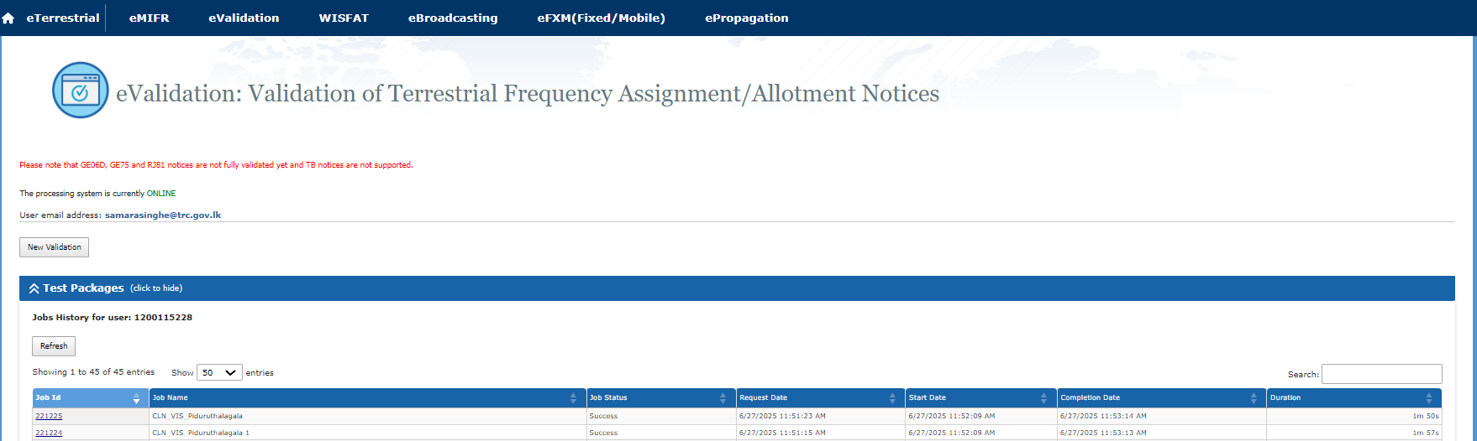
Figure 1: ITU e-Validation Tool for Validating MIFR Notices in Terrestrial Services

The careful approach for data submission and validation helps to maintain an accurate and efficient recording of frequency assignments in MIFR ensuring consistent and effective international spectrum management.

What Should Be Notified

The following frequency assignments that must be notified in compliance with RR No. 11.3–11.9:
- Assignments capable of causing harmful interference to the services of another administration.
- Assignments used for international radiocommunication.
- Assignments subject to a world or regional frequency allotment/assignment plan without its own notification procedure.
- Assignments requiring coordination under Article 9 of the RR.
- Requests for international recognition.
- Assignments submitted for informational purposes only (RR 4.4).
The following assignments must not be notified as per RR Nos. 11.13–11.14:
- Assignments to stations in the amateur service.
- Assignments to ship stations (ship-to-ship) and mobile stations of other services.
- Assignments involving specific frequencies prescribed by the RR for common use and already recorded in the MIFR.
- Broadcasting stations operating in the High Frequency (HF) bands in 5,900 kHz to 26,100 kHz (Article 12).

When Should Be Notified

Notices for recording frequency assignments in the MIFR must reach the BR within specific timeframes based on the type of assignment:

- Terrestrial stations coordinated with satellite networks and high-altitude platform stations (HAPS) operate as a base station for IMT: Notifications must be submitted not earlier than three years before the assignment is brought into use.
- High-altitude platform stations (HAPS) in the fixed service: Notifications must be submitted not earlier than five years before the assignment is brought into use.
- All other terrestrial stations: Notifications must be submitted not earlier than three months before the assignment is brought into use (as per RR No. 11.24).
Notifications that are received earlier than these specified deadlines but still within acceptable timeframes are provisionally recorded in the MIFR. This ensures that assignments are properly documented while meeting regulatory requirements.

If the Radiocommunication Bureau is not informed of the use of recorded frequency assignments, BR sends a reminder to the concerned administration. If no confirmation is received within the stipulated timeframe, the BR may cancel these entries from the MIFR in accordance with RR No. 11.47, ensuring the administration is informed beforehand.

For plan modifications, administrations can submit their notifications at any time as required, ensuring that changes are accurately recorded and compliant with international regulations.

Notification Format

In accordance with Resolution 906 (WRC-07), all frequency assignment notifications to the Radiocommunication Bureau must be submitted in electronic format. The submission should include a structured text file with clearly marked sections:

- A <HEAD> section identifying the notifying administration.
- One or more <NOTICE> sections containing all required administrative and technical data for each frequency assignment.
- A <TAIL> section specifying the total number of notices included.

This electronic format allows for unlimited notices in a single file, streamlining the notification process and ensuring compliance with ITU requirements. For additional information and samples of electronic notice types, refer to the official ITU guidelines available at the following link:
https://www.itu.int/en/ITU-R/terrestrial/tpr/Pages/Notification.aspx

This resource provides detailed instructions and examples to facilitate the submission of frequency assignment notifications.

Administrations must submit comprehensive data for frequency assignments. Key details include:

- Characteristics listed in Appendix 4 of the RR, including administrative and technical parameters.
- The Preface to the BR IFIC serves as a reference guide for interpreting symbols and codes used in notifications. Accurate and complete submissions ensure consistency across international spectrum management processes.

Each frequency assignment requires individual notification unless multiple assignments share identical characteristics, allowing for batch submissions. Specific notice types for allotment plans and broadcasting services simplify the process. These guidelines ensure that all required data is included, reducing the likelihood of errors during submission.

  - Electronic Notice Categories

Frequency assignment notices submitted electronically to the Radiocommunication Bureau are categorized into three groups based on the type of service and frequency bands:

- LMF (Low and Medium Frequency Bands for Sound Broadcasting) Included Notice Types under LMF: T03 (Regions 1 and 3), T04 (Region 2)

- FMTV (VHF and UHF Frequency Bands for Sound and Television Broadcasting) Included Notice Types under FMTV: T01, T02, GS1, GT1, GS2, GT2, GB1

- FXM (Fixed, Mobile, and Other Terrestrial Services) Included Notice Types under FXM: T11, T12, T13, T14, T15, T16, T17, G11, G12, G13, G14

  - Notice Types - Appendix 4

These notice types help streamline the notification and registration process for different types of radiocommunication services.

Table 01: Basic Notice Types for Notification Outside the Planning Area and Bands Governed by the GE06 Agreement
Notice Type | To Be Used For | Applicable Provisions | Class of Stations
T11 | Terrestrial transmitting station (TX) in the fixed service (Appendix 4, Annexes 1A and 1B) | RR No. 11.2 | FX
T12 | Terrestrial transmitting station (TX) in the fixed service (except station in the fixed, or LF/MF/VHF/UHF broadcasting services, or typical station) | RR No. 11.2, RR No. 9.21, GE85N | AL, BC, FA, FB, FC, FD, FG, FL, FP, LR, NL, OE, RN, SM, SS
T13 | Terrestrial receiving land station (RX) (Appendix 4, Annexes 1A and 1B) | RR No. 11.9, RR No. 9.21 | AM, AA, ML, MO, MR, MS, NR, OD, RM, SA
T14 | Terrestrial typical transmitting station (TP) (Appendix 4, Annexes 1A and 1B) | RR No. 11.17 | AL, FA, FB, FC, FD, FG, FL, FP, LR, NL, OE, RN, SM, SS
T15 | Frequency allotment in the maritime mobile service (Appendix 25) | AP25/1.1.1, AP25/1.1.25 | FC
T16 | Terrestrial transmitting station (TX) (Plan update Regional Agreement, Geneva, 1985) (Article 4 of the agreement) | GE85 (R1-MAR), GE85 (R1-AER) | AL, FC
T17 | Terrestrial transmitting station (TX) using adaptive systems (Appendix 4, Annexes 1A and 1B) | RR No. 11.2 | FX, FA, FB, FC, FD, FG, FL, FP

Table 02: Notice Types for the Broadcasting Service Within the Planning Area and Bands Governed by the GE06 Agreement
Notice Type | To Be Used For | Reference in GE06 Agreement
T01 | VHF sound broadcasting station | Table A.1 (GE06)
T02 | VHF/UHF television broadcasting station | Table A.1 (GE06)
T03 | LF/MF broadcasting station in Region 1 and MF broadcasting station in Region 3 | Table A.1 (GE06)
T04 | MF broadcasting station in Region 2 | Table A.1 (GE06)
G02 | Application of Article 4 procedures for analogue television broadcasting (transition period) | Table A.2 (GE06)
GS1 | Application of Article 4 procedures for digital sound (T-DAB) broadcasting | Table A.1 (GE06)
GS2 | Application of Article 4 procedures for digital sound (T-DAB) broadcasting | Table A.1 (GE06)
GT1 | Application of Article 4 procedures for digital television (DVB-T) broadcasting | Table A.1 (GE06)
GT2 | Application of Article 4 procedures for digital television (DVB-T) broadcasting | Table A.1 (GE06)
GB1 | Application of Article 5 procedures for broadcasting assignments using modified characteristics | 5.1.3 (GE06)
GA1 | Addition or suppression of allotment sub-area for digital television and sound broadcasting | Table A.1 (GE06)

Table 03: Notice Types Applicable to Terrestrial Services Other Than Broadcasting in the Planning Area and Bands Governed by the GE06 Agreement
Notice Type | Applicable to | Based on Notice Form
G11 | TERRESTRIAL TRANSMITTING STATION IN THE FIXED SERVICE  Application of Article 4* and 5** procedures including No. 5.1.3 | T11
G12 | TERRESTRIAL TRANSMITTING STATION, except station in the fixed service, or typical station  Application of Article 4* and 5** procedures including No. 5.1.3 | T12
G13 | TERRESTRIAL RECEIVING LAND STATION  Application of Article 4* and 5** procedures including No. 5.1.3 | T13
G14 | TERRESTRIAL TYPICAL TRANSMITTING STATION  Application of Article 4* and 5** procedures, except No. 5.1.3 | T14

*Note:
- Article 4 of the GE06 Regional Agreement involves the procedure for modifications to the Plans and the coordination of other primary terrestrial services.
**Note:
- Article 5 of the GE06 Regional Agreement involves the notification of frequency assignments to the Master Register.

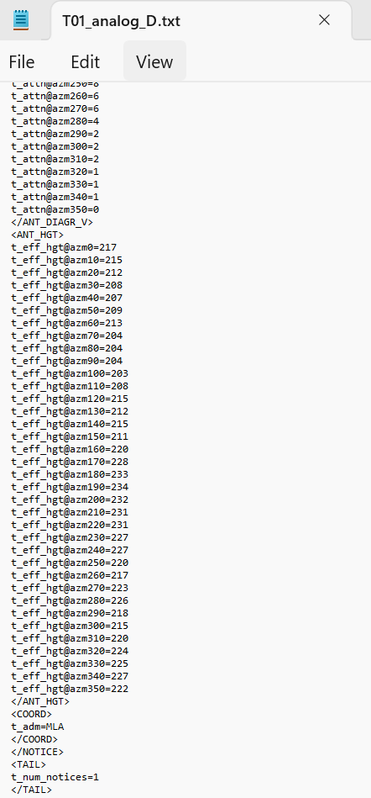
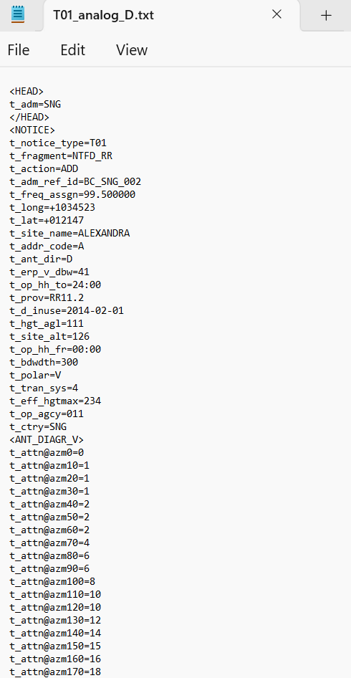

Figure 2: Example of a successfully generated T01 Notice file in .txt format, showing Part 1 (left-hand side of the above screenshot) and Part 2 (right-hand side the screenshot).

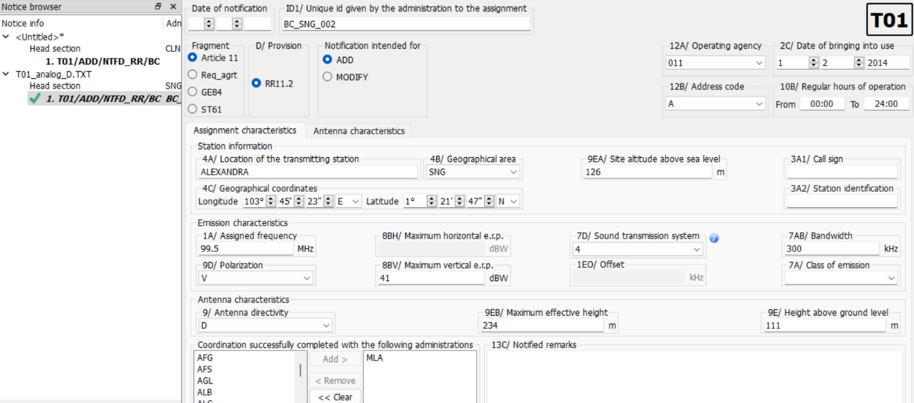

Figure 3: Example of T01 Notice file opened in ITU TeraNotice software

Table 04: Simplified Notice Types to Be Used for the Notification in the Broadcasting Service (BT and BC)
Notice Type | To Be Used For | Applicable Provision | Applicable to
TB1 | Notification of a modification to the unique identification code given by the administration | RR No. 11.2, GE84, GE89, ST61 | VHF Sound broadcasting and VHF/UHF Television broadcasting station
TB2 | Notification under Article 11 of an assignment with all technical characteristics as in the Plan | GE84, GE89, ST61, GE06A, GE06D | VHF Sound broadcasting and VHF/UHF Television broadcasting station
TB3 | Requesting publication of a modification in Part B of the corresponding Special Section | GE84, GE89, ST61, GE06A, GE06D | VHF Sound broadcasting and VHF/UHF Television broadcasting station
TB4 | Update the coordination information of a notice under treatment | RR No. 11.2, GE84, GE89, ST61 | VHF Sound broadcasting and VHF/UHF Television broadcasting station
TB5 | Suppress a recorded assignment or withdraw a notice under treatment | RR No. 11.2, GE84, GE89, ST61 | VHF Sound broadcasting and VHF/UHF Television broadcasting station
TB6 | Notification of a modification to the unique identification code given by the administration | RR No. 11.2, GE75, RJ81 | LF/MF broadcasting station in Regions 1 and 3, MF broadcasting station in Region 2
TB7 | Notification under Article 11 of an assignment with all technical characteristics as in the Plan | GE75, RJ81 | LF/MF broadcasting station in Regions 1 and 3, MF broadcasting station in Region 2
TB8 | Requesting publication of a modification in Part B of the corresponding Special Section | GE75, RJ81 | LF/MF broadcasting station in Regions 1 and 3, MF broadcasting station in Region 2
TB9 | Suppress a recorded assignment or withdraw a notice under treatment | RR No. 11.2, GE75, RJ81 | LF/MF broadcasting station in Regions 1 and 3, MF broadcasting station in Region 2

Table 05: Symbols used for designation of Terrestrial Services Stations
Service | Code | Station | Description/Definition
Fixed | FX | Fixed station | Station in the fixed service
Generic Mobile | FL | Land station | Station in the mobile service not intended to be used while in motion
 | MO | Mobile station | Station in the mobile service intended to be used while in motion or during halts at unspecified points
Land Mobile | FB | Base station | Land station in the land mobile service
 | ML | Land mobile station | Mobile station in the land mobile service
Maritime Mobile | FC | Coast station | Land station in the maritime mobile service
 | FP | Port station | Coast station in the port operations service
 | MS | Ship station | Mobile station in the maritime mobile service
 | OE | Oceanographic data interrogation station | Oceanographic data interrogation station
 | OD | Oceanographic data station | Oceanographic data station
Generic Aeronautical Mobile | FA | Aeronautical station | Land station in the aeronautical mobile service
 | MA | Aircraft station | Mobile station in the aeronautical mobile service
Aeronautical Mobile Route | FD | Aeronautical station | Land station in the aeronautical mobile (R)
Aeronautical Mobile Off Route | FG | Aeronautical station | Land station in the aeronautical mobile (OR)
Generic Radionavigation | RN | Radionavigation land station | Land station in the radionavigation service
 | NR | Radionavigation mobile station | Mobile station in the radionavigation service
Maritime Radionavigation | NL | Maritime radionavigation land station | Land station in the maritime radionavigation service
 | RM | Maritime radionavigation mobile station | Mobile station in the maritime radionavigation service
Aeronautical Radionavigation | AL | Aeronautical radionavigation land station | Land station in the aeronautical radionavigation service
 | AM | Aeronautical radionavigation mobile station | Mobile station in the aeronautical radionavigation service
Radiolocation | LR | Radiolocation land station | Land station in the radiolocation service
 | MR | Radiolocation mobile station | Mobile station in the radiolocation service
Meteorological Aids | SM | Meteorological aids base | Land station in the Meteorological aids service
 | SA | Meteorological aids mobile | Mobile station in the meteorological aids service
Standard Frequency and Time Signal | SS | Standard frequency and time signal station
Broadcasting | BC | Sound broadcasting station

Submission of Notifications to the Bureau – WISFAT

Administrations are encouraged to validate their frequency notices using the online validation tool provided by the BR before official submission. This tool is accessible via the ITU Terrestrial Web Tools platform; “eValidation”.

Key Features of eValidation:

- Validation includes checks on frequency bands, geographical coordinates, and the identification of potential duplicate notices.
- Once the validation process is completed in batch mode, users receive notifications via email.

Electronic frequency notices must be submitted to the BR via the WISFAT platform, a secure web-based system. WISFAT ensures seamless and safe submission of notifications.

Key Features of WISFAT:

- Access is restricted to registered notifiers approved by their administration and who hold an ITU user account with TIES Services.
- Upon submission, notifiers receive an immediate acknowledgment of receipt for all successfully submitted notifications.

- To become a registered notifier, administrations must send an official request to brmail@itu.int, including the notifier's name, position, service email, and ITU username. Administrations may appoint multiple notifiers as needed.
- For bulk submissions, it is strongly recommended to zip multiple electronic notice files into a single file when submitting on the same day.

The WISFAT platform is accessible at:
https://www.itu.int/net4/ITU-R/submission/wisfat/index.aspx

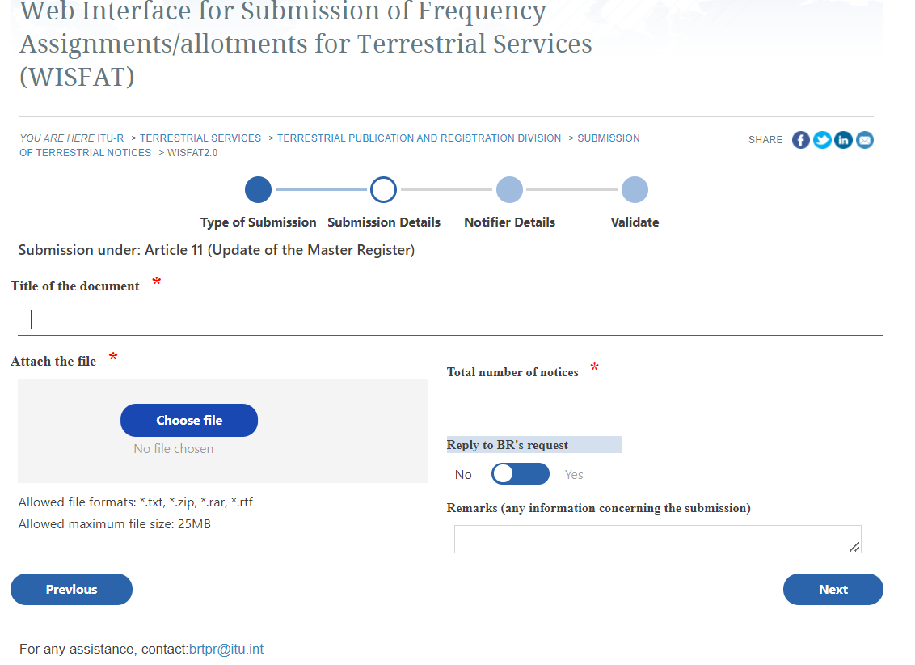
Figure 4: ITU WISFAT (Web Interface for Submission of Frequency Assignments for Terrestrial Services) Interface

By leveraging WISFAT, administrations can streamline their submission process while ensuring compliance with ITU standards.

Procedure Undertaken for Notified Frequency Assignments

The following steps outline the process undertaken for notified frequency assignments:

- Validation of Notices:
  - Notices received via WISFAT are validated using a tool equivalent to eValidation.
- Handling of Incomplete Notices:
  - Incomplete or erroneous notices may be returned under RR No. 11.27, with clarification requested if necessaryPre-Submission Validation:It is essential to validate notices before submitting them to the Radiocommunication Bureau (BR).
- Publication of Valid Notices:
  - Valid notices are published in Part 1 of the BR International Frequency Information Circular (BR IFIC), serving as an official acknowledgment of receipt.
- Examination for Compliance:
  - Notices are examined for conformity with RR Provisions Nos. 11.30 to 11.36, depending on the frequency band and type of assignment.
- Outcome of Examination:
  - Favorable results: The notice is published in Part 2 of the BR IFIC and recorded in the Master Register.
  - Unfavorable results: The notice is published in Part 3 of the BR IFIC and returned to the administration with detailed explanations.

This structured procedure ensures accuracy, compliance with the Radio Regulations, and efficient processing of frequency notifications.

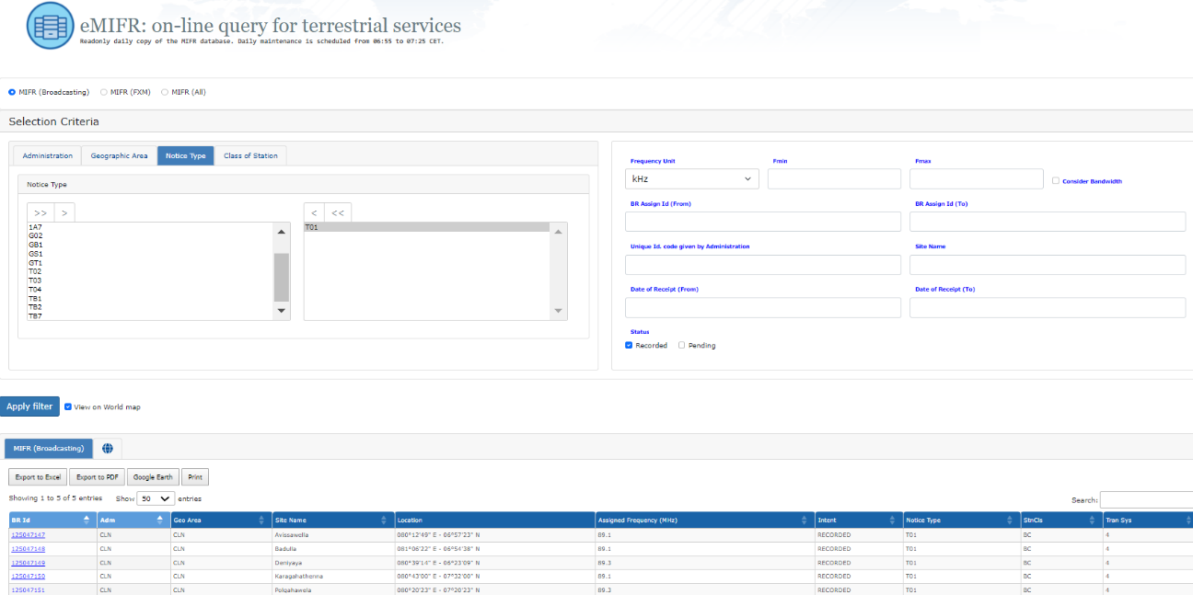

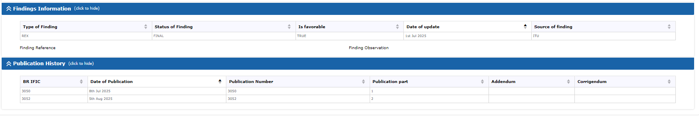
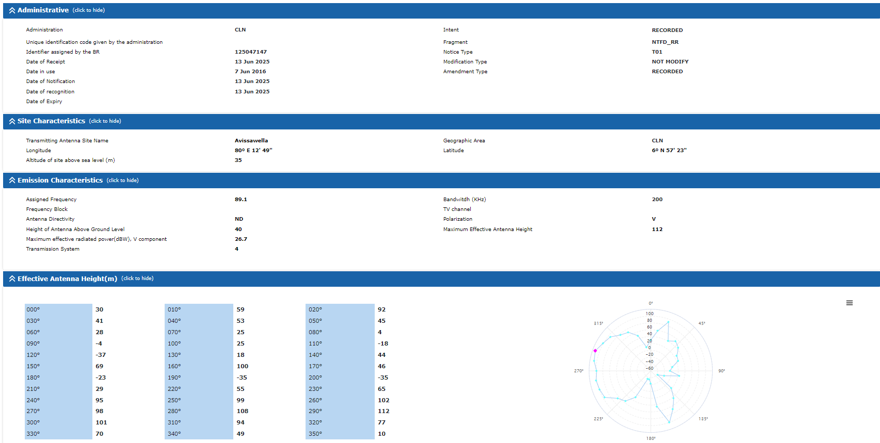

Figure 5: Overview of Successfully Recorded T01 Notices in MIFR Retrieved from ITU eTerresrial Portal

Summary of MIFR Notification Procedure for Terrestrial Service

The notification procedure for terrestrial services begins with the submission of complete and valid notices through the WISFAT platform to the ITU BR. Upon receipt, the BR examines these notices to ensure compliance with the Radio Regulations. Validated notices are subsequently published in the relevant sections of the BR IFIC.

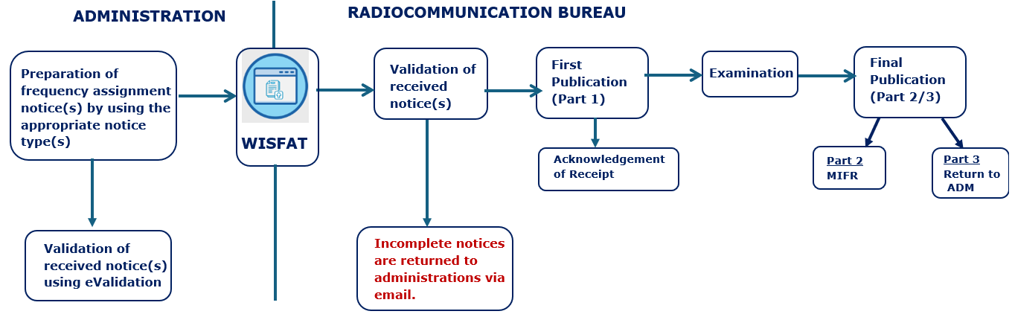
Figure 6: Simplified diagram of the MIFR notification procedure
  - Key Aspects of Notification:

- Obligation of Administrations:
Administrations must comply with the provisions of the Radio Regulations, as these are part of an international treaty signed by all ITU Member States.

- Claim for International Recognition:
Notifications enable administrations to secure international recognition of their frequency assignments.

Considering that frequency assignments recorded in the Master Register have the right to international recognition, it is essential to consult the BR IFIC regularly for updates.

For further details, refer to:
https://www.itu.int/en/ITU-R/terrestrial/brific/Pages/default.aspx

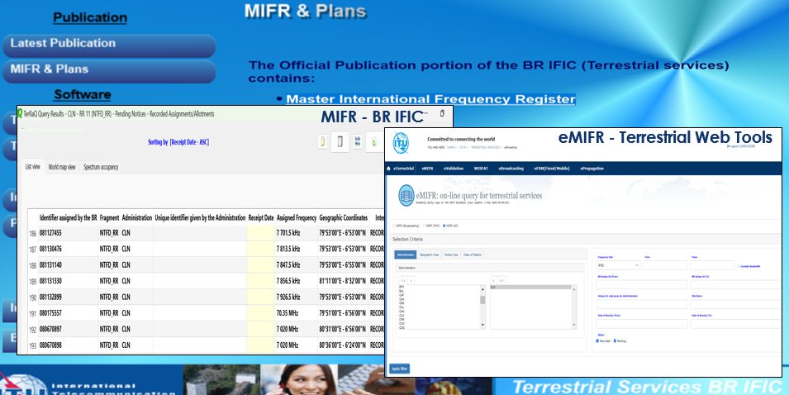
Figure 7: Examples of MIFR records accessed through BR International Frequency Information Circular (BR IFIC) and eMIFR Web Tool - Terrestrial Services

Challenges in the Submission of Frequency Assignments to the MIFR

- Limited Knowledge and Expertise
- Lack of awareness and in-depth understanding of the MIFR registration process and ITU Radio Regulations among regulators.
- Insufficient training on ITU’s frequency assignment notification procedures.
- Difficulties in utilizing ITU Software Tools
  - Challenges in using ITU-provided software such as SpaceCap, SpaceVal, eTerrestrial, and WISFAT for validation, notice generation, and submission.
- Frequent updates and modifications to ITU tools
  - Difficulty in ensuring compliance with ITU coordination requirements, including Articles 9 and 11 of the ITU Radio Regulations.
  - Time-consuming coordination procedures, especially for frequencies requiring international agreement.
- Lack of structured internal workflows for submission and processing
- Lack of structured internal workflows for preparing, validating and approvals related to submission of MIFR notices.
- Data Accuracy and Notice Rejections
- Errors in submitted data, including non-availability of mandatory data and coordination details.
- Non-compliance with ITU formatting and regulatory provisions.
- Lack of Coordination Among Stakeholder including Operators and National Authorities
- Inefficient coordination between stakeholders including relevant operators and different national agencies
- Overlapping responsibilities between national regulatory authorities and other stakeholders.
- Regulatory and Procedural Misinterpretation
- Misinterpretation of ITU regulations and procedures for different frequency bands and services.

- Challenges in Keeping Up with ITU Regulatory Changes
- Updates to ITU Radio Regulations, relevant software and MIFR-related procedures requiring continuous adaptation.
- Limited participation in ITU workshops, discussions, and updates on regulatory changes.
- Human Resource Constraints
- Shortage of dedicated staff with specialized knowledge in frequency notification and coordination.
x) Challenges in Data Collection for Notice Forms

- Difficulty in obtaining complete and accurate data from telecom operators, particularly for mandatory fields required in notice forms.
- Missing or inconsistent technical parameters hinder the validation and timely submission of frequency assignment notices.

PART II – SPACE SERVICES

Overview of Space Services and Regulatory Framework

The ITU Space Services primarily focuses on the coordination and recording of frequency assignments for space systems and earth stations. These services facilitate the efficient use of spectrum and orbit resources while ensuring compliance with international regulatory standards.

Key responsibilities include the capture, processing, and publication of geostationary satellite data. Additionally, the ITU carries out examinations of frequency assignment notices submitted by administrations for recording in the MIFR. This ensures that all assignments comply with technical and regulatory requirements.

The legal framework for Space Services is established under the following provisions of the Radio Regulations (RR): Article 1 defines the purposes and scope of the ITU; Article 44 governs the use of the radio-frequency spectrum and satellite orbits, ensuring equitable access and rational usage; and Article 45 outlines measures to mitigate harmful interference between radiocommunication services.

Recording a frequency assignment in the MIFR grants international recognition to Member States for their use of spectrum and orbit resources. This process is critical for protecting assignments from harmful interference and ensuring their availability for future use. The notification of frequency assignments, governed by Article 11 of the RR, represents the final step before recording in the MIFR. This step formalizes the assignment's compliance with international regulations, solidifying its recognition and protection on a global scale.

The Radio Regulations aim to ensure interference-free operations, a critical objective for space services. The risk of signal interference arises from interactions between Geostationary Satellite Orbit (GSO) and Non-Geostationary Satellite Orbit (NGSO) systems, as well as terrestrial networks. Effective coordination is essential to avoid harmful interference that could disrupt operations.

To control interference and ensure equitable access, five regulatory and technical mechanisms are implemented:

- Allocation: Frequency separation for stations of different services.
- Power Limits: Setting thresholds such as power flux density (pfd) to protect terrestrial services, equivalent isotropic radiated power (eirp) to safeguard space services, and equivalent power flux density (epfd) to protect geostationary satellites from NGSO systems.
- Coordination: Between administrations to achieve interference-free operations.
- Monitoring: Using an international monitoring system to oversee compliance and detect interference.
- Recording: Registering assignments in the MIFR for international recognition and protection.
Additionally, geo-orbital congestion highlights the growing density of satellites, making these mechanisms crucial for the efficient management of spectrum and orbital resources. The ITU's regulatory framework ensures these tools are applied effectively to mitigate interference risks and support seamless satellite communications.

  - Approaches for Recording in the MIFR

The Radio Regulations govern access to orbit and spectrum resources, providing two primary approaches for recording frequency assignments in the MIFR:

- Coordination Approach: This approach is used for non-planned services and is based on addressing requirements as they arise. It ensures the rational, efficient, and economical use of spectrum and orbit resources. Key elements of the coordination approach include submitting a coordination request, fulfilling the requirements specified in the Radio Regulations, negotiating with concerned administrations to reach agreements, and recording the coordinated assignments in the MIFR to ensure they are taken into account by other administrations.
- Planning Approach: This approach applies to planned services and involves priori planning for future use. It ensures equitable access to spectrum and orbit resources by establishing pre-defined plans for specific services and frequency bands.
Both approaches are essential for the effective management of spectrum and orbital resources, promoting fairness and operational efficiency in global space communications.

  - Satellite Networks Coordination Procedure

Satellite networks can be classified into two categories based on their requirement for coordination procedures:

- Satellite Networks Not Subject to Coordination Procedure:
These include certain non-GSO satellite networks. The process begins with Advanced Publication Information (API), which starts the seven-year clock to bring the assignment into use. During this period, administrations are informed of the planned network's general description, but no priority or examination is required. The process culminates with notification and recording in the MIFR, granting international recognition.
- Satellite Networks Subject to Coordination Procedure:
These include both GSO and non-GSO planned satellite networks. The process involves coordination, where all concerned administrations are informed of the network's detailed description to resolve potential interference issues and ensure interference-free operations. Similar to the non-coordinated process, the seven-year clock is initiated, and the procedure concludes with notification and recording in the MIFR, securing international recognition.
These processes ensure proper management and compliance for all satellite networks, safeguarding equitable and interference-free use of the spectrum.

  - Earth Station Coordination Procedure

The coordination procedure for earth stations is outlined in Section II of Article 9 of the Radio Regulations, under the "Procedure for Effecting Coordination." The key elements of this process include:
- Coordination: The responsible administration of a planned earth station informs concerned administrations about the detailed descriptions of the station. However, there is no publication or identification of affected administrations by the BR. Earth stations must be associated with a satellite network for which Advanced Publication Information (API) and/or Coordination Request (CR) have been published.
- Notification: Following coordination, the assignment is recorded in the MIFR, granting international recognition. The station must be brought into use by the planned date.
The BR does not conduct an examination or identify coordination requirements during this process. Instead, examination is conducted at the notification stage to ensure conformity with the Radio Regulations and compliance with coordination requirements. This approach facilitates the efficient management and registration of earth station frequency assignments.

  - Coordination Procedure and Key Elements

The coordination procedure ensures compliance with the Radio Regulations and establishes a systematic approach to managing frequency assignments. The key elements and relevant provisions are as follows:

- Request for Coordination: Administrations submit a request for coordination using the format specified in Appendix 4 of the Radio Regulations. This step involves submitting technical and regulatory data for initiating the coordination process.
- API/CR Publication: Advanced Publication Information (API) and Coordination Requests (CR) are published to inform concerned administrations. This process includes a technical and regulatory examination along with the identification of coordination requirements as per the provisions in Articles 9 and 11.
- Regulatory Period: A regulatory period is set to ensure compliance with timelines and other regulatory requirements.
- Setting Priority: Priority is determined based on Resolution 2 and No. 9.53 of the RR to manage conflicts between assignments and ensure fairness.
- Findings and Affected Administrations: The BR examines the findings as per No. 9.35 and identifies the affected administrations under No. 9.36 to facilitate effective coordination.
Relevant Provisions:

- Procedures: Articles 9 and 11.
- Submission Format: Appendix 4.
- Technical and Operational Limits: Article 5 and Articles 21 and 22.
- Criteria and Methods for Coordination Requirements: Appendix 5, including Appendices 7 and 8.

This process ensures that all frequency assignments comply with the technical, regulatory, and coordination requirements of the Radio Regulations, facilitating efficient spectrum management.

Notification Provisions

Notification provisions for frequency assignments are detailed in Article 11 of the RR. These provisions require administrations to notify frequency assignments for purposes such as coordination under Article 9, compliance with international or regional frequency plans, and securing international recognition. The table below provides references to Article 11 in other parts of the Regulations, specifically concerning services in the non-planned bands in relation to services in the planned bands.

Table 06: Provisions of Radia Regulation related to the categories of Space Services
Categories of Space Services | Provisions | Remark
All space services except those listed below | Article 11
Fixed-satellite service in the frequency bands 11.7-12.2 GHz (in Region 2), 12.2-12.7 GHz (in Region 3), and 12.5-12.7 GHz (in Region 1) | Article 7 of Appendix 30 | Cross-reference to application of Article 11
Fixed-satellite service (space-to-Earth) in the frequency bands 17.7-18.1 GHz (in Regions 1 and 3), 17.7-17.8 GHz (in Region 2) and broadcasting-satellite service in the frequency bands 17.3-17.8 GHz (in Region 2) 14.5-14.8 GHz (Earth-to-space fixed-satellite service) | Article 7 of Appendix 30A | Cross-reference to application of Article 11
Fixed-satellite service in the frequency bands 4.500-4.800 MHz, 6.725-7.025 MHz, 10.7-10.95 GHz, 11.2-11.45 GHz, and 12.75-13.25 GHz | Article 8 of Appendix 30B | Cross-reference to application of Article 11

What Needs to Be Notified

As specified in Nos. 11.2 and 11.9 of the Radio Regulations, any frequency assignment to transmitting and receiving stations must be notified to the Radiocommunication Bureau under the following conditions:
a) If the use of the assignment is capable of causing harmful interference to any service of another administration.
b) If the assignment is intended for international radiocommunication.
c) If the assignment is part of a world or regional frequency allotment or assignment plan that does not have its own notification procedure.
d) If the assignment is subject to the coordination procedure of Article 9 or is involved in such a case.
e) If international recognition is desired for the assignment.
f) If the assignment is non-conforming under No. 8.4, and the administration wishes to have it recorded for informational purposes.

These conditions ensure that frequency assignments are properly documented, comply with regulatory requirements, and avoid potential interference with other services.

Time Frame –Notification Procedure

Timely submission of notifications is critical to maintaining the integrity of the spectrum management process.

Space Stations

- Provision No. 11.44.1: The first notice for recording space station frequency assignments must be submitted within seven years of receiving complete and relevant information.
- Notification can begin after completing the Advance Publication Information (API) or coordination procedures, as specified in Provision No. 11.38.
- If disagreements arise between administrations, or if assistance is sought, the BR may examine the notice under No. 11.32A or No. 11.33. Based on its findings, the BR can either record the assignment in the MIFR for a favorable finding or return the notice to the notifying administration for an unfavorable finding.
- Provision No. 9.1: Allows simultaneous submission of notification information along with the advance publication procedure.

Earth Stations

- The notification procedure for earth stations must begin or conclude after completing the associated space station notification process, as per Provision No. 11.32 of the Radio Regulations.
This process ensures that frequency assignments for space and earth stations comply with regulatory requirements and are recorded in a timely manner for international recognition.

The notification procedure for frequency assignments follows a structured time frame to ensure compliance with regulatory requirements. The key steps and timelines include:

- API/Coordination: The process begins with the submission of Advanced Publication Information (API) or a Coordination Request (CR), initiating the seven-year regulatory period as specified in No. 11.44 of the Radio Regulations.
- Notification: Administrations must submit the notification for the frequency assignment during the seven-year period, ensuring compliance with all regulatory requirements.
- DBIU (Date of Bringing Into Use): The assignment must be brought into use within the seven-year limit. Administrations are required to provide the exact DBIU to the Radiocommunication Bureau.
- DBIU Confirmation: Within 90 days of the DBIU, administrations must confirm the use of the assignment. For Geostationary Satellite Orbit (GSO) systems, the confirmation must meet the deadlines set in No. 11.44B.
- Continuous Use: Once confirmed, the assignment enters the continuous use phase, with its validity governed by Resolution 49. Any suspension of the assignment is handled under No. 11.49.
- Bringing Into Use Deadline: The process concludes with the final bringing into use deadline as stipulated by Nos. 11.44 and 11.47 of Radio Regulation.
This structured approach ensures that all frequency assignments are properly managed, avoiding delays and maintaining compliance with international regulations.

Notification Procedures

- Provision No. 11.44.1 mandates that the first notice for recording space station frequency assignments must be submitted within the regulatory timeframe. The notification procedures outlined in Article 11 of the Radio Regulations are divided into two key sections:
  - Section I – Notification: This section details the procedures for initiating the notification process, ensuring that the required information is submitted to the BR in the proper format and within the specified deadlines.
  - Section II – Examination and Recording: This section describes the procedures for the processing, examination, and recording of frequency assignments. It includes steps for handling notifications, verifying compliance with regulatory requirements, and either recording the assignments or returning them to the notifying administration for corrections.
- The BR publishes "as received" notifications from administrations in the International Frequency Information Circular (BR IFIC) in DVD-ROM/ISO format within 30 days of receipt. These notifications are also accessible on the ITU website under the path: Radiocommunication (ITU-R) ➔ Space Services ➔ SNL ➔ More ➔ Information “As Received” (Part-C).
- This structured approach ensures transparency, compliance, and international recognition of frequency assignments.

  - Section I: Notification

The Notification Procedure begins when an administration provides the required characteristics for frequency assignments as stipulated in No. 11.15 of the Radio Regulations. The key steps and requirements are as follows:

- Submission Format: Notice forms for satellite networks and earth stations must be submitted electronically, as required by Resolution 55 (Rev. WRC-19). These forms must be compatible with SpaceCap software.
- Required Data Structure: The description of information and data structure must align with the specifications in Appendix 4 of the Radio Regulations and Section 3 of the Preface to the BR IFIC.
- Graphical Data: Submissions requiring graphical data must use a format compatible with the Graphical Interference Management System (GIMS) to ensure proper processing.
- Submission Platform: All notice forms required under Article 11 must be submitted via the ITU’s e-Submission of Satellite Network Filings web interface. The platform can be accessed at the following link:
https://www.itu.int/en/ITU-R/space/e-submission/Pages/default.aspx
- Access to Tools: Electronic notification software and tools can be retrieved from the ITU website or included in the BR IFIC on DVD ROM, ensuring accessibility for administrations to meet the procedural requirements.
This systematic approach ensures consistency and accuracy in submitting notifications, enabling the Radiocommunication Bureau to effectively process and examine frequency assignment filings.

Guide for Obtaining Notification Software Tools

The ITU provides various software tools to support the notification process for satellite networks and earth stations. These tools assist in data capture, validation, and graphical representation. The details of the tools and their functions are listed below:

Table 07: Software tools to support the notification process for satellite networks and earth stations
Notification Software Tools and Aids | Description | Internet Address Path to Follow
Space Data Capture Software (SpaceCap) | Electronic AP4/II and III forms for capturing notification data. | SpaceCap Software
Space Filing Validation Software (SpaceVal) | PC-based software for validating electronic notices captured by the SpaceCap software. | SpaceVal Software
GIMS | PC-based software package for capturing, modifying, and validating graphical data related to satellite networks. | GIMS Software
Space Publication Software (SpacePub) | PC-based software utility for printing satellite networks and earth stations. | SpacePub Software

Application of Tools in the Notification Process

- SpaceCap: Used for the initial data capture process in creating API and notification forms.
- SpaceVal: Ensures the validation of captured data for regulatory compliance.
- GIMS: Provides graphical data modification and validation, critical for coordination processes.
- SpacePub: Prints finalized forms and data for documentation and submission.

Notification Workflow

- API: SpaceCap and SpaceVal tools are used to create and validate initial Advanced Publication Information.
- Coordination: SpaceCap, SpaceVal, and GIMS tools are applied during the coordination phase to manage data and graphical details.
- Notification: The validated data is submitted for notification through the required channels.
This systematic approach, supported by ITU's tools, ensures the accuracy and completeness of satellite network filings while maintaining compliance with Radio Regulations.

  - Useful Information for Submitting Notifications

The following table provides a summary of the key considerations and requirements for submitting notifications to ensure compliance with the Radio Regulations:

Table 08: Key considerations and requirements for submitting notifications to ensure compliance with the Radio Regulations
Key Considerations | Details
Accuracy and Completeness | To prevent delays or returns, notices must align with Radio Regulation provisions and be complete and accurate.
Validation of Notices | Administrations are advised to validate notices using SpaceVal and GIMS software before submission, as recommended by the Radio Regulation guidelines.
Coordination Information | Information should be current and clearly identified, adhering to Radio Regulation requirements, especially when multiple coordination procedures are involved.
Handling of Incomplete Notices | Notices lacking necessary information under Radio Regulation Nos. 9.1 or 9.2 (or 9.1A for specific cases) will be returned, emphasizing compliance with frequency bands.
Time Constraints | Submissions must meet the timelines specified in Radio Regulation Nos. 11.44, 11.44.1, and 11.25.
Checklist for Submission | A checklist of essential items is provided to ensure correct and complete notice submissions, as outlined in Radio Regulation procedures.

This structured approach ensures that notifications are compliant, timely, and correctly formatted, minimizing the risk of rejections or delays in processing.

  - Section II – Examination and Recording of Frequency Assignments

The process of examining and recording frequency assignments involves detailed steps to ensure compliance with the Radio Regulations. Key points are outlined below:

- Initial Review: Upon receiving notices, the Bureau checks for completeness based on Radio Regulation No. 11.27.
- Processing Order: Complete notices are processed in chronological order of receipt, following the guidelines in Radio Regulation Nos. 11.28 and 11.29.
- Deferring Impacting Notices: Notices that impact earlier submissions are deferred until the issues with the earlier ones are resolved.
- Formal Receipt Date: The date of receipt is formally confirmed when all submitted information is verified as complete and accurate by the BR.
- Handling Incomplete Notices: If a notice lacks mandatory information as specified in Radio Regulation Annex 2 of AP4, the BR informs the administration and halts processing until the missing information is provided.
- Clarification Requests: If additional clarification is required, the BR requests it within 30 days. If the clarification is submitted within the timeframe, the original receipt date is retained.
- One-Year Deadline: Submissions that remain incomplete after one year are returned to the notifying administration, in line with the Radio Regulation guidelines.
This structured process ensures that all frequency assignments are thoroughly reviewed and comply with international standards before recording in the MIFR.

  - Examination of Notices

- The BR examines each notice for conformity with the Table of Frequency Allocations and other provisions under Radio Regulation No. 11.31.
- The process includes verifying compliance with coordination procedures (No. 11.32) and assessing the probability of harmful interference if requested (Nos. 11.32A and 11.33).
- Examinations are conducted at the assignment level, allowing for different findings within a group of assignments, referred to as "split findings".
- Findings are established individually for each assignment, enabling frequency assignments to be notified at different times.
This process ensures that all frequency assignments meet the required technical and regulatory standards before recording in the MIFR.

  - Modification of Characteristics of Assignments Already Recorded

- Request for Modifications: Administrations can request changes to the characteristics of assignments already recorded in the MIFR (No. 11.43A).
- Examination Process: Modified assignments are examined by the BR under Nos. 11.31 to 11.33.
- No Increase in Harmful Interference: If changes conform to No. 11.31 and do not increase harmful interference, the amended assignment retains its original entry date.
- Increase in Harmful Interference: If changes conform to No. 11.31 but increase harmful interference, coordination under Section II of Article 9 is required.
- Coordination Requests: Requests for modified assignments and additional agreements must be submitted simultaneously with the notification request under No. 11.43A.
This process ensures that modifications to assignments are carefully evaluated to maintain compliance with the Radio Regulations and minimize interference.

  - Location Where the Findings Are Published

- Favorable Findings: Published in Part II-S of the BR-IFIC DVD-ROM, with the date of protection recorded in Column 2D of the MIFR.
- Unfavorable Findings: Published in Part III-S of the BR-IFIC DVD-ROM, and notices are returned to the notifying administration via communication channels.
- Monitoring: Administrations can monitor BR-IFIC publications through the Space International Frequency Information Circular Databases Online, accessible at:
www.itu.int ➔ Radiocommunication (ITU-R) ➔ Space Services ➔ BR IFIC ➔ BR IFIC data.
- Coordination Requirements: Verified using information in boxes A5/A6 of the notice form, as outlined in Part I-S and Part II-S of the BR-IFIC.
- Comments on Assignments: Administrations may comment on assignments to earth stations bearing symbol Z/9.7/... in Part II-S if their space service assignments may be affected.
- BR Examination: The BR evaluates assignments with respect to No. 9.7, applying Appendix 8, and updates or maintains the initial finding as necessary.
This structured publication system ensures transparency and provides administrations with the necessary information to monitor and manage their assignments effectively.

Publication in the BR IFIC

The Bureau publishes findings related to frequency assignments in different parts of the BR IFIC:
- Part I-S: Acknowledges the receipt of notices and provides the particulars of complete frequency assignment notices.
- Part II-S: Includes findings (primarily favorable) that result in the recording of the frequency assignment in the MIFR.
- Part III-S: Contains unfavorable findings that result in the return of the notice to the notifying administration.
Important points to note include:
The Bureau publishes "as received" notifications from administrations in the BR IFIC DVD-ROM/ISO format within 30 days of receipt.
- These publications are also accessible online via the ITU website under the path:
Radiocommunication (ITU-R) ➔ Space Services ➔ SNL ➔ More ➔ Information “As Received” (Part-C).
- This structured publication process ensures transparency and allows administrations to monitor the progress of their notifications and take corrective actions if necessary.

  - CR/C Special Section of the BR IFIC

The CR/C Special Section of the BR IFIC on DVD-ROM provides critical network data and Radiocommunication Bureau comments. Key details include:

1. Content:
  - Findings: Related to No. 11.31 (examination under No. 9.35).
  - Coordination Examination: In accordance with No. 9.36, which includes:
    - Administrations identified under all forms of coordination.
    - A list of satellite networks (No. 9.36.2).
    - Potentially affected administrations (No. 9.36.1) listed for information purposes only.
2. Procedure:
  - Upon receiving a request for coordination, administrations must examine interference concerns with respect to their own assignments.
  - Within four months of BR IFIC publication, the requesting administration and the BR must be informed of one of the following:
    - Agreement: Consent to the proposed use.
    - Disagreement: A refusal to consent, accompanied by reasons for the disagreement.
This section ensures transparent handling of coordination requests and the resolution of interference issues, facilitating efficient spectrum management.

Recording in the MIFR

Frequency assignments with final characteristics must be notified under Article 11 for recording in the MIFR within the regulatory period. To ensure recording in the MIFR, the following conditions must be met:

- Conformity with Regulations:
  - Assignments must conform to the Allocation Table and other provisions listed in the Radio Regulations under No. 11.31 (No. 11.31 examination).
  - All required coordination procedures must be completed as per No. 11.32 (No. 11.32 examination).
- Favorable Examination: Assignments must receive a favorable result regarding the probability of harmful interference (C/I) under No. 11.32A examination.

- Frequency assignments can also be recorded in the MIFR upon request under specific conditions:
- Under Nos. 4.4/8.4: Assignments recorded for information purposes without international recognition.
- Unfavorable Findings:
  - Assignments with unfavorable findings under No. 11.31.
  - Assignments with unfavorable findings under Nos. 11.32 and 11.32A.

- Information Only: Assignments recorded for informational purposes, without international recognition.
- Under No. 11.41: Assignments that require a coordination effort or involve unfavorable findings.
- Requirement of No. 11.41.2 and No. 11.42: Includes assignments requiring the indication of coordination efforts and the elimination of harmful interference.

- Additionally, bringing assignments into use must be confirmed during the notification process as per Nos. 11.47 and 11.44B-E, ensuring compliance within the regulatory period.

Due Diligence and Resolution 49

Resolution 49 addresses the issue of orbit and spectrum reservation without actual use. The key aspects of this resolution are as follows:

- Applicability: It applies to satellite networks in the Fixed-Satellite Service (FSS), Mobile-Satellite Service (MSS), and Broadcast-Satellite Service (BSS) that are subject to coordination procedures.
- Required Information: Administrations must provide details regarding:
  - The identity of the satellite network.
  - The spacecraft involved.
  - The launch services provider.

- Regulatory Deadlines: All required information must be submitted within 30 days from the regulatory deadline. Failure to do so results in the suppression of submissions.
This resolution ensures the efficient use of orbital and spectrum resources by preventing unnecessary reservations and fostering transparency and accountability in satellite network operations.

Maintenance of the MIFR

The Bureau of Radiocommunication is responsible for the ongoing maintenance of the MIFR to ensure its accuracy and relevance. Key points include:
- BR Responsibilities: The BR consults with administrations under No. 13.6 to request additional information about the Date of Bringing into Use (DBIU) and/or the continuous use of frequency assignments. These consultations are based on reliable information available to the BR.
- Cancellation of Entries: The cancellation of any entry in the MIFR is subject to a formal decision made by the Radio Regulations Board (RRB).
This process ensures that the MIFR remains up to date and that frequency assignments adhere to the conditions set by the Radio Regulations.

Experience in SATRC Countries

Member countries of the South Asian Telecommunication Regulators’ Council (SATRC) place a strong emphasis on capacity building and regional collaboration to streamline the MIFR registration process. Adherence to ITU Radio Regulations and efficient use of ITU tools have notably enhanced spectrum management practices throughout the region.

In order to gather the experience of each SATRC country in recording frequency assignments to the MIFR of the ITU, a questionnaire was circulated among the administrations, and the responses are tabulated in Annex 1 of this report.

Proposals and Recommendations

Proposals:

Proposed Capacity-Building Initiatives for MIFR Notification in the SATRC Region are listed below.
- Conduct Regional Hands-On Workshops
Organize practical, interactive workshops and training programs for the SATRC region, focusing on the effective use of ITU software tools for frequency assignment notifications in the Master International Frequency Register.
- Develop On-Demand Training Modules
Create virtual and/or physical training modules tailored to the needs of SATRC Member countries, ensuring easy access, regular updates, and coverage of ITU tools and regulations relevant to frequency assignment notifications for both terrestrial and space services.
- Establish an Expert User Group
Form a dedicated SATRC expert group to provide a platform for member states to discuss MIFR-related challenges, exchange best practices, and access peer and expert support in resolving notification issues.

Recommendations

Proposed Actions for Enhancing MIFR-Related Capacity and Coordination in SATRC are listed as follows.
  - Encourage Active Engagement with ITU Resources
Promote regular participation by administrations in ITU-organized workshops, training courses, and technical programs to strengthen expertise in frequency notification processes.
  - Establish a Regional Coordination Mechanism
Create a structured platform for SATRC countries to coordinate and address MIFR-related challenges collectively, facilitating a more efficient and collaborative approach to frequency notifications.
  - Advocate Regional Harmonization of Procedures
Align notification processes across SATRC countries with ITU guidelines to support regional harmonization, improve cross-border coordination, and enhance spectrum management efficiency.
  - Implement an Impact Assessment Framework
Develop and apply a structured approach to evaluate the effectiveness of training programs, online forums, and capacity-building initiatives, ensuring continuous improvement and adaptability to evolving regulatory needs.
  - Facilitate Knowledge Sharing and Best Practices
Promote the exchange of practical experiences through case studies, documentation of successful notifications, and creation of a shared repository accessible to all SATRC members.

Conclusions

The ITU’s Master International Frequency Register plays a critical role in ensuring equitable spectrum access and securing international recognition of frequency assignments. By adhering to the ITU’s mandated frequency notification procedures and effectively utilizing its data management and administrative tools, SATRC member countries can significantly improve the efficiency and fairness of spectrum usage. This collaborative approach, supported by the ITU, strengthens cross-border interference resolution mechanisms, enabling interference-free operations and promoting sustainable spectrum management for the long-term benefit of the region.

- References
- International Telecommunication Union (ITU).
Radio Regulations (Edition of 2024): Articles 9, 11 and Appendix 4 — Notification and Recording of Frequency Assignments in the Master International Frequency Register.
Geneva: ITU Radiocommunication Bureau (BR), 2024.
Available at: https://www.itu.int/pub/R-REG-RR
- International Telecommunication Union (ITU).
Master International Frequency Register (MIFR): Overview and Procedures.
ITU-R Official Webpage, Radiocommunication Bureau.
Geneva: ITU, 2023.
Available at: https://www.itu.int/en/ITU-R/terrestrial/broadcast/Pages/MIFR.aspx
- ITU Radiocommunication Bureau.
Notification and Recording of Frequency Assignments in the Master International Frequency Register.
Presentation prepared for the ITU Regional Radiocommunication Seminar (RRS).
Geneva: ITU, 2022.
Available at: https://www.itu.int/en/ITU-R/terrestrial/broadcast/Americas/Documents/Presentatins%20Belize/MIFRandPlanningProcess.pdf
- ITU Radiocommunication Bureau (BR).
FAQ: Master Register (MIFR) — Questions and Answers on Notification and Registration.
ITU-R Terrestrial Services, 2023.
Available at: https://www.itu.int/en/ITU-R/terrestrial/Pages/by-categories-faq.aspx?subcategorizedby=6
- International Telecommunications Satellite Organization (ITSO).
Notification and Recording of Frequency Assignments in Space Services (Non-Planned Services).
Training Material presented at ITSO–ITU Joint Workshop on Space Services, Washington D.C., 2018.
Available at: https://itso.int/wp-content/uploads/2018/04/Day-2-ITU-2-Notification-Recording-Non-Plan-Services.pdf
- International Telecommunications Satellite Organization (ITSO).
Notification and Recording of Assignments: Procedures and Findings under Articles 9 and 11 of the Radio Regulations.
ITSO–ITU Joint Workshop on Space Services, 2018.
Available at: https://itso.int/wp-content/uploads/2018/04/3.1.6-Notification-and-recording-of-assignments.pdf
- United Nations Office for Outer Space Affairs (UNOOSA) and ITU.
Steps to File a Satellite Network with the ITU and Registration in the MIFR.
Vienna: UNOOSA, 2020.
Available at: https://www.unoosa.org/documents/pdf/psa/hsti/SpaceLaw/UNOOSA_Access_to_Space_to_All_-_ITU_sat_networks_fillings_steps.pdf
- Aubineau, P. (for CEPT and ITU-R).
Notification and Recording of Frequency Assignments — ITU-R Procedures and BR IFIC Publication Process.
Presentation to CEPT–ITU Workshop on the Radio Regulations, 21 June 2022.
Copenhagen: CEPT, 2022.
Available at: https://cept.org/files/2378/2022-06-21%20-%20P.%20Aubineau%20-%20CEPT-WS-ITU-R-part%202.pdf
- International Telecommunication Union (ITU).
Managing the Radio-Frequency Spectrum for the World: Overview of the Master International Frequency Register and Coordination Process.
Geneva: ITU Media Centre, 2023.
Available at: https://www.itu.int/en/mediacentre/backgrounders/Pages/itu-r-managing-the-radio-frequency-spectrum-for-the-world.aspx

Annex 1

Responses to the Survey on the Experience of SATRC Countries in Notifying Frequency Assignments for Recording in the MIFR

# | Questions | Responses
1 | Does your administration notify the frequency assignments for recording in the Master International Frequency Register (MIFR)? If yes, since how long have you been in this process? | Afghanistan:  No Yes, we have two databases for spectrum Management, SMS4DC and MS. Access based Database.
1 |  | Bangladesh:  No. We don’t notify the frequency assignments for recording in the MIFR.  N/A
1 |  | Bhutan:  We haven’t done for terrestrial yet but done for satellite services.
1 |  | India:  Yes, since several years.
1 |  | Iran:  Yes, this Administration proceeded to notify the frequency assignments for more than 4 decades.
1 |  | Maldives:  Yes, for the few extra border services we have. Voice of Maldives and Coastal Radio. They don’t change and so on a regular basis we don’t have entries to notify MIFR.
1 |  | Nepal:  As of now, No. But notifying the frequency assignments for recording in MIFR is expected to start soon.
1 |  | Pakistan:  Yes, since inception
1 |  | Sri Lanka:  For the time being such process is not implemented. However, the process is initiated with the consultation of ITU.
2 | Does your organization maintain a Spectrum Management Database? If yes, please give a brief description of this database system. If not, how do you store relevant data and perform spectrum management activities in your organization? | Afghanistan:  We newly start transition of our old and new data from access database to SMS4DC and the SMS4DC have the ability to notify spectrum assignments to the MIFR.
2 |  | Bangladesh:  Yes. We maintain a Spectrum Management Database.  It’s not a database system. We store the data in MS Excel file.  N/A
2 |  | Bhutan:  Yes. We maintain the spectrum database through a localized database manually.
2 |  | India:  Yes. All frequency assignments are issued through an online web-based portal named Saral Sanchar. The frequency assignment data including details such as Applicant Name and Address, Location, Emission, RF Power and Spectrum Charges are stored in a database. The frequency details and other technical parameters such as Emission, Bandwidth, RF Power and geo-coordinates of the location are stored in the National Frequency Register (NFR). The NFR is referred to, whenever any new frequency assignment is required to be done. Also, there is a site (tower height) clearance known as SACFA (Standing Advisory Committee on Frequency Allocation) which contains location wise details of each station. The details include antenna height, RF and other parameters.
2 |  | Iran:  Yes, the database includes all radio services that are on the SQL Server platform which has been launched for more than 20 years This database is used for licensing, billing, planning, monitoring and standard issues, which is being issued licenses through the system.
2 |  | Maldives:  No. Using Excel and Spectrum Allocation chart.
2 |  | Nepal:  Yes. Spectrum Management Module has been developed in Office Automation System to maintain spectrum related database.
2 |  | Pakistan:  Yes. we have specialized tools and software to store/maintain spectrum database.
2 |  | Sri Lanka:  TRCSL has spectrum management database.  Spectrum Management database came with Spectrum Management System provided by LS Telecom, Germany.
3 | Does the Spectrum Management Database system support or facilitate the preparation of notification data to be submitted for recording in MIFR? If not, how do you prepare notification data according to the formats provided by the ITU? | Afghanistan:  We do not notify MIFR.
3 |  | Bangladesh:  N/A
3 |  | Bhutan:  No
3 |  | India:  No. The notification data is prepared using the software and web-interface provided by ITU BR.
3 |  | Iran:  Yes, the spectrum management system prepare the notification electronic file in formats provided by ITU.
3 |  | Maldives:  N/A
3 |  | Nepal:  N/A
3 |  | Pakistan:  Spectrum management database system is currently undergoing upgradation. This feature will be available in due course of time.
3 |  | Sri Lanka:  As per the vendor of spectrum Management System, such facility is available with the system and presently we are consulting them to extract necessary data from spectrum management database.
4 | What are the challenges which you have identified during the process of notification and recording frequency assignments in the MIFR? | Afghanistan:  Not applicable yet
4 |  | Bangladesh:  N/A
4 |  | Bhutan:  NA
4 |  | India:  None at this stage
4 |  | Iran:  The validation facilities provided by ITU did not specify some necessary errors and warnings according to Radio Regulations which needs some improvements.
4 |  | Maldives:  N/A
4 |  | Nepal:  N/A
4 |  | Pakistan:  NIL
4 |  | Sri Lanka:  i. Unavailability of necessary data fields. ii. Removal of garbage data in existing MIFR. iii. Lack of skilled staff. iv. Difficulties in extracting the necessary data in the required format from the database. v. Due to process discontinuation presently huge amount of assignment to be notified.
5 | What are the radiocommunication services which you have been notified of and recorded in the MIFR? | Afghanistan:  DoMC.  DoMC
5 |  | Bangladesh:  N/A
5 |  | Bhutan:  For satellite services
5 |  | India:  All the satellites whether for FSS, MSS, BSS or any other radiocommunication service launched and operated by this administration undergo all the necessary processes such as coordination, notification and recording in MIFR.
5 |  | Iran:  We have recorded Fixed, mobile and broadcast services in MIFR.
5 |  | Maldives:  N/A
5 |  | Nepal:  N/A
5 |  | Pakistan:  VHF Sound Broadcasting, Terrestrial Transmitting Station, Terrestrial Receiving Land Station, Terrestrial Typical Transmitting Station, HF Broadcasting, FSS, BSS etc.
5 |  | Sri Lanka:  Broadcasting and fixed services were notified in MIFR a long time back. However, we are planning to notify Broadcasting, Cellular, Fixed Services.
6 | Have you experienced or been experiencing interferences from neighboring countries? If yes, how do you resolve the interference issues? | Afghanistan:  DoMC.  We are currently manage this kind of issues through the ministry of external affairs and the next coming meeting, we will discuss the new ways for solving interference matters.
6 |  | Bangladesh:  Yes. We experienced interferences from neighboring countries.  We resolved the interferences bilaterally.
6 |  | Bhutan:  Yes. we currently have not resolved the terrestrial interference issue.
6 |  | India:  Yes. The interference issues with the neighbouring countries have been resolved through mutual cooperation and joint efforts.
6 |  | Iran:  Yes, if interference cases occurs and we could identify the source of interference, we provide an interference report for the Administration the interfering source exist and request for necessary Actions.
6 |  | Maldives:  We don’t have neighboring countries interference.
6 |  | Nepal:  Yes, we have experienced occasional cross-border interference. Such issues are resolved by mutual coordination of operators, regulators and governments of the two countries.
6 |  | Pakistan:  Yes. Surveys have been carried out in the border areas of Pakistan with spectrum analyzers and network scanners. Monitoring reports have been shared with the respective countries to control the interference / spillover.
6 |  | Sri Lanka:  Yes, We have been experiencing intermitted cross boarder interferences during such interferences operators managed to mitigate the effect of interference by technical adjustments in the antenna system as well as by coordinating operators in India. But such interferences are not resolved permanently.
7 | Have you ever experienced situations where resolving interferences with neighboring countries was not successful? If yes, how did you manage such interferences? | Afghanistan:  DoMC
7 |  | Bangladesh:  No  N/A
7 |  | Bhutan:  Yes, work still on process
7 |  | India:  No.
7 |  | Iran:  Yes, sometimes that interference cases do not resolve, we request the assistance of the BR to resolve the issue.
7 |  | Maldives:  N/A
7 |  | Nepal:  Yes. The interference is minimized by mutual coordination between operators and regulator.
7 |  | Pakistan:  Yes. Interference / Spillover from neighboring countries have been received since 2006. Monitoring reports are shared with the concerned administration for resolution of same. However, the matter remains unresolved.
7 |  | Sri Lanka:  Yes We had discussion with Indian government, but we couldn’t come to a permanent solution.
8 | Have you sought the intervention of ITU in resolving interferences with neighboring countries? | Afghanistan:  DoMC
8 |  | Bangladesh:  No. We never sought the intervention of ITU in resolving interferences with neighboring countries
8 |  | Bhutan:  No
8 |  | India:  Occasion did not arise for seeking ITU intervention. In certain instances of ITU intervention, full cooperation was extended by this administration.
8 |  | Iran:  Yes.
8 |  | Maldives:  N/A
8 |  | Nepal:  No
8 |  | Pakistan:  Yes. Monitoring reports have also been shared with ITU to assist in resolving the spillover / interference issue.
8 |  | Sri Lanka:  Yes. In consultation with ITU, they request to notify the frequency assignments of transceivers in interfering frequency bands to the MIFR before the intervention of ITU for the resolution.
9 | How was the usefulness of the intervention of the ITU in resolving interferences with neighboring countries? | Afghanistan:  DoMC
9 |  | Bangladesh:  We never sought the intervention of ITU in resolving interferences with neighboring countries.
9 |  | Bhutan:  NA
9 |  | India:  Refer to response to Question 8.
9 |  | Iran:  The member states are obliged by the ITU to respect to the Radio Regulation and ITU as an international and UN specialized organization can force the Administration in which territory the interfering source exist to meet the provisions of radio regulations if any.
9 |  | Maldives:  N/A
9 |  | Nepal:  N/A
9 |  | Pakistan:  ITU has provided assistance and has urged the respective administrations to engage in technical dialogue to reach the resolution of issues related to interference / spillover.
9 |  | Sri Lanka:  We are in the process of notifying frequency assignment to MIFR and for the time being we don’t have any experience of the intervention of the ITU in resolving interferences with neighboring countries.
10 | What are the mandatory requirements for the intervention of ITU in the process of resolving such interference? | Afghanistan:  DoMC
10 |  | Bangladesh:  We never sought the intervention of ITU in resolving interferences with neighboring countries.
10 |  | Bhutan:  NA
10 |  | India:  The requirements are provided in the Article 15 of the Radio Regulations.
10 |  | Iran:  If a case of interference report to ITU, it is important that the interfered station recognized by the ITU. It means that it should be recorded in ITU database and meet the relevant provisions of Radio regulation.
10 |  | Maldives:  N/A
10 |  | Nepal:  N/A
10 |  | Pakistan:  In order to avoid harmful interference, it is necessary to coordinate the use of radio-frequency spectrum at the international borders. The procedure for solving the problems of harmful interference is indicated in Section VI of Article 15 of the RR. In case of harmful interference, full particulars relating to the case to be provided using the form indicated in Appendix 10 of the RR. Infringements of the Constitution, Convention or Radio Regulations to be reported using the form indicated in Appendix 9 of the RR.
10 |  | Sri Lanka:  Before intervention of ITU Administration should notify the frequency assignment to MIFR to have international recognition for such assignment.
11 | How does your administration collaborate with neighboring countries or within regional plans to ensure harmonization of frequency assignments? | Afghanistan:  DoMC
11 |  | Bangladesh:  We don’t have any collaboration with neighboring countries to ensure harmonization of frequency assignments. We follow our National Frequency Allocation Plan (NFAP) and WRC recommendations to ensure this issue.
11 |  | Bhutan:  We usually see their publications on frequency assignments and try to harmonize it with them, if not we follow the ITU recommendations. We also route such issues through the Ministry of Foreign Affairs.
11 |  | India:  As per the requirements of the specific case(s); through bilateral meetings, joint monitoring exercises etc.
11 |  | Iran:  We always collaborate the neighboring Administrations through bilateral or multilateral coordination meeting to resolve the challenging issues.
11 |  | Maldives:  N/A
11 |  | Nepal:  During the frequency assignment, there is no such formal collaboration/coordination.
11 |  | Pakistan:  At the forums of APT, SATRC and ITU.
11 |  | Sri Lanka:  We try our best to align with frequency assignment plan which have been implemented in India to ensure the harmonization of frequency assignment.
12 | Are there any challenges in aligning with Cross Boarder Frequency Coordination Agreements? | Afghanistan:  DoMC
12 |  | Bangladesh:  Currently, we don’t have any agreement like that.
12 |  | Bhutan:  Yes
12 |  | India:  Yes, challenges were faced in the past. However, with time & sustained efforts, harmonization of band plans and technical solutions were achieved.
12 |  | Iran:  Cross border frequency coordination helps to resolve some problems and reducing interferences, however, the limitations of some Administrations in replanting their radio communications networks or the sea border neighbors may cause some challenges in this regard.
12 |  | Maldives:  N/A
12 |  | Nepal:  There is no such cross-boarder frequency coordination agreements.
12 |  | Pakistan:  NIL
12 |  | Sri Lanka:  For the time been there is no such Cross Boarder Frequency Coordination Agreement.
13 | Does your organization have dedicated staff responsible for notification of frequency assignments for recording in MIFR? | Afghanistan:  No
13 |  | Bangladesh:  We don’t notify the frequency assignments for recording in the MIFR and we don’t have any dedicated staff.
13 |  | Bhutan:  No
13 |  | India:  Yes. Dedicated staff are provided for the notification of frequency assignments for satellite based services. For terrestrial services, the responsibility for the notification of frequency assignments is with the respective spectrum management and licensing group.
13 |  | Iran:  There are some experts in our organization assigned for coordination and registration of radio assignments.
13 |  | Maldives:  No
13 |  | Nepal:  No
13 |  | Pakistan:  Yes
13 |  | Sri Lanka:  Yes. We are training a few staff in this task.
14 | How does your organization regularly provide training for staff regarding the MIFR notification procedures? | Afghanistan:  N/A
14 |  | Bangladesh:  We don’t notify the frequency assignments for recording in the MIFR.
14 |  | Bhutan:  No, the officials doesn't have a required capabilities to process MIFR notification procedures.
14 |  | India:  Participation of concerned officers is ensured in the ITU World/ Regional Radiocommunication Seminars to get, among other things, experience with ITU notification procedures as well as with the software and electronic publications made available by the Radiocommunication Bureau. Further, training/ workshops on coordination and notification procedures are also organized.
14 |  | Iran:  Usually, the ITU set up training courses regionally or within ITU world seminar which is helpful and include the latest information the experts need to update their knowledge in this regard.
14 |  | Maldives:  -
14 |  | Nepal:  N/A. Such trainings are not provided.
14 |  | Pakistan:  Through ITU online seminars and documentation.
14 |  | Sri Lanka:  We are encouraging our staff to participate in ITU and APT training and workshops relating to this subject.
15 | What suggestions do you have for streamlining this MIFR notification process within administrations? | Afghanistan:  This administration need for staff training in different areas, especially in MIFR notification and spectrum Management system (SMS4DC).
15 |  | Bangladesh:  N/A.
15 |  | Bhutan:  Training needs to be provided by the ITU and the APT for the countries which have not excelled in this notification process.
15 |  | India:  ITU-R should organize regular training programs for the staff of respective administrations responsible for managing the MIFR notification/ recording process.
15 |  | Iran:  The effective relationship between the Administrations internal database and ITU MIFR and retrieving the necessary information from MIFR and adoption with relevant provisions of radio regulation can facilitate the notification process.
15 |  | Maldives:  -
15 |  | Nepal:  As of now, a special workshop/training for the personnel involved or expected to be involved in this process from this region may be beneficial.
15 |  | Pakistan:  NIL
15 |  | Sri Lanka:  Better to have regional and international trainings/workshops related to MIFR notification.

